|  |  |  |
| --- | --- | --- |
| **CMGT 235 – Electrical and Mechanical Systems** | | |
| **Discussion No. 2** | **Unit 1 - Mechanical Systems** | **Fall 2022** |

**Heating Load Computations for Buildings**

**Heat Loss in Buildings**

***Building Heat Load***

* Heat flows to colder areas.
* Because a difference in temperature exists between inside and outside, heat will move through walls, floors, ceilings, windows, and doors at a rate related to temperature difference and the ability of the structure’s materials to transfer heat.

***Heat loss*** is the amount of heat that a building or building space loses from heat transfer during cold weather.

* It is dependent on the size, type, and quality of construction, weather conditions, and the climate in the geographical area where the building is constructed.
* The rate of heat loss from the building will determine the size of the heating plant (e.g., furnace or boiler), the size of terminal heating units (radiators, ducts, and so on), and ultimately, the heating cost.
* The heating load is the heat that the HVAC equipment must generate and introduce into the building to maintain comfortable conditions in the building interior.
* A designer needs to know the peak heating load so that a space heating system can be designed.

Heat losses that contribute to the heating load in a building occur generally through:

|  |  |
| --- | --- |
| **Transmission**  Transmission heat losses are the result of heat passing through a material in the building envelope (e.g., glass) or through an assembly of materials (e.g., walls, ceilings, floors, and so forth).  **Infiltration**  Infiltration heat losses relate to air leakage through the building envelope and the energy required to heat unconditioned air that has leaked into the structure.  Certain amount of cold air leaks into the building and an equal amount of hot air leaks out. Doors and windows!  **Ventilation**  Ventilation is the introduction of outdoor air into the building, or parts of the building, at a controlled rate with the intent to maintain or improve indoor air quality. | Figure 1. Heat losses from a building consists of transmission heat loss (qtransmission), infiltration heat loss (qinfiltration), and ventilation heat loss (qventilation). |

**R–Values [Resistance]**

* An insulating material’s resistance to conductive heat flow is measured or rated in terms of its thermal resistance or R-value -- the higher the R-value, the greater the insulating effectiveness.
* The R-value depends on the type of insulation, its thickness, and its density. The R-value of some insulations also depends on temperature, aging, and moisture accumulation.
* When calculating the R-value of a multilayered installation, add the R-values of the individual layers.

**U-Factor [Conductance]**

The reciprocal of the sum of the R values in a construction is called U.

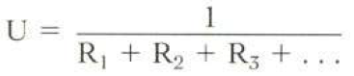

* U is an index of a construction’s tendency to conduct heat. U is defined as the number of BTUs that will be conducted through 1 square foot of a construction in 1 hour when there is a 1 °F temperature difference driving the heat flow.

U = BTU/sq. ft./hr/°F

Example 1. Calculate U for the wall shown.

|  |  |  |
| --- | --- | --- |
|  | **Material**  Air film outside  4” brick  Air space facing foil  2” polyurethane  5” concrete  Air space  ½” gypsum board  Air film inside | **R** |

Example 2. Using the R-Value Table and the Thermal Resistance (R) of Selected Confining Air Spaces Table below, determine the U-Factor of the wall assembly shown.

Wall - Wood Frame, no insulation

Air film inside

½” Gypsum Board

3 1/2” Air Space

1” Mineral Fiber with Resin Binding

Wood Siding, Bevel, 0.5 by 8 in lapped

|  |  |
| --- | --- |
| **Component** | **R-Value** |
| Air Film inside |  |
| 1/2" Gypsum Board |  |
| 3 1/2" Air Space |  |
| 1" Fiberboard Sheathing |  |
| Wood Siding |  |
| Air Film Outside |  |
| Rtotal |  |
| U-factor |  |

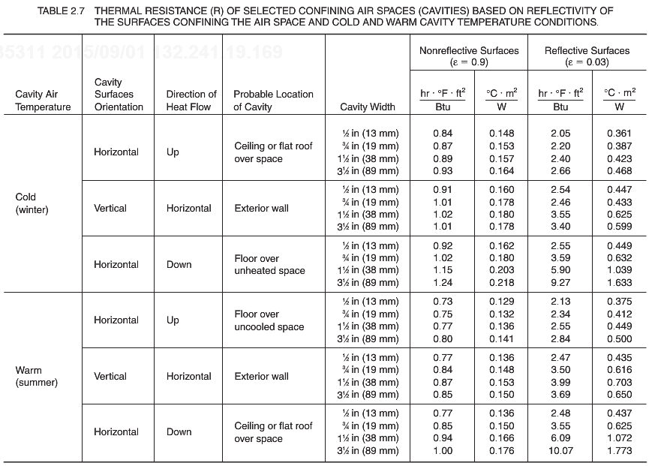

**Transmission Heat Loss in Constructions**

Transmission heat loss is heat lost through the building envelope.

**Q = U x A x ∆T x t** Q is the quantity of heat loss in Btu

**q = U x A x ∆T** q is the rate of heat transfer in Btu/hr

Where,

U is the overall heat transmission coefficient in Btu/hr x °F x ft2

A is the area in ft2

∆T is the temperature difference in °F

t is the time period in hours

The area, A, is of the construction (i.e. wall, ceiling, floor) that is between the heated and unheated spaces.

∆T is found by subtracting the outside air temperature from the air temperature of the heated spaces (design temperature) ∆T = (Toutside – Tinside)

The various portions of the building envelope may differ in the amounts of heat conducted through them because they have different U-factors (R-values). Such differences will depend upon the conductive qualities of the materials used in each section. The concrete used in the foundation, wood in the walls, glass of the windows, and shingles of the roof, all have different conductive characteristics.

Heat transfer analysis is required for each of the different construction assemblies of a building.

Example 3.

A house has 1000 ft2 of net exterior wall area (after subtracting for windows, doors, and so on). The outside temperature is 0°F and the inside temperature is 68°F.

1. Compute the rate of heat loss through an insulated wall (U = 0.073 Btu/hr x °F x ft2)
2. Compute the rate of heat loss through an uninsulated wall (U = 0.267 Btu/hr x °F x ft2)
3. Compute the transmission heat loss through an insulated wall (U = 0.073 Btu/hr x °F x ft2) over a period of one day (24 hr).

Note: The uninsulated wall assembly has a rate of heat loss much greater than the insulated wall!

**Transmission Heat Loss in Construction Below Grade**

The overall coefficient of heat transfer (Us) is based on soil depth below grade.

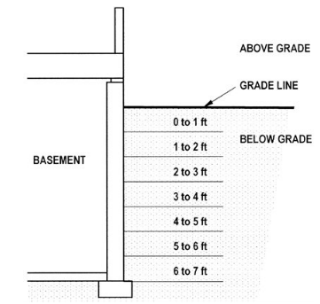

Figure 2.

Table 1. Overall Coefficient of Heat Transfer (Us) for Uninsulated and Insulated Walls Below Grade.

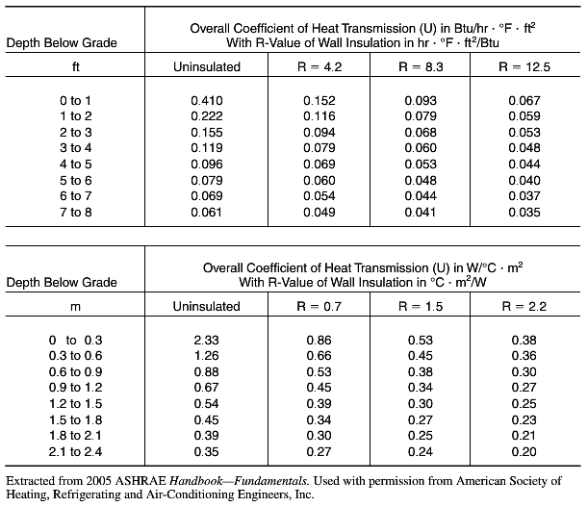

**Transmission Heat Loss on Floors on Grade**

For design purposes, the heat loss of a slab on or near grade is primarily from energy passing from the slab edge at the exterior building perimeter. Although the slab area away from exterior walls contributes somewhat to heat loss, it only accounts for a very small fraction (usually less than a few percent with perimeter insulation).

Thus, transmission heat loss in floors on grade is based upon length of exposed perimeter edge rather than the area of the slab itself.

Heat loss through the exterior edge of a concrete slab on grade or a slab within 3 ft of grade is based on:

**Q = Uf x L x t**

**q = Uf x L**

where, rate of heat loss per unit length (Uf) is expressed in Btu/hr-ft

L is lineal feet (ft) of edge of the slab exposed to the outside conditions

T is the time period in hours

Q is the quantity of heat loss in Btu

q is rate of heat loss

Table 2. Rate of Heat Loss Per Unit Length (Uf) Through the Exterior Edge of Concrete Slabs on Grade Based on Winter (Outside) Design Temperature

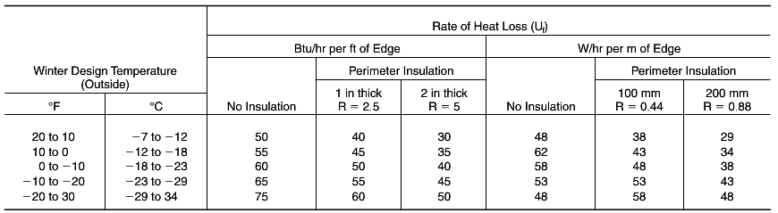

Example 4.

A house is built on a slab on grade foundation that is a 25 ft by 41 ft rectangular shape. Assume the outside design temperature is -5°F.

1. Determine the rate of heat loss through the exterior edge of a concrete slab if the slab edge perimeter is insulated with 2 in of perimeter insulation (an R-value of about 5).
2. Determine the rate of heat loss through the exterior edge of a concrete slab if the slab edge is not insulated.

**Infiltration Heat Loss Computations**

Infiltration occurs when unconditioned outside air leaks into the building through the building envelope, is conditioned, and then leaks out (exfiltrates) from the structure. Infiltration air enters through openings in walls, cracks around doors and windows, electrical outlet holes, and a variety of other openings.

The quantity of heat lost through infiltration depends on many factors, including inside–outside air temperature difference, wind velocity, occupancy patterns, furnace operation, and the physical condition of the structure.

Warm inside air is more buoyant and rises to the top of the structure interior (chimney effect). In the winter, inside air leaks out through openings in the building envelope and is replaced by colder outside air that infiltrates through the building envelope.

Wind creates a difference in pressure within the building, thereby increasing the rate of infiltration. As wind velocity increases, the amount of air leakage also increases. The proximity of large trees, fences, and other buildings will affect the amount of infiltration caused by wind.

Infiltration is the exchange of conditioned air with outside air, so it is necessary to know the ***heat capacity of air***.

The heat capacity (C) of air is the amount of heat necessary to change the temperature of one cubic foot (or cubic meter) of air one degree. It is expressed in units of Btu/ft**3** x °F.

Heat capacity is dependent on the density of air, which varies with temperature and atmospheric pressure.

The heat capacity of air will generally range from 0.014 to 0.018 Btu/ft**3** x °F ; the lower value applies to higher altitudes (e.g., Denver).

**It is common practice to use** **0.018 Btu/ft3 x °F as the heat capacity of air in heating load calculations**.

There are two methods used to calculate heat loss from infiltration:

1. The crack-estimation method is calculated on the basis of physical size and length of known cracks, such as around doors and windows.
2. The air-change method is based on an approximation of the number of air exchanges per hour based upon the volume of the structure or room under consideration.

An **air change per hour (ACH)** is a way of expressing the rate at which air in an interior space is replaced by outside air caused by infiltration. It is expressed in terms of the exchange rate of the equivalent of one volume of the space or room under consideration; that is, 1.0 ACH relates to an infiltration rate equivalent to the volume of the space or room in one hour, a 2.0 ACH means that twice the volume of the space or room has been replaced by infiltration, and so on.

Establishing the ACH for heating load computations requires engineering judgment on the quality of construction of the building envelope because the only reliable way to determine the ACH is to measure it after the building is built.

One method of estimating infiltration rates is reported in the 2001 ASHRAE Handbook—Fundamentals. It is based on outside design temperature and construction quality:

For tight, energy-efficient construction, the ACH is between 0.41 and 0.59.

For medium construction, the ACH is between 0.69 and 1.05.

For loose construction, the ACH is between 1.11 and 1.47.

An ACH of at least 0.5 is desirable to maintain air quality over the long-term.

Once an estimate of air exchange rate has been established, infiltration heating load (Qinfil) and rate of infiltration loss (qinfil) can be computed using the following equation:

**Qinfil = C x ACH x V x ∆T x t**

**qinfil = C x ACH x V x ∆T**

C is the heat capacity of air (use 0.018 Btu/ft3 x °F)

ACH is the number of air changes per hour

V is the volume of the space in ft3

∆T is the inside-outside temperature difference

Example 5.

Calculate the rate of infiltration heat loss of a room with a 200 ft2 are and 8 ft high ceilings. Use an inside temperature of 68°F, an outside ambient temperature of 0°F, and an hourly ACH of 0.5. Assume the heat capacity of air is 0.018 Btu/ft3 x °F .

Solution.

**Heat Loss From Ventilation**

Ventilation air is unconditioned outdoor air that is mechanically introduced into the building interior that, as a result, contributes to the building heating load.

*For residences*, ventilation heat loss is generally ignored in heating load computations because it is typically not a code requirement and is generally small.

*For nonresidential buildings*, ventilation heat loss is a significant consideration in heating load computations because ventilation air is required in these buildings for occupant comfort and health. This is particularly true of high-occupancy buildings.

In large buildings, ventilation heat loss is treated as a separate component of the heating load. For example, ASHRAE Standard 62 specified rates at which outside air must be supplied to a room, which is generally within the range of 15 to 60 cfm/person, depending on the activities that normally occur in that room. (A cfm is a cubic foot per minute of airflow).

For example, assume a classroom space is designed for an occupancy of 30 persons. The ASHRAE

Standard calls for a minimum outside airflow rate for classrooms of 15 cfm per person. Therefore, the classroom requires 15 cfm/ person x 30 persons, or 450 cfm.

Sensible heat loss from ventilation air is based on the quantity and conditions of outdoor air. The sensible heating load from ventilation can be computed as follows, based on the outside design temperature and inside design temperature difference (ΔT), in °F, and the volumetric airflow rate (Qairflow), in cfm.

The constant 1.1 is based on the heat capacity of air under standard conditions multiplied by 60 min in an hour: 0.018 Btu/ft3 x °F x 60 min/hr = 1.08 (rounded to 1.1).

**qventilation = 1.1 x Qairflow x ∆T**

Example 6.

A college classroom is designed for an occupancy of 55 persons. The ASHRAE Standard call for a minimum outside airflow rate for classrooms of 15 cfm per person. The target inside design temperature is 72**°**F and the outside design temperature is 3**°**F. Determine the sensible heating load from ventilation.

Solution.

Table 3. Suggested Indoor Design (Dry Bulb) Temperature and Relative Humidity Ranges for Selected Occupancies. Lower Temperatures Typically Apply to the Heating Season. Code Requirements May Vary.

