CMGT 235 – Mechanical and Electrical Systems
Homework #2 – Calculating Heat Loss in Buildings
Due: 8/30

Name: ______________________________________________________________________________________

- Calculate the total heat loss due to transmission during a 24-hour period for a flat roof 90 ft X 135 ft. The roof is constructed per the detail below. The inside temperature is 70 °F and the outside temperature is 52 °F. Assume winter conditions. Show all calculations.

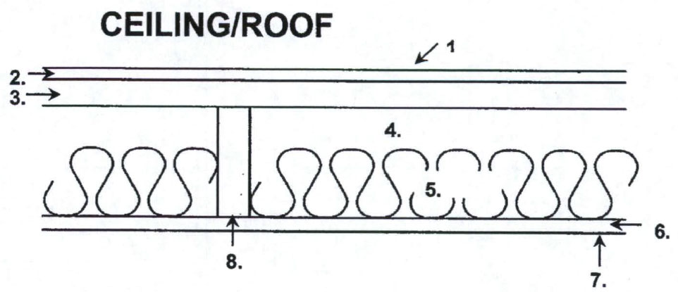

 |  | R (Between joist) | R (At joist)
1. | Air film outside
2. | 3/8 in. Built-up roofing
3. | 5/8 in. Plywood Sheathing
4. | 1 ½ in. Air space
5. | R-15 Fiberglass Batt Insulation
6. | 5/8 in. Gypsum board
7. | Air film inside
8. | Nominal 2-in x 12-in Doug Fir Joist @ 24 in. o.c.
R_{Total}
R_{Total} (Average)
U-Factor (Use Three Decimals)

- An exterior wall is made up of 8" of stone (R= 0.08 per inch), 3" of foamed-in-place polyurethane, and 0.75" Plywood, and 5/8" gypsum board. Determine the total R-value and U-Factor for the wall. Use the lookup table provided in class. Assume winter.
Component | R-Value
Wall – Outside Air Film
8" stone
3" foamed-in-place polyurethane
¾" plywood
5/8" gypsum board
Inside Air Film
Total Wall Assembly R-Value
U-Factor (Use Three Decimals)

- If the wall in problem 2 is 40 ft long and 12 ft. high what is the heat loss through the wall for an indoor winter design temperature of 78 °F and an outside temperature of 42°F?

