CMGT 235 – Mechanical and Electrical Systems
Homework #2 – Calculating Heat Loss in Buildings
Due: 8/30
Solution
Name: ______________________________________________________________________________________

- Calculate the total heat loss due to transmission during a 24-hour period for a flat roof 90 ft X 135 ft. The roof is constructed per the detail below. The inside temperature is 70 °F and the outside temperature is 52 °F. Assume winter conditions. Show all calculations.

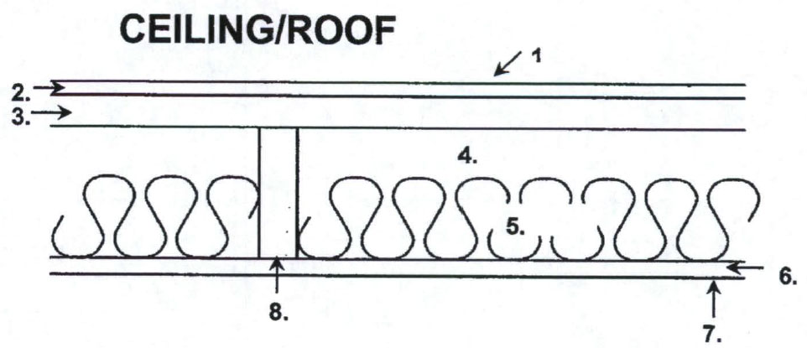
 |  | R (Between joist) | R (At joist)
1. | Air film outside | 0.17 | 0.17
2. | 3/8 in. Built-up roofing | 0.33 | 0.33
3. | 5/8 in. Plywood Sheathing | 0.77 | 0.77
4. | 1 ½ in. Air space | 1.00 | ---
5. | R-15 Fiberglass Batt Insulation | 15.00 | ---
6. | 5/8 in. Gypsum board | 0.56 | 0.56
7. | Air film inside | 0.68 | 0.68
8. | Nominal 2-in x 12-in Doug Fir Joist @ 24 in. o.c. . (1.5” x 11.25”) R=1.00 | --- | 11.25
R_{Total} |  | 18.51 | 13.76
R_{Total} (Average) |  | 18.21
U-Factor (Use Three Decimals) |  | 0.055

Determine the average U-Factor for the ceiling

22.5”
1.5”

R_{AVG} = (1.5”/24”) x 13.76 + (22.5”/24”) x 18.51 = 0.86 + 17.35 = 18.21
U_{AVG} = 1 / R_{AVG} = 1 / 18.21 = 0.055 Btu/hr x °F x ft²

Total Heat Loss
Q = U x A x ∆T x 24 hr = 0.055 Btu/hr x °F x ft² x (90 ft x 135 ft) x (70°F - 52°F) x 24 hr = 12,029 BTU
- An exterior wall is made up of 8" of stone (R= 0.08 per inch), 3" of foamed-in-place polyurethane, and 0.75" Plywood, and 5/8" gypsum board. Determine the total R-value and U-Factor for the wall. Use the lookup table provided in class. Assume winter.
Component | R-Value
Wall – Outside Air Film | 0.17
8" stone | 0.64
3" foamed-in-place polyurethane | 18.75
¾" plywood | 0.93
5/8" gypsum board | 0.56
Inside Air Film | 0.68
Total Wall Assembly R-Value | 21.73
U-Factor (Use Three Decimals) | 0.046

- If the wall in problem 2 is 40 ft long and 12 ft. high what is the heat loss through the wall for an indoor winter design temperature of 78 °F and an outside temperature of 42°F?

Rate of Heat Loss
q = U x A x ∆T = 0.046 Btu/hr x °F x ft² x (40 ft x 12 ft) x (78 °F - 42°F) = 795 Btuh

Heat loss per Day
Q = U x A x ∆T = 0.046 Btu/hr x °F x ft² x (40 ft x 12 ft) x (78 °F - 42°F) x 24 hr = 19,080 Btu

