How to Perform a Heat-Loss Calculation — Part 2
Simple ways to calculate transmission losses and exfiltration losses
By Martin Holladay | April 27, 2012

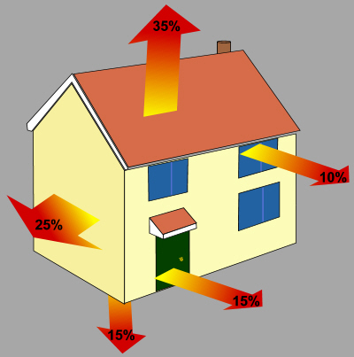
You can't stop the flow of heat, which always moves from hot to cold — all you can do is slow it down.

To continue last week’s discussion of heat-loss calculation methods, let’s consider a simple rectangular building, 20 feet by 30 feet, with 8-foot ceilings. Let’s assume it has an 8-foot-high basement with uninsulated concrete walls; the below-grade portion of the basement is 7 feet high, with 1 foot above grade.

To keep things simple, we’ll assume that the house has a flat roof, and that each side of the house has two windows (each 3 ft. by 4 ft.) and one door (3 ft. by 7 ft.). The house doesn’t have a chimney.

We’ll assume that the building is in Boston, Massachusetts, a location with an outdoor design temperature of 9°F. That means we have a ∆T of 61 F°. Let’s calculate the expected heat flow rate per hour through the floor, walls, and ceiling at the design temperature. (For the time being, we’ll ignore infiltration.)

First, determine the relevant areas and U-factors
The first step is to group all of the envelope components with similar U-factors together and calculate their areas. The second step is to look up or calculate the relevant U-factors.
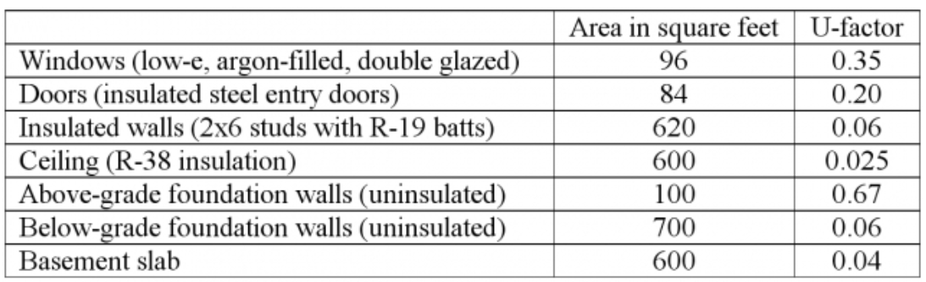

The listed U-factors for these assemblies are subject to discussion, and some readers may dispute whether the chosen values are appropriate. For the time being, however, let’s leave that discussion aside and use these U-factors to illustrate the calculation method.

(Tables listing U-factors for a variety of building assemblies can be found online; here’s one of them. The original I=B=R table of building assembly U-factors can be found here. Almost all of these tables are subject to dispute. If you prefer, you can calculate your own building assembly U-factors by adding up the R-values of the relevant layers and converting these R-values to U-factors, using the equation U=1/R. Click here to read more about calculating the U-factor of building assemblies.)

The heat loss formula for determining transmission losses through floors, roofs, and walls is Q = A • U • ∆T. In other words, the rate of heat flow through a building assembly (in Btu/h) is equal to the area of the assembly (in ft²) times the U-factor (in Btu/ft² • hr • F°) of the assembly times the ∆T (in F°).

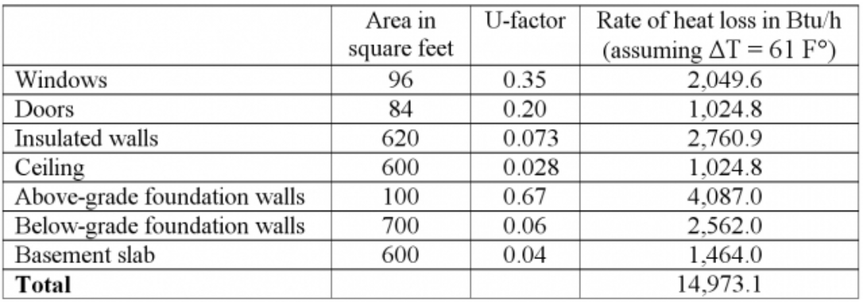

Next, calculate the exfiltration heat loss
Although we’ve come up with an estimate of the rate of heat flow for the home in question (14,973 Btu/h) under design conditions, we’re not done yet. The above calculation does not yet include heat loss due to exfiltration (air escaping through cracks in the building envelope).

These days, the most common way to calculate heat loss due to exfiltration is to use a software program. Before computers became common, however, the I=B=R method estimated these losses by adding up exfiltration loss estimates for each room. Rooms were sorted into five categories, as shown in the table below.

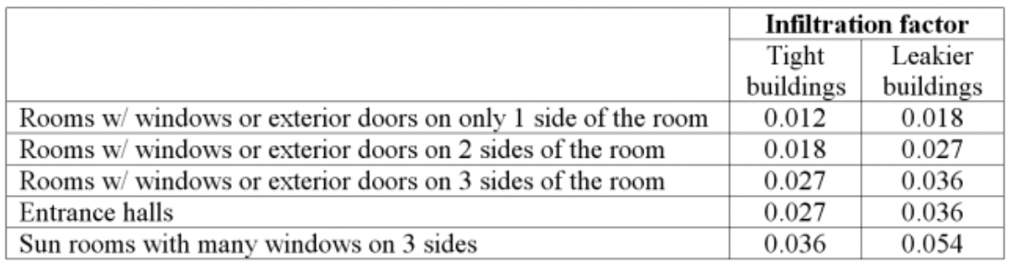

The infiltration factors correspond to the assumed natural air changes per hour for each room, as shown in the table below:

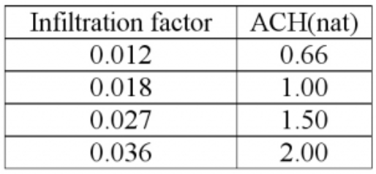

The calculation method requires that the volume of each room be calculated; then the rate of heat loss at the design temperature is calculated using the formula:

Exfiltration heat loss = Room volume Ã—∆T Ã— ACH(nat) Ã— Infiltration factor

Needless to say, the I=B=R method is fairly crude, and is intended to be used for houses with fairly high air leakage rates — a reflection of the fact that the calculation method is decades old. In most cases, the I=B=R method overestimates exfiltration losses; the usual result is the oversizing of furnaces and boilers.

To return to our example, let’s assume that the 20 ft. by 30 ft. house has only two rooms; each room measures 15 ft. by 20 ft. and has three exterior walls. We’ll assume that the building is “tight,” using the obsolete definition in the old I=B=R method.
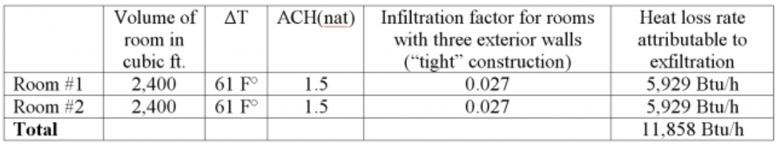

Other ways of calculating exfiltration and ventilation heat loss
If you want to do a pencil-and-paper calculations of the heat loss due to exfiltration and mechanical ventilation, you can also perform the calculations using the following formula:

Ventilation heat loss (in BTU/h) = 1.08 x Ventilation or exfiltration rate (in cfm) x ∆T (in F°)

Where does the 1.08 come from, you might ask?
The constant 1.08 is based on the heat capacity of air under standard conditions multiplied by 60 min in an hour: 0.018 Btu/ft³ x °F x 60 min/hr = 1.08 (often rounded to 1.1).

Add the exfiltration heat loss to the transmission heat loss
To determine the rate of heat loss at the design temperature for the entire house, we add the exfiltration heat loss (for all of the rooms) to the previously calculated transmission heat loss. In this example, the sum would be:

11,858 Btu/h + 14,973 Btu/h = 26,831 Btu/h.

This method, or one very much like it, was the method used for years by HVAC contractors when sizing furnaces or boilers. If the smallest available furnace from the local HVAC equipment dealer is rated at 35,000 Btu/h, that’s the model that a contractor would choose to install in this house.

Although the example we looked at did not include a slab on grade, a crawl space, or an attic, the I=B=R method can certainly be used to perform heat-loss calculations for buildings with these features. There is no need to delve any deeper into the details of the pencil-and-paper I=B=R method in this blog, however, since most heat-loss calculations are now performed using computer software. (GBA readers who want more details on the I=B=R method — so that they can perform heat-loss calculations the way their grandparents did — can consult the original 1951 manual.)

These days, the most popular heat-loss software programs are all based on the Manual J method developed by the Air Conditioning Contractors of America (ACCA). For more information on Manual J software, see Saving Energy With Manual J and Manual D.

But is it accurate?
Although the heat loss method described above, with its various equations and factors, has an aura of precision, it isn’t based on an accurate description of heat loss.

- Since no one knows what the “natural” air changes per hour on a cold winter night will be for any particular house design, any ACH(nat) figure is no more than a guess.
- The simple one-dimensional heat flow equation used by this calculation method is a gross simplification of the way heat flows actually occur in a three-dimensional building.
- This heat loss calculation method does not account for thermal mass effects.
- This heat loss calculation method does not account for losses due to mechanical ventilation.
- This heat loss calculation method ignores internal gains from occupants, pets, refrigerators, lighting, and electronic appliances.
- Large errors can be introduced when a designer is uncertain of a building assembly’s U-factor.
- This heat loss calculation method ignores most thermal bridges.
- As energy consultant Michael Blasnik has pointed out, this heat loss calculation method ignores “thermal regain” (reduced transmission losses due to the effects of heat piggybacking on stack-effect air movement) in basements and attics.

Most of the errors introduced by pencil-and-paper heat-loss calculations trend in the same direction: namely, they overestimate heat loss. Moreover, HVAC contractors commonly add fudge factors to cover any unknown defects in construction, pushing heat loss estimates higher still. The net result: most furnaces and boilers are grossly oversized.

In recent years, energy modelers have developed increasingly sophisticated software programs that do a much better job of predicting heat loss rates than the crude pencil-and-paper method described above. Unfortunately, improved accuracy comes at a cost: the need for more data entry.

The purpose of this introduction to heat loss calculations is to provide designers with a framework for understanding how these calculations are made. There is, of course, much more to say on the topic.

In Part 3 of this blog series, I’ll discuss cooling load calculations. In Part 4 of the series, I’ll discuss the question of when room-by-room heat-loss calculations are necessary and when they are a waste of time.

