|  |  |  |
| --- | --- | --- |
| **CMGT 235 – Electrical and Mechanical Systems** | | |
| **Discussion No. 3** | **Unit 1 - Mechanical Systems** | **Fall 2022** |

***Properties of Air-Water Mixtures***

**Definitions and Concepts**

* HVAC – Heating, Ventilation, and Air conditioning
* Psychrometrics –The behavior of mixtures of air and water vapor under varying conditions of heat
* Enthalpy = Total heat in the air = Sensible plus Latent heat
* Sensible Heat – Changes in temperature that do not alter the moisture content of air
* Latent Heat – Related to level of moisture in the air
* BTU (British Thermal Unit) – The amount of heat that must be added to or subtracted from a pound of water at 60°F to affect a temperature change of 1°F
* BTUH or BTU/H – BTU’s per hour
* MBTUH – 1000 BTUH
* Ton
* 1 Ton equals the amount of heat needed to melt 1 ton of ice in one day
* 12,000 BTUH’s
* Drybulb Temperature – The temperature reading given by a dry thermometer that gives a direct indication as to the sensible heat content of air
* Wetbulb Temperature – The temperature reading from a wetted bulb that gives a direct indication as to the total heat content of air
* Dew Point Temperature – Temperature at which air will begin to release moisture.
* Relative Humidity (RH)
* The actual amount of moisture in the air expressed as a percentage of the amount of moisture the air is capable of holding.

More technically:

* The amount of water vapor in the air divided by the amount of water vapor the air can hold (at the same temperature and pressure.)
* The ratio of the air's vapor pressure to its saturation vapor pressure.
* Example: An air sample that is at 50% RH is holding half the moisture it is capable of holding at the same temperature (at dew point or saturated.)
* RH is inversely relational to temperature for the same moisture level (grains of moisture per pound of dry air) – warm air can hold more moisture
* RH is what we sense
* High RH: Sticking, mold
* Low RH
* Affects electronics, promotes static
* Low RH air is seeking saturation, absorbing moisture wherever it can
* Specific Humidity or Humidity Ratio
* The weight of the water vapor in each pound of dry air
* Typically grains of moisture/pound of dry air
* Grain = 1/7000 pound
* Density – Unit weight of dry air at a given temperature and moisture content, lb/ft3
* Specific Volume – Space occupied by dry air at a given temperature and moisture content (the reciprocal of density), ft3/lb

**The Psychrometric Chart [SEE PAGE 4 FOR PSYCHROMETRIC CHART]**

* Constant Drybulb Temperature: Vertical Lines

➋ Constant Wetbulb temperature: Upward left sloping lines

➌ Relative humidity: Curving lines (100% line is the saturation curve or correlates with Dew Point)

➍ Left hand scale: Constant Dew Point (°F):   
Right hand scale: Humidity Ratio (grains of moisture/lb of dry air) and Vapor Pressure (in of Hg)

➎ Enthalpy or total heat, BTU/lb of dry air: Staggered scale left of saturation curve and left sloping lines

➏ Constant specific volume, ft3/lb of dry air: Sloping lines

➐ Saturation Curve: 100% RH Curve (or the point at which an air mixture can hold no additional moisture at a given temperature); temperature on the curve is the Dew Point

**Latent vs. Sensible Changes**

* Latent Changes move in the direction of the y-axis
* Sensible changes move in the direction of the x-axis

**Relationship of Drybulb (DB), Relative Humidity (RH), Dewpoint (DP) , and Wetbulb (WB)**

**Impact to Relative Humidity from Sensible Changes**

Temperature and Relative Humidity are inversely related:

* the higher the temperature, the lower the RH
* the lower the temperature, the higher the RH

**Example 1. See Psychrometric Chart, Example 1**

If the air temperature of 75°F at 40% RH is warmed to 90°F without adding moisture, what is the new RH?

What is the RH is the air is cooled to 55°F?

**De-humidification**

What happens when the RH is 100%? _____________________________________

* As air cools, it eventually reaches its dewpoint and moisture begins to appear.

If the air is continued to be cooled, at what temperature will the saturation point be reached?

What happens if the air is continued to be cooled below 49°F?

**Humidification**

If the air temperature of 75°F at 40% RH what is the new RH if 12 gr of moisture/lb of dry air is added to the air?

What is the new DP?

**Enthalpy Changes**

* Enthalpy = Total heat in the air = Sensible plus Latent heat
* Sensible Heat – Changes in temperature that do not alter the moisture content of air
* Latent Heat – Related to level of moisture in the air
* Enthalpy is measured in BTU/lb dry air

What is the change in enthalpy when air at 75°F at 40% RH changes to 80°F at 60% RH?

**Example 2. See Psychrometric Chart, Example 2**

A space at sea level is 70°F and RH = 50%. Find the other properties of the air in that space.

Solution. Use Psychrometric Chart

|  |  |
| --- | --- |
| DB = | **70°F** |
| RH = | **50%** |
| WB = |  |
| Humidity Ratio= |  |
| VP = |  |
| Enthalpy = |  |
| Vs = |  |
| Dew Point = |  |

**Example 3.**

A saturated mixture contains 100 lb of dry air. How much heat is required (Btu) to raise the dry bulb temperature from 30°F to 70°F?

Solution. Use Psychrometric Chart

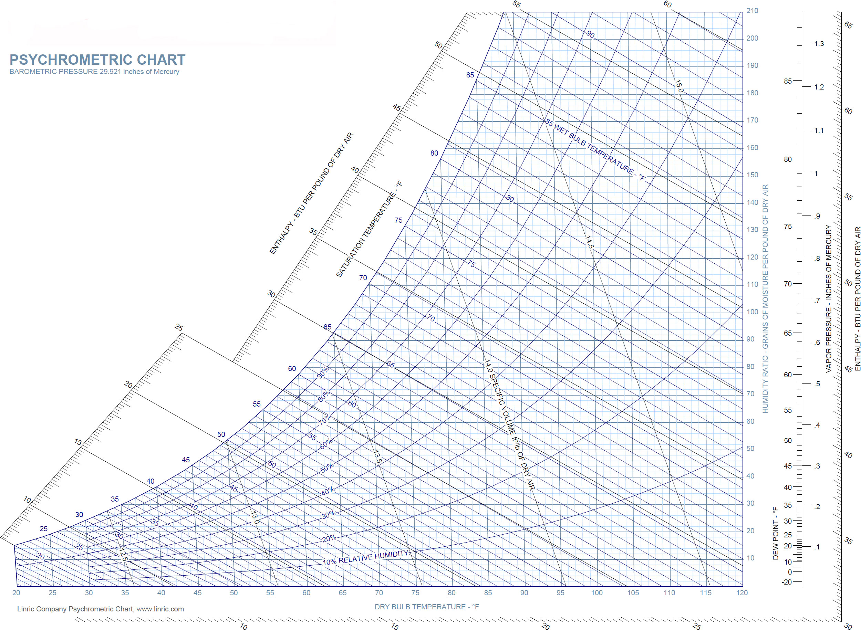

**➋**

**➐**

**➏**

**➎**

**➍**

**➌**

**Sensible**

**Latent**

**Humidity Ratio & Vapor Pressure**

**RH**

**WB**

**DP**

**DB**

**➊**



**Example 1**

**RH**

**WB**

**DP**

**Latent**

**Sensible**

**DB**



**Example 2**

**RH**

**DB**

**WB**

**DP**

**DB**