|  |  |  |
| --- | --- | --- |
| **CMGT 235 – Electrical and Mechanical Systems** | | |
| **Discussion No. 5** | **Unit 1 - Mechanical Systems** | **Fall 2022** |

**HVAC System Design**

**Air Conditioning Contractors of America (ACCA)**

HVAC Design Protocols

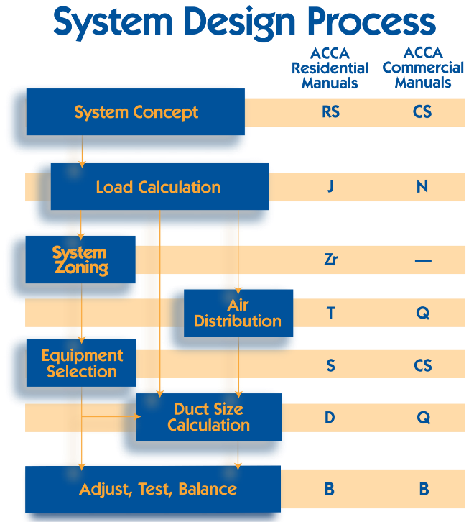 

HVAC design is more than ACCA Manual J. Most HVAC contractors, home energy raters, contractors and others in the residential construction field know about Manual J. Many non-builders even know about Manual D, which describes how to design the duct system. Not as many, however, know about the missing links - Manual S and Manual T. For a properly designed heating & cooling system, the designer must go through the whole process contained in all four protocols: J, S, T, and D.

**Manual J**

This manual is for determining how much heat the house loses in winter and gains in summer. Manual J is both a whole house and a room-by-room calculation, which allows you to determine how much conditioned air each room needs for both heating and cooling.

It factors in all the surfaces of the building envelope, with separate areas and insulation levels for each type of assembly. Each wall is given its proper orientation, because windows and doors are attached to them. Other important data include the location and tightness of the duct system, the infiltration rate of the house, the internal loads (appliances and people), and where the house is located.

The results specify the BTUs of heat lost by each room in the winter and gained in the summer. The heat gain is split into two parts: sensible (related to temperature) and latent (related to humidity). The heat gained or lost in a room then determines how much conditioned air that room needs in cubic feet per minute (cfm).

**Manual S**

Once the amount of conditioned air (cfm) necessary for each room is known, the designer reviews and selects a right-sized piece of equipment. Which air conditioner, heat pump, furnace, or boiler is a good fit for the calculated loads? With forced-air cooling systems, this selection is critical because every piece of equipment has different characteristics - sensible and latent capacities, the amount of air moved (cfm), and the static pressure delivered are the key attributes applied to the design in the next stages.

**Manual T**

With the room-by-room cfm requirements, the designer will determine how to distribute the air in the room to deliver enough to meet the needs (the higher of the heating and cooling cfm requirements from Manual J).

The questions answered here are: Where will the supply registers, diffusers, or grilles be located? Where will the return grilles be located? What type of register, diffuser, or grille will be used? How big does it need to be?

Good choices at this step eliminate drafts or inadequate mixing. It's possible to provide enough conditioned air to a room but still have comfort issues because of poor velocity at the register, which results in poor mixing or drafts from poor register placement.

**Manual D**

Finally, with all the data, the cfm needed for each room, the selected equipment, and how the air is distributed in the room, you can design the duct system.

At this stage the designer evaluates the path with the greatest friction, which may not be the longest path, by evaluating the ducts lengths, how many fittings and turns in the route, and how much air needs to be delivered.

The type of duct has a big impact on the results, as sheet metal ducts have a lower friction rate than flex duct or rigid fiberglass duct board.

The underlying principle of Manual D is to design a duct system which delivers the correct cfm to each room against the friction created by the ducts and fittings with the static pressure available from the blower.

**Pulling It All Together**

Utilizing the processes from all four ACCA manuals will result in a well-designed HVAC system. The result is a high-performance system that's more efficient and comfortable than typical installations.

Even the best HVAC design in the world, if it's not installed as designed, will perform poorly. It's a good idea to have every new system tested and commissioned.

**Heat Loss in Buildings - Building Heating Load**

**Heat Gain in Buildings - Building Cooling Load**

Root Cause 🡺 Heat Transfer – flow of heat

**How a House Gains Heat**

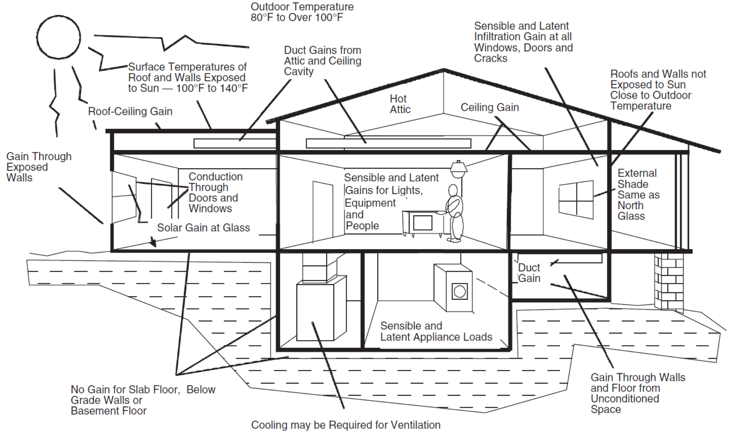

**How a House Loses Heat**

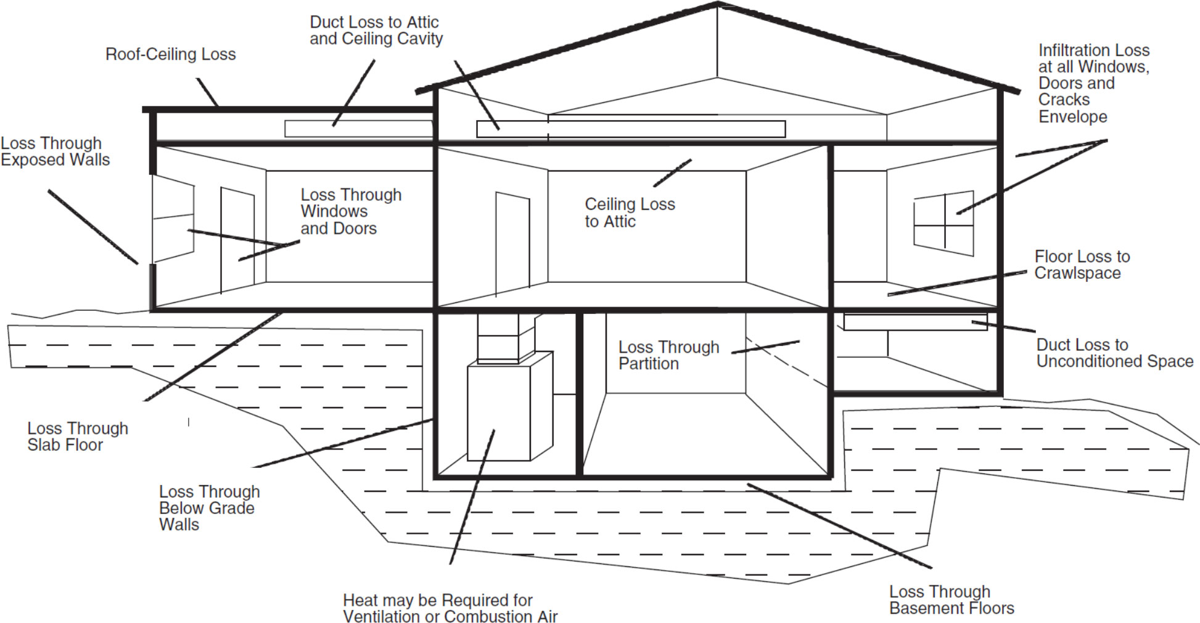

**Applied Heat Transfer**

|  |  |
| --- | --- |
| **Summer**   * Heat flows INTO the home * Sensible heat – dry heat (dry bulb; thermometer) * Latent heat – wet heat (wet bulb; humidity)   Heat Gain so we need cooling | **Winter**   * Heat flows OUT OF the home * Sensible heat only   Heat Loss so we need heating |

**2nd Law of Thermodynamics:**

* Over time, differences in temperature and pressure will decrease, leading to thermodynamic equilibrium
* Nature doesn’t like temperature differences, so heat flows from a region of high temperature to a region of lower temperature until both are equal
* But we humans do like temperature differences, so we’ve designed objects and processes to slow this physical phenomenon down or combat it outright.

**Purpose of a Load Calculation**

* First step in designing a mechanical system that can add or remove heat energy at a rate that will provide the acceptable level of comfort for the occupants.
* An account of the total heat flow into and out of a home, depending on the time of year.
* Using the load calculation, the designer will be able to choose equipment that has acceptable capacity.

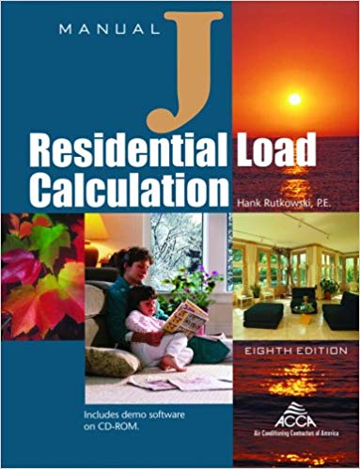**Manual J Load Calculation Method**

Two sets of design conditions.

The peak loads.

**Heat loss (winter)**

* Outdoor design temperature – heating 99% dry bulb (db)
* Indoor design temperature – 70°F db

**Heat gain (summer)**

* Outdoor design temperature – cooling 1% db
* Indoor design temperature – 75°F db

**Design Temperatures**

**Outdoor Design Temperature**

* Must be for the home’s specific location
* 30-year average compiled by ASHRAE
* Manual J – Tables 1A and 1B (free download)
* Updated in 2014

**Indoor Design Temperature**

* Within the ASHRAE comfort zone charts (per ANSI/ASHRAE 55 Thermal Environmental Conditions for Human Occupancy Standard)

**Manual J Outdoor Design Temperatures**

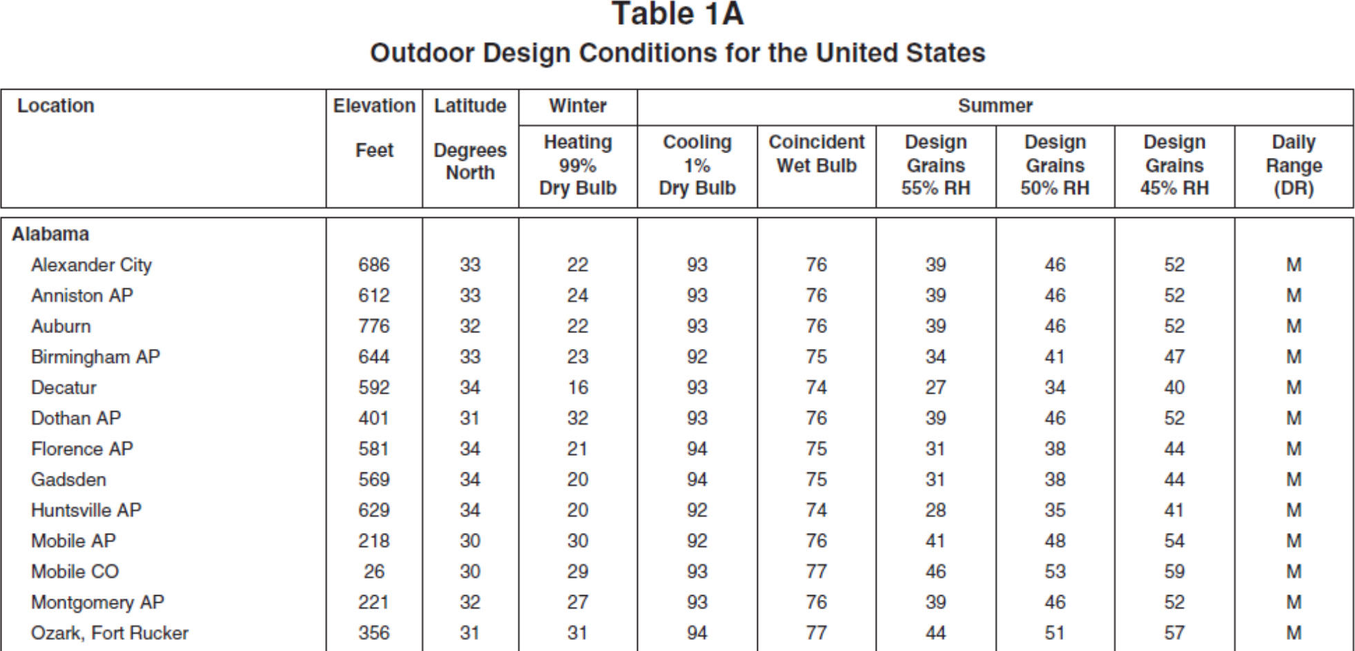

In a load calculation, the designer is going to account for every source of heat gain or heat loss.

These sources are what we call loads.

**Loads That Must Be Accounted For**

As applicable for the specific home:

* Fenestration (windows, glass doors, skylights)

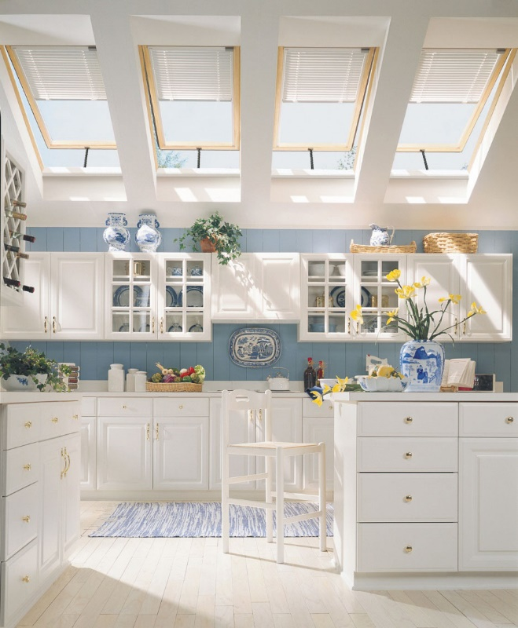 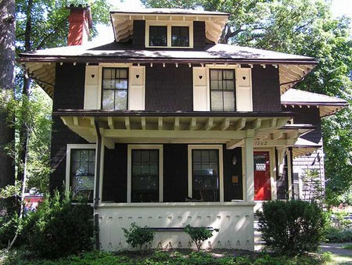

**Orientation – Important for Fenestration**

* What direction does the front door face? (Orientation)
* This is important because of the movement of the sun throughout the day, and it will have a huge effect on loads from windows, glass doors, and skylights.
* Opaque panels (wood/metal doors, above & below grade walls, partition walls, ceilings, floors)
* Infiltration

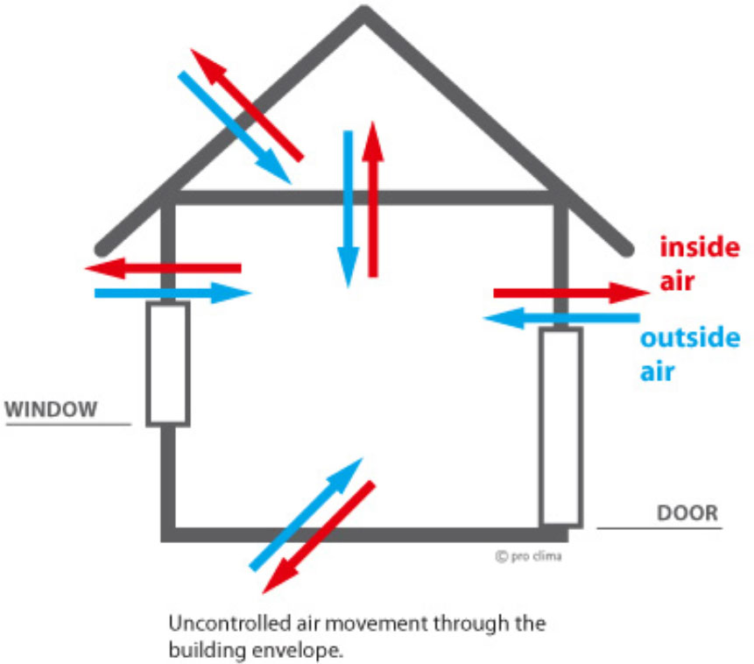

* Ventilation

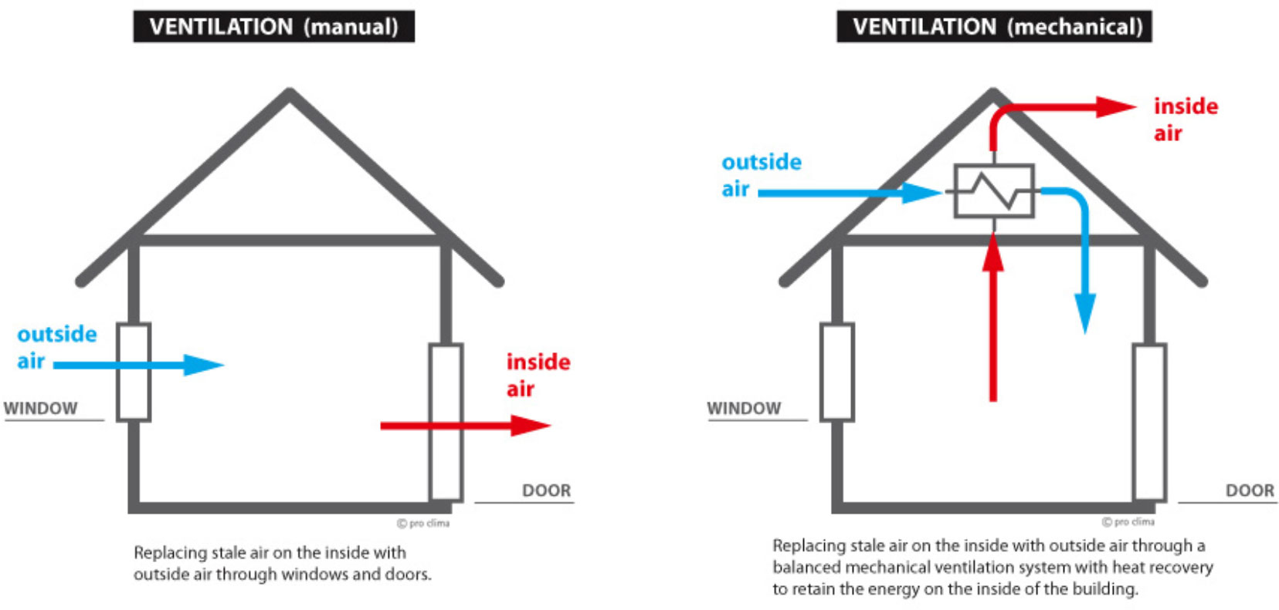

* Internal (number of people and appliances)

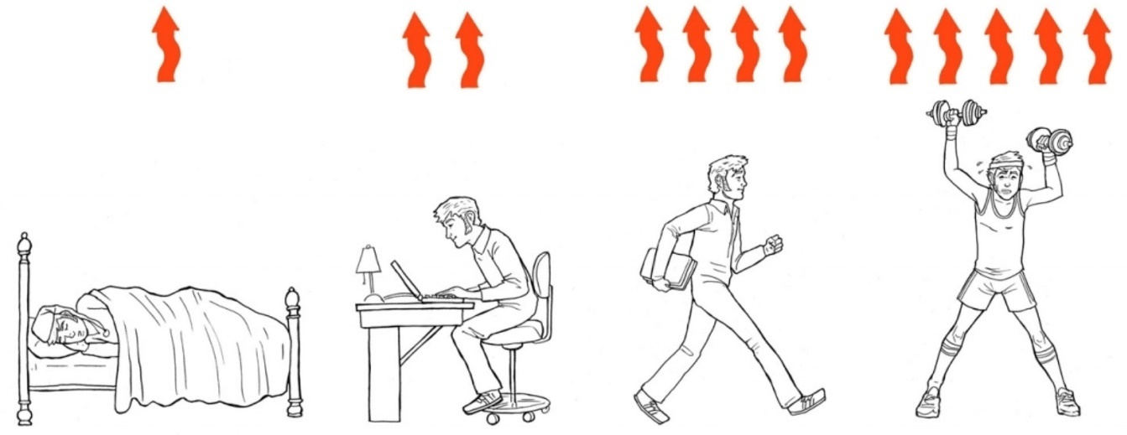

* System (ducts and blower)

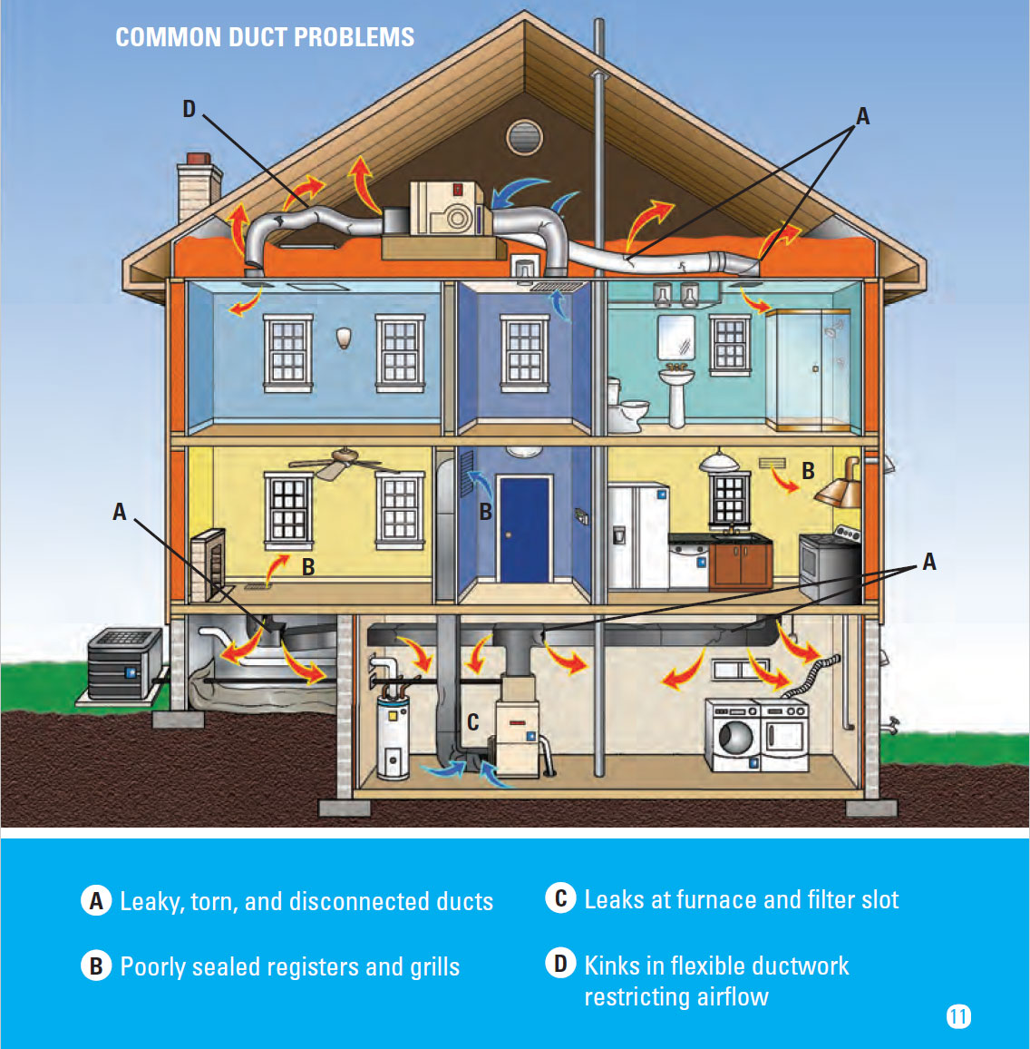

**Basic Load Equation**

**Load = U x A x ΔT**

U is the heat transfer performance index (how well, a material transfers heat; it’s the reciprocal of R- value)

* A is the Area
* ΔT is the Temperature Difference (TD)
* Load units are Btu/h

Can be simplified as Load = HTM x A

* HTM is the heat transfer multiplier
* HTM = U x ΔT

**Table Values**

Manual J 8th Edition (MJ8) has tables that contain specific values used in calculating individual loads.

Example: Table 4A (Heating and Cooling Performance for Opaque Panels) contains:

* Construction numbers,
* U values, or
* CLTD (cooling load temperature difference)

**Heating and Cooling Performance for Opaque Panels**

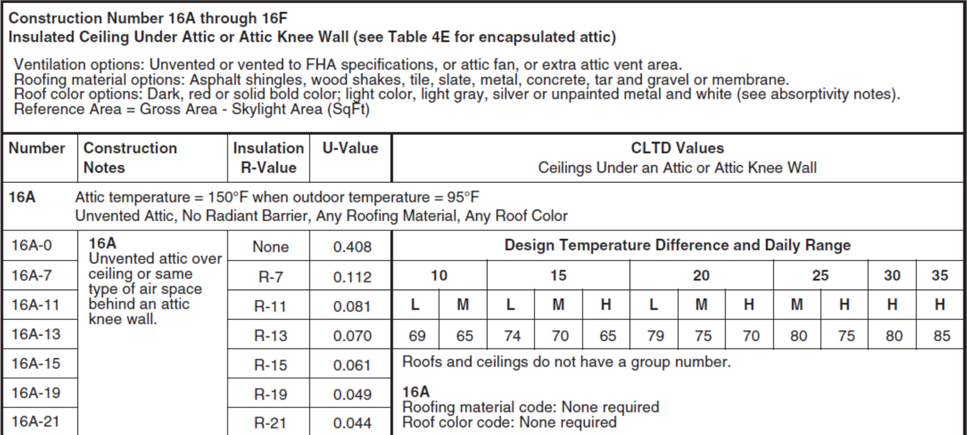

**Generic Fenestration**

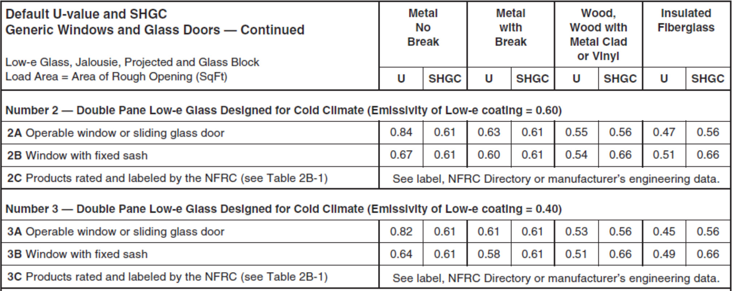

**HTM for Generic Window and Glass Door**

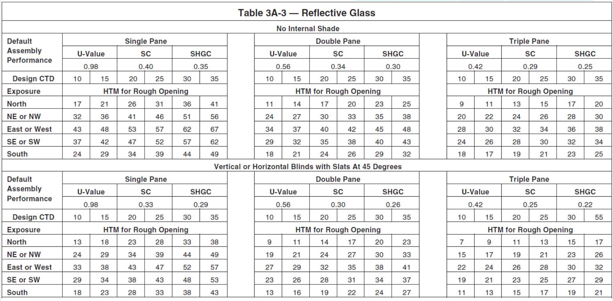

**Infiltration Defaults**

When measuring is not possible.

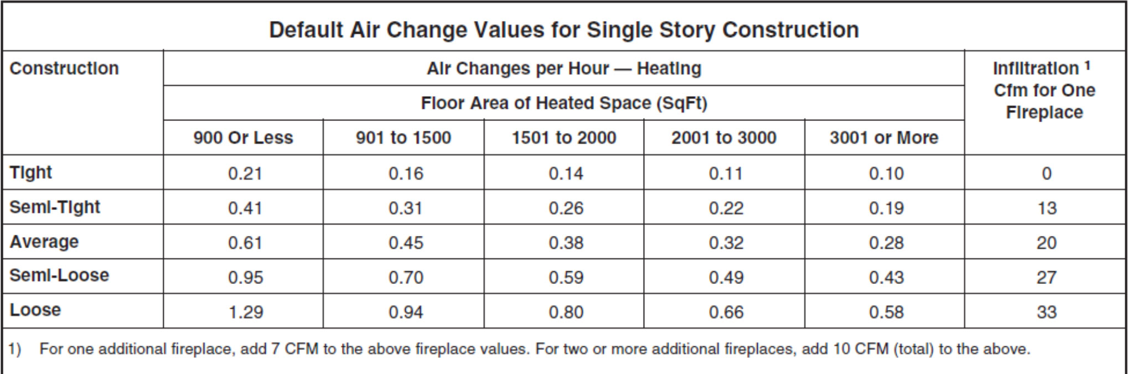

**Internal Load Defaults**

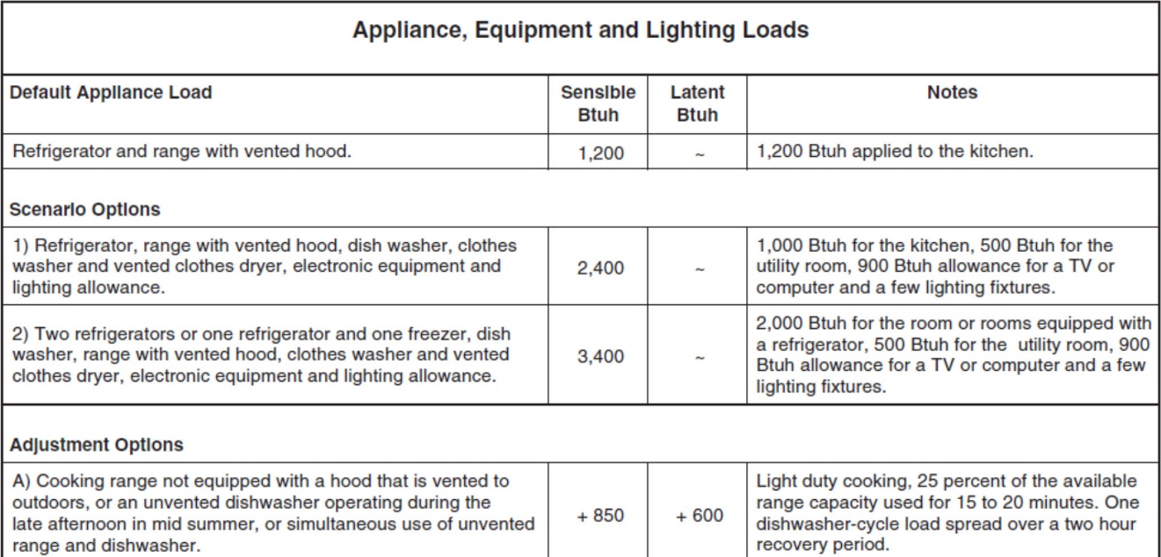

**Duct Load Scenarios**

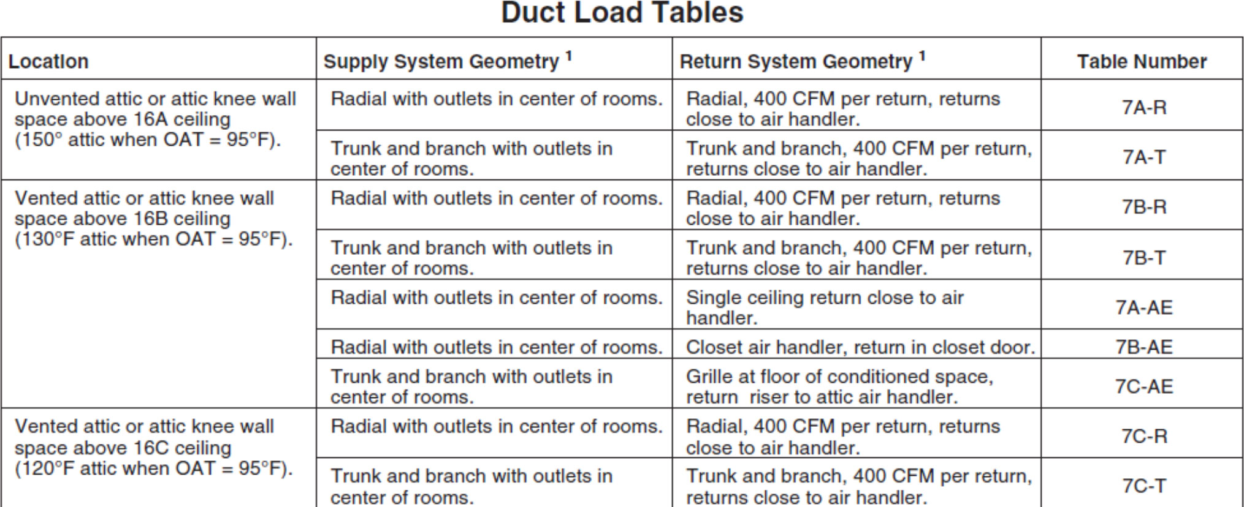

**Designer Options**

Simple load calculation – MJ8AE (Abridged Edition)

* Dwelling must be 100% compatible with AE Checklist
* Can be done by hand or using ACCA MJ8 speedsheet

Full load calculation – Full MJ8

* Can be done by hand, but extremely time consuming
* Usually use third party software

**Example - Accu-Size Heating & Cooling Home Analysis Form**

**How to Perform a Quick Load Calculation (Residential)**

Step 1. Measure the Home, location of the windows, orientation (North-South- East-West) and draw it fairly accurately. Grid paper is helpful. Measure each window (sf) and enter on the drawing.

Step 2. Complete the Accu-Size Heating & Cooling Home Analysis Form

**Cooling Load (heat gain) – 95 degree day**

Enter in the square Footage of the Windows by orientation and single or double

Enter the square footage of the doors (exclude crawl space doors)

Enter in the square footage of the walls (total perimeter x ceiling height). Vaulted ceilings use an average of the height, for example if the vaulted height is 12 feet use 9 ft or 10 ft based on the distance.

Determine what type of insulation is in the walls, attic, and floor and enter the square footage of the net walls, ceiling and floor.

Enter in the home’s total square footage in Infiltration/Ventilation and use the 3.5 multiplier (for a certified tight home 3.5 is not used)

Enter in the number of people (bedrooms) under Internal Gains

Step 3. Calculate the heat gain for each entry and add to get the Subtotal BTU/h heat gain

Step 4. Calculate the Gains for Ductwork

Step 5. Add to get the Total BTU/h Heat Gain

**Heating Load (heat Loss) – 0 degree day**

Repeat similar steps