CMGT 235 – Mechanical and Electrical Systems
Homework #5 | Due: 9/8
Show all work for full credit.
20 pts total
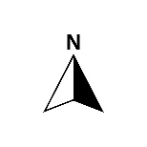
Name: ______________________________________________________________________________________

51 ft

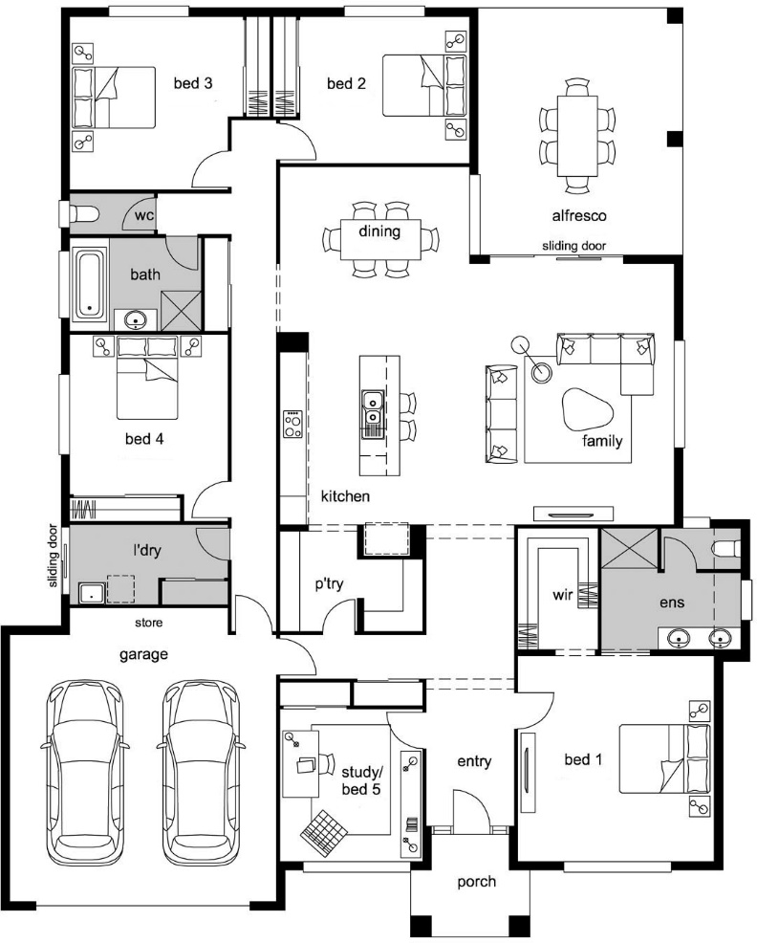
3 ft
2 ft
(Unconditioned space)
2 ft
2 ft
22 ft
45 ft
34 ft
(22 ft x 22 ft)
1 ft
4 ft
18 ft
12 ft
(16 ft x 16 ft)
35 ft
18 ft
5 ft

Window Specifications  All windows are Double Glass  Dining 5 ft x 4 ft  Family 8 ft x 5 ft  Bed 1 5 ft x 4 ft  Bed 2, Bed 3, and Bed 4 5 ft x 3 ft  Study/bed 5 5 ft x 4 ft  Bath 4 ft x 3 ft and 2 ft x 3 ft  Ens 3 ft x 3 ft and 2 ft x 3 ft  Door Specifications  Entry Door 7 ft x 3 ft (wood no storm door)  Garage Doors 7 ft x 3 ft (Wood no storm door)  Double Glass Patio Doors:  Sliding door 6 ft x 8 ft  Sliding door (l’dry) 4 ft x 8 ft | Building Construction  Floor SOG (edge insulation)  Walls R-19 (6” Insulation)  Ceilings R-30 (10” insulation)  Wood Frame Walls  Attic Space  Average Ceiling Height 10 ft  Porch 7 ft x 7 ft  Furnace 90% Efficiency Loss
Note: Garage Area is unconditioned space

SHOW ALL WORK FOR FULL CREDIT.
Part 1: Cooling Load (Heat gain)

- For the five-bedroom, two-bathroom house shown, write the square footage of each window along the outside of the window and the square footage of the entry door, garage doors, and sliding doors (patio) next to the doors on the floor plan. (See class example)

- Determine the total wall perimeter:
Wall Side | Length (ft) [Show calculations]
North
South
East
West
Total Wall Perimeter

Determine the total Glass Area (Includes Sliding Doors):
Side | Glass Area (ft²) [Show calculations]
North
South
East
West
Total Glass Area

Determine the total Door Area:
Door | Door Area (ft²) [Show calculations]
Wood No Storm Door
Total Door Area

- Determine the Net Wall Area.

- Determine the Ceiling Area.

Part 2: Heat Load (Heat Loss)
Item | Area (ft²)
Total sq. ft of Double Glass Windows
Total sq. ft. of Double Glass Patio (Sliding Doors)
Total sq. ft. of Wood No Storm Doors

- Using the attached Accu-Size Heating & Cooling Home Analysis Form complete the Cooling Load (heat gain) and the Heating Load (heat loss) for the home.

