|  |  |  |
| --- | --- | --- |
| **CMGT 235 – Electrical and Mechanical Systems** | | |
| **Discussion No. 6** | **Unit 1 - Mechanical Systems** | **Fall 2022** |

**Heating and Cooling Production Equipment**

Basic Purpose of HVAC

* Air-Conditioning for thermal and humidity comfort
* Heating
* Cooling
* Dehumidification
* Humidification

Source: ASHRAE Fundamentals Handbook 2017

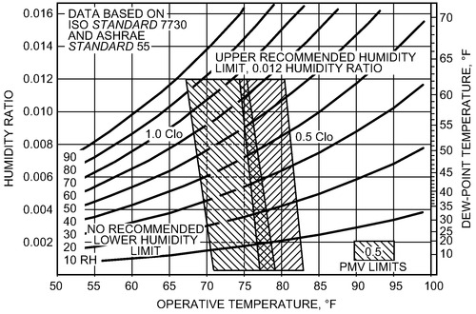

Figure 5. ASHRAE Summer and Winter Comfort Zones [Acceptable ranges of operative temperature and humidity with air speed ≤ 40 fpm for people wearing 1.0 and 0.5 clo clothing during primarily sedentary activity (≤1.1 met).]

* Ventilation
* Introduction of required outside air
  + International Mechanical Code (IMC) – Chapter 4: Ventilation
  + ASHRAE Standard 62.1
  + California Mechanical Code 2016

**Chapter 4 Ventilation Air.**

Chapter 4 regulates the minimum requirements for ventilation air supply, exhaust, and makeup air for spaces within a building. Building ventilation is one important factor affecting the relationship between airborne transmission of respiratory infections and the health and productivity of workers. Ventilation air may be composed of mechanical or natural ventilation, infiltration, recirculated air, transfer air, or a suitable combination of that. Providing a comfortable and healthy indoor environment for building occupants is of primary concern. When considering how much ventilation should be supplied, typical and unusual significant sources of indoor pollution need to be controlled. Areas such as kitchens, bathrooms, and laundries are all built to allow specific functions. These spaces produce pollutants such as moisture, odors, volatile organic compounds, particles, or combustion byproducts. The purpose of local exhaust is to control concentrates of these pollutants in the room into which they were emitted in and to reduce the spread of the pollutants into other parts of the occupancy. Local exhaust ventilation is the source control for pollution that is expected in certain rooms. Using local exhaust to extract contaminants before they can mix with the indoor environment is essential.

* Filtration of recirculated air
  + ASHRAE 52.2 Method of Testing General Ventilation Air-Cleaning Devices for Removal Efficiency by Particle Size
* Exhaust of undesirable air (toilet, kitchen, lab exhaust)
* Air movement in space
* Space pressurization
* Control infiltration
* Makeup of exhausted air

Heat Gain vs. Heat Loss

|  |  |
| --- | --- |
| * **Heat Gains** * Solar thru windows / walls * Summer transfer / infiltration * Internal * Electric use, Lighting & Equipment * Body Heat | * **Heat Loss** * Air Leaks (Infiltration) * Transfer (Conduction & Radiant) through: * Walls * Roofs * Floor * Windows |

* Difference supplied by:
* **Air Conditioner** or
* **Heater**

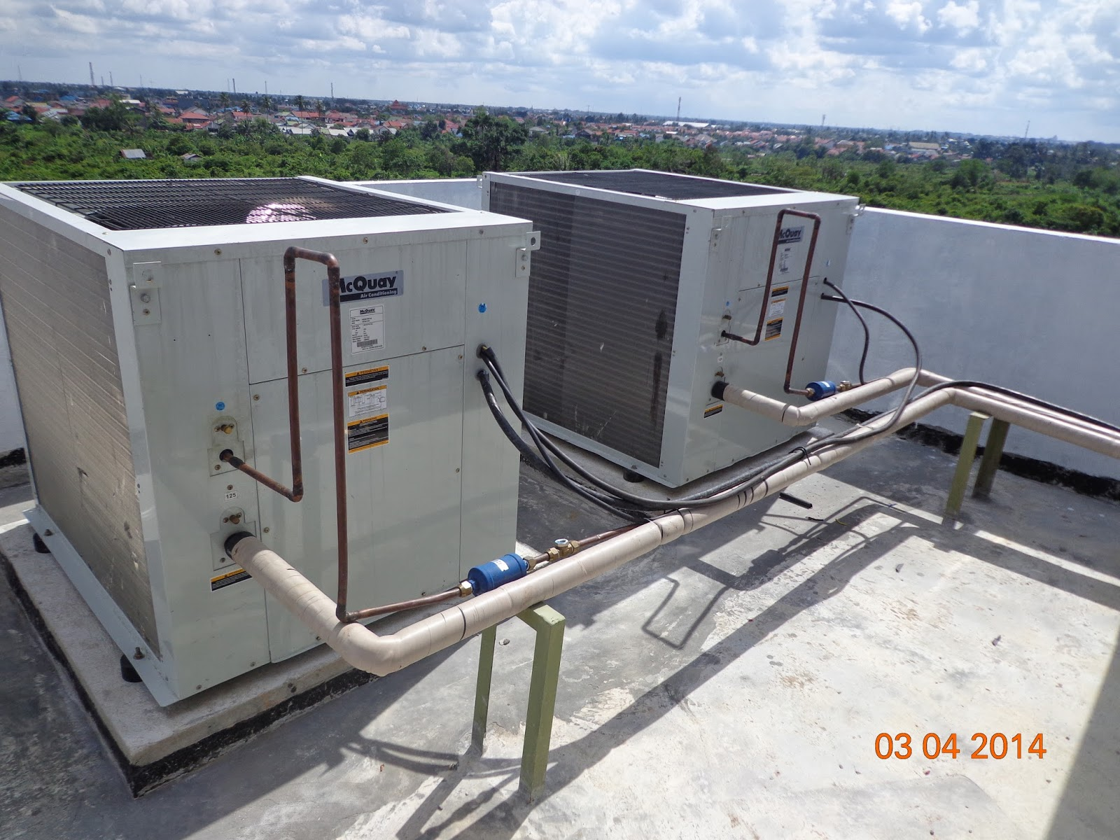

Air Conditioning

* + Two general types of air conditioning (cooling)
    - Refrigerant-based: refrigeration cycle moves heat from one space (indoors) to another (outdoors)
      * Refrigerant evaporates and condenses continuously within cycle
      * Refrigerant has a low boiling point, making it ideal for HVAC systems
      * Like a car AC system
    - Non-refrigerant: evaporative cooling
  + Simple vs. Complex
    - Simple systems often use direct expansion coils or heat
      * Directly use refrigerant to cool or heat air
      * Gas, oil or electricity in a furnace to heat air
      * Simple systems usually serve one zone with direct control
    - Complex systems transfer heating and cooling to secondary units
      * Cooling: the refrigerant is in the chiller and chilled water goes to cooling coils
      * Heating: a boiler generates hot water or steam that is piped to heating coils
      * Complex systems usually serve multiple zones

System Capacity Sizing

* + Verify that cooling and heating capacity sizing (load calculations) have been completed (C403.2.1)

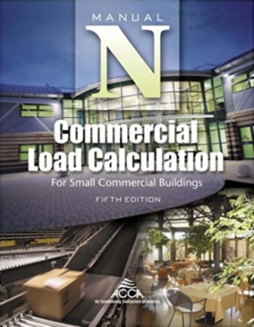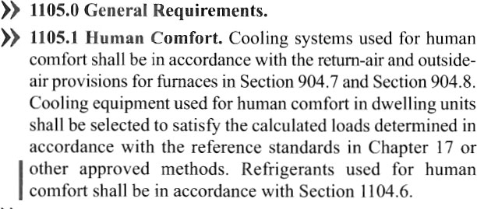

* + Verify that equipment is not unreasonable over-sized (C403.2.2)
* Why?
  + - For simple constant volume equipment, fan energy use will be significantly higher because fans must run constantly to provide ventilation
    - For larger multiple-zone VAV systems, fan and reheat energy use will be higher because the turndown of oversized zone boxes is limited.

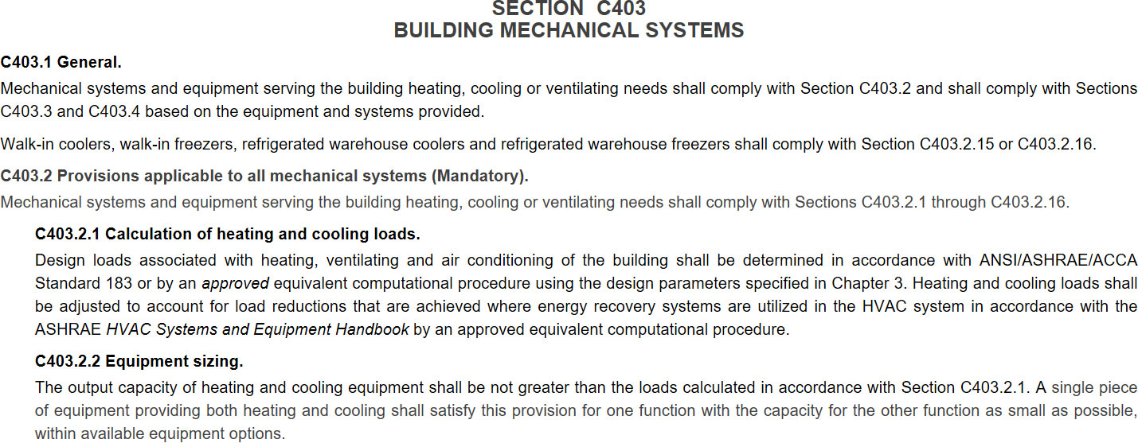

Ventilating

* + Two types:
    - Mechanical ventilation (Active)
      * Fans pull outside air into building for ventilation
      * Ventilation includes both outside air and recirculated air
      * Requirements are available for minimum outside air, based on occupancy, floor area and number of occupants
        + International Mechanical Code (IMC) Chapter 4 Ventilation
        + ASHRAE Standard 62.1 Ventilation for Acceptable Indoor Air Quality
        + California Mechanical Code (CMC) Chapter 4 Ventilation Air
    - Natural ventilation (Passive)
      * No fans
      * Uses wind and thermal buoyancy to create air movement in and out of your home without the use of mechanical systems, with the goal of bringing fresh air into your home.
        + Wind driven
        + Stack ventilation
        + <https://greenhome.osu.edu/natural-ventilation>

Simple HVAC Systems

* + Package Units
    - Thru-wall air conditioner
    - Package Terminal Air Conditioner (PTAC)
    - Package Terminal Heat Pump (PTHP)
  + Unitary
    - Air conditioner
    - Furnace
    - Heat Pumps
    - Packaged, split, mini-split
    - Variable refrigerant flow (VRF)

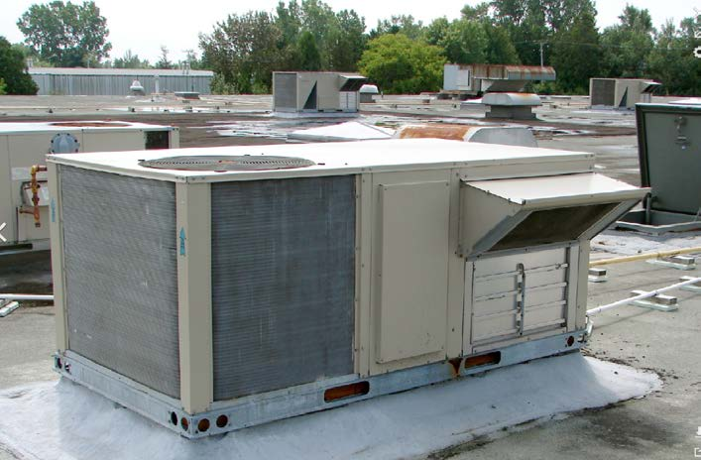 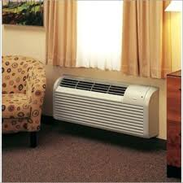 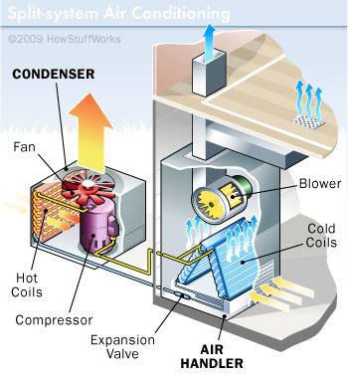

Packaged Rooftop Cooling Unit (RTU)

Packaged Unit (DX cooling) Outside Air Ventilation

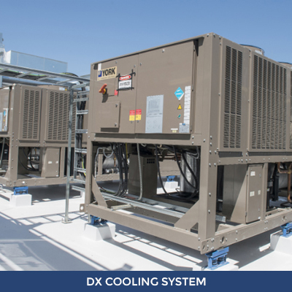 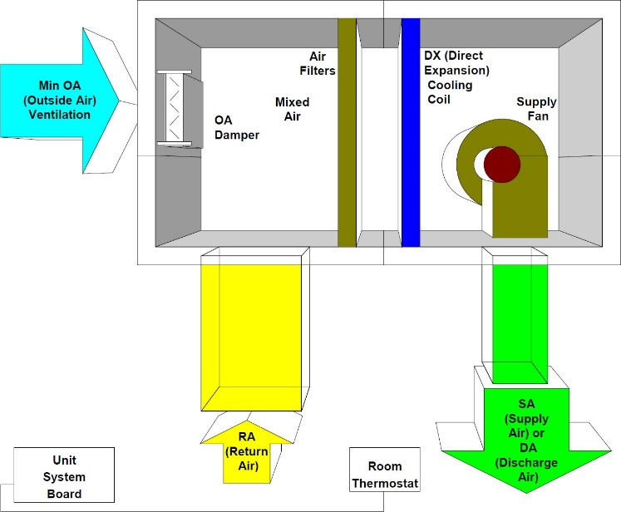

Refrigeration Cycle

* + 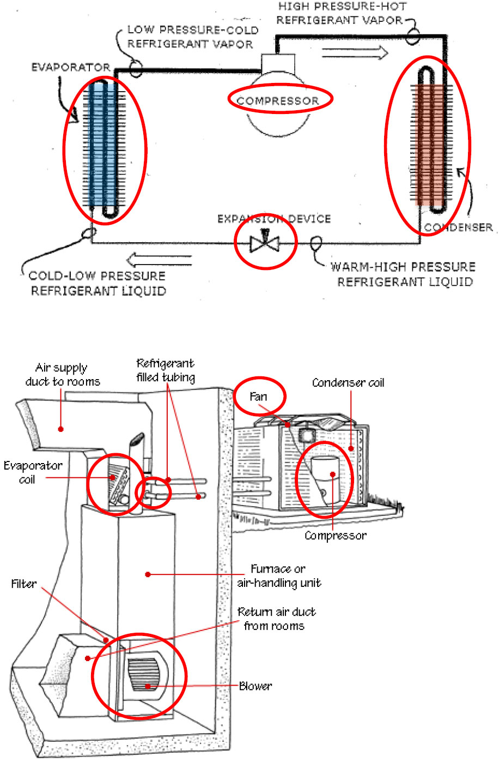Compressor use electric power to increase pressure of refrigerant
  + Condenser “cools” refrigerant, refrigerant changes from gas to liquid. Removes thermal energy from system
  + Expansion device lowers pressure
  + Evaporator (cooling coli) “heats” refrigerant and cools air, refrigerant changes back to gas. Adds thermal energy to system
  + Power: compressor, condenser fan, furnace blower, furnace in heating mode

Variable Refrigerant Flow (VRF)

* + Could be single zone (mini-split)
  + Multiple zone (VRF system)
  + Complex heat pump, serving multiple zones

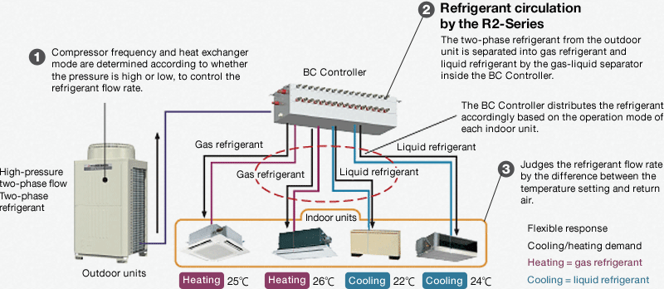

Energy Code

* + Equipment Efficiency
    - Tables in C403.2.3
    - CMC 2016 Appendix E – Table 503.7.1(1)
    - Separate tables for each type
    - Different efficiency ratings
    - Higher is generally better
      * Furnace: AFUE vs. Et
      * Cooling: SEER vs. EER vs. IEER vs. COP
      * Heat pump heating: HSPF vs. COP
    - If multiple requirements: must meet all
  + Equipment Efficiency Importance
    - Most equipment must meet manufacturing requirements
    - Exceptions:
      * Regional requirements
      * Old inventory

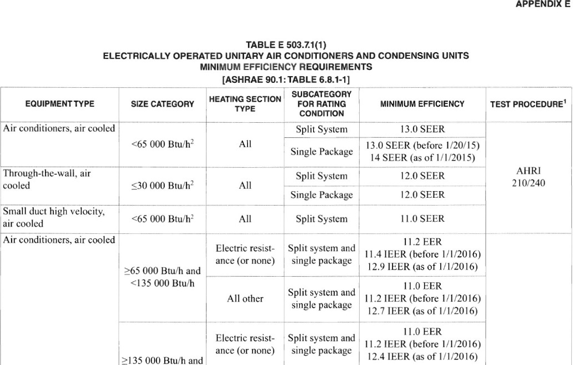

Basic Controls that Save Energy

Top of the Charts

* + Most Impactful Basic HVAC Control Measures
    - Snow and ice melt heater control
    - Temperature setback scheduling
    - Full 5-degree thermostat deadband
    - Economizer controls
    - Limits on simultaneous heating and cooling (VAV reheat)
    - VAV ventilation optimization
    - Supply air temperature & fan static reset controls
    - Exterior ductwork insulation (C403.2.9)
    - Fan power limits
    - Proper equipment sizing
    - Commissioning

Snow and Ice Melt Heater Control

* + Snow and ice melt heaters will use a large amount of energy if not properly and automatically controlled

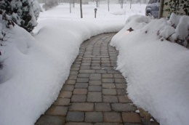

Temperature Setback Scheduling

* + 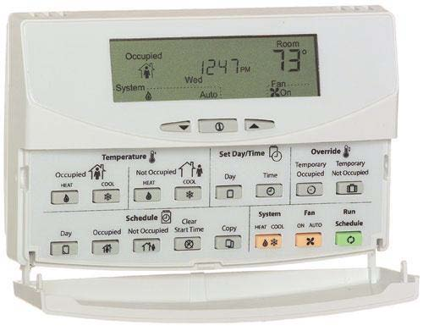Simple control systems
    - Programmable thermostats
      * Seven different daily schedules/week
      * Manual override
    - Occupant sensor is an alternative
  + DDC (Direct Digital Control) systems
    - Central scheduling of all units
    - Optimum start activated

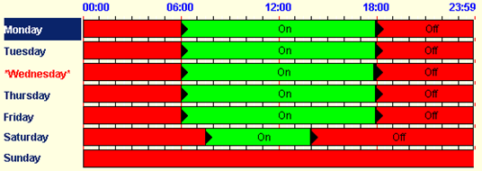

Full 5-degree thermostat deadband Economizer controls

* + 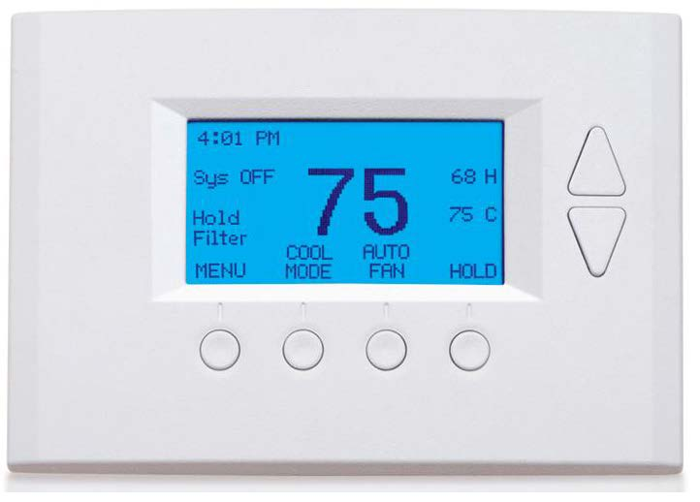A most significant control feature is temperature deadband
  + If heating is set at 70°F, then cooling should be ≥ 75°F
  + Should be the found condition during an inspection
  + Why?
    - Simple systems can fight each other in open office areas
    - VAV systems have excessive reheat if settings are too tight
  + Energy Star recommended factory default setpoints of:
    - Heating 70°F
    - Cooling 78°F

Outside Air Economizers

HVAC – Economizers “Free Cooling”

* + Quantity of Outside Air (OA): Meet Minimum Ventilation Requirement
  + Economizer Function: Flush out building heat with cool outside air

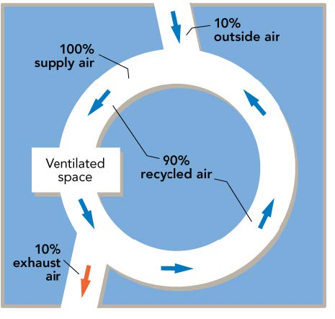

Ventilation Air

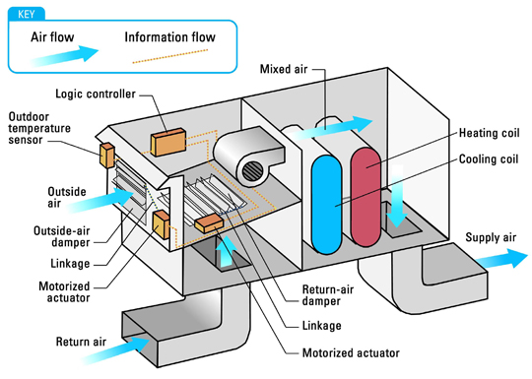

Packaged Rooftop Cooling Unit

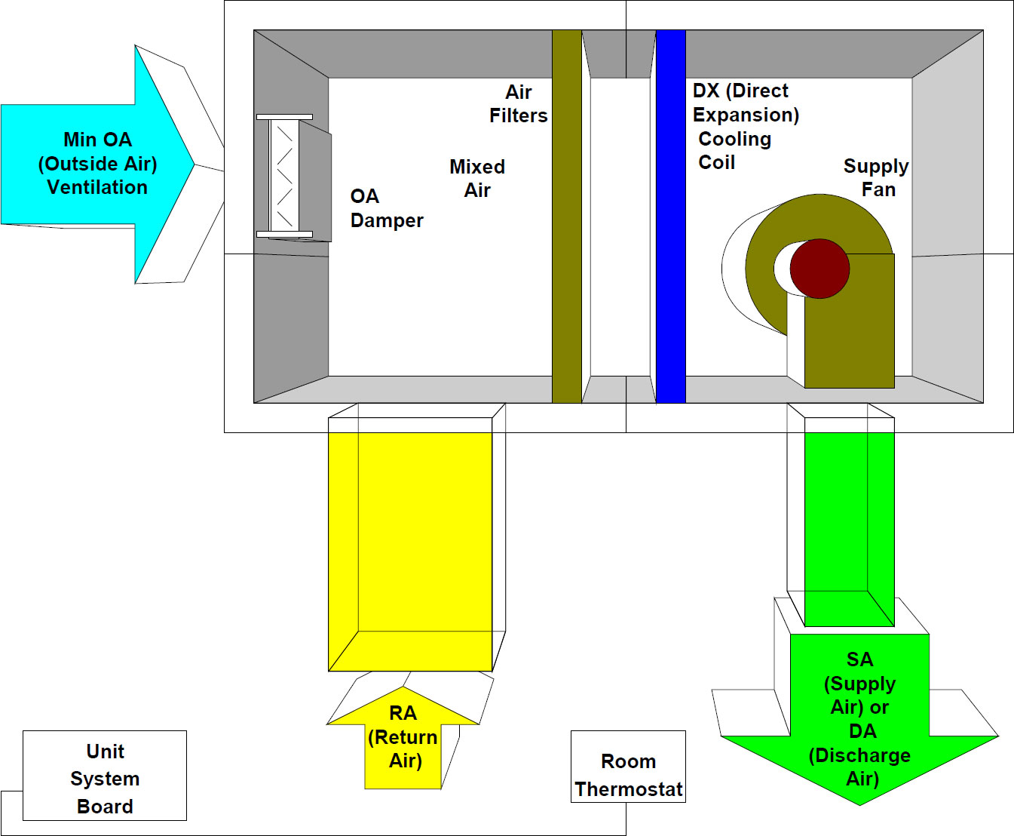

Basic OA Economizer Idea

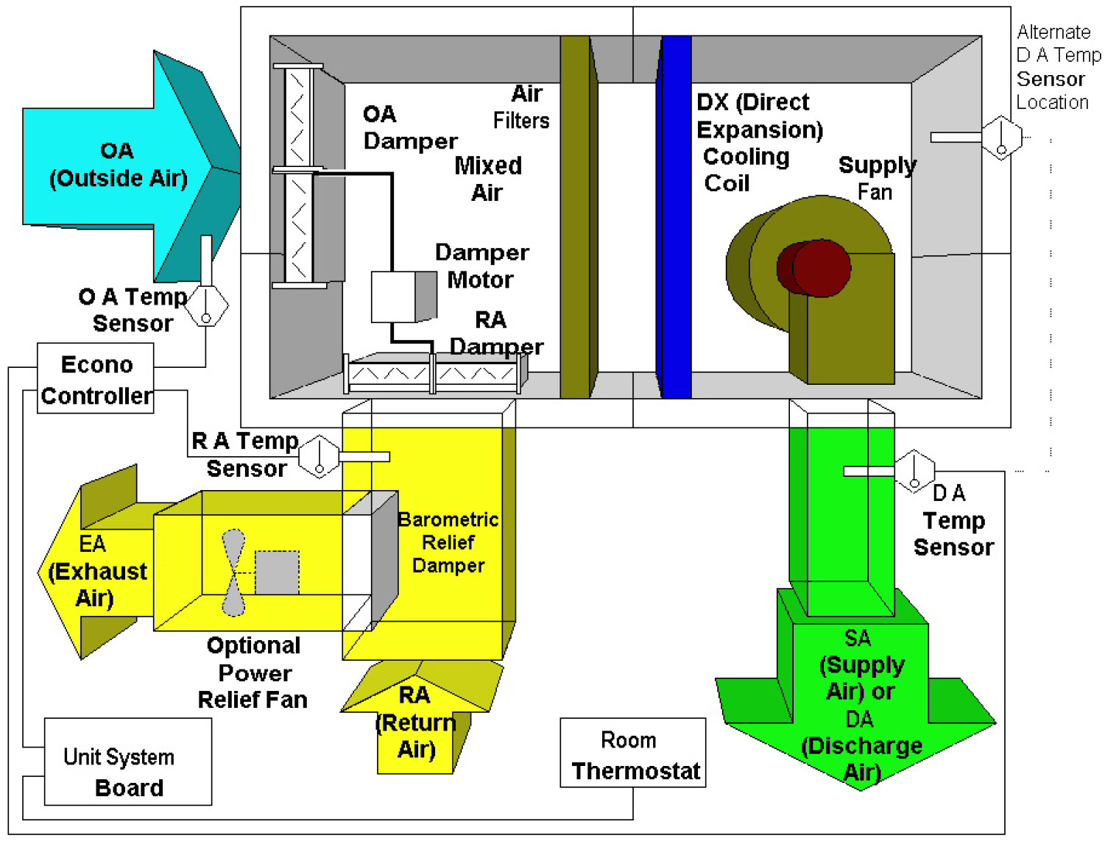

Top of the Charts

* + Most Impactful Basic HVAC Control Measures
    - Snow and ice melt heater control
    - Temperature setback scheduling
    - Full 5-degree thermostat deadband
    - Economizer controls
    - Limits on simultaneous heating and cooling (VAV reheat)
    - VAV ventilation optimization
    - Supply air temperature & fan static reset controls
    - Exterior ductwork insulation (C403.2.9)
    - Fan power limits
    - Proper equipment sizing
    - Commissioning

Ductwork in attics or outside the building (exposed on the roof) requires more insulation:

* + International Energy Conservation Code (IECC)
    - CZ 1-4 R-8 in
    - CZ 5-8 R-12 in
  + 2016 California Mechanical Code

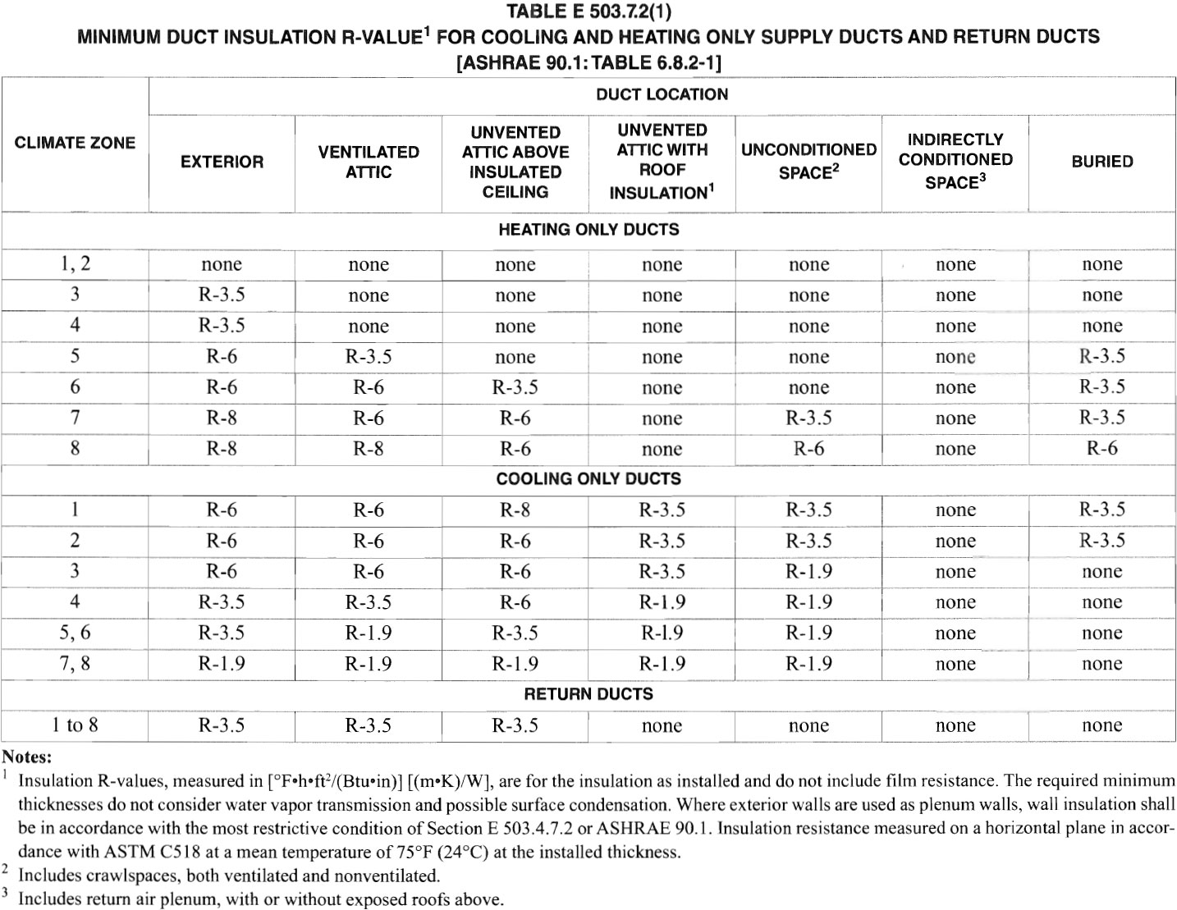

Fan Energy Limits

Overall Fan System Efficiency Multiple Conversions = Multiple Losses

* + Losses occur for each conversion of energy

|  |  |  |  |  |
| --- | --- | --- | --- | --- |
|  | Efficiency | Loss | kW |  |
| Meter  Wire  Motor  Belt  Fan | 80%  70% | 2%  20%  6%  30% | 9.65  9.46  7.57  7.14  5.00 | Meter kW  Motor Input kW  Motor Shaft kW  Fan Shaft kW  Air kW = Work |
| System | 52% | 48% | 4.65 | Losses |

Overall System Efficiency = 5.0 kW work / 9.65 kW = 52%

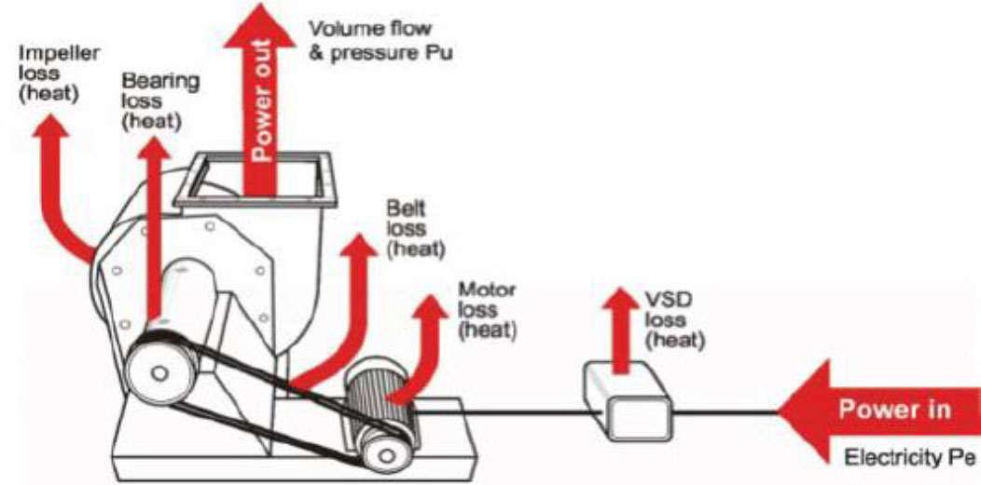

* + The energy code manages overall large fan efficiency by limiting nameplate motor hp or fan bhp per cfm of airflow supplied.
  + Centrifugal Fans
    - Advantages
      * Large air volumes against low pressure
      * Relatively small size
      * Low noise level
    - Disadvantages
      * Not high pressure / harsh service
      * Difficult to adjust fan output
      * Low energy efficiency 55-65%

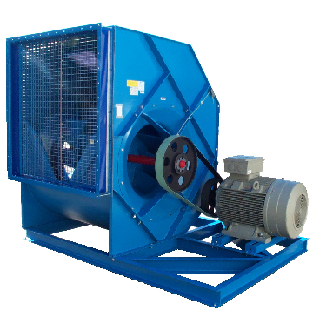

Complex Systems: Central Plant

Complex Building Energy Use - HVAC

* + Categories of HVAC Systems:
    - Central Plant
      * Boilers, chillers, cooling towers
      * A few pieces of large equipment
    - Distribution Systems
      * Pumps
      * Pipe and control valves
      * Ductwork, diffusers and registers
    - Secondary & Zonal HVAC Systems
      * Air handlers, with coils & economizers
      * Fan coils, VAV boxes
  + Selected based on:
    - Space temperature and humidity requirements
    - First cost, operating cost, and maintenance cost
    - Spatial constraints
    - Redundancy

Heating and Cooling

* + Heating
    - Typical fuels are electricity and natural gas
    - Efficiency matters:
      * Electricity is 100% efficient
        + 1000 W blow dyer heats the room by 1000 W
        + But what’s the source efficiency? Coal-fired power plants are typically only 35% efficient
      * Heat pump is much more efficient than resistance heat
        + @ 47F: 330% or COP = 3.3 / 17F: 225% or COP = 2.25 / HSPF = 6.8
      * Natural gas typically is 80% efficient
        + E.g., 100,000 Btu/h gas input to a furnace may yield 80,000 Btu/h of heating
        + A condensing boiler or furnace has higher efficiency; exceeding 90%
  + Cooling
    - Central chiller
    - Water cooled or air cooled
    - Water cooled requires cooling tower or heat rejection

Central Plant: Boilers

* + Hot water or steam boilers are typical
    - Hot water more common for smaller buildings
    - Usually natural gas, but sometimes electric or oil

Central Plant: Chillers

* + Chillers use electricity to remove heat from the chilled water loop (and thus the building)

e.g., cool the chilled water from 54°F to 44°F

Central Plant: Cooling Tower

* + Rejects heat from the chiller (transfers it outdoors).

e.g., cool the condenser water (water from the chiller) from 85°F to 75°F.

* + Water-cooled chiller is more efficient than air-cooled chiller due to evaporative cooling

Energy Code Checks

* + Equipment Efficiency
    - California Mechanical Code (CMC) 2016
      * Table E 503.7.1(1) ELECTRICALLY OPERATED UNITARY AIR CONDITIONERS AND CONDENSING UNITS MINIMUM EFFICIENCY REQUIREMENTS [ASHRAE 90.1:TABLE 6.8.1-11
    - IECC Tables C403.2.3
    - Boiler efficiency
    - Chiller efficiency
      * Path A or Path B
      * Meet both Full Load & IPLV
    - Heat rejection (tower) efficiency

Complex Systems: Secondary HVAC Systems

Complex Secondary HVAC Systems

* + Similar to residential and small commercial HVAC systems, but bigger
    - Work to maintain comfort conditions in the space
  + Complex systems may be more expensive, but are usually more efficient than smaller / simpler systems (depends)
  + Usually get heating and cooling energy from a central plant through chilled water and heating water pumped throughout the building
  + Some “packaged VAV systems” are unitary, but serve multiple zones

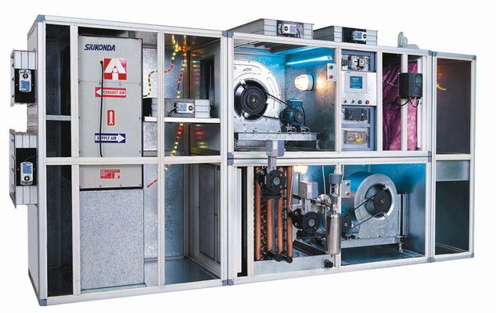

Secondary HVAC System Air Handlers

* + An air handler, or air handling unit (often abbreviated to AHU), is a device used to regulate and circulate air as part of a heating, ventilating, and air-conditioning (HVAC) system.
  + The H, the V, the AC in one piece of equipment.
  + Uses air dampers, and chilled and heating water from the chiller and the boiler to heat and cool the air.
  + Also filters the air and draws in outside air.

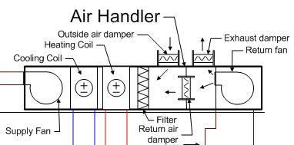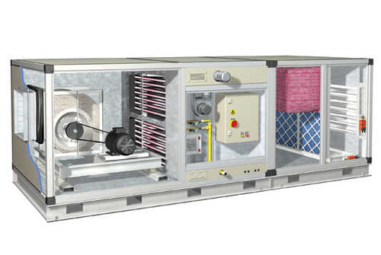

Distribution: Heating Coils, Radiant Heaters

* + Hydronic distribution: Water or steam is heated by the boilers, then delivered to secondary heating units throughout the building
  + Various types of heat exchangers:
    - Heating coils in airstreams
      * Air handlers, fan coils (hotels)
    - Radiant heat
      * Baseboard heaters
      * Radiant floor heating
  + Chilled water distribution is similar;

CHW from chiller goes to cooling coils through pipes

* + Ductwork is used to distribute heated or cooled air and return or exhaust air

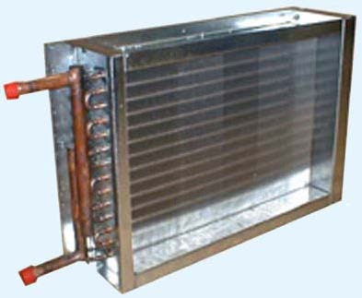 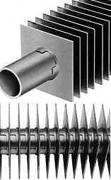

VAV Multiple Zone System Concept

* + One variable air volume (VAV) central air system serves several zones
    - The air handling unit (AHU) maintains the desired
      * Primary supply air temperature (SAT)
      * Duct static pressure (SP) using a variable speed drive
      * The setpoints for both SAT & SP can be reset
      * Has preheat capability and may subcool air to reduce humidity
      * Coordinates the OSA economizer with the cooling coil to provide cooling
  + Each zone has a VAV box or terminal unit that:
    - Modulates air flow based on cooling load
    - Maintains minimum airflow for ventilation needs
    - Reheats air to meet heating needs

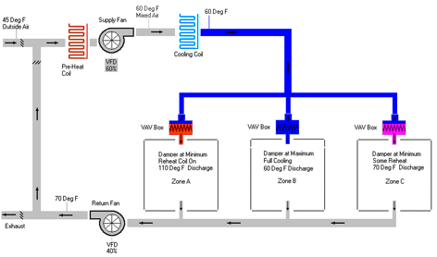

Multiple Zone System Example: VAV Terminal Unit (VAV Box)

