|  |  |  |
| --- | --- | --- |
| **CMGT 235 – Electrical and Mechanical Systems** | | |
| **Discussion No. 7** | **Unit 1 - Mechanical Systems** | **Fall 2022** |

**Air Distribution Systems**

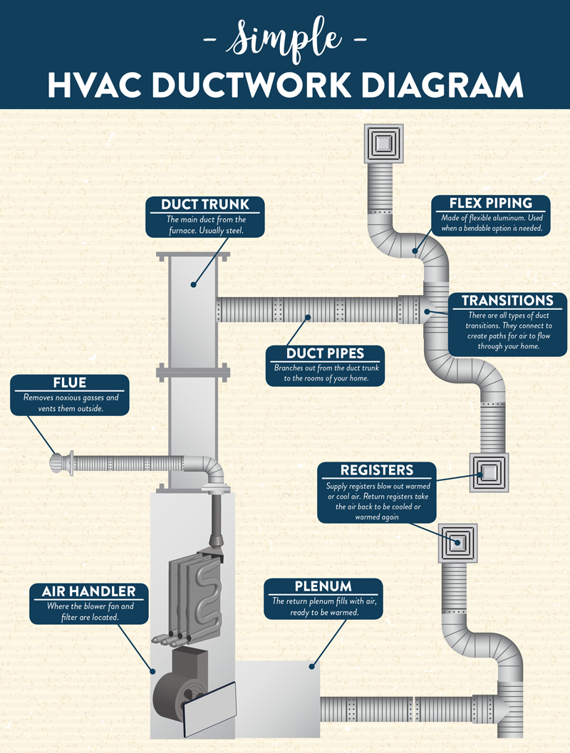

**Duct Design**

Step 1. Heating and Cooling Load Calculation

ACCA’s Manual J

ASHRAE Handbook of Fundamentals

Determine the amount of heating and cooling needed for each room in BTUH or BTU/hr

BTUH translates to room-by-room air flow requirements in cubic feet per minute (cfm)

Step 2. Once you know the BTUH and cfm numbers for the building, you need to select the right equipment.

ACCA’s Manual S protocol

Equipment selected must meet the total heating and cooling loads for the home or building

Adjustments for indoor and outdoor design conditions must be considered.

Manufacturer’s performance tables

Step 3. Duct Design

**The Weight of Air**

* Air has weight

1 cubic foot of air weighs 0.0807 lb at standard temperature and pressure

Example 1.

What is the weight of the air (lb/minute) for a 2.5-ton air conditioner?

**The Physics of Air Flow**

* Air produced by a fan confined to a channel has to work against the pressure that builds up in that space. The smaller the tube or make it longer or turn the air with it, the more static pressure builds up. This reduces air flow.
* Two Factors Involved in Reducing air flow in ducts:

**Friction** – air interacts with the surfaces. Smoother the inner surface, the better it is for air flow. Rougher slows down the air.

**Turbulence** – arises when you move air through fittings, or when you turn the air.

Rigid ducts use fittings

Flexible ducts not always the case

Whenever air encounters a filter, coil, heat exchanger (if there's a furnace), registers, grilles, balancing dampers, and the ducts themselves, it loses pressure.

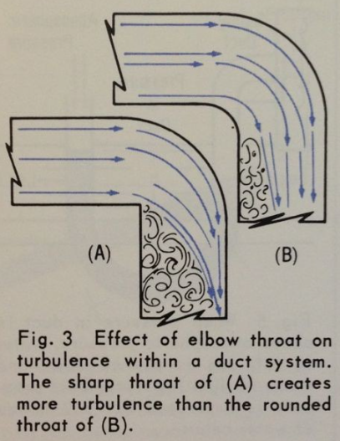

Must start out at a high pressure from the blower at the AHU

**AHU – Air Handling Unit**

* The blower is inside the AHU

Air gets pulled back to the AHU through the return ducts

The AHU conditions the air and sends it back into the building through the supply ducts

The high pressure at the supply has “driving potential” to force the air into the space and flow to the area of lower pressure at the return

The farther from the blower, the closer the static pressure in the ducts gets to zero, or room pressure

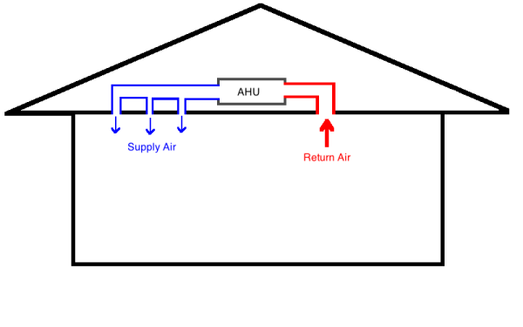

**Blower Capacity**

* To get a certain amount of air flow, a blower needs to operate against a certain pressure and at a certain blower speed setting. Here's a table from one unit.

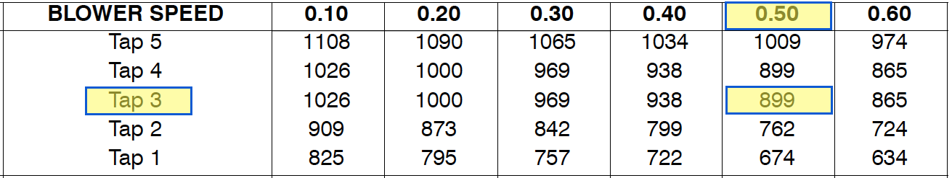

* The blower speed is set by moving wires to different taps. In this case, there are 5 of them. The row of numbers across the top is the total external static pressure (TESP) the AHU is rated for. That's the pressure change across the AHU when pushing and pulling air through the ducts.
* You generally want to design a system to operate on medium speed (tap 3 in the table above). That way you have some room for adjustment when you commission the system. Also, most systems are rated to operate at a total external static pressure of 0.50 inches of water column (iwc). For the system above, those parameters yield an air flow of 899 cfm. If that's the number you need, you just have to make sure you design your system to operate at 0.5 iwc.
* From the return (most negative) side of the AHU to the supply (most positive), we want a total pressure change of no more than 0.5 iwc. (That's the typical number. Some air handlers are rated higher. Some are rated lower.) That's the total pressure change across the AHU. The actual pressure in the system will depend on the ducts and other components. As long as we're at or below 0.5 iwc in this case, we'll get good air flow.

**Available Static Pressure (ASP)**

* Two kinds of pressure drop occur in the duct system:

Pressure drop of the components that are not ducts or fittings (e.g., registers, grilles, filters …)

Pressure drop of the ducts and fittings

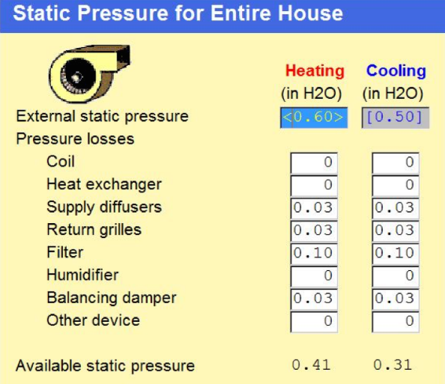

**Total Effective Length (TEL)**

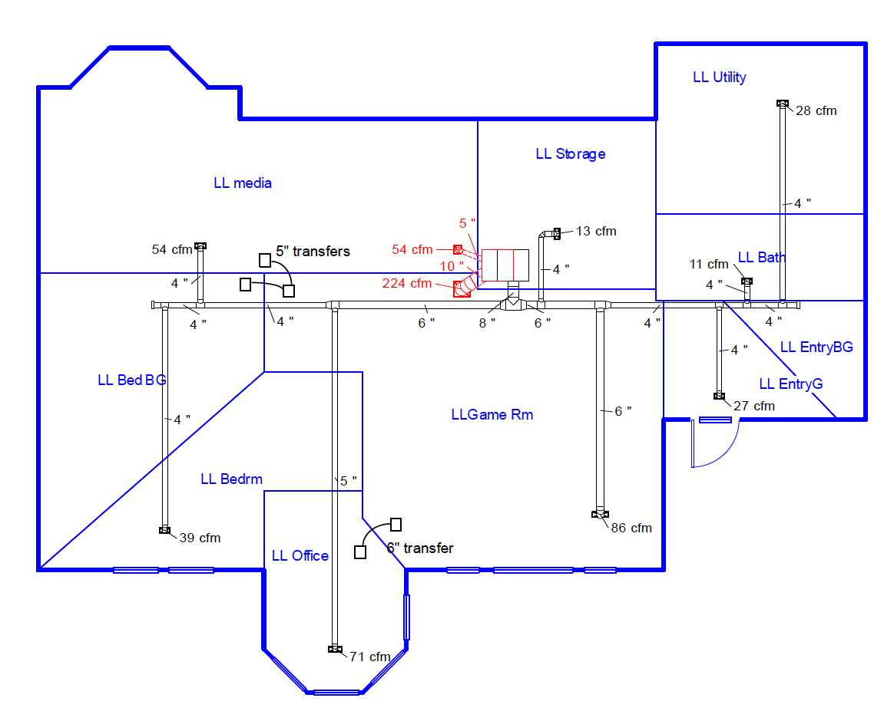

* Each fitting has an effect on the pressure drop and total effective length (TEL)

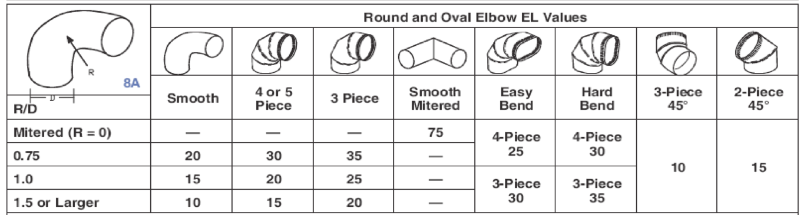

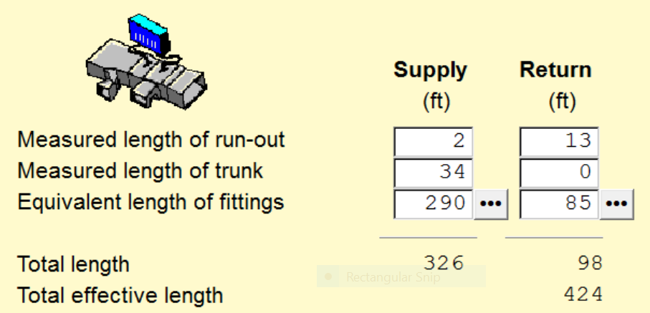

**Calculating Friction Rate**

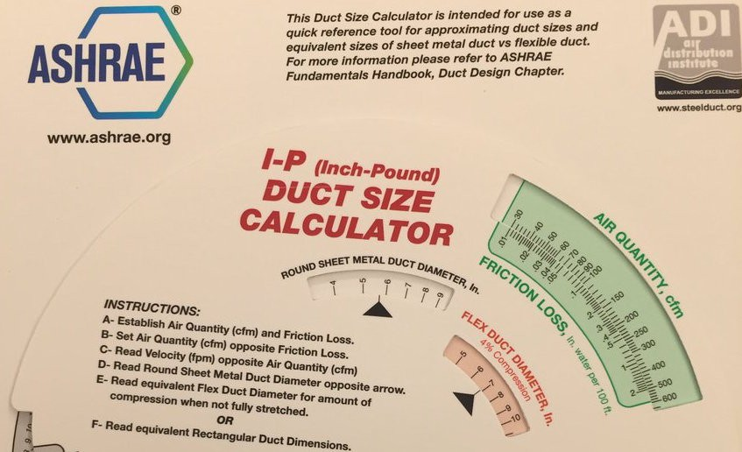

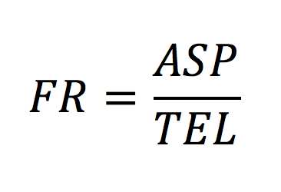

Example 2

ASP = 0.31 inches of water column (iwc)

TEL = 424 feet

* This represents the amount of pressure drop to expect in each foot of duct run.

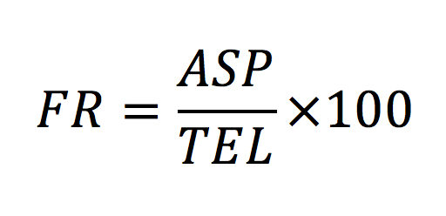

Friction Rate for a Design

If the FR is a higher number – you can use smaller, more restrictive ducts

If the FR is a lower number – you have to use larger ducts

**Sizing the Ducts**

* ACCA Manual D Protocol

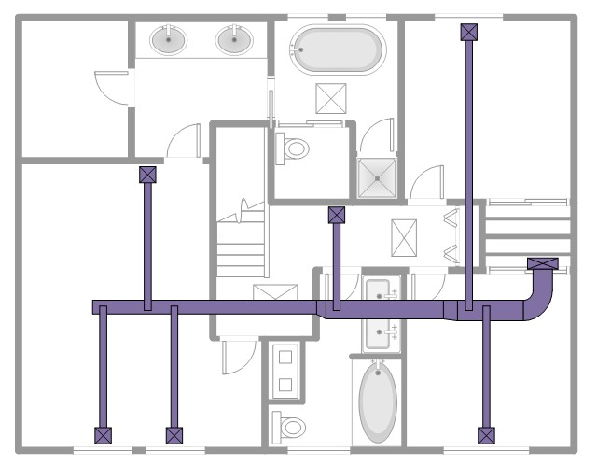

* Sizing the Ducts by Friction Rate

The rate total external static pressure (TESP) tells how much resistance their can be across the furnace or air handler when it is delivering the rated air flow. To stay within the design value, you must control the resistance of the duct system

Duct systems with greater total effective length (TEL) have greater resistance

It TEL is high, the duct area has to be increased

It TEL is low, smaller diameter ducts can be used.

Example

FR = 0.073 iwc per 100 ft of total effective length

Assume a section of ductwork needs 400 cfm

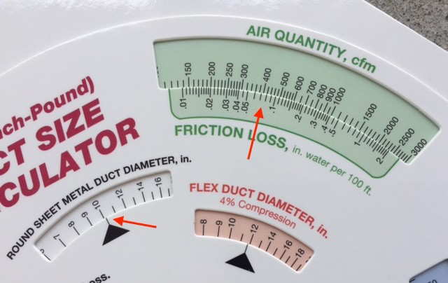

* Sizing the Ducts by Velocity

Need to make sure the velocity of the air isn’t too high

400 cfm corresponds to a velocity of approximately 725 feet per minute (fpm)

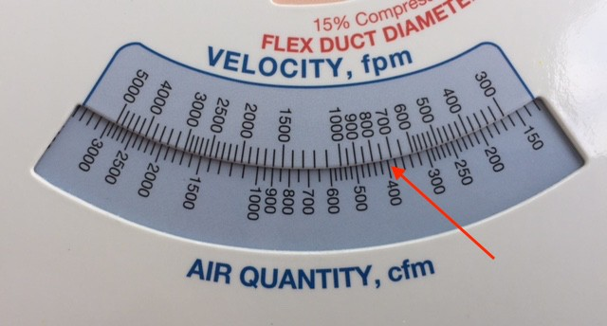

Manual D, Table N3-1 specifies the maximum velocities for supply and return trunks and branches.

Supplies – 900 fpm

Returns – 700 fpm

* When sizing by the friction rate results in too high a velocity, you size by the velocity, which results in a larger duct.
* But larger ducts also result in less resistance, which means there may be too much air flow in that run.
* What do we do about that? Install balancing dampers.