CMGT 235 – Mechanical and Electrical Systems
Homework #7 – Air Distribution Systems Design - ACCA Manual D
Show all work for full credit.
Due: 9/15
20 points

Name: ______________________________________________________________________________________

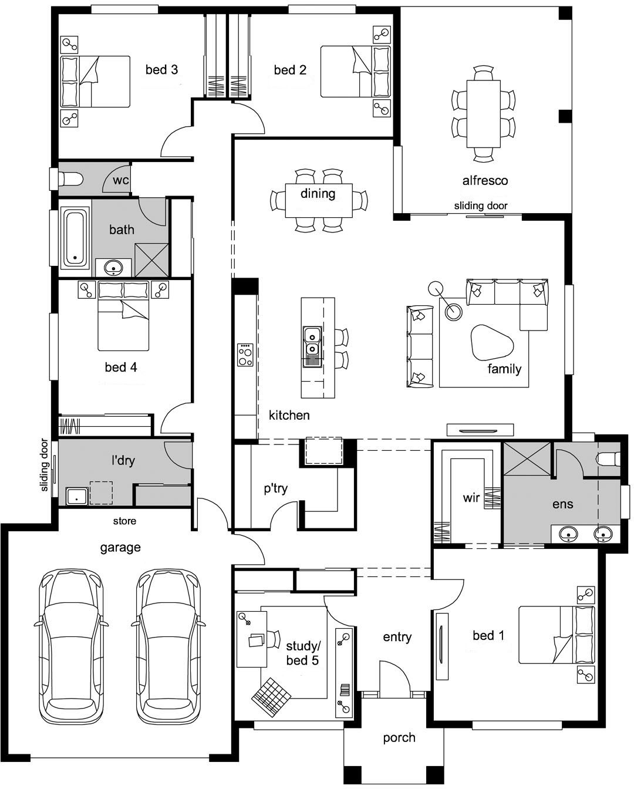
2,706 BTUH
2,706 BTUH
2,706 BTUH
1,353 BTUH
4,058 BTUH
4,058 BTUH
1,353 BTUH
13,528 BTUH
5,411 BTUH
The Room-By-Room Cooling Load calculation has been completed for the home used in HW#5 and the room loads are shown on the plan on the previous page.

Size of HVAC Unit Required
To calculate the required equipment size, divide the HVAC load for the entire home by 12,000. One ton equals 12,000 BTUs, so if a house or office needs 24,000 BTUs, it will take a 2-ton HVAC unit. If you get an uneven number, such as 2.33 for a 28,000 BTU load capacity, round up to a 2.5-ton unit.

From HW#5
Peak Cooling Load = 37,878 BTUH

HVAC Unit Size = 37,878 BTUH / 12,000 = 3.16 tons Round to 3.5 tons

- Using the industry standard of 400 CFM per ton determine the required Total Ventilation Rate (CFM)

- Using the equation shown below, calculate the required CFM per room and complete the table shown below. Round CFM to whole number (No Decimal Values).

Room Ventilation (CFM) = [Room Heat Gain (Btuh) / Total Heat Gain (Btuh)] X Total Ventilation Rate (CFM)

Room | Heat Gain (BTUH) | Required CFM
Family, dining, kitchen
bed 1 / ens
bed 2
bed 3
bath
bed 4
l’dry
study/bed 5
Totals

- Write the required CFM for each room on the plan shown on the next page in the corresponding room.

SA 2
SA 1
AHU
RA
- Determine the total CFM as shown below (Show All Calculations):
Duct | Total CFM
Supply Air Duct (SA 1)
Supply Air Duct (SA 2)
Return Air Duct (RA)

