|  |  |  |
| --- | --- | --- |
| **CMGT 235 – Electrical and Mechanical Systems** | | |
| **Discussion No. 9** | **Unit 2 - Plumbing Systems** | **Fall 2022** |

**Plumbing Material, Fixtures, LEED**



**Web Site** <http://codes.iapmo.org/home.aspx?code=UPC>

**2021 UPC** <https://epubs.iapmo.org/2021/UPC/>

**Uniform Plumbing Code (UPC)**

The Uniform Plumbing Code provides consumers with safe and sanitary plumbing systems while, at the same time, allowing latitude for innovation and new technologies.

The public at large is invited and encouraged to take part in IAPMO's open consensus code development process. This code is updated every three years. The Uniform Plumbing Code is dedicated to all those who, in working to achieve "the ultimate plumbing code," have unselfishly devoted their time, effort, and personal funds to create and maintain this, the finest plumbing code in existence today.

The Uniform Plumbing Code updates every three years in revision cycles that begin twice each year that takes two years to complete.

**Web Site** <http://www.bsc.ca.gov/codes.aspx>

**2019 California Plumbing Code** <https://epubs.iapmo.org/2019/CPC/>

**BASIC PLUMBING MATERIALS**

Pipe – Cylindrical Tubing

Fittings – used to make connections between pipes and equipment

Valves – used to regulate fluid flow

Meters – Used to measure and indicate fluid flow

Classification of Pipe and Pipe Fitting Materials

Plastic

Check your plumbing code to determine which materials and products may be used for each application, what product standards apply, and whether there are any special provisions regarding use of the materials.

Copper

Cast Iron Soil Pipe

Steel

**PLASTIC PIPE AND FITTINGS**

Plastics

Petroleum-based products

Thermosetting resin – cannot be re-melted after it is formed and cured

Thermoplastic resin – can be heated and reformed

Plastic Pipe

Excellent resistance to solvents and corrosives

Resistance to heat and high temperature

Smooth interior walls

Resist bacteria growth

Good flexibility

Do not conduct electricity

Plastic Piping Used for Plumbing Some Jurisdictions

Acrylonitrile-Butadiene-Styrene (ABS) Polyethylene (PE)

Polyvinyl Chloride (PVC) Polybutylene (PB)

Chlorinated Polyvinyl Chloride (CPVC) Polypropylene (PP)

Cross-Linked Polyethylene (PEX)

Local plumbing code determines what type may be used.

|  |  |  |  |  |  |  |
| --- | --- | --- | --- | --- | --- | --- |
| **APPLICATION** | Water Distribution | Sewer and Mains | Drain, Waste, and Vent | Hot and Cold Water Distribution | Fire Sprinklers | Industrial Process Piping |
| **COLOR** | Black, light blue, white, clear, or gray | Green, white, black, or gray | Black, or white | Tan, red, white, blue, silver, or clear | Orange | Dark gray – PVC  Light gray - CPVC |
| **PLASTIC PIPING MATERIALS** | ABS | ABS | ABS | CPVC | CPVC | PVC |
| PVC | PVC | PVC | PEX | PB | CPVC |
| CPVC |  | PP | PB |  |  |
| PEX |  |  | PP |  |  |
| PE |  |  |  |  |  |
| PB |  |  |  |  |  |

***Acrylonitrile-Butadiene- Styrene (ABS) Pipe and Fittings***

Schedule 40 ABS DWV

Black plastic

Sanitary Drainage and Vent piping

Aboveground and underground storm water drainage

Easier to install and cheaper than metal pipe. Less time needed to rough-in than metal DWV

-40°F to 180°F

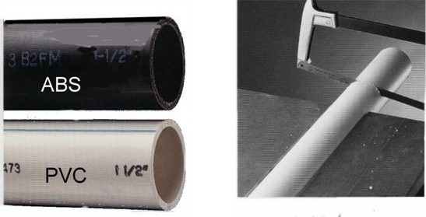No priming required

1 ¼" – 6"

10' and 20' pipe lengths

***Polyvinyl Chloride (PVC) Pipe and Fittings***

Schedule 40 PVC DWV

White plastic

Sanitary Drainage and vent piping

Aboveground and underground storm water drainage

Water mains

Water service lines

Joined by solvent cementing

1 ¼” – 6”

10’ and 20’ pipe lengths

Up to 16” available – underground drainage piping

ABS can only be joined to PVC using the proper transition coupling

Maximum length of rigid plastic DWV piping is 35’

Where pipe penetrates fire-rated walls, floors, and ceilings must use firestop (caulk), foam, or restricting collar

***Chlorinated Polyvinyl Chloride (CPVC) Pipe and Fittings***

Cream-colored thermoplastic

Commonly used for hot and cold water distribution

Potable water distribution

Fire Suppression systems

Industry fluid handling

Rated for 180°F at 100 psi of pressure

Joined by solvent cementing

½” to 12”

Schedule 40 and Schedule 80

10’ pipe length

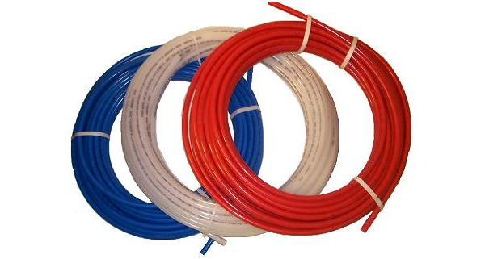***Cross-Linked Polyethylene (PEX) Pipe and Fittings***

Water Service piping

Hot and cold water distribution

¼” to 2”

Straight lengths of 20’

Coils of 100’, 300’, 400’, 500’, and 1000’

Fast to install

Corrosion resistance

Superior strength

High-temperature and high-pressure resistant

**COPPER TUBE AND FITTINGS**

**TABLE 1. Copper Tube: Types, Standards, Applications, Tempers, Lengths**

|  |  |  |  |  |  |  |
| --- | --- | --- | --- | --- | --- | --- |
| **Tube Type** | **Color**  **Code** | **Standard** | **Application1** | **2**  **Commercially Available Lengths** | | |
| **Nominal or Standard Sizes** | **Drawn** | **Annealed** |
| TYPE K | Green | ASTM B 88**3** | Domestic Water  Service and Distribution, Fire Protection,  Solar, Fuel/Fuel Oil, HVAC,  Snow Melting, Compressed Air, Natural Gas, Liquified  Petroleum (LP) Gas, Vacuum | **STRAIGHT LENGTHS:** | | |
| 1/4-inch to 8-inch | 20 ft | 20 ft |
| 10-inch | 18 ft | 18 ft |
| 12-inch | 12 ft | 12 ft |
| **COILS:** | | |
| 1/4-inch to 1-inch | — | 60 ft |
| — | 100 ft |
| 11/4 inch and 11/2-inch | — | 60 ft |
| 2-inch | — | 40 ft |
| — | 45 ft |
| TYPE L | Blue | ASTM B 88 | Domestic Water  Service and Distribution, Fire Protection,  Solar, Fuel/Fuel Oil,  Natural Gas, Liquified  Petroleum (LP) Gas, HVAC,  Snow Melting, Compressed Air, Vacuum | **STRAIGHT LENGTHS:** | | |
| 1/4-inch to 10-inch | 20 ft | 20 ft |
| 12-inch | 18 ft | 18 ft |
| **COILS:** | | |
| 1/4-inch to 1-inch | — | 60 ft |
| — | 100 ft |
| 11/4 inch and 11/2-inch | — | 60 ft |
| 2-inch | — | 40 ft |
| — | 45 ft |
| TYPE M | Red | ASTM B 88 | Domestic Water  Service and Distribution, Fire Protection,  Solar, Fuel/Fuel Oil, HVAC,  Snow Melting, Vacuum | **STRAIGHT LENGTHS:** | | |
| 1/4-inch to 12-inch | 20 ft | N/A |
| DWV | Yellow | ASTM B 306 | Drain, Waste, Vent, HVAC,  Solar | **STRAIGHT LENGTHS:** | | |
| 11/4-inch to 8-inch | 20 ft | N/A |
| ACR | Blue | ASTM B 280 | Air Conditioning, Refrigeration,  Natural Gas, Liquified  Petroleum (LP) Gas, Compressed Air | **STRAIGHT LENGTHS:** | | |
| 3/8-inch to 41/8-inch | 20 ft | 4 |
| **COILS:** | | |
| 1/8-inch to 15/8-inch | — | 50 ft |
| OXY, MED, OXY/MED, OXY/ACR, ACR/MED | (K)Green  (L)Blue | ASTM B 819 | Medical Gas  Compressed Medical Air, Vacuum | **STRAIGHT LENGTHS:** | | |
| 1/4-inch to 8-inch | 20 ft | N/A |

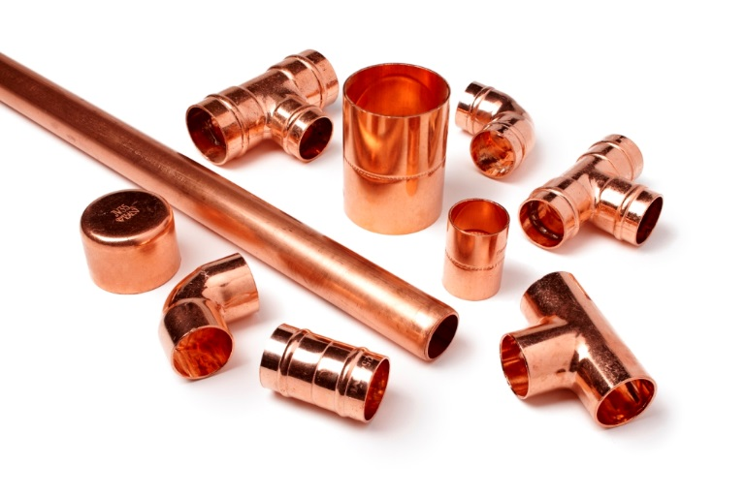***Copper Tube Fittings***

Cast copper alloy

Cast Bronze

Wrought Copper

***Joining***

Solder Joint Fittings

Copper Press Fittings

Rolled Groove Joint Fittings

Flared Joint Fittings

Compression Joint Fittings

**CAST IRON SOIL PIPE AND FITTINGS**

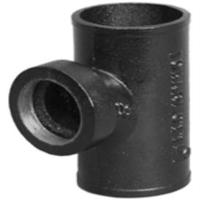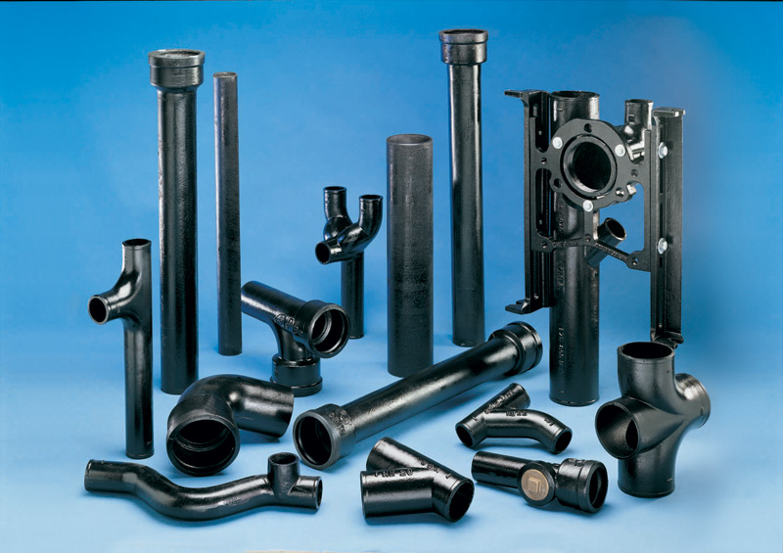

Gray cast iron – strong, corrosion-resistant

Leakproof, nonabsorbent, easily cut and joined

No-hub and Bell-and-spigot

*No-hub*: aboveground sanitary drainage, vent, and storm water drainage piping

*Bell-and-spigot*: underground sanitary drainage, vent, and storm water drainage piping

**STEEL PIPE AND FITTINGS**

Water distribution, sanitary waste and vent, storm water drainage, and gas piping systems

Inexpensive, strong, and rugged

Weight and installation cost are factors

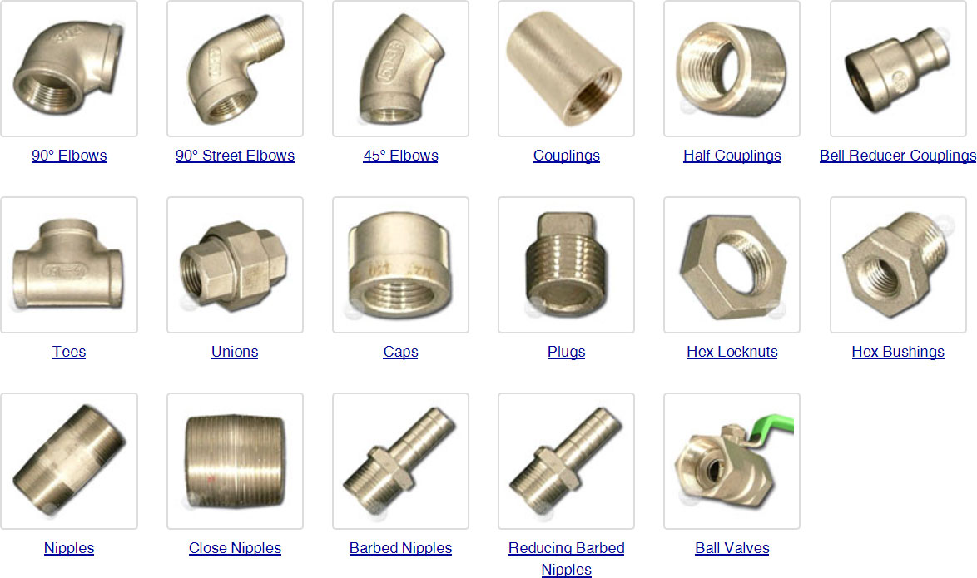

**Reading Reducing Fittings**

A variety of types most commonly required for piping systems are illustrated on this page. In these illustrations, each opening of the fitting is identified with a letter which indicates the sequence to be followed in reading the size of the fitting.

In designating the outlets of reducing fittings, the openings should be read in the order indicated by the sequence of the letters "A", "B", "C", and "D". The following information is based on ASME B16.11 and MSSSP-106.

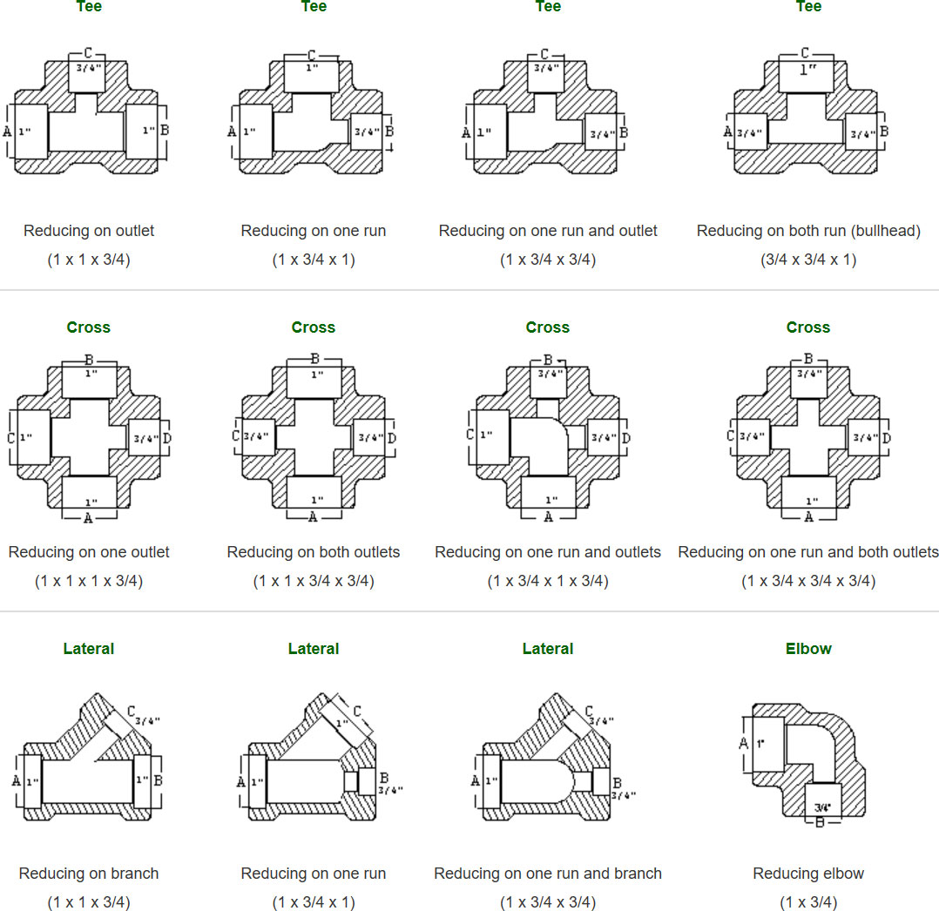

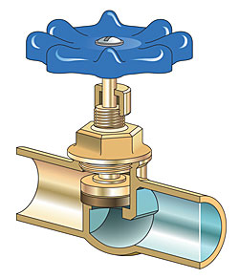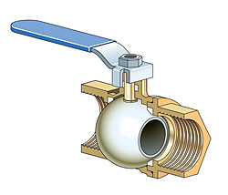**PLUMBING VALVES**

Used to regulate fluid flow

On or off

Control direction, pressure, and/or temperature

***Types of Valves:***

|  |  |  |  |  |
| --- | --- | --- | --- | --- |
| Gate | Globe | Compression stop | Stop-and-waste | Sillcocks |
| Boiler drains | Core cocks | Ball | Butterfly | Check |
| Backwater | Pressure-reducing | Relief |  |  |

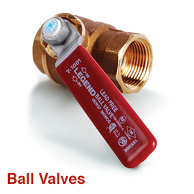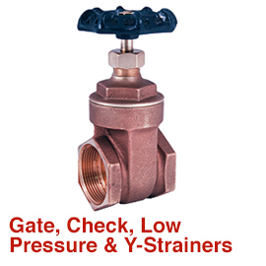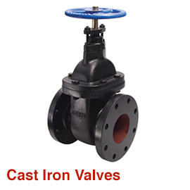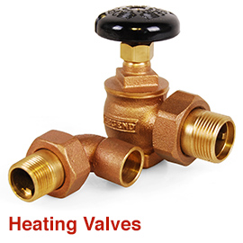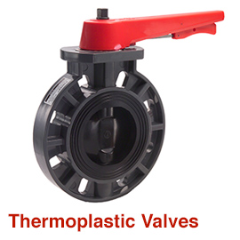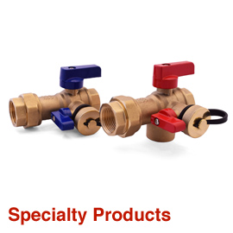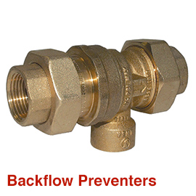

**WATER METERS**

Measure and indicate water usage for a building in order to be charged for the amount of water used.

Measures in cubic feet or gallons

Installed at the end of the water service pipe – inside or outside the building

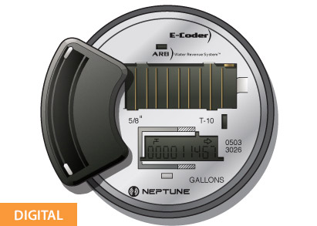 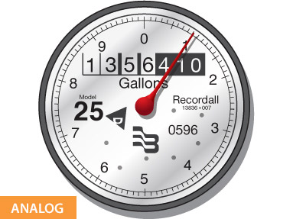

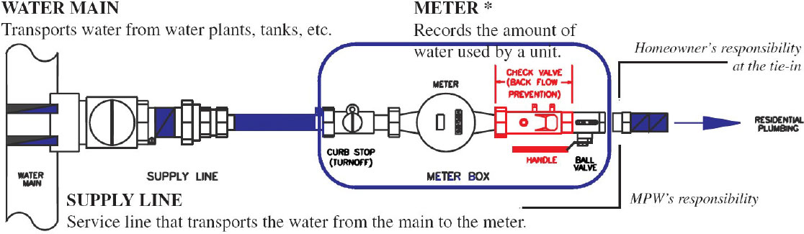

**Plumbing Fixtures**

|  |  |
| --- | --- |
| **Building Water Use – Indoor**   * Flush and Flow Fixtures * Appliances and Process Water Use | **Building Water Use – Outdoor**   * Landscape Irrigation * Process Water Use: Cooling and Heating |

* Potable water usage in buildings constitutes a large portion of freshwater consumption.
* Strategies to reduce potable water use in buildings entail the selection of efficient plumbing fittings, fixtures, and equipment.
* Fixtures that use 20% to 50% less water than code-required levels are now widely available.
* The WaterSense® label was developed by the U.S. Environmental Protection Agency to identify these efficient fixtures and ensure that higher efficiency does not come at the cost of performance.

<https://www.epa.gov/watersense>

**WaterSense® Products**

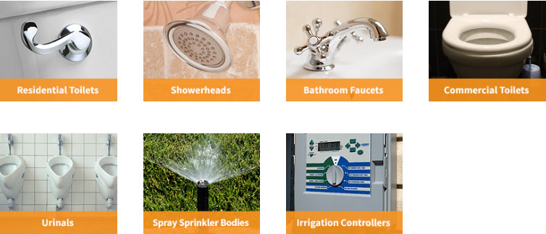

<https://www.epa.gov/watersense/watersense-products>

**Water Closets**

|  |  |  |
| --- | --- | --- |
|  |  |  |
| **Floor Mounted** | **Wall Hung** | **Floor Mounted** |
| **Tank** | **Flushometer** | |

**2016 California Plumbing Code**

|  |  |  |  |
| --- | --- | --- | --- |
| **Table 1.** Maximum Installed Flush or Flow Rates | | | |
| **Fixture or fitting** | **2016 CA Plumbing Code** | **EPAct 1992**  **Federal Standard** | **WaterSense**® |
| **Flush Fixtures** |  |  |  |
| Flushometer-Valve Toilet (Water Closet) | 1.28 gpf | 1.6 gpf | 1.28 gpf |
| Tank Toilet (Water Closet) | 1.28 gpf | 1.6 gpf | 1.28 gpf |
| Urinal (Wall Mounted) | 0.125 gpf | 1.0 gpf | 0.5 gpf |
| Urinal (Floor Mounted) | 0.5 gpf | 1.0 gpf | 0.5 gpf |
| **Flow Fixtures** |  |  |  |
| Residential Lavatory Faucet | 1.2 gpm @ 60 psi | 2.2 gpm @ 60 psi | 1.5 gpm @ 60 psi |
| Public lavatory (restroom) faucet | 0.5 gpm @ 60 psi | 0.5 gpm @ 60 psi |  |
| Kitchen Faucet | 1.8 gpm @ 60 psi | 2.2 gpm @ 60 psi |  |
| Showerhead | 2.0 gpm @ 80 psi | 2.5 gpm @ 80 psi | 2.0 gpm @ 60 psi |
| Pre-Rinse Spray Valve | 1.6 gpm @ 60 psi | 1.6 gpm @ 60 psi | 1.28 gpm @ 60 psi |

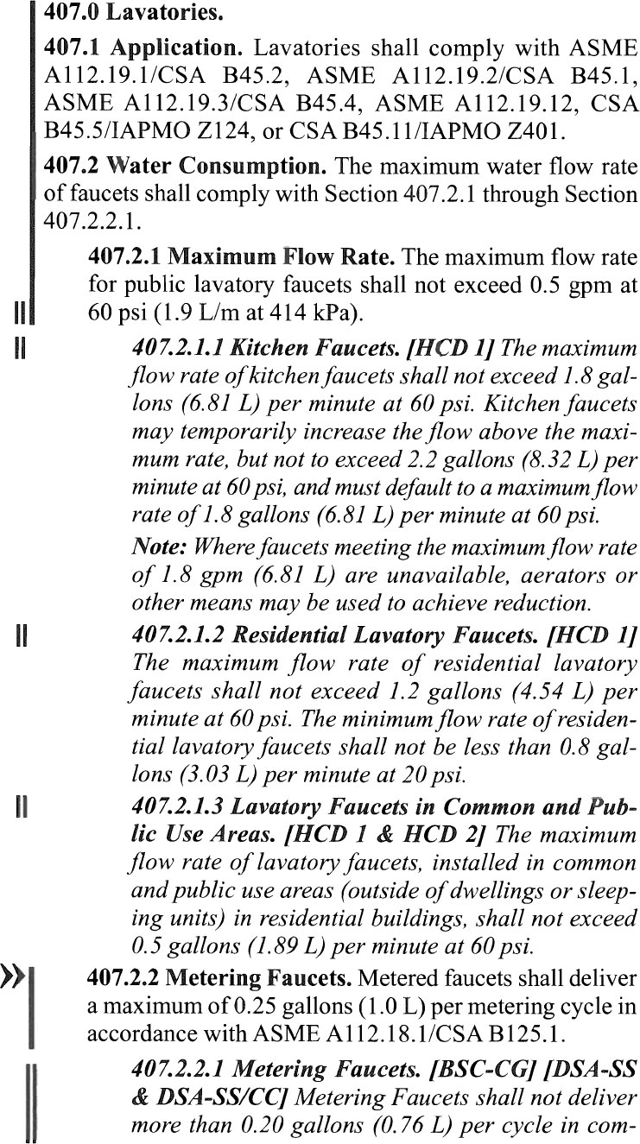 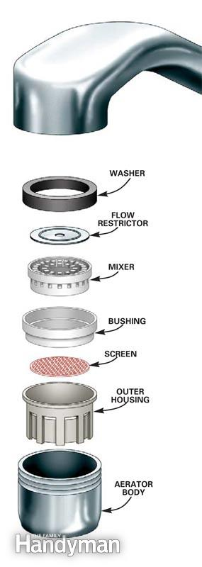

**LEED for Building Design and Construction (LEED BD+C v4)**

**Credit Category**

**Water Efficiency (WE)**

Prereq Outdoor Water Use Reduction Reduce 30%

Prereq Indoor Water Use Reduction Reduce 20%

Prereq Building-Level Water Metering

Credit Outdoor Water Use Reduction No irrigation system or Reduce 50% or 100%

Credit Indoor Water Use Reduction Reduce 25%, 30%, 35%, 40%, 45%, 50%, EP ≥55%

Credit Cooling Tower Water Use Cycles of Concentration

Credit Water Metering

**Prerequisite Indoor Water Use Reduction**

**LEED Requirement**

|  |  |  |  |  |
| --- | --- | --- | --- | --- |
| **Table 2.** Maximum Installed Flush or Flow Rates | | | | |
| **Fixture or fitting** | **EPAct 1992**  **Federal Standard** | **WaterSense**® | **LEED BD+C v4** | **Percent Savings** |
| **Flush Fixtures** |  |  |  |  |
| Flushometer-Valve Toilet* | 1.6 gpf | 1.28 gpf |  | 20% |
| Tank Toilet* | 1.6 gpf | 1.28 gpf |  | 20% |
| Urinal* | 1.0 gpf | 0.5 gpf |  | 50% |
| **Flow Fixtures** |  |  |  |  |
| Private lavatory faucet* | 2.2 gpm @60 psi | 1.5 gpm @60 psi |  | 32 % |
| Public lavatory (restroom) faucet | 0.5 gpm @60 psi |  | 0.4 gpm @60 psi | 20% |
| Kitchen faucet | 2.2 gpm @60 psi |  | 1.75 gpm @60 psi | 20% |
| Showerhead* | 2.5 gpm @80 psi | 2.0 gpm@60 psi |  | 20% |
| Pre-Rinse Spray Valve* | 1.6 gpm @60 psi | 1.28 gpm@60 psi |  | 20% |

gpf = gallons per flush gpm = gallons per minutes

* The WaterSense® label is available for this fixture type.

Energy Policy Act (EPAct) of 1992 (Baseline)

The average flush rate for **dual-flush toilets** must be calculated as the average flush volume of one full flush and two reduced flushes, using a 1:2 (high flush:low flush) ratio.

|  |  |
| --- | --- |
| **Table 3. Typical public and private lavatory faucet applications** | |
| **Lavatory faucet** | **Classification** |
| Restroom sink  School classroom sinks (if used primarily for hand washing) | Public (baseline: 0.5 gpm @60 psi) |
| Residential bathroom sink  Hotel or motel bathroom sink  Dormitory bathroom sink  Patient room sink  Patient bathroom sink in hospital or nursing home | Private (baseline: 2.2 gpm @60 psi) |