CMGT 235 – Electrical and Mechanical Systems
Department of Construction Management California State University, Chico

Exam #1

Name: ____________________________________________________________________________________

5 pts  5pts  5 pts  5 pts  5 pts  5 pts  5 pts  5 pts  5 pts  5 pts  1 pt  1 pt  1 pt  3 pts  2 pts  2 pts  6 pts  2 pts  2 pts  5 pts  5 pts  6 pts  5 pts  5 pts  4 pts | - If you have a six-inch thick, R – 19 fiberglass insulation batt that measures 2 ft x 8 ft and one side of the batt is 20°F and the other side is 70°F, what is the total heat loss through the batt?  - Calculate the total R-value of the wall.  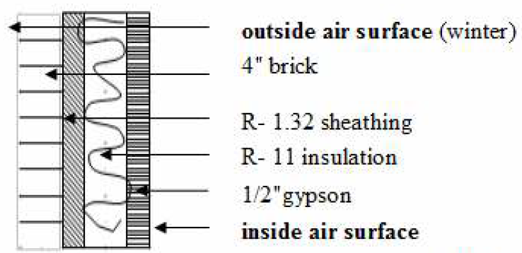  - If the wall in problem 3 is 40 ft long and 9 ft. high what is the heat loss through the wall for an indoor winter design temperature of 70°F and an outside temperature of 23°F?  - Determine the total heat loss due to infiltration for a house that is 1678 ft², 9 ft high with an infiltration rate of 0.38 ACH and 13 CFM due to a fireplace for an indoor winter design temperature of 70°F and an outside temperature of 23°F.  - A 60-gal hot water tank is installed in a residential garage where the temperature is 37°F. The tank has been off for several days. How many kW of electricity will be needed to raise the water temperature to 120°F?  - If a duct is 18-inches by 2 feet and the average measured air velocity is 130 feet per minute, what is the resulting flow rate?  - How much heat (Btu) is produced by a 150-W light bulb that is on for 10-hours?  - If the lighting load for a 25,000 SF building is estimated at 0.8 W/SF, what will be the resulting heat generated by lighting in units of MBtu for one full year of lights on 24 hour per day?  If the electric power being used by the building is provided by a coal fired plant and the plant produces 2.4 lb of CO₂ per kWh. How much CO₂ will be liberated to the atmosphere due directly to the lighting operation in the building?  - A 100 ft² concrete wall 8 in thick is at a temperature of 65°F. If after prolonged exposure to sunlight the concrete wall is storing 66,000 Btu, what is the temperature of the concrete wall?  - One Therm is equal to __________________ Btu.  - ASHRAE Standard ________ helps you to select an air filter.  - ASHRAE Standard ________ presents recommendations pertaining to ventilation, or the amount of outdoor air introduced into a given area.  - ASHRAE Standard ________ links ____________________ and ____________________ together to provide a measure of thermal comfort.  - How many tons of air conditioner are needed to produce 54,000 BTUH?  - What two main factors affect our sense of thermal comfort?  1.  2.  - Using the Psychrometric chart find the characteristics of an air/water vapor mixture and complete the following table:  Characteristic Case 1 Case 2  Dry-bulb temperature 75°F 95°F  Relative Humidity 50% %  Wet-bulb temperature °F 80°F  Humidity grains/lb grains/lb  Vapor Pressure In Hg In Hg  Dew point °F °F  Enthalpy BTU/lb BTU/lb  Specific volume ft³/lb ft³/lb  - If you have a wet bulb temperature of 65 degrees and 30 BTU/lb Enthalpy what is the dry bulb temperature?  - Find the Relative Humidity of an air/water vapor mixture at 70°F dry bulb and 50°F wet bulb.  - How much heat is required to vaporize five gallons of water?  - A room measures 9' x 12' x 8', and 1.5 ACH are expected. Find the outdoor air CFM for the room.  - Estimate infiltration and ventilation air quantities for a 10,000 sq. ft. school classroom building built in 1954. The conditioned space is 12 feet high, and the total population is 320 students and teachers.  Infiltration CFM.  1.5 ACH in winter  1.0 ACH in summer  Ventilation CFM. Estimate 15 CFM per person.  - Find the heat loss through a 200 sq. ft window if its U value is 1.1, the indoor temperature is 70°F and the outdoor temperature is 10°F.  - A building has an expected infiltration rate of 400 CFM. Find the BTUH heat loss when the indoor temperature is 70°F and the outdoor temperature is -10°F.  - An exterior wall is made up of 8" of stone (R= 0.08 per inch), 3" of foamed-in-place polyurethane, and 0.75" Plywood, and 5/8" gypsum board. Determine the total R-value and U-Factor for the wall. Use the lookup table provided in class. Assume winter.  Component R-Value  Wall – Outside Air Film  8" stone  3" foamed-in-place polyurethane  ¾" plywood  5/8" gypsum board  Inside Air Film  Total Wall Assembly R-Value  U-Factor

