CMGT 235 – Electrical and Mechanical Systems
Department of Construction Management California State University, Chico
Exam #1 – Mechanical Systems

Name: ____________________________________________________________________________________
10 pts
- A 2 ft² x 3 in block of aluminum and 2 ft² x 3 in block of copper are each at 40°F. How much heat is required to heat each block to 95°F?

- How much heat is required to vaporize 2.5 gallons of ice held at -15°F?
10 pts

- The wall section shown consists of two different cross section:
30 pts
- Where there are no 2x4 studs
- The section where there are 2x4 studs
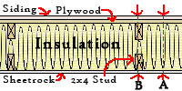
The 2x4 studs are 24” apart and the distance between the
½” sheetrock and 5/8” plywood is 9”. The insulation used is cellulose @ R=3.7 per inch. The siding is vinyl with ½” insulating board.

- Determine the R-Value (use 2-decimals) and U-Factor (use 3-decimals) during winter for the exterior wall assembly at section A:

- Determine the R-Value (use 2-decimals) and U-Factor (use 3-decimals) during winter for the exterior wall assembly at section B:

- What percentage of the wall assembly is section A?

- What percentage of the wall assembly is section B?

- If U_{Wall} = (U_{A} x % Section A) + (U_{B} x % Section B) determine the U-factor of the complete wall.

- Determine the heat loss due to transmission for the wall if the gross wall area is 150 ft² and the wall has one window (2 ft x 3 ft). The outdoor design temperature is 12°F and the inside temperature is 78°F.

- Using a Psychometric Chart answer the following:
18 pts
- A space at sea level is 55°F and RH = 30%
Find the other properties of the air in that space.
DB | 55°F
RH | 30%
WB | °F
Humidity | Gr/lb
VP | In Hg
Enthalpy | Btu/lb
Vs | ft³/lb
Dew Point | °F

- A saturated mixture contains 150 lb of dry air. How much heat is required (Btu) to raise the dry bulb temperature from 55°F to 75°F?

- If you have a wet bulb temperature of 45 degrees and a relative humidity of 90%, what is the dry bulb temperature?

- Which air/water vapor mixture will occupy the larger volume?
90°F DB, 70°F WB; or 80°F DB, 70°F WB

- The air supply for heating a room can be provided at 90°F DB, 40% RH or 95°F DB, 25% RH. Which air supply has the higher total heat?

- The CFM for the flexible duct system is shown in the duct diagram below. The Friction Rate per 100 ft is 0.075 iwc. Using the chart below determine the size of each of the branches, the return, and first and second section of the supply trunk. Round up to the next larger size if the point is above the duct size line. Label the duct sizes on the diagram.
12 pts
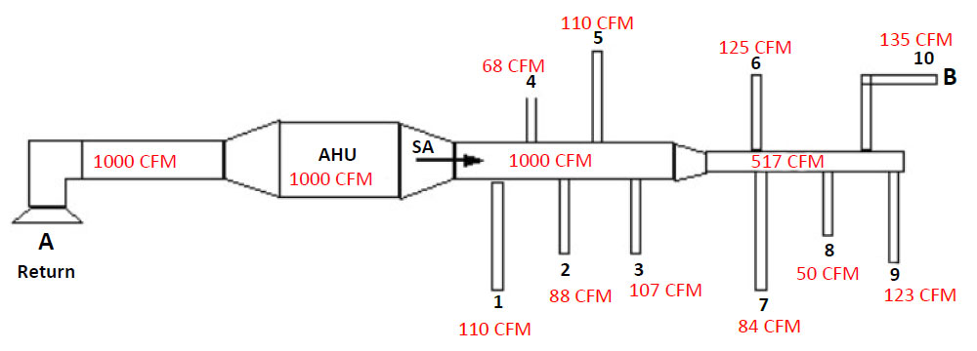

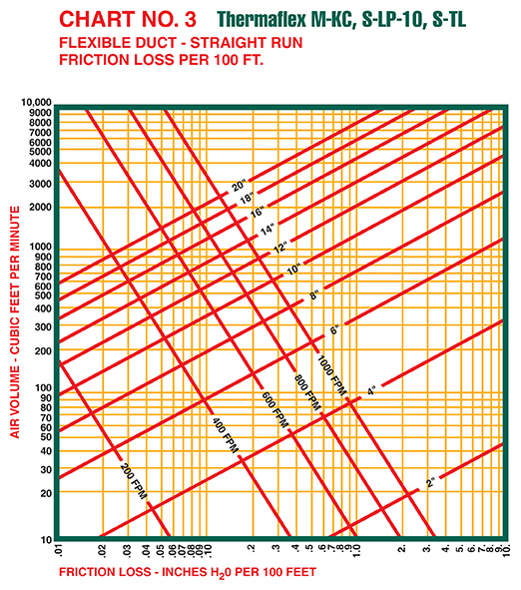
- An 1,800 square foot house has an 8 ft ceiling. Compare the hourly heat loss due to infiltration for tight, medium, and loose construction. In winter, use 0.5, 0.85, and 1.3 ACH respectively. The outside temperature is 38°F and the indoor temperature is 72°F.
10 pts

10 pts
- A theater is designed for an occupancy of 165 persons. The ASHRAE Standard call for a minimum outside airflow rate for theaters of 15 cfm per person. The target inside design temperature is 70°F and the outside design temperature is 43°F. Determine the sensible heating load from ventilation.

