Guide to Fitting Types & Materials

Different types, what they do, where they're used, and what they're made of
Plumbing is all about pipes and fittings. Pipes establish the runs that bring or take water, with fittings controlling and manipulating the flow. Pipes are simple enough: they're straight, and come in different sizes. Pick the right material and length, and you're pretty much good to go. Fittings - for a plumber - are much the same. But for the average homeowner, there are a lot of fittings. Some can be perplexing, others downright intimidating once materials and sizing are considered. The sizing we'll explore in another article; for now, you can learn a little bit about the most common fittings found in your home's plumbing. Never again will you need to ask for “the thingy with the two ends that connects the two pipes at an angle”!

Different Fitting Types

Adapters
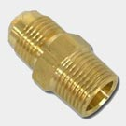  Brass Flare x MIPS Adapter | Adapters are used to extend runs, or to simply change the connection type at the end of a pipe. This allows dissimilar pipes to be connected, without the need for a more involved setup.  Adapters are available in most all standard materials: ABS, brass, copper, CPVC, malleable (galvanized and black), PVC, and stainless steel.

Bushings
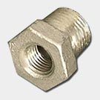Stainless Steel Bushing | Bushings are used to join pipes of different sizes, usually by reducing a larger fitting down to a smaller pipe. Bushings are usually - not always - threaded both inside and out, and take up very little space compared to a coupling or union, which accomplish the same goal.  Offered in: ABS, brass, chrome-plated brass, copper, CPVC, malleable (galvanized and black), PVC, and stainless steel.
Note: Some fitting types, like bushings, have limitations placed on their use (or are not allowed at all) by some plumbing codes. Remember to check local plumbing codes prior to purchasing.

Caps & Plugs
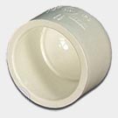  PVC Cap | Caps are, surprisingly enough, used to cap a pipe end. Plugs do pretty much the same thing, but usually fit inside the fitting, and are threaded to allow for future use of the pipe. Caps can be threaded, glued, or soldered onto pipe (depending on its material).  Both are available in: ABS, brass, chrome-plated brass, copper, CPVC, malleable (galvanized and black), PVC, and stainless steel.

Couplings
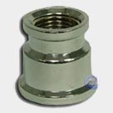  Chrome Coupler | A coupling is used to extend the run of a pipe, or change pipe sizes (in the case of a reducing coupling, also sometimes called a “bell” reducer due to its shape). Available with female threads, or unthreaded for either plastic gluing (solvent welding) or copper soldering, these are among the most-used of fittings.  Offered in: ABS, brass, chrome-plated brass, copper, CPVC, malleable (galvanized and black), PVC, and stainless steel.

Elbows
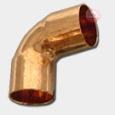  Copper 90° Elbow | If you need to change the direction of flow, elbows are likely your best bet. Produced primarily in 90 and 45 degree angles (unique sizes like 22.5 and 60 are also available), elbows can be threaded or sweated, and are one of the most crucial fittings used in plumbing. Street elbows feature male and female threaded ends to easily connect differing pipes or fittings. Some unique elbows also feature a side outlet, making it act more like a tee with a bend.  Available in: ABS, brass, chrome-plated brass, copper, CPVC, malleable (galvanized and black), PVC, and stainless steel.

Flanges
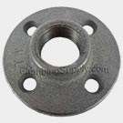  Black Iron Floor Flange | Flanges are used to connect pipes. Pipe is threaded or welded to the flanges, which are then sealed together (usually with bolts). Flange connections are used extensively in industrial applications handling high pressures. They can also be found connecting residential pump systems. “Closet” (or toilet) flanges are found in the home mounting the toilet to the floor and drain beneath.  Offered in: brass, copper, malleable (galvanized and black), and PVC (for closet/toilet flanges).

Nipples
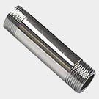  Chrome Pipe Nipple | Nipples are a short stub of pipe, male-threaded at each end, that are used to connect straight pipe runs. Close nipples are threaded from each end along their whole length for particularly tight connections.  Available in: brass, chrome-plated brass, copper, malleable (galvanized and black), PVC, and stainless steel.

Tees
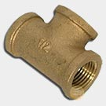  Brass IPS Tee | When more than one branch is required of a water supply, tees are the way to go. Essentially a long coupling with an outlet on the side, these fittings feature their outlets at 90° from the inlet, and are sized per their “run” (the horizontal, or straight-through dimension of the fitting), and the side outlet (the “top” of the fitting, 90 degrees off the run). When the run of a tee is smaller than the side outlet, it's often referred to as a “bull head” fitting.  Tees are offered in ABS, brass, chrome-plated brass, copper, CPVC, malleable (galvanized and black), PVC, and stainless steel.

Crosses
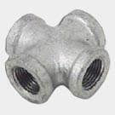  Galvanized Cross | “Cross” fittings are 4-way fittings that are essentially the combination of two tees. Many opt to use two tees instead.  Crosses are available in brass, malleable (galvanized and black), and PVC.

Saddle Tees
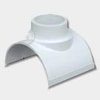  PVC Saddle Tee | These fittings are used to quickly add a tee to an existing length of pipe, without having to cut and re-solder what’s there. Most often, this takes place with irrigation systems to add a new sprinkler line. Also referred to as snap-tees, saddles are glued to the pipe, and after setting, the new hole is drilled.  Saddle tees are offered only in PVC.

Unions
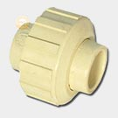  CPVC Union | Unions are an alternative to couplings, when the latter are impractical or inconvenient. Whereas couplings (when not soldered) need to have pipe threaded into them, unions rely upon their own nut to create a seal between the pipe ends. This makes them the perfect choice for connecting two fixed pipes (that are unable to be threaded into a regular coupling), and make future repairs that much easier. Dielectric unions are used to join pipes of different metals by providing a barrier against galvanic corrosion. For all their benefits, unions do have drawbacks: they are not to be used with natural and LP gas.  They are available in in brass, chrome-plated brass, copper, CPVC, malleable (galvanized and black) PVC, and stainless steel.

Wyes
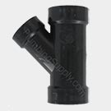  ABS Wye | Wyes are primarily drainage fittings, and feature a 45° branch line designed to keep flow smooth. While sanitary tees are used with vertical drain connections, they can cause problems when used flat on a horizontal connection: those situations call for a wye.  These are available in brass, ABS, and PVC.

Common Fitting Materials

ABS
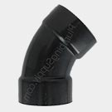  ABS 60° Elbow | Acrylonitrile Butadiene Styrene, a black plastic used in drainage, sewer, waste and vents. ABS pipe/fittings as well as PVC have replaced much of the cast iron, lead, and steel pipes formerly used for DWV. Important to note is that no solvent cement (or primer) can totally "glue" (solvent weld) ABS to PVC plastic.

Brass
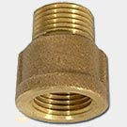  Brass Fitting Extender | Made with a mixture of metal alloys: mostly copper and zinc, as well as small amounts of lead, tin, manganese, nickel, aluminum or iron. Brass fittings used for potable water usually have approximately 62-65% copper, 30-35% zinc and very small percentages of tin and lead. Brass works particularly well in hot water applications, and is highly resistant to corrosion.

Copper
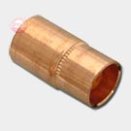  Copper Bushing | Reddish-brown, non-ferrous metal widely used for household plumbing pipes. Copper is a relatively soft and often thin material, making threading difficult. As a result, most copper fittings are not threaded, and must be soldered to copper pipe.

CPVC
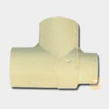  CPVC Reducing Tee | Chlorinated Polyvinyl Chloride is a plastic product designed for drinking water at temperatures up to 180 degrees (where code permits), and can generally withstand higher temperatures than standard PVC. The CPVC fittings we offer will not glue on PVC schedule 40 pipe.

Malleable (Galvanized or Black)
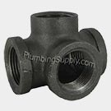  Black Iron Side Outlet Tee | Made from steel. Black iron is mostly used in gas and oil applications, and is often coated with black paint or lacquer. Galvanized fittings are coated with zinc to protect against rust and corrosion. Galvanized piping was widely used for home plumbing in the past, but no longer, due to leak issues over time. Galvanized fittings today are most often used for non-potable outdoor applications, and to repair existing galvanized systems.

PVC
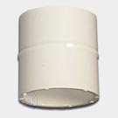  PVC Coupling | A rigid, generally white plastic pipe. Used for waste and vent systems as well as cold water (underground) supplies outside of the house as well as used for sprinkler and irrigation pipes, sewers, drains, wastes and venting pipes and fittings. PVC in the plumbing business is generally white (Sch 40) but sometimes comes in other colors (in our industry gray is the second most popular, and is typically used for Sch 80 PVC). Another color you may see more frequently as water conservation efforts grow is purple, which is used to differentiate reclaimed or grey water systems from potable drinking water systems.

Stainless Steel
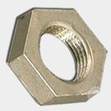  Stainless Steel Lock Nut | A combination of iron alloys and chromium, stainless steel is durable and offers excellent rust and corrosion resistance. Stainless steel comes in many types, with 304 and 316 being the most used in plumbing. Both are rated to pressures of 150 psi, with type 316 steel providing greater protection against chemical corrosion.

