|  |  |
| --- | --- |
| CMGT 235 | Plumbing Materials |

Discussion #13

**Pipe – Cylindrical Tubing**

**Polyvinyl Chloride (PVC)**

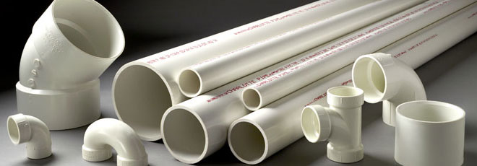

Polyvinyl Chloride (PVC) piping is the most widely used plastic piping material. [PVC piping](https://www.ppfahome.org/faq.aspx?prod=5) systems are:

* Environmentally sound.
* Provide long service life.
* Easy to install and handle.
* Corrosion resistant.
* Cost effective.
* Widely accepted by codes.

PVC pipe is manufactured by extrusion in a variety of sizes and dimensions and generally sold in 10' and 20' lengths. PVC pipe is available in both solid wall or cellular core construction. Cellular core construction involves the simultaneous extrusion of at least three layers of material into the pipe wall: a solid outer layer, a cellular core intermediate layer, and a solid inner layer. PVC pipe is made to conform to various ASTM standards for both pressure and non-pressure applications.

[USES/APPLICATIONS](https://www.ppfahome.org/uses.aspx)  
PVC piping is used for:

* Drain-waste-vent (DWV).
* Sewers.
* Water mains.
* Water service lines.
* Irrigation.
* Conduit.
* Various industrial installations.

It can be used under ground or above ground in buildings. It can also be used outdoors if the pipe contains stabilizers and UV inhibitors to shield against ultraviolet radiation and it is painted with a water-based latex paint.

PVC materials are resistant to many ordinary chemicals such as acids, bases, salts and oxidants.

Because PVC piping system components can be manufactured in a variety of colors, identification of application is easy. A common color scheme (although not universal) is:

* White for DWV and some low pressure applications.
* White, blue, and dark gray for cold water piping.
* Green for sewer service.
* Dark gray for industrial pressure applications.

This color scheme has an exception in that much of the white PVC pipe is dual rated for DWV and pressure applications.

PVC piping systems should not be used to store and/or convey compressed air or other gases. PVC piping systems should not be tested with compressed air or other gases either.

[CODE STATUS](https://www.ppfahome.org/codepb.aspx)  
PVC piping is recognized as acceptable material for DWV, sewers, and potable water services and distribution in all model plumbing codes. These Codes normally identify acceptable products for specific uses based on the ASTM Standard designation.

AVAILABILITY  
PVC is available from plumbing supply houses, hardware stores, and home centers throughout North America. Refer to our [member website links](https://www.ppfahome.org/members.aspx?prod=5) .

MARKING  
Because printing on PVC piping is simple, markings are always easy to identify. ASTM standards mandate that PVC pipe be labeled as follows:

1. The manufacturer's name or trademark.
2. The standard to which it conforms.
3. Pipe size.
4. Material designation (e.g., PVC 12454, of PVC 1120, or PVC Type 1, Grade 1).
5. DWV, if for drainage.
6. Pressure rating if for pressure.
7. SDR number or Schedule number.
8. If the pipe is for potable water, a laboratory seal or mark attesting to suitability for potable water.

[Installing PVC](https://www.ppfahome.org/Landing_Pages/pvcpipedwvspec.html) piping systems is easy. Contractors love this lightweight piping material. Just follow some simple, common-sense steps:

* Follow local code requirements.
* Follow recommended safe work practices.
* Follow proper handling procedures.
* Read the manufacturer's installation instructions.
* Keep pipe and fittings in original packaging until needed.
* Cover pipe and fittings with an opaque tarp if stored outdoors.
* Inspect pipe for damage prior to use.
* Use tools specifically designed for use with plastic pipe.
* Use a drop cloth to protect finishes in the work area.

When joining PVC pipe and fittings with solvent cement, always:

* Cut the pipe ends square.
* Bevel and deburr the pipe ends with a chamfering tool.
* Use the proper primer and solvent cement and follow manufacturer's application instructions.
* Use the proper size applicator for the pipe being joined.
* Rotate the pipe 1/4 turn when bottoming pipe in fitting socket.
* Avoid puddling of primer or cement in fittings and pipe.

For threaded connections, always:

* Use Teflon® tape or approved paste thread sealant.
* Assemble threaded joints carefully (maximum two turns past finger tight).

To properly support PVC piping systems:

* Allow for movement due to expansion and contraction.
* Use hangers designed for use with plastic.
* Follow proper hanger support spacing requirements.
* Protect from nails, screws, and abrasive surfaces.

When testing an installed PVC piping system:

* Follow the manufacturer's recommended cure times prior to pressure testing.
* Test in accordance with local codes.
* Use only glycerin and water solutions for freeze protection when applicable.

**Chlorinated Poly Vinyl Chloride (**[**CPVC**](https://www.ppfahome.org/faq.aspx?prod=2)**)**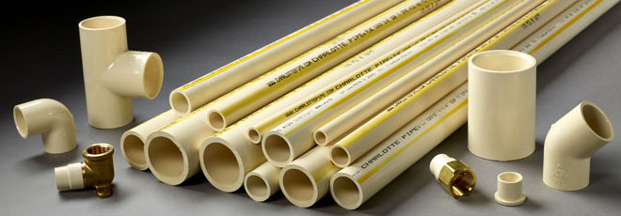

Chlorinated Poly Vinyl Chloride ([CPVC](https://www.ppfahome.org/faq.aspx?prod=2)) is a thermoplastic pipe and fitting material made with CPVC compounds meeting the requirements of ASTM Class 23447 as defined in ASTM Specification D1784.[CPVC applications](https://www.ppfahome.org/pressure.aspx) are for potable water distribution, corrosive fluid handling in industry, and fire suppression systems.

CPVC piping systems are:

* Environmentally friendly.
* Provide long service life.
* Easy to install and handle.
* Corrosion resistant.
* Cost effective.
* Widely accepted by codes.

Industrial CPVC pipe is manufactured by extrusion in sizes from ¼" to 12" diameter to Sch 40, Sch 80, and SDR (Standard Dimension Ratio) dimensions.

CPVC pipe for plumbing systems is manufactured by extrusion in sizes ¼" through 2" copper tube size (CTS) dimensions. The CTS plumbing products are made to copper tube outside diameter dimensions, in accordance with ASTM D-2846 specifications, and have an SDR 11 wall thickness. The pressure ratings of the CTS SDR 11 systems are 400 psi (pounds per square inch) at 73 F and 100 psi at 180 F. CPVC plumbing pipe is sold in both straight lengths and (in small diameters) coils.

USES/APPLICATIONS  
CPVC piping which is suitable for hot and cold water distribution has a 400 psi pressure rating at room temperature, and a 100 psi pressure rating at 180 F.

CPVC materials are resistant to many everyday household chemicals.

Since CPVC materials do not support combustion, they cannot burn without an external fuel source. This property makes CPVC pipe an attractive alternative to steel and copper pipe for fire sprinkler applications. CPVC fire sprinkler piping systems are approved for light hazard applications and for use in single and multifamily dwellings. Installation shall be in accordance with the NFPA Section 13, 13D, and 13R.

[CODE STATUS](https://www.ppfahome.org/codepb.aspx)  
CPVC piping for potable hot and cold water distribution systems is recognized in all model plumbing codes.

Also, CPVC plumbing pipe is safe for installation in return air plenums; however, the installation must be approved by the local jurisdiction. Even though CPVC is considered a combustible material it will not burn without a significant external flame source. Once the flame source is removed CPVC will not sustain combustion. Testing indicates that water filled CPVC in diameters 3" or less will pass the 25/50 flame smoke developed requirements for non-metallic material in return air plenums.

CPVC fire sprinkler pipe tested and listed in accordance with UL 1887, "Fire Test of Plastic Sprinkler Pipe for Flame and Smoke Characteristics," meets the requirements of NFPA 90A for installation in return air plenums.

AVAILABILITY  
CPVC pipe and fittings are produced by many manufacturers, and are available in Schedule 40 and Schedule 80 dimensions, as well as CPVC tubing which is suitable for potable hot and cold water distribution. The tubing is based on copper tube sizes (OD) and IPS pipe (OD), with SDR 11 wall thicknesses.

MARKING  
CPVC pipe must be labeled at not more than 1.5 meters (5 feet) intervals as follows:

1. The manufacturer's name or trademark
2. The standard to which it conforms
3. Pipe size
4. Resin type or cell class according to ASTM D-1784, e.g. CPVC 23447
5. Pressure rating
6. SDR number or Schedule number
7. If the pipe is for potable water, a laboratory seal or mark attesting to suitability for potable water

**Acrylonitrile-Butadiene-Styrene (ABS)**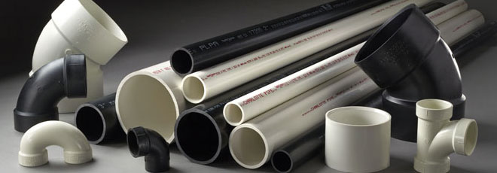

ABS pipe and fittings are made from a thermoplastic resin called Acrylonitrile-Butadiene-Styrene (ABS for short).

ABS PIPING SYSTEMS:

* Are easier and less expensive to install than metal piping
* Feature superior flow due to smooth interior finish
* Do not rot, rust, corrode or collect waste
* Withstand earth loads and shipping (with proper handling)
* Resist mechanical damage, even at low temperatures
* Perform at an operational temperature up to 140°F (60°C)
* Are lightweight (one person can load and unload)
* Take less time to rough in than metal DWV materials

ABS pipe and fittings were originally developed in the early 1950s for use in oil fields and the chemical industry. In 1959, John F. Long, a prominent Arizona builder, used ABS pipe in an experimental residence. Twenty-five years later, an independent research firm dug up and analyzed a section of the drain pipe. The result: no evidence of rot, rust or corrosion. ASTM standard for ABS-DWV pipe and fittings was originally approved in 1967.

USES/APPLICATIONS  
ABS pipe and fittings have become a leading material for [DWV applications](https://www.ppfahome.org/nonpressure.aspx) because they offer an outstanding combination of properties. Contractors have installed more than 10 billion feet of ABS pipe in residential and commercial construction. [ABS pressure pipe](https://www.ppfahome.org/pressure.aspx) is also available for certain industrial applications. ABS pipe is sold in 10' and 20' lengths, plus 12' lengths in Canada.

ABS pipe is available in solid-wall and cellular-core construction in Schedule 40 dimensions. These two forms may be used interchangeably for DWV applications.

ABS pipe may be used in buried or above ground DWV applications. It may be used outdoors if the pipe contains pigments to shield against ultraviolet radiation, or jurisdictions may require the pipe to be painted with water-based latex paint for outdoor use. Check with the pipe supplier for details about local regulations for this material.

Specifying ABS pipe is a relatively easy task as the pipe wall of Schedule 40 ABS DWV pipe is the same thickness as Schedule 40 (IPS) steel pipe.

Architects, mechanical engineers and builders should incorporate ABS pipe and fittings into their specifications by a reference similar to the following: "All soil lines, waste lines, vents, and building drains shall be installed with ABS pipe and fittings conforming to Schedule 40 ASTM F 628 or ASTM D 2661. All products shall bear the seal of a nationally-recognized listing or certifying agency."

[CODE STATUS](https://www.ppfahome.org/codepb.aspx)  
ABS is recognized as acceptable for use in DWV systems in all major model plumbing codes.

AVAILABILITY  
ABS is available from plumbing supply houses and retail home supply stores throughout most of North America.

MARKING  
The standards for plastic pipe generally require that the product be marked so that it can be readily identified, even if cut in short pieces. Most of the standards require at least the following items:

1. The manufacturer's name or trademark
2. The standard to which it conforms
3. Pipe size
4. Resin type
5. DWV if for drainage
6. SDR number or Schedule number
7. If the pipe is for potable water, a laboratory seal or mark attesting to suitability for potable water

CHEMICAL RESISTANCE  
According to studies performed by the ABS Institute, ABS pipe was shown to be unaffected by commonly used household chemicals - including drain and bowl cleaners, such as:

* Tide detergent
* Soilax cleanser
* Borax cleaners
* Calgon water softener
* Ammonia 5% solution
* Renuzit spot remover
* Drano
* Liquid Sani-flush
* Liquid Plumber
* Lysol bowl cleaner
* Vanish bowl cleaner
* Liquid Vanish bowl cleaner
* Sno-Bol bowl cleaner

FIRE-RATED CONSTRUCTION  
When properly installed in compliance with building and fire codes, ABS can be used in fire-rated construction, such as high-rise dwellings. Schedule 40 ABS DWV systems are suitable for fire-rated wall, floor and ceiling assemblies.

ABS pipe must be heated to over 871°F (465°C) before it will self-ignite. In comparison, the types of wood commonly used in home framing self-ignite around 500F (260°C). In an out-of-control fire, temperatures reach well over 1,000F (540°C), at which point all combustibles burn.

ABS DWV pipe systems typically represent less than 1% of the total combustible products in wood-frame construction. In addition, ABS DWV piping systems are installed behind walls, under floors and above ceilings; therefore, ABS pipe will melt and collapse long before it burns, preventing flame spread up vertical stacks or along horizontal waste lines.

Like all combustible materials, ABS pipe releases gaseous products when burned. Although no nationally recognized standard exists for measuring toxicity, testing indicates that gases released from burning styrene-based plastics, such as ABS, present no greater hazard than gases released from common building materials, such as the wood used in wall construction.

STORAGE & HANDLING  
You can store ABS pipe and fittings either inside or outside. Protect the material from direct sunlight as exposure to the sun can cause uneven expansion. Store ABS pipe on a level support to prevent sagging or bending.

[10 QUICK INSTALLATION STEPS](https://www.ppfahome.org/abs/absspec.pdf)

* Measure pipe from bottom or shoulder of each socket into which pipe is to fit.
* Cut pipe to required length, making sure cut is square.
* Ream inside and chamfer outside of pipe to eliminate all burrs. Sand lightly.
* Clean all dirt, moisture, and grease from pipe and fitting socket using a clean, dry cloth.
* Check dry fit of pipe in fitting socket.
* Apply a light coat of ASTM D2235 compliant ABS solvent cement to the inside of the fitting socket and the outside of the pipe.
* Insert pipe into fitting socket, giving the pipe a one-quarter turn and making sure it goes all the way to the socket bottom.
* Hold the joint together until a tight set is attained.
* Check cement bead around joint; wipe excess cement from the pipe.
* Don't move the system until the joints have cured (set) at least as long as recommended by the solvent

Polyethylene (PE) is a thermoplastic material produced from the polymerization of ethylene. PE plastic pipe is manufactured by extrusion in sizes ranging from ½" to 63". PE is available in rolled coils of various lengths or in straight lengths up to 40 feet. Generally small diameters are coiled and large diameters (>6" OD) are in straight lengths. [PE pipe](https://www.ppfahome.org/faq.aspx?prod=3) is available in many varieties of wall thicknesses, based on three distinct dimensioning systems:

* Pipe Size Based on Controlled Outside Diameter (DR)
* Iron Pipe Size Inside Diameter, IPS-ID (SIDR)
* Copper Tube Size Outside Diameter (CTS)

PE pipe is available in many forms and colors such as the following:

* Single extrusion colored or black pipe
* Black pipe with coextruded color striping
* Black or natural pipe with a coextruded colored layer

[SUSTAINABILITY (GREEN BUILDING)](https://www.ppfahome.org/sustainability.aspx)  
A significant benefit of plastic pipe is its small environmental impact compared to other materials.  To learn more [click here](https://www.ppfahome.org/sustainability.aspx).

[USES/APPLICATIONS](https://www.ppfahome.org/pressure.aspx)  
PE pipe offers distinct advantages as a piping material:

* Light weight
* Flexibility
* Chemical resistance
* Overall toughness
* Longevity

These benefits make it an ideal piping material for a broad variety of applications such as potable water service or distribution lines, natural gas distribution, lawn sprinklers, sewers, waste disposal, and drainage lines. PE materials are generally resistant to most ordinary chemicals.

Polyethylene can be used in low temperatures without risk of brittle failure. Thus, a major application for certain PE piping formulations is for low-temperature heat transfer applications such as radiant floor heating, snow melting, ice rinks, and geothermal ground source heat pump piping.

[CODE STATUS](https://www.ppfahome.org/codepb.aspx)  
PE pipe is recognized as acceptable plumbing piping for water services, drainage, and sewer applications in most model plumbing codes. Verify acceptance and installation of PE piping systems with the local code enforcement authorities having jurisdiction.

[AVAILABILITY](https://www.ppfahome.org/Landing_Pages/pespec.html)  
PE pipe and fittings are available from plumbing supply houses and various hardware retailers throughout the U.S.A. and Canada. PE pipe is generally less expensive than metallic piping materials.

MARKING  
PE pipe must be labeled as follows:

1. The manufacturer's name or trademark
2. The standard to which it conforms
3. Pipe size
4. Material designation code (PE 2406 or PE 3408)
5. DWV if for drainage piping
6. Pressure rating if applicable
7. DR number or Schedule number
8. If the pipe is for potable water, a laboratory seal or mark attesting to suitability

**Cast Iron Soil Pipe for Drains and Vents**

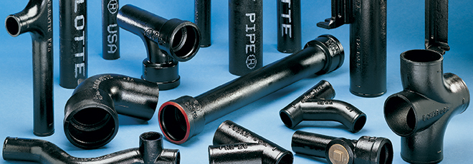

**Copper for Water or Gas Supply**

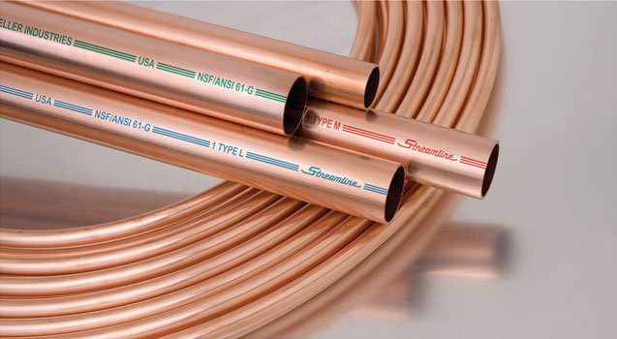

**Galvanized Steel (Water Supply) and Black Iron (Gas Supply)**

