CMGT 235 – Electrical and Mechanical Systems
Department of Construction Management California State University, Chico
Exam #1 [100 points]
You may work together as a group or individually. Every student SHALL complete their own answer sheet.

Name:
Name:
Name:

15 pts
- A 6 in x 6 in x 3 in ice cube is held in a freezer at 0°F. How much heat is required to turn the ice cube to steam?

- For the tiny home plan shown the inside temperature is 72°F and the outside temperature is -15°F.
35 pts
Specifications
Window Sizes  Bathroom 3 ft x 2 ft  Nook 3 ft x 3 ft  Living Room 6 ft x 4 ft and 5 ft x 3 ft  Master Bedroom 5 ft x 3 ft E  Door 21 ft² E  Ceiling Height 8 ft  Wood Porch 4 ft x 18 ft | Walls R-19 (6” insulation)  Ceilings R-30 (10” insulation)  Windows R-3.13  Doors R-3.70  Floor SOG (2 in thick edge insulation, R=5)


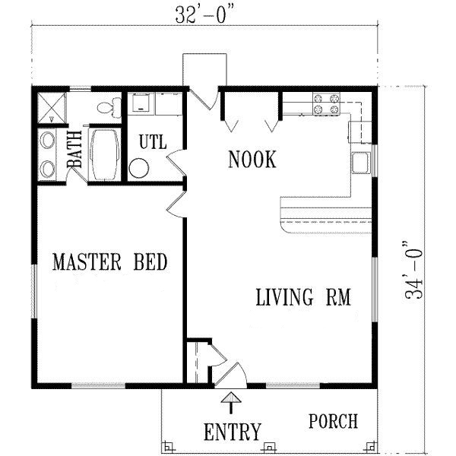

Use 3-decimals for all U-factors. Round all calculations to whole numbers.

- Determine the total heat loss due to transmission.

- Determine the heat loss due to infiltration for an ACH = 1.2

- Determine the Total Heat Loss.

- Calculate the total heat loss during a 24-hour period for a flat roof 55 ft X 70 ft. The roof is constructed per the detail below. The inside temperature is 70 °F and the outside temperature is 52 °F. Assume winter conditions. Use 2-decimals for R Values and 3-decimals for U-Factors. Round answer to a whole number.
25 pts

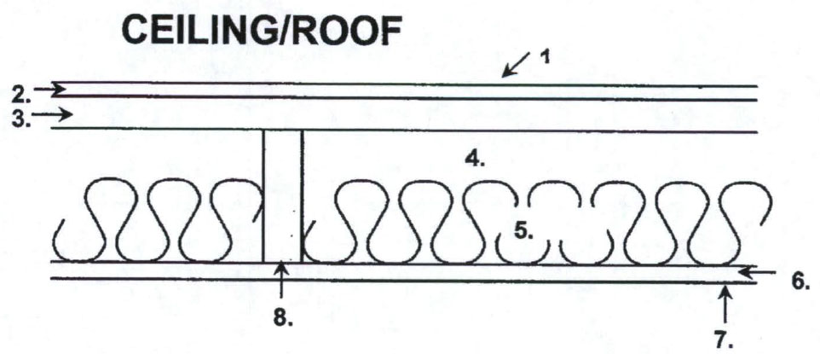

 |  | R (Between joist) | R (At joist)
1. | Air film outside
2. | 3/8 in. Built-up roofing
3. | 5/8 in. Plywood Sheathing
4. | 1 ½ in. Air space
5. | R-13 Fiberglass Batt Insulation
6. | 5/8 in. Gypsum board
7. | Air film inside
8. | Nominal 2-in x 12-in Doug Fir Joist @ 24 in. o.c.
R_{Total}

Determine the average U-Factor for the ceiling

Psychrometric Chart
10 pts
- Given the ambient temperature is 70°F measured by a dry bulb thermometer and 60°F measured by a wet bulb thermometer, what is the relative humidity?

Is this point an acceptable temperature and humidity for personal comfort all year for people in the USA?

15 pts
- A house is 4500 ft² and has 12 ft ceilings. For comfort, the homeowner specifies 0.3 changes of air per hour. The outside air temperature is 90°F dry bulb and 73.5° wet bulb. The air indoors is 75°F dry bulb 50% relative humidity. What is the amount of cooling required to provide the fresh air?

