CMGT 235 – Electrical and Mechanical Systems
Department of Construction Management California State University, Chico
Exam #1 [100 points]
You may work together as a group or individually. Every student SHALL complete their own answer sheet.
Solution
Name:
Name:
Name:

- The floor plan for a 16 ft x 32 ft cabin with 1 bedroom and 1 bathroom is shown below. The cabin located in Bellevue, Washington is being built on a SOG and with a flat roof. Wall height is 8ft.
8 pts
- Highlight the windows with a yellow highlighter and write the area of each window along the outside of the window and the area of the entry door next to the door. Outside temperature is 10°F and inside temperature is 78°F.
Window Specifications
Living Room 2 ft x 4 ft and 6 ft x 4 ft
Bedroom 2 ft x 3 ft and 5 ft x 3 ft
Bathroom 3 ft x 3 ft
Entry Door 7 ft x 3 ft
Floor SOG (2 in thick edge insulation, R=5)
9
24
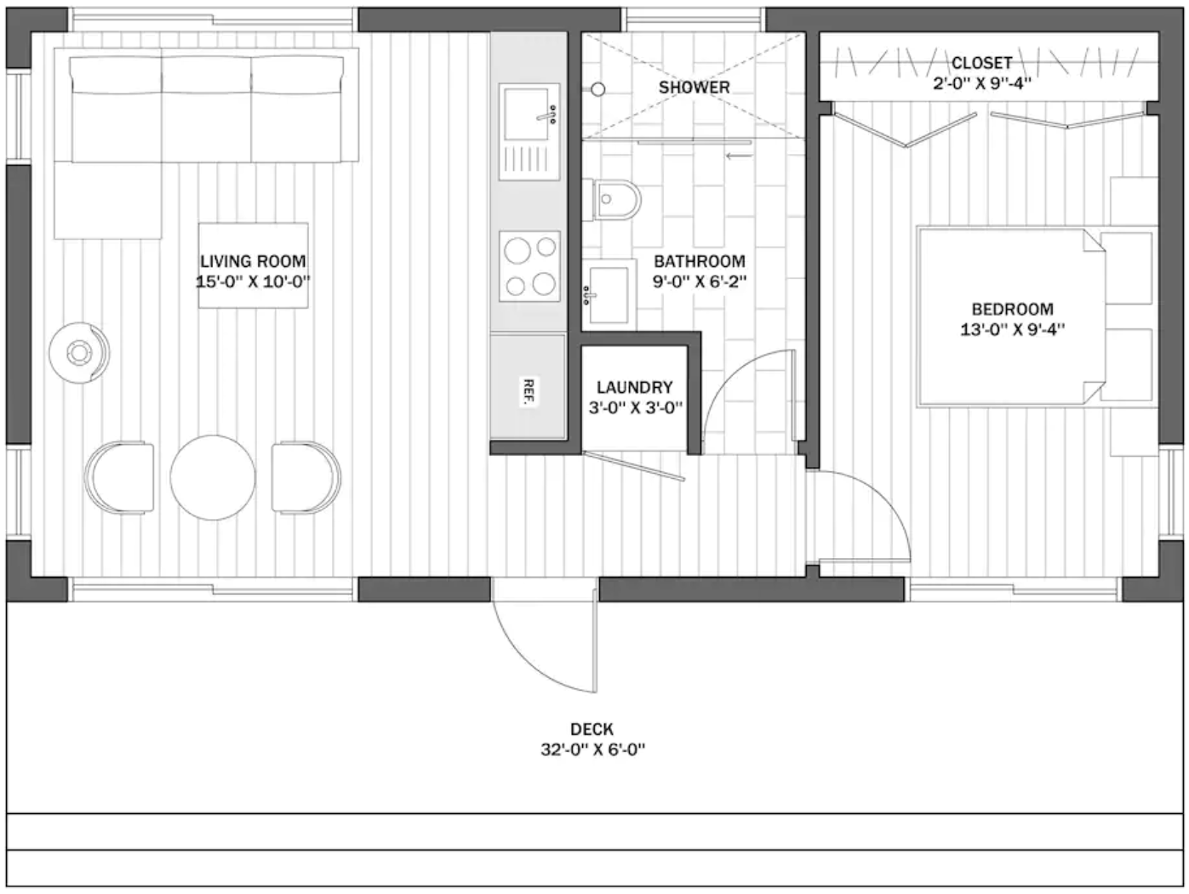
8
8
24
21
15
6
- Determine the total R-value and U-Factor for the roof and walls. Use the R-Value lookup table provided in class. Assume winter. For all answers, use 2-decimals for R-Values and 3-decimals for U-Factor.
9 pts
Roof Construction
0.4375 x 1.25 = 0.55
Component | R-Value
Outside Air Film | 0.17
Asphalt Shingles | 0.44
1” Air gap | 1.00
7/16” OSB Plywood Sheathing | 0.55
5 1/4" Fiberglass Batt (high density) | 21.00
5/8” Drywall | 0.56
Inside Air Film | 0.68
Total Roof Assembly R-Value | 24.40
U-Factor (Use Three Decimals) | 0.041

Wall Construction - 2x6 Wood Framing 16in O.C.
20 pts
Wall Construction
0.375 x 1.25 = 0.47
Component | R (Between stud) | R (At stud)
Outside Air Film | 0.17 | 0.17
3/8" plywood siding | 0.47 | 0.47
1 Layer 15-lb Felt (R=0.06) | 0.06 | 0.06
5/8” Structural Plywood Sheathing | 0.77 | 0.77
2x6 Framing | --- | 6.88
R-21 Cavity Insulation | 21.00 | ---
Interior ½” Gypsum Board | 0.45 | 0.45
Inside Air Film | 0.68 | 0.68
Total Wall Assembly R-Value | 23.60 | 9.48
U-Factor (Use Three Decimals) | 0.042 | 0.105
10 pts
- Determine the average U-Factor for the wall. Show all calculations

R_{avg} = (1.5/16) x 9.48 + (14.5/16) x 23.60 =22.28

U_{avg} = 0.045

- Determine the U-Factor for the windows and the entry door (show calculations)
2 pts
Component | U-Factor
Windows R-3 | 0.333
Entry Door R-5 | 0.200
8 pts
- Determine the areas shown in the table below (show all calculations)
Gross Wall Area | (2 x 16 ft x 8 ft) + (2 x 32 ft x 8 ft) = 768 ft²
Total Window Area | 24 + 9 + 6 + 15 + 24 + 8 + 8 = 94 ft²
Entry Door Area | 21 ft²
Net Wall Area | 768 ft² – (94 ft² + 21 ft²) = 653 ft²
10 pts
- Calculate (Round all answers to whole number) the rate of heat loss due to transmission for:
Walls

q_{walls} = U x A X ΔT = 0.045 x 653 x (78°F - 10°F) = 1,998 BTUH

Windows

q_{windows} = U x A X ΔT = 0.333 x 94 x (78°F - 10°F) = 2,129 BTUH

Door

q_{door} = U x A X ΔT = 0.200 x 21 x (78°F - 10°F) = 286 BTUH

Roof

q_{roof} = U x A X ΔT = 0.041 x (16ft x 32ft) x (78°F - 10°F) = 1,427 BTUH

SOG

q_{slab} = Uf x L = 35 x (2x16ft + 2x32ft) = 3,360 BTUH

2 pts
- Calculate the total rate of heat loss due to transmission.

q_{transmission} = 1998 + 2129 + 286 + 1427 + 3360 = 9,200 BTUH

- Determine the rate of heat loss due to infiltration for an ACH = 1.2
5 pts

q_{infil} = 0.018 x 1.2 x (4096 ft³) x (78°F - 10°F) = 6,016 BTUH

2 pts
- Calculate the Total Rate of Heat Loss for the home

q_{total} = 9,200 BTUH + 6,016 BTUH = 15,216 BTUH

4 pts
- A 5-ton air conditioner is equivalent to how many BTUs of air conditioning?

BTUs = 5 ton x 12,000 BTU/ton = 60,000 BTU

4 pts
- A heat pump has a cooling effect of 12,000 BTUH and an input power of 1200 W. What is the COP?

P_{out} = 12,000 Btuh x 1 kW/3,414 Btu = 3.5 kW

COP = P_{out} / P_{in} = 3.5 kW / 1.2 kW = 2.9

Use a Psychometric Chart to answer the following questions.
6 pts
- A space at sea level is 65°F and RH = 30%
Find the other properties of the air in that space.
DB | 65°F
RH | 30%
WB | 49.1 °F
Humidity | 27 Gr/lb
VP | 0.19 In Hg
Enthalpy | 19.9 Btu/lb
Vs | 13.3 ft³/lb
Dew Point | 32.8 °F

- A residential steam boiler contains 30 gallons of water that is stored at 55°F. How much heat must be added to convert the water to steam at 220°F?
10 pts

One gallon of water weighs 8.34 lb
M = 30-gal x 8.34 lb / gal = 250 lb

Sensible Heat 55°F to 212°F
Q = M x C x ∆T = 250 lb x 1 Btu/lb°F x (212°F - 55°F) = 39, 250 Btu

Latent Heat 212°F to Vapor
Q = 970 Btu/lb x 250 lb = 242,500 Btu

Sensible Heat vapor @212°F to 220°F
Q = M x C x ∆T = 250 lb x 1 Btu/lb°F x (220°F - 212°F) = 2,000 Btu

Total Heat (Enthalpy) = 39,250 Btu + 242,500 Btu + 2,000 Btu = 283,750 Btu

