|  |  |  |
| --- | --- | --- |
| **CMGT 235 – Electrical and Mechanical Systems** | | |
| **Discussion No. 11** | **Unit 2 - Plumbing Systems** | **Fall 2022** |

**Water Supply and Distribution**

**Building Plumbing Systems**

There are three main components of a building’s plumbing system:

1. **Water Supply System**

Public system with water main

Private well

Harvesting rainwater

1. **Sanitary Drain, Waste, Vent (DWV) System**

Public sewer system

Private septic tank

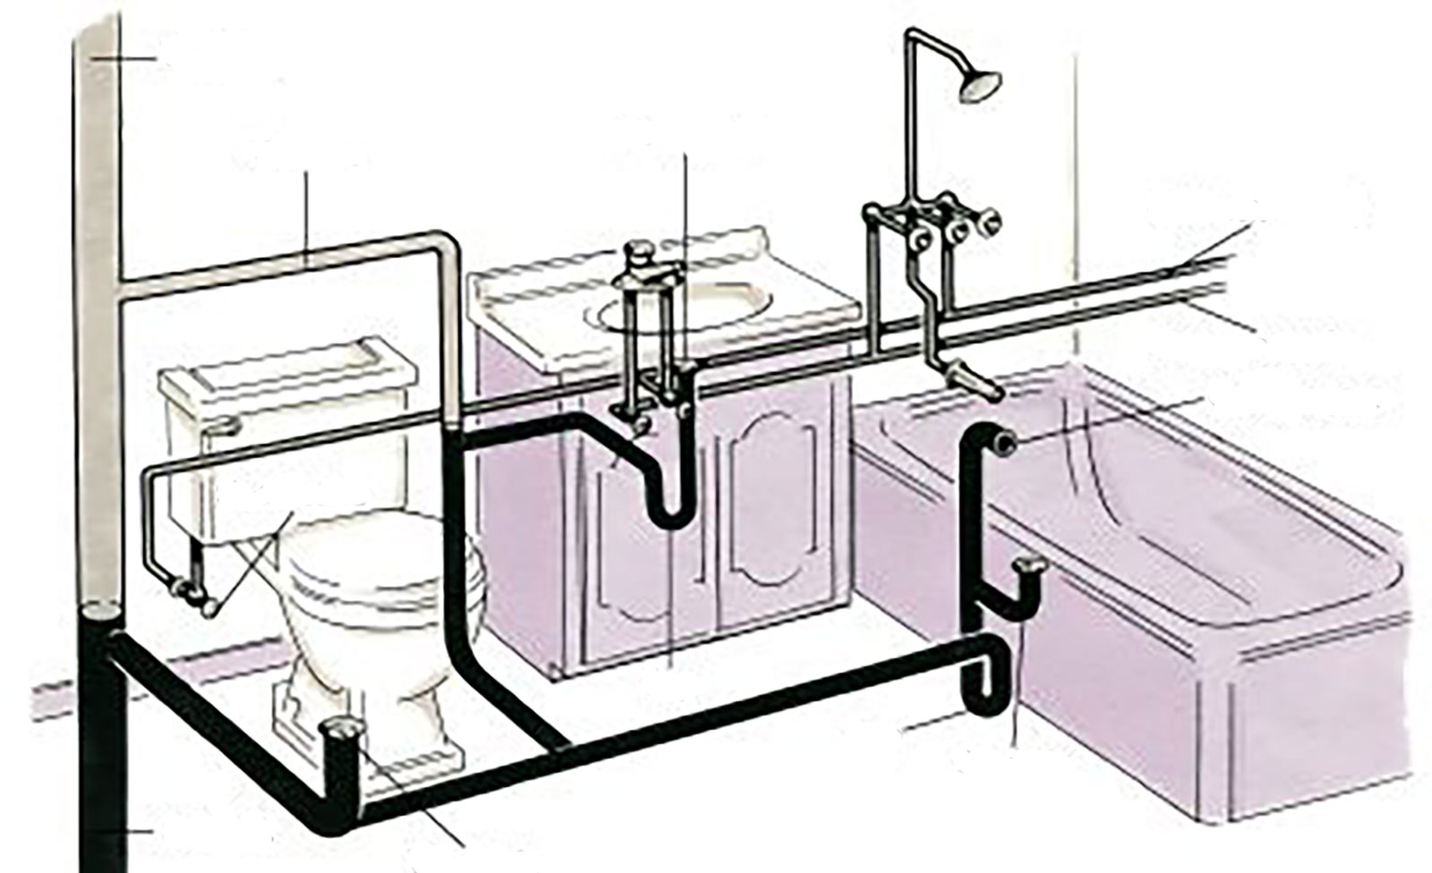

**Vent pipe**

**Vent stack**

**Lavatory drain**

**Cold water supply**

**Hot water supply**

**Overflow pipe**

**Tub drain**

**Trap**

**Trap**

**Toilet drain**

**Soil stack**

**Shutoff valve**

**Your home's supply and drainage system must always be two distinct subsystems, with no overlapping. At the fixtures (bridges between the two systems), the air admitted by the vent stack and vent pipes keeps the traps sealed and prevents sewer gases from backing up through the drains.**

1. **Stormwater Drainage System**

The stormwater drainage system conveys rainwater and other precipatation to the storm sewer or other places of retention.

Rainwater is relatively clean and can be discharged into a natural drainage terminal, such as a drainage basin, without negatively affecting the ecology.

In most municipalities private buildings are required to have drainage systems that connect to the municipality storm sewer.

**Water Supply and Distribution**

**Types of Water**

**Potable** **water** is water which is fit for consumption by humans and other animals. Drinking water.

**Gray water** is untreated household wastewater that has not come into contact with toilet waste. Gray water includes used water from bathtubs, showers, and bathroom wash basins, and water from clothes- washers and laundry tubs. It shall not include wastewater from kitchen sinks or dishwashers.

**Blackwater** is not fit for human consumption. Water that comes into contact with human waste and food is blackwater.

Water is often a scarce resource; nevertheless, almost 3/4 of potable water in the United States is used for irrigation and flushing toilets—where potable water is not generally required.

**Water Supply and Distribution System in Commercial and Residential Applications is Comprised of:**

**Cold Water System**

Supplies water at the standard water inlet temperature. Water supply lines are typically run underground outside a building, and the water in these lines will be at or near the underground temperature (approximately 55⁰F in most locations).

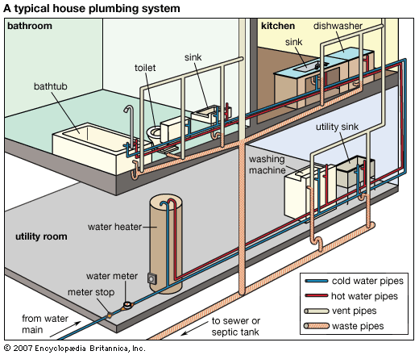

**Hot Water System**

Supplies fixtures (lavatory faucets, kitchen faucets, showerheads) and appliances (dishwasher, washing machine) with hot water.

A hot water heater, supplied with water from the cold water system, is used to heat the water to the desired temperature.

Standard outlet temperature of a hot water heater is 110⁰F to 120⁰F. Hospital, scouring, and other applications may require hotter water (140⁰F - 160⁰F).

**Hot Water Recirculation**

Hot water delivered over a great distance (100 feet or more), may require a recirculation system.

The hot water may either periodically or constantly circulate through the hot water supply system, keeping the water temperature at the desired level throughout the system.

**Building Water Service Line**

* District Water System (utility main) - provided by the local water utility company

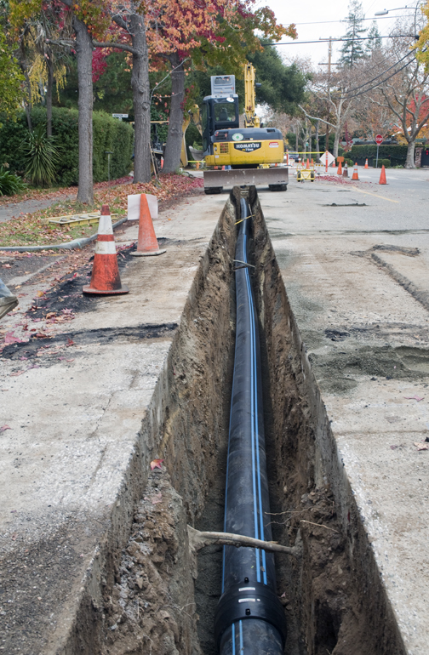

Plumbing Fixtures must be supplied with water at the flow rate and pressure required for proper operation.

* Private Well

Shallow Well – less than 25 feet

Deep Well – best source, little or no treatment

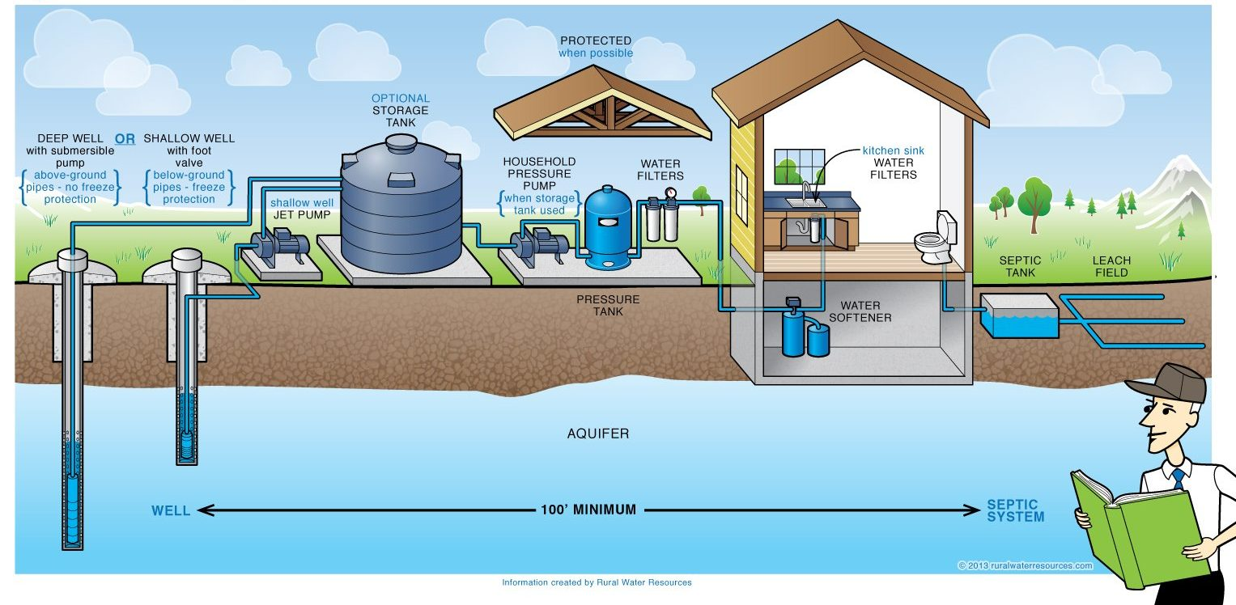

**Processes building water supply may have to include before it is delivered to various building locations:**

Pressure Regulation – reducing, increasing, balancing

Pressurization – booster pump and pressure tank

Filtration - strainers

Purification and Treatment – softening, reverse osmosis

Heating – boiler, domestic hot water

Cooling – chilling, chiller

**Hydraulics**

Hydraulics is the study of the physical principles that govern the behavior of liquids at rest and in motion.

**Pressure**

Static pressure, is measured when no water is flowing.

Dynamic pressure, is measured when water is flowing.

**Static Pressure**

Static pressure is caused by the weight of water above any point in the system.

Weight = Volume x Density Density of Water (ρ) = 62.4 lb/ft3

|  |  |  |
| --- | --- | --- |
| Pressure | = | Weight |
| Area |

**Determine the static pressure of each of the columns of water below. Forget the duck.**

***1 ft***

|  |  |
| --- | --- |
| ***1 ft***  ***1 ft*** | ***1 ft*** |

Static pressure is independent of the surface area or total volume of liquid and depends only on the depth, the height of liquid (water) “column” above the point in question.

Static pressure can be expressed in feet of water using the conversion of 1 ft of water equals 0.433 psi. Conversely, 1 psi = 1/0.433 = 2.31 ft of water

To convert psi to feet of water, multiply by 2.31 or divide by 0.433

To convert feet of water to psi, multiply by 0.433 or divide by 2.31

Since static pressure in a water system is caused by the weight of water, it is also referred to as hydrostatic pressure.

Municipal mains normally have a pressure between 40-80 psi.

Line pressure above 80 psi cannot be used directly, it requires installation of a pressure reducing valve (PRV) as a code requirement, see 608.0 below.

Under no-flow conditions, the street mains pressure is reduced throughout the system vertically, by height.

**Example 1.**

1. What is the total hydrostatic pressure under no-flow conditions at the bottom of a water riser in a five-story building with 10 ft between floors and the highest fixture is 3 ft above the fifth floor?

Solution.

[4(10 ft) + 3 ft] x 0.433 psi/ft of water = 43 ft x 0.433 = 18.6 psi

If the mains pressure were at 40 psi, then under no-flow conditions the static pressure at the top fixture would be:

40 psi – 18.6 psi = 21.4 psi

Which is well below the permissible maximum fixture pressure of 80 psi.

1. Determine the pressure at a similar fixture 2 ft above the first floor, under no-flow conditions.

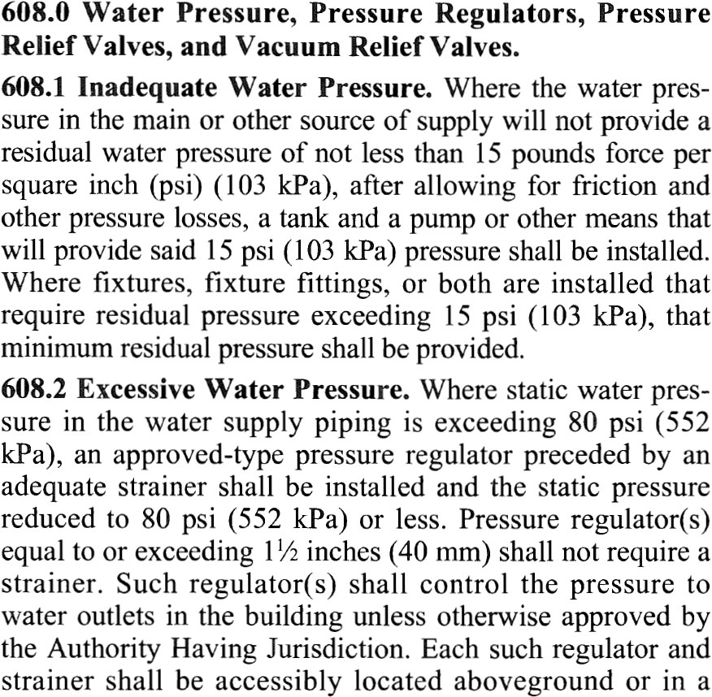

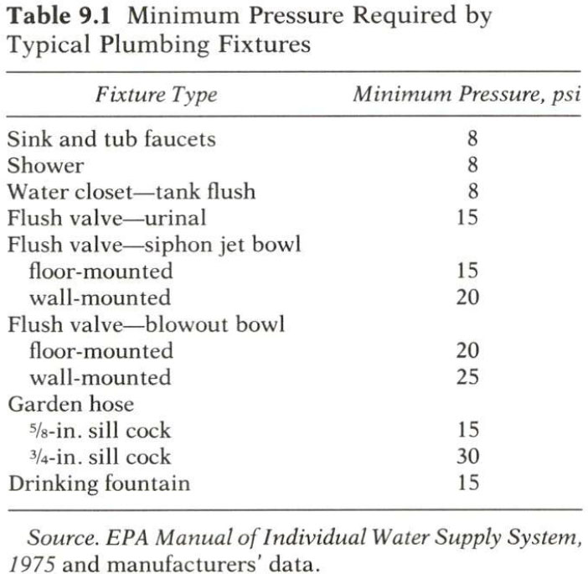

**When a fixture operates and water flows, the pressure equation changes completely.**

**Under flow conditions:**

Total (mains) pressure = Static head + Friction head (loss) + Flow pressure

Static head – used to overcome height

Friction head – used to overcome the friction between the moving water and the piping

Flow pressure – used to impart kinetic energy (motion) to the water

Flow pressure – pressure available at the fixture when the outlet is wide open

It must equal or exceed the minimum pressure required for proper operation (Table 9.1) in order for the fixture flow to be adequate.

**Example 2.**

For the same five-story building in Example 1, assume the highest fixture is a sink faucet and that the total friction head loss from the mains to the fixture, including the water meter, piping and all fittings, is 10 psi. Would the fixture flow pressure be sufficient?

Solution.

Mains pressure 40 psi

Static head to top fixture 18.6 psi (43 ft high)

Friction head 10 psi

Flow pressure ?

Total (mains) pressure = Static head + Friction head (loss) + Flow pressure

Flow pressure = 40 psi – 18.6 psi – 10 psi = 11.4 psi

From Table 9.1 we see that this is sufficient for a faucet or a water closet tank but insufficient for a flush valve, which requires a minimum pressure of 15 psi.

**The Design procedure reverses the order of the calculation.**

Step 1. Determine the minimum flow pressure needed, from Table 9.1

Step 2. Calculate the maximum permissible system friction, and with that number size the piping

**Example 3**

Using the same building, assume a flush valve as the higher fixture:

Mains pressure 40 psi

Static head to top fixture 18.6 psi

Minimum flow pressure 15 psi

Maximum Friction head ?

Total (mains) pressure = Static head + Friction head (loss) + Flow pressure

40 psi = 18.6 psi + 15 psi + Maximum friction head

Maximum friction head = 40 psi – 18.6 psi – 15 psi = 6.4 psi

The piping would then need to be designed to give a maximum overall friction loss of 6.4 psi,

The piping design would provide this fixture, and all other, with sufficient pressure to deliver the minimum flow as listed in by code.

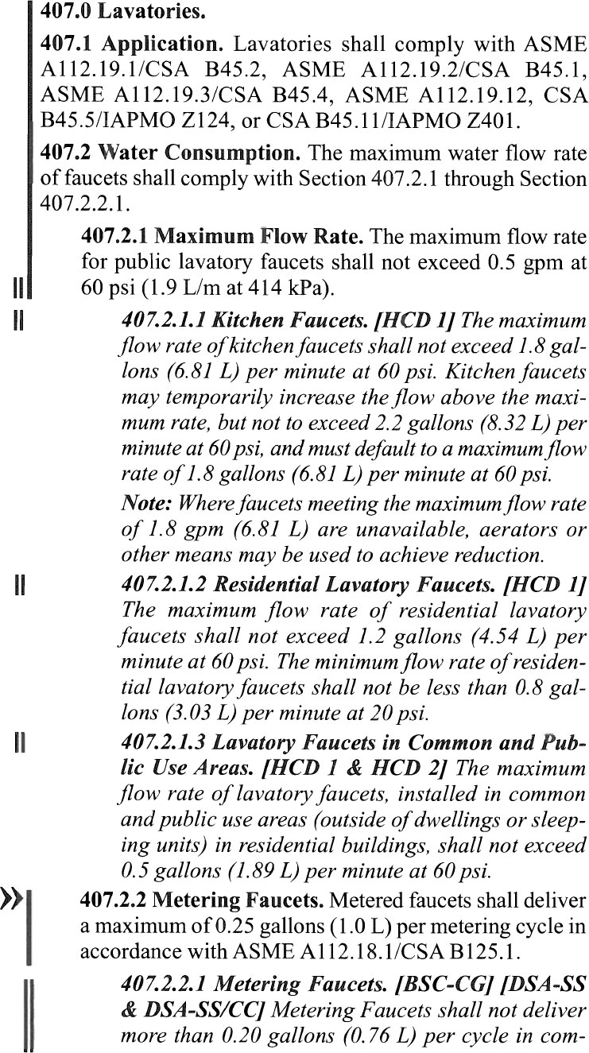 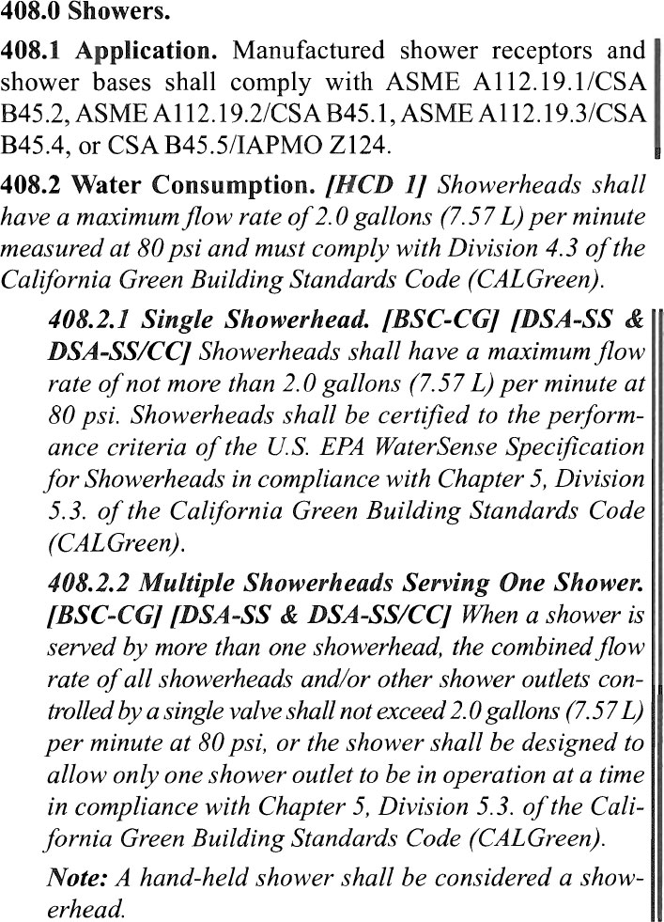

**Water Supply System**

**Upfeed system**

When the pressure from the city mains is sufficient to overcome all friction in the system with the calculated flow and still maintain the minimum pressure needed at the highest outlet, the system used is called an upfeed system.

***Will 40 psi minimum maintained city mains pressure be sufficient for the structure shown?***

|  |  |
| --- | --- |
| **Assumptions**  5 psi friction loss on the water meter  9 psi / 100 ft pressure loss in piping  Fittings add 50% to effective pipe length  Distance from water main to the farthest fixtures:  Second-floor shower head = 90 ft  Garden hose bibb = 60 ft  9 ft floor height  5 ft from mains to first-floor | From Table 9.1:  Required minimum flow pressures are:  8 psi – showerhead  15 psi – 5/8-in sillcock  Highest fixture is the shower head:  Shower head – 7 ft above the second floor  Total height = 5 ft + 9 ft + 7 ft = 21 ft  Garden hose bibb is 8 ft above the water main |

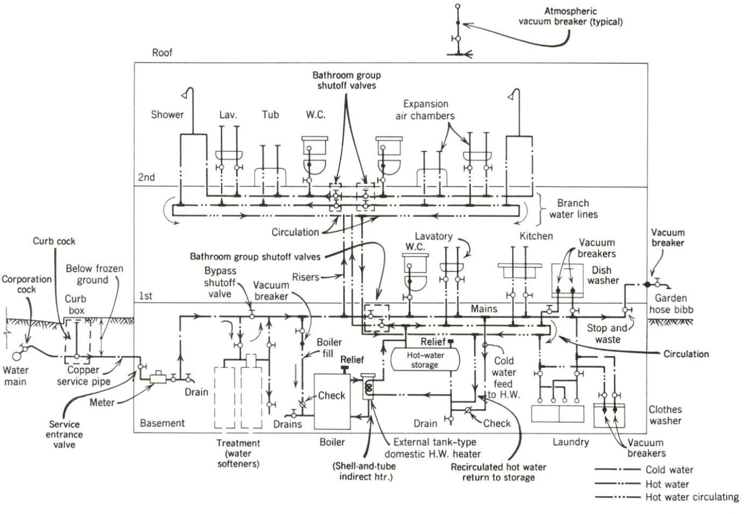

Schematic plumbing section of an upfeed water distribution system using city mains pressure. The building is a two-story residence.

**Shower**

Fixture pressure = Mains pressure – Static head – Total friction

**Hose bibb**

Fixture pressure = Mains pressure – Static head – Total friction

If the hose bibb was a ¾-in, requiring 30 psi, would the mains pressure be adequate?

**Downfeed System**

When the street main pressure is insufficient, the design can either use a *roof tank* and *downfeed system* or *booster pump upfeed system*.

