|  |  |  |
| --- | --- | --- |
| **CMGT 235 – Electrical and Mechanical Systems** | | |
| **Discussion No. 12** | **Unit 2 - Plumbing Systems** | **Fall 2022** |

**Water Supply Fixture Unit (WSFU) and Sizing Water Supply Piping**

**Water Consumption**

Estimates vary, but, on average, each person uses about 80-100 gallons of water per day, for indoor home uses.

2016 California Plumbing Code

|  |  |  |  |
| --- | --- | --- | --- |
| **Table 1.** Maximum Installed Flush or Flow Rates | | | |
| **Fixture or fitting** | **2016 CA Plumbing Code** | **EPAct 1992**  **Federal Standard** | **WaterSense**® |
| **Flush Fixtures** |  |  |  |
| Flushometer-Valve Toilet (Water Closet) | 1.28 gpf | 1.6 gpf | 1.28 gpf |
| Tank Toilet (Water Closet) | 1.28 gpf | 1.6 gpf | 1.28 gpf |
| Urinal (Wall Mounted) | 0.125 gpf | 1.0 gpf | 0.5 gpf |
| Urinal (Floor Mounted) | 0.5 gpf | 1.0 gpf | 0.5 gpf |
| **Flow Fixtures** |  |  |  |
| Residential Lavatory Faucet | 1.2 gpm @ 60 psi | 2.2 gpm @ 60 psi | 1.5 gpm @ 60 psi |
| Public lavatory (restroom) faucet | 0.5 gpm @ 60 psi | 0.5 gpm @ 60 psi |  |
| Kitchen Faucet | 1.8 gpm @ 60 psi | 2.2 gpm @ 60 psi |  |
| Showerhead | 2.0 gpm @ 80 psi | 2.5 gpm @ 80 psi | 2.0 gpm @ 60 psi |
| Pre-Rinse Spray Valve | 1.6 gpm @ 60 psi | 1.6 gpm @ 60 psi | 1.28 gpm @ 60 psi |

**LEED Baseline Daily Water Consumption (Residential)**

|  |  |  |  |  |
| --- | --- | --- | --- | --- |
| **Activity** | **Fixture Flush/Flow Rate** | **Duration** | **Uses per Day** | **Water Consumed (gal)** |
| Water Closet | 1.6 GPF | 1 | 5 | 8 |
| Lavatory, Private | 2.2 GPM | 60 sec | 5 | 11 |
| Shower | 2.5 GPM | 480 sec | 1 | 20 |
| Kitchen Sink | 2.2 GPM | 60 sec | 4 | 8.8 |
| Total |  |  |  | 47.8 gal |
|  |  |  |  |  |
|  |  |  |  |  |
|  |  |  |  |  |
|  |  |  |  |  |
|  |  |  |  |  |
|  |  |  |  |  |
|  |  |  |  |  |

WC = 1.6 GPF x 1 F x 5 uses = 8 gal

LAV = 2.2 gpm x 60 sec x 1 min / 60 sec x 5 uses = 11 gal

SHW = 2.5 gpm x 480 sec x 1 min / 60 sec x 1 use = 20 gal

KS = 2.2 gpm x 60 sec x 1 min / 60 sec x 4 uses = 8.8

**Water Demand**

The instantaneous peak demand for water in a pipe serving a number of plumbing fixtures or serving an entire building is referred to as the demand load.

**Demand Load**

* Maximum probable or peak instantaneous demand for domestic water by a group of fixtures. The demand load is typically expressed in gpm (or L/min or L/sec).
* Depends on the number and type of fixtures installed and the operation of the fixtures.

Continuous flow: faucets, hose bibb, and shower

Intermittent flow: water closets and urinals

It is highly unlikely that every sink, dishwasher, water closet, bathtub, shower, clothes washer, and garden hose in a building be operated at one time. Totaling fixture flow rates for all fixtures in an entire building distribution system would give the total demand for water usage only if all fixtures were used at one time. In most instances, totaling fixture requirements provides a very high estimate that results in overdesign of the piping.

|  |  |  |  |
| --- | --- | --- | --- |
|  | **Fixture**  1 – SHW  3 – LAV  1 – TUB  1 – WC  1 – BS  1 – CW  1 – LS | **Flow Rate (GPM)**  2.5  2.2  5.0  3.0 (refill tank)  2.2  4.0  2.2  **Demand Load = 25.5 gpm** | **Total (GPM)**  2.5  6.6  5.0  3.0  2.2  4.0  2.2  25.5 gpm |

**Simple Empirical Design Method**

Piping is sized with rules of thumb based upon observation and experience.

Branch pipes can be sized from minimum branch requirements cited in the building code.

* Up to three ½ in branches can be served by a ¾ in main.
* Up to three ½ in branches or up to six ¼ in branches can be served by a 1 in main.
* Up to five ¾ in branches or up to ten ½ in branches can be served by a 1 ¼ in main.

The empirical approach is used in design of plumbing systems for residences and similar buildings with simple plumbing systems. Typically, a qualified plumber does design during rough in of the piping. This approach can lead to system problems in complex piping arrangements.

**Water Supply Fixture Unit (WSFU)**

* Arbitrarily chosen measure that allows all types of plumbing fixtures to be expressed in common terms.
* Purpose is to make it possible to calculate the design load on a system composed of different types of fixtures, each having different flow rates.
* Fixture unit values are assigned to the different types of fixtures.
* The total number of fixture units is used to establish the maximum probable water supply load.

The *Water Supply Fixture Unit (WSFU)* is an arbitrarily chosen measure that represents each fixture connected to the water supply system.

**2016 California Plumbing Code**

**Table 610.3** Water Supply Fixture Units (WSFU) and Minimum Fixture Branch Pipe Sizes

**Chart A 103.1(2**) Enlarged Scale Demand Load

|  |  |  |  |
| --- | --- | --- | --- |
|  | **Fixture**  1 – SHW  3 – LAV  1 – TUB  1 – WC  1 – BS  1 – CW  1 – LS | **WSFU**  2.0  1.0  4.0  2.5  1.0  4.0  1.5  **Demand Load = 15 gpm** | **Total WSFU**  2.0  3.0  4.0  2.5  1.0  4.0  1.5  22 WSFU |

**15.0 gpm**

**22 WSFU**

**2016 CPC Chart A 105.1 (3) – Friction Loss in Fairly Rough Pipe**

Assume a maximum velocity of 8 feet/sec (fps)

Plot on the graph where our demand (25.5 gpm and 17 gpm) meets this velocity.

From that point, you select the nearest pipe size to the left of the 8-fps velocity curve.

**15.0 gpm**

**1-1/2"**

**1"**

**25.5 gpm**

**Velocity Design Method**

* The *velocity design method* entails selecting the smallest pipe diameter without exceeding a pre-established maximum velocity for the demand load in the pipe.
* It works well in preliminary design of a plumbing system provided system layout is reasonably symmetrical.
* This method does require an investigation of pressure loss to ensure that the residual pressure at the most remote fixture is adequate.

**Procedure**

1. Sum the total number of Water Supply Fixture Units (WSFU) for hot water and cold water combined.
2. Determine the maximum probable demand in gpm.
3. Based upon the maximum desired velocity (8 ft/sec) and demand load (Q), solve for the  
   minimum diameter (Di-min):

In U.S. customary units

Di-min = √0.409 Q / v inch

1. Select a pipe size (from design tables) with an inside diameter equal to or greater than the minimum required diameter, Di-min.

|  |  |  |  |  |
| --- | --- | --- | --- | --- |
| Q (gpm) | v (fps) | Di-min | Copper Tube: Type M | Copper Tube: Type L |
| 25.5 | 8 | 1.142 | 1-1/4" | 1-1/4" |
| 15.0 | 8 | 0.876 | 1" | 1" |

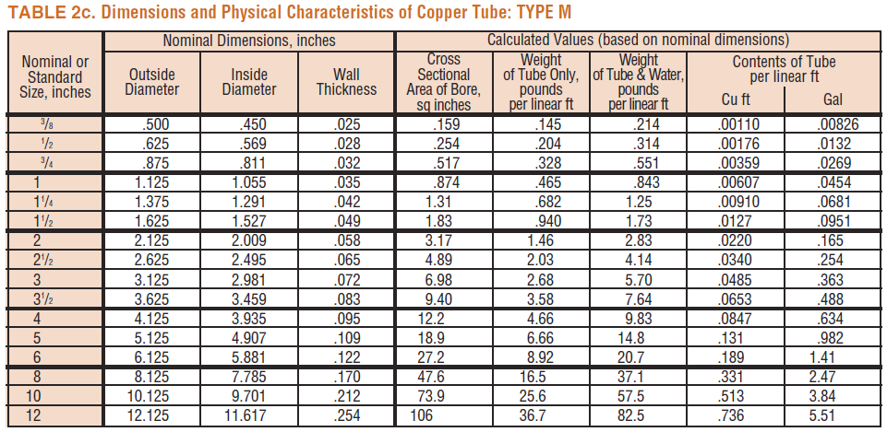

<https://www.plumbersstock.com/plumbing/pipe/copper.html>

1" Type M – 5′ $27.40/ea

1-1/4" Type M – 5′ $25.65/ea

1" Type L – 5′ $23.65/ea

1-1/4" Type L – 5′ $78.65/ea

**Example 1.**

1. Using the 2016 CPC Table 610.3 and Chart A 103.1(2) Enlarged Scale Demand Load, determine the total WSFUs and total demand load for the one-bedroom home shown. Each side of the house has a hose bibb.

**17.0 gpm**

|  |  |  |  |  |  |  |  |  |  |  |  |  |  |  |  |  |  |  |  |  |  |  |  |  |  |
| --- | --- | --- | --- | --- | --- | --- | --- | --- | --- | --- | --- | --- | --- | --- | --- | --- | --- | --- | --- | --- | --- | --- | --- | --- | --- |
|   **LT** | |  |  | | --- | --- | | **Fixture Type** | **WSFU** | | 2-LAV | 2.0 | | 1-SHW | 2.0 | | 1-WC FT | 2.5 | | 1-BT | 4.0 | | 1-CW | 4.0 | | 1-LT | 1.5 | | 1-KS | 1.5 | | 1-DW | 1.5 | | 4-HB | 5.5 | |  |  | | TOTAL | 24.5 |   **Demand Load = ___________________** |

1. Using the velocity design method, determine the minimum required size for the main water supply pipe. Use a maximum velocity of 8 ft/sec. Assume a system with flush tanks and Type L copper tube.

Di-min = √0.409 Q / v inch

Di-min = √0.409 X 17 GPM / 8 FPS inch

Di-min = 0.932

A 1 inch Type L Copper Tube with an inside diameter of 1.025 is adequate for the main water supply pipe.

**Sizing Water Supply Pipes**

**2016 CPC Chapter 6 Water Supply and Distribution**

**610.0 Procedure**

**Determining the required meter and pipe work sizes is a four-step process:**

Step 1. Calculate the Available Water Pressure

Step 2. Find the Effective Maximum Developed Length (DL) of pipe

Step 3. Calculate the Total WSFU

Step 4. Use Table 610.4 Fixture Unit Table for Determining Water Pipe and Meter Sizes

**Example (JLC Article)**

**2016 CPC Table 610.4**

**1.5**

**0.433**

**Example 2**. Determine the meter and pipe work sizes for the standard 1-story, two-bath home shown below. The home has a main meter, backflow preventer, water heater, water softener, and dishwasher. Assume a minimum daily static service pressure available (MDSSPA) of 80 psi. A hose bibb is installed on each outside wall. Assume an 8 psi loss through the meter, 5 psi loss through the backflow preventer, and a 15 psi loss through the water softener. The highest water outlet in the building is 10 feet above the source of supply. The length of the piping between the source of supply and the fixture in the building that’s the farthest away is 130 feet. Use the 2016 California Plumbing Code, Chapter 6 – 610.0

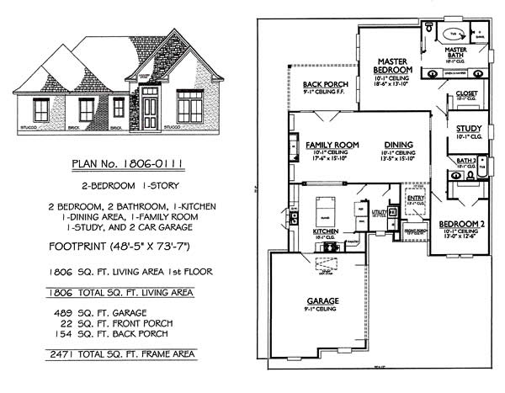

**Solution.**

**Step 1.** Calculate the Available Water Pressure

Municipal Water Service Pressure = 80 psi

Minus pressure loss from equipment

Main Meter - 8 psi

Backflow Preventer - 5 psi

Water Softener - 15 psi

Minus pressure loss from elevation (10 ft x 0.433 psi/ft) - 4.33

**Adjusted Pressure** 47.67 psi

Note: Deduct any pressure drop of more than 8 psi for the installation of special plumbing fixtures. Some of these are temperature-controlled showers or flushometer tank toilets. In this example none installed.

**Step 2.** Find the Effective Maximum Developed Length (DL) of Pipe

Length of pipe to the farthest fixture x 1.5 (to allow for pressure loss through the fittings) = 130 x 1.5 = 195 feet

**Step 3.** Calculate the Total WSFU

|  |  |
| --- | --- |
| Fixture Type | WSFU |
| 1 – BT/SHW | 4.0 |
| 1 – BT | 4.0 |
| 1 – SHW | 2.0 |
| 3 – LAV | 3.0 |
| 2 – WC FT | 5.0 |
| 1 – KS | 1.5 |
| 1 – DW | 1.5 |
| 1 – CW | 4.0 |
| 4 – HB | 5.5 |
| Total WSFU | 30.5 |

**Step 4.** Look at Table 610.4. The tables give you a choice of three pressure ranges: 30 to 45 psi, 46 to 60 psi, or over 60 psi. Using the table Pressure Range – 46 to 60 psi:

1. Select the correct column for Maximum Developed Length (feet). There are 15 choices, 40 feet up to 1000 feet. Always use the column higher than the number calculated. In our example this number is 195 feet, so use the 200 feet column.
2. Find the number in the column that is the same as or the next higher number than the one we calculated for the WSFU value in our example. Our WSFU was 30.5. The next higher number in the 200 feet column is 32.
3. Now, look at the far left-hand column, Meter and Street Service (inches) and the Building Supply and Branches (inches) column directly to its right. Moving left from our number 32 in the example, these numbers are:

3/4 inch for the Meter and Street Service

1-1/4 inch for the Building Supply

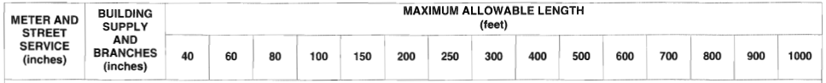

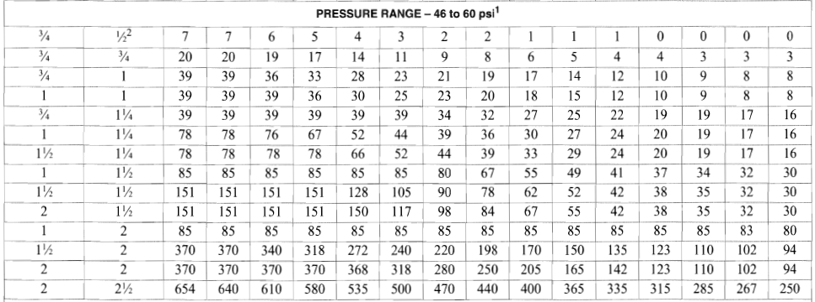

**Sizing Branch Piping**

How do you determine the size of pipe work you need for each branch?

**Procedure**

1. Calculate the WSFU value for all the fixtures you plan to install on each branch.

Note: Most plumbing fixtures are connected to both cold water and hot water branches. Water is typically drawn from both the cold water and hot water supply lines.

The fixture unit value for fixtures having both cold and hot water connections are taken as three-quarters (3/4) of the listed total value of the fixture. If both hot and cold branches supply a fixture (which, except for urinals, water closets, dishwashers and hose bibbs, is nearly always the case), then the WSFU for the fixture is reduced by a factor of 0.75.

From Table 610.3 (Private)

|  |  |  |  |
| --- | --- | --- | --- |
|  | Water Supply Fixture Unit Load (WSFU) | | |
| Fixture Type | Hot Water | Cold Water | Combined Total |
| Bathtub or combination Bath/Shower (fill) | 3.0 | 3.0 | 4.0 |
| Lavatory | 0.75 | 0.75 | 1.0 |
| Shower | 1.5 | 1.5 | 2.0 |
| Kitchen Sink | 1.125 | 1.125 | 1.5 |

If the water in a branch will be:

Only hot, use the Hot value (0.75 x Combined value)

Only cold, use the Cold value (0.75 x Combined value)

Both hot and cold, use the Combined column

1. Calculate the length of pipe you need and multiply by 1.5 to allow for pressure loss through the fittings.
2. Use Table 610.4 for the pressure range determined for the project and select the column that’s the same as or greater than the DL. Find the WSFU that is the same as or greater than the WSFU. Look to the left to the second column and locate the pipe size you need for that branch line.

Repeat these calculations for each branch line from the distribution pipe to each one of the water branches you plan to install in the residence.

**18**

**25.75**

**8.5**

**5.25**

**5.625**

**11.625**

**4.875**

**11.625**

**5.625**

**4.125**

**6.0**

**5.25**

**1.125**

**3.0**

**0.75**

**0.75**

**0.75**

**3.0**

**0.75**

**1.5**

**1.125**

**3.0**

**0.75**

**0.75**

**2.5**

**0.75**

**3.0**

**0.75**

**1.5**

**1.50**

**4.0**

**1.0**

**1.0**

**2.5**

**1.0**

**4.0**

**1.0**

**2.0**

|  |  |  |  |  |  |  |  |
| --- | --- | --- | --- | --- | --- | --- | --- |
| Water Supply Fixture Units | | | | | | | |
| Fixture | # of Fix. | HOT WSFU | | COLD WSFU | | TOTAL WSFU | |
| EACH | THIS JOB | EACH | THIS JOB | EACH | THIS JOB |
| SHW | 1 | 1.5 | 1.5 | 1.5 | 1.5 | 2.0 | 2.0 |
| LAV | 3 | 0.75 | 2.25 | 0.75 | 2.25 | 1.0 | 3.0 |
| BT | 1 | 3.0 | 3.0 | 3.0 | 3.0 | 4.0 | 4.0 |
| WC FT | 1 | ------ | ------ | 2.5 | 2.5 | 2.5 | 2.5 |
| BS | 1 | 0.75 | 0.75 | 0.75 | 0.75 | 1.0 | 1.0 |
| CW | 1 | 3.0 | 3.0 | 3.0 | 3.0 | 4.0 | 4.0 |
| KS | 1 | 1.125 | 1.125 | 1.125 | 1.125 | 1.5 | 1.5 |
|  |  |  |  |  |  |  |  |
|  |  |  |  |  |  |  |  |
|  |  |  |  |  |  |  |  |
| TOTALS |  |  | 11.625 |  | 14.125 |  | 18.0 |

**13 GPM**

TOTAL GPM _____________________

**Design Assumptions:**

Step 1: The design water supply pressure is between 40 and 49 psi.

Step 2: The developed length (DL) of the water pipe from the water meter to the furthest plumbing fixture is 84 feet.

