|  |  |  |
| --- | --- | --- |
| **CMGT 235 – Electrical and Mechanical Systems** | | |
| **Discussion No. 13** | **Unit 2 - Plumbing Systems** | **Fall 2022** |

**Sanitary Drainage and Venting**

**Sanitary Drainage Pipes**

|  |  |
| --- | --- |
| **Soil Pipe (Soil Stack)**  A soil pipe is designed to carry soiled water from the toilet, urinal or bidet to the sewer. | **Waste Pipe (Waste Stack)**  A waste pipe carries water from your sinks, shower, washing machine or bath. |

**DWV Terminology**

The **Drain, Waste, and Venting (DWV) System** provides for the collection of sanitary soil (solid particles) and waste (fluids) within a building, and the discharge of those products outside the building to a municipal sewer system or to a septic system.

**2016 California Plumbing Code**

**Chapter 7 Sanitary Drainage**

**Drainage Fixture Unit (DFU)**

Measure of the probable discharge of wastewater and waterborne waste into the drainage system.

1 drainage fixture unit (DFU) = 7 ½ gallons per min (gpm)

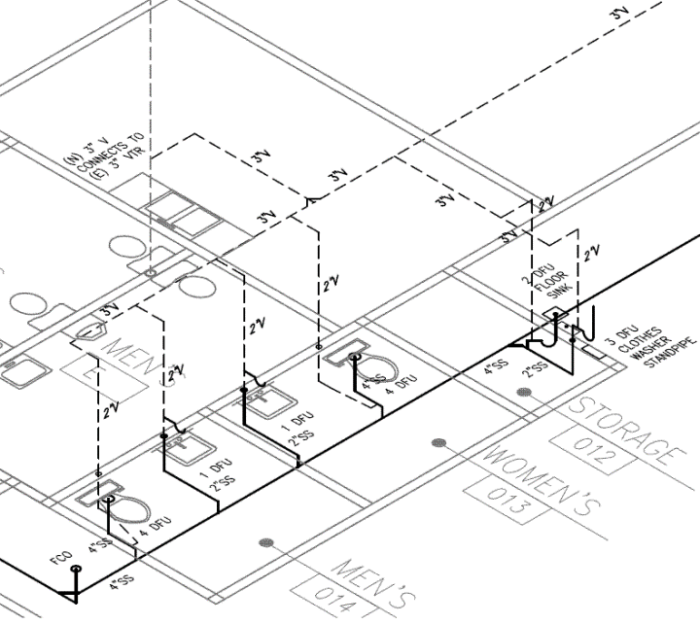

|  |  |  |  |  |
| --- | --- | --- | --- | --- |
| Fixture | # of Fix. | Minimum Trap Size and Trap Arm (inches) | DFU | |
| EACH | THIS JOB |
|  |  |  |  |  |
|  |  |  |  |  |
|  |  |  |  |  |
|  |  |  |  |  |
|  |  |  |  |  |
|  |  |  |  |  |
|  |  |  |  |  |
|  |  |  |  |  |
|  |  |  |  |  |
|  |  |  |  |  |
| TOTALS |  |  |  |  |

**2016 California Plumbing Code**

**Chapter 9 Vents**

