|  |  |  |
| --- | --- | --- |
| **CMGT 235 – Electrical and Mechanical Systems** | | |
| **Discussion No. 13** | **Unit 2 - Plumbing Systems** | **Fall 2022** |

**Isometric Drawings and Plumbing Plans**

**Isometric Drawings**

Plumbing plans for the DWV piping system are typically drawn by the plumber or mechanical engineer as “isometric drawings”.

Terminology

**Fitting**: an object used to connect one or more pieces of piping material to another.

**Isometric**: a method of representing three-dimensional objects on a flat surface by means of a drawing that shows three planes of the object.

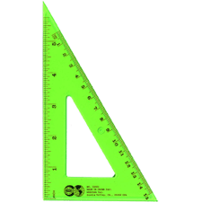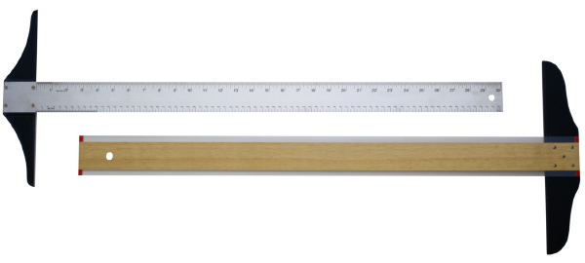**Orthographic**: a method for representing a three-dimensional object by means of several views from various planes.

Tools Used

Pencil, ruler, eraser

Tee square

30/60/90 triangle

Materials

Unlined paper

Isometric paper

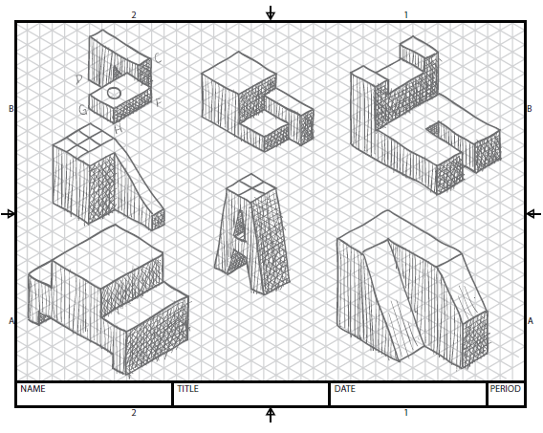

**Orthographic drawings**

Orthographic drawings are projections from a single angle. Most objects can be fully represented showing a front view, side view, and top (or plan) view.

The biggest limitation of orthographic drawings is they represent a single perspective that may not show details hidden from view. For this reason, several views may have to be shown to indicate all details. Most commonly, front views and top views are shown.

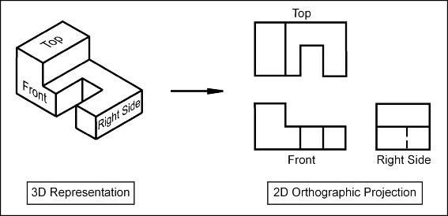

**Example 1.**

Sketch the 2D Orthographic Projection of the isometric view shown

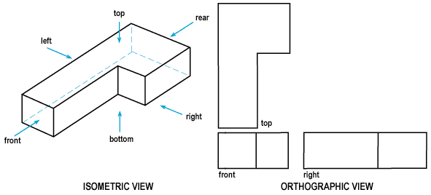

Pipe Orthographics

Piping systems are regularly represented by orthographic projections. Blueprints of a large project are typically top (or plan) views.

The challenge of creating piping orthographics is that symbols must be used to represent 90° elbows or tees pointing toward or away from the viewer. The figure below identifies the possible orthographic projection views that could be used to represent an elbow fitting.

|  |  |
| --- | --- |
|  |  |
| Elbow fitting with possible orthographic projection views labelled | Orthographic projections for the elbow fitting |

|  |  |
| --- | --- |
|  |  |
| Tee fitting with possible orthographic projection views labelled | Orthographic projections for the tee fitting |

Notes

* A fitting shown pointing “outward” from the page is shown with a dot. This represents the inside of the fitting.
* A fitting shown pointing “inward” into the page is indicated with a solid line halfway through the fitting. This represents the back of a fitting.
* As the sample plumbing orthographic illustrates, the biggest drawback of orthographic projections is that fittings are often hidden from view. In other words, the fittings closest to the viewer are clearly indicated, but the details of piping “in behind” are not shown.
* The hashmarks indicate the connection to another pipe or fitting.

**Example 2.**

Sketch the orthographic front view, plan view, and right view for the tube structure.

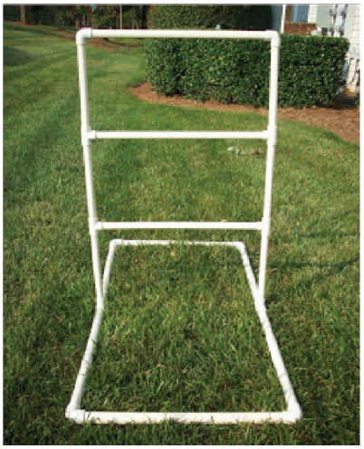

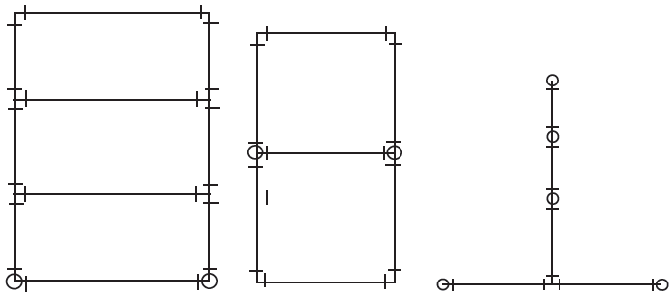

Front view Plan view Right view

**Isometric Drawings and Plumbing Plans**

Isometric drawings are most commonly used by tradespeople to communicate a large amount of information in a single drawing. Because isometric drawings show three sides of an object, they make it easy to visualize how a finished project may look or to better understand how the pieces will fit together. As demonstrated in the development of orthographic drawings, much more detail can be conveyed in a single isometric drawing than in a series of three orthographic drawings.

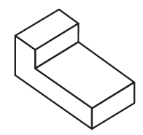

Isometrics show a three-dimensional object from three perspectives in a single drawing.

An isometric drawing can be identified by several factors:

* Vertical planes or edges are still drawn vertically.
* Left and right planes are drawn at an angle of 30° above horizontal.
* No horizontal lines are found on isometrics.

The strength of using isometrics in the plumbing trade is that all fittings can be shown on a single drawing, whereas an orthographic may have fittings hidden from view. This can create confusion and uncertainty in the mind of the tradesperson. It is common practice for a tradesperson to examine blueprint drawings (orthographic plan views) and create isometric sketches to clarify areas of uncertainty. This can be used to discuss issues with inspectors, supervisors, architects, or homeowners. The ability to visualize and plan a project before actually using materials is a valuable skill.

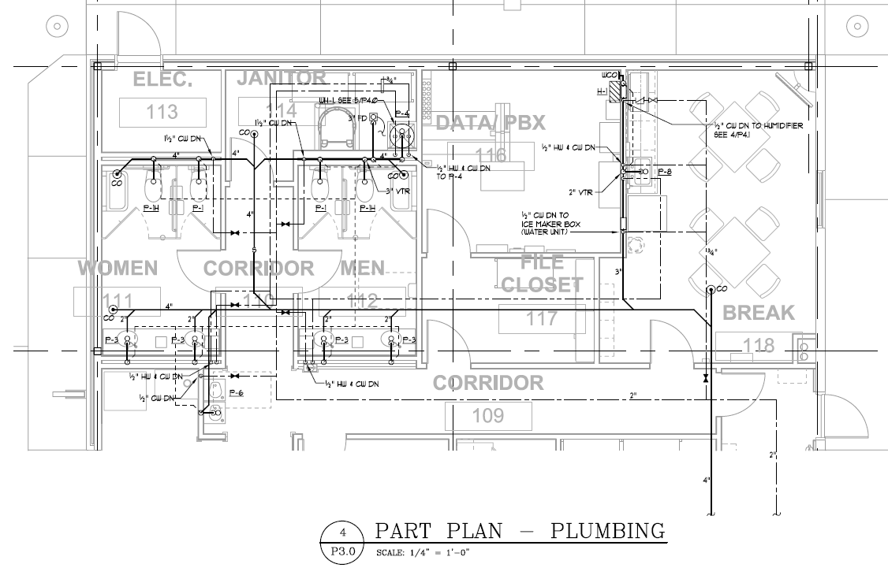

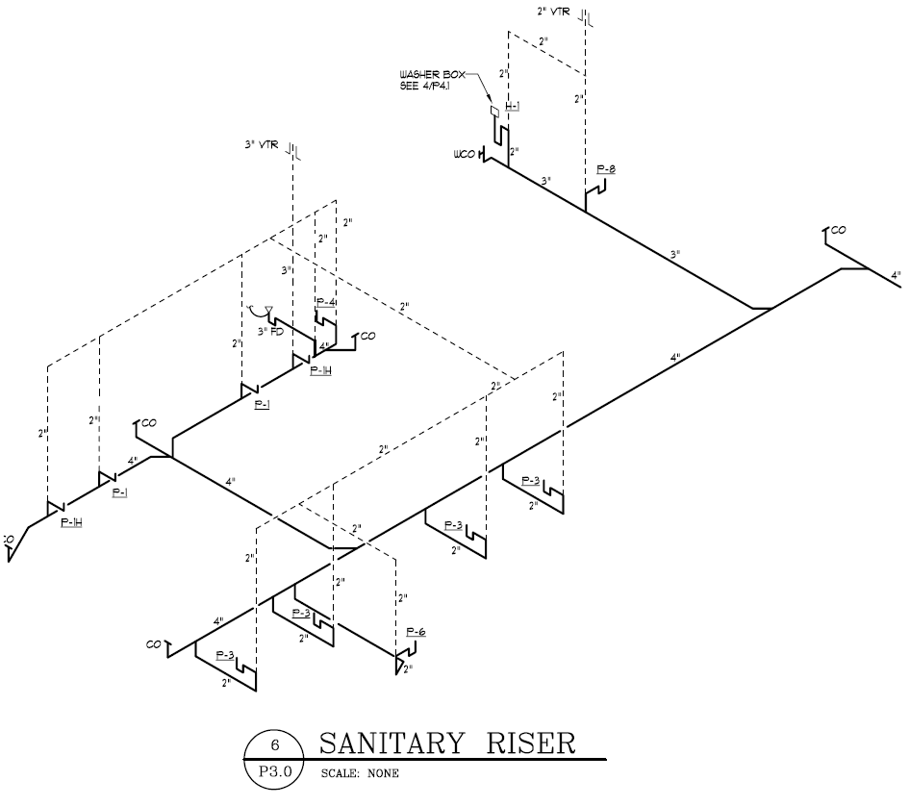

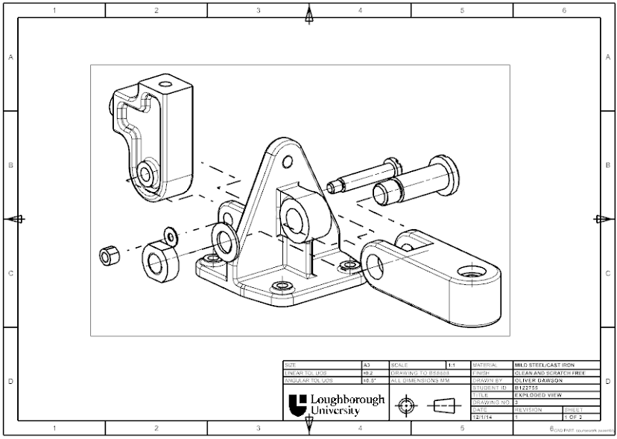

Isometric Exploded Assembly – Often used to convey how parts are to be connected

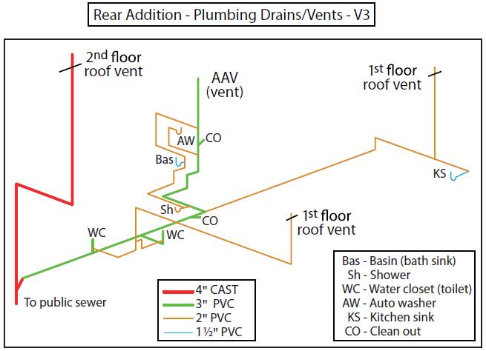

Isometric drawings allow a tradesperson to accurately determine how systems will be integrated and what supplies will be necessary for construction.

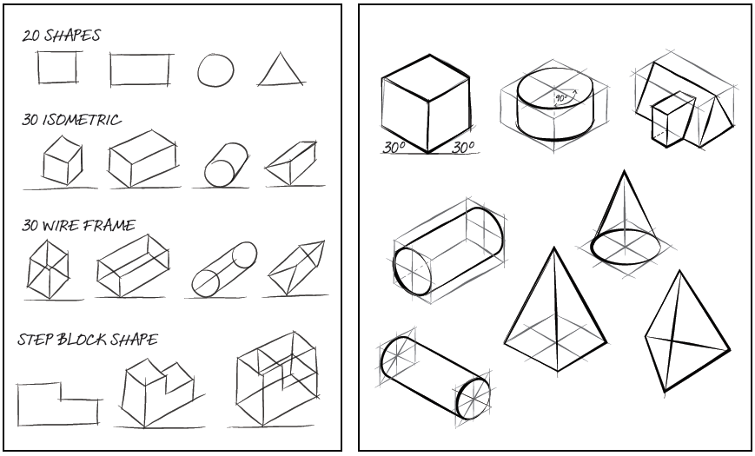

|  |  |
| --- | --- |
| Basic shapes and simple ideas can be shown more realistically through the development of isometric sketches. | More complex shapes can be created by creating wire frames or boxes to which detail is added. |

**Example 3**

Sketch the isometric drawing for the shape shown



**Example 4**

ABS piping installation

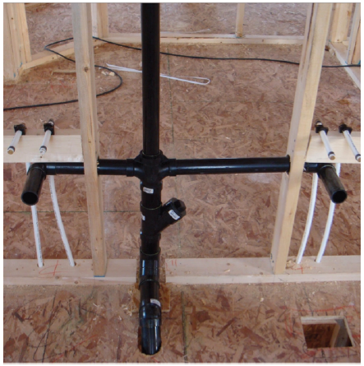



Isometric drawing of ABS piping installation

**Example 5**

Drainage and water lines

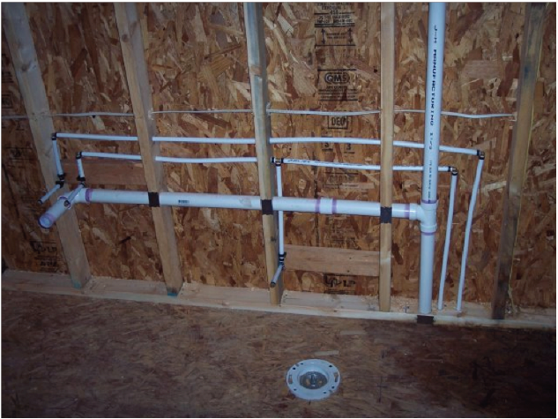



**Example 6**

Lamp constructed from piping and bottles

