CMGT 235 – Electrical and Mechanical Systems
In Class Activity #3 – WSFU and Sizing Supply Pipes
Points: 50 [4 points each properly formatted answer]
Due: At the End of Class Today

WRITE NEATLY
Check One: Worked as a: GROUP INDIVIDUAL
Name | Solution
Name
Name

Complete the following steps to determine the Meter and Street Service, the Building Supply, and the hot and cold supply pipe sizes for the Dwelling shown. Use 2016 California Plumbing Code.

Specifications: The minimum daily static service pressure available (MDSSPA) is 70 psi. The pressure loss in the meter is 5 psi and 15 psi in the water softener. The highest water outlet from the source of supply is 22 ft. The length of piping from the source of supply to the fixture in the building that is furthest away is 122 ft. Each side of the house has two ½" hose bibbs (total of 8). Half the hose bibbs are supplied by one segment of water distribution pipe and the other half by another segment. The dishwasher has only a hot water supply pipe.
Step 1. Calculate the Available Water Pressure

- Determine the pressure loss due to static head.

= 0.433 psi/ft x 22 ft = 9.526 psi

- Determine the Total Available Water Pressure Under no Flow conditions.

= 70 psi – 5 psi – 15 psi – 9.526 psi = 40.474 psi

- Determine the pressure loss due Type M copper tube (9 psi/100 ft).

= 122 ft x 1.5 x 9 psi/ft = 16.47 psi

- Determine the Available Pressure (@furthest Fixture).

= 40.474 psi – 16.47 psi = 24 psi

- Is Type M copper tube ok? Why?

Yes. 24 psi is sufficient for the plumbing fixtures given
Step 2. Determine the Effective Maximum Developed Length (DL) of Pipe

DL = 122 ft x 1.5 = 183 ft

Step 3. Use a yellow highlighter and COLOR and COUNT all plumbing fixtures shown on the main and first floor house plans provided. Complete the Water Supply Fixture Units Table shown below.
Water Supply Fixture Units
Fixture | # of Fix. | HOT WSFU |  | COLD WSFU |  | TOTAL WSFU
 |  | EACH | THIS JOB | EACH | THIS JOB | EACH | THIS JOB
WC FT | 8 | --- | --- | 2.5 | 20.0 | 2.5 | 20.0
BIDET | 1 | 0.75 | 0.75 | 0.75 | 0.75 | 1.0 | 1.0
LAV | 8 | 0.75 | 6.0 | 0.75 | 6.0 | 1.0 | 8.0
BT/SHW | 2 | 3.0 | 6.0 | 3.0 | 6.0 | 4.0 | 8.0
SHW | 3 | 1.5 | 4.5 | 1.5 | 4.5 | 2.0 | 6.0
BT | 2 | 3.0 | 6.0 | 3.0 | 6.0 | 4.0 | 8.0
KS | 1 | 1.125 | 1.125 | 1.125 | 1.125 | 1.5 | 1.5
DW | 1 | 1.5 | 1.5 | --- | --- | 1.5 | 1.5
LS | 1 | 1.125 | 1.125 | 1.125 | 1.125 | 1.5 | 1.5
BS | 6 | 0.75 | 4.5 | 0.75 | 4.5 | 1.0 | 6.0
Hose Bibb | 8 | --- | --- | 2.5 | 20.0 | 5.5x2 | 11.0
TOTALS |  |  | 31.5 |  | 70.0 |  | 72.5

Using the GPM Table (Table 6-8 Conversion of Fixture Units to Equivalent gpm) and the interpolation method shown on the course Web site to determine the Demand Load (GPM).
If the Total Demand = 72.5 WSFU What is the demand in GPM?
From Table 6-8 - Use Flush Tank Column
g₁ = 70 WSFU d₁ = 35 gpm
g₂ = 80 WSFU d₂ = 38 gpm
g = 72.5 WSFU (given value)

d = d1 + (g – g1 / g2 – g1) x (d2 – d1)
d = 35 gpm + (72.5 – 70 / 80 – 70) x (38-35) = 35.75 gpm

Step 4. Determine the Meter and Street Service, the Building Supply pipe size, and the hot and cold water supply pipe sizes using the 2016 CPC Table 610.4 complete the table below for your results:

Pressure Range (psi) (Table Used) | 30 to 45 psi
Maximum Allowable Length (feet) (Column Used) | 200 ft
Supply Distribution Piping | Pipe Size (inches)
Meter and Street Service | 1”
Building Supply | 2”
Cold water Supply | 2”
Hot Water Supply | 1 ¼”
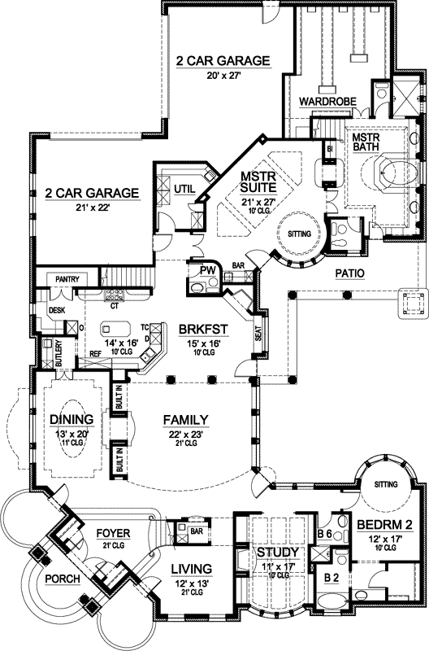
MAIN FLOOR
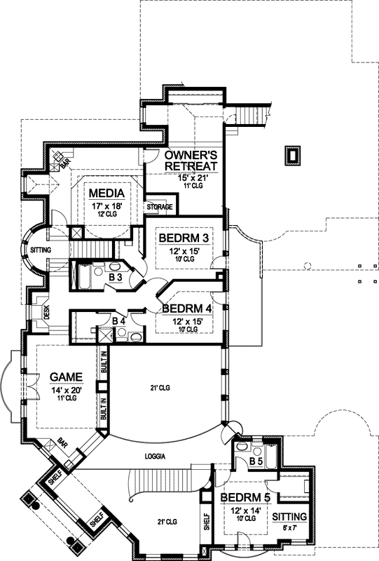
FIRST FLOOR

