|  |  |  |
| --- | --- | --- |
| **CMGT 235 – Electrical and Mechanical Systems** | | |
| **Discussion No. 15** | **Unit 2 - Plumbing Systems** | **Fall 2022** |

**DFU and Sizing Sanitary Piping**

**Sanitary Sewers and Vents**

Important for maintaining the quality of the indoor environment of a building

Correct sizing is crucial to their proper functioning

Sizing is made easier using the set of charts published in the California Plumbing Code (CPC) or International Plumbing Code (IPC)

**Steps for Properly Sizing Sanitary Sewer Pipes and Vents**

1. Add up the total number of drainage fixture units (DFU) for each sanitary branch
2. Determine the sanitary branch sizes using the DFU values
3. Calculate the size of the main building drain using the total of all DFU values
4. Size the vents using the 2016 CPC Table 703.2 and the DFU values

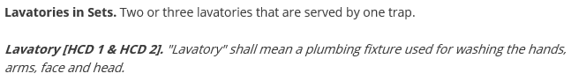

<https://up.codes/viewer/california/ca-plumbing-code-2016/chapter/2/definitions#2>

**Drain and Sewer Pipe Size Calculation**

Example 1. Assume a new, four bedrooms, 2 ½ bathrooms, home with the plumbing fixtures described in the following table. The full bathrooms are on the second floor. The remaining fixtures are on the first floor.

|  |  |  |  |  |
| --- | --- | --- | --- | --- |
| Fixture | # of Fix. | Minimum Trap Size and Trap Arm (inches) | DFU | |
| EACH | THIS JOB |
| SHO |  |  |  |  |
| BT |  |  |  |  |
| WC FT |  |  |  |  |
| LAV |  |  |  |  |
|  |  |  |  |  |
|  |  |  |  |  |
| BT |  |  |  |  |
| LAV |  |  |  |  |
| WC FT |  |  |  |  |
|  |  |  |  |  |
|  |  |  |  |  |
| KS |  |  |  |  |
| DW |  |  |  |  |
|  |  |  |  |  |
| LAV |  |  |  |  |
| WC FT |  |  |  |  |
|  |  |  |  |  |
| CW |  |  |  |  |
|  |  |  |  |  |
|  |  |  |  |  |
| TOTALS |  |  |  |  |



**CW**

**WC**

0

**LAV**

**DW**

**KS**

**WC**

**LAV**

**LAV**

**BT**

**LAV**

**LAV**

**WC**

**BT**

**SHO**

PIPE

SIZE

DFU

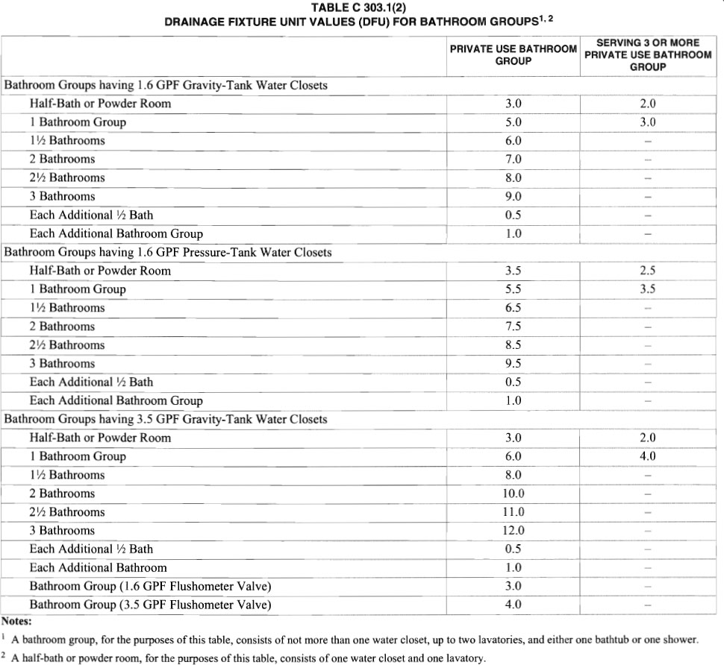

Example 2. Determine the total DFU for the house plan shown using (a) As individual fixtures using Table 702.1 and (b) as bathroom groups using Appendix C.

|  |  |  |  |  |
| --- | --- | --- | --- | --- |
| Fixture | # of Fix. | Minimum Trap Size and Trap Arm (inches) | DFU | |
| EACH | THIS JOB |
|  |  |  |  |  |
|  |  |  |  |  |
|  |  |  |  |  |
|  |  |  |  |  |
|  |  |  |  |  |
|  |  |  |  |  |
|  |  |  |  |  |
|  |  |  |  |  |
|  |  |  |  |  |
|  |  |  |  |  |
|  |  |  |  |  |
|  |  |  |  |  |
|  |  |  |  |  |
|  |  |  |  |  |
|  |  |  |  |  |
|  |  |  |  |  |
|  |  |  |  |  |
|  |  |  |  |  |
|  |  |  |  |  |
|  |  |  |  |  |
| TOTALS |  |  |  |  |

**Building Drain and Sewer Size**

Table 703.2 ____

Table C 304.2 ____ @ 1/8 inch per foot slope

Table C 304.2 ____ @ 1/4 inch per foot slope



