|  |  |  |
| --- | --- | --- |
| **CMGT 235 – Electrical and Mechanical Systems** | | |
| **Discussion No. 16** | **Unit 2 - Plumbing Systems** | **Fall 2022**  **Answers** |

**Storm Drainage Systems**

**Purpose:** Convey rainwater from building roof drains, area drains, subsoil drains, and foundation drains to a point of discharge, subsurface dispersal, or reuse.

**Authority Having Jurisdiction (AHJ) Regulates the Discharge Point:**

Municipal Sewer

Combined Sewer

Ground Surface

Subsurface

**Codes, Standards, and Regulations**

Environmental protection laws establish the requirements for groundwater and surface-water protection.

Environmental agencies regulate watersheds based on specific locations.

Local codes, ordinances and laws are the primary requirements used and must be obtained from the local AHJ.

Clean Water Act (CWA)

U.S. Environmental Protection Agency (EPA)

National Pollutant Discharge Elimination System (NPDES)

**Materials**

Stormwater system components include piping, fittings, bedding, backfill, supports and hangers, fixtures, and treatment devices. Must be approved by the AHJ

**Interior Building Drainage System**

Based on local code requirements. All designs must meet or exceed the local code requirements.

|  |  |
| --- | --- |
|  |  |

**Typical Roof Drain and Roof Leader**

**Sizing Roof Drainage System**

The sizing of the roof drainage system must consider all components: the rain storm, the flow of rainwater on the roof surface, the ability of the roof drain to move the water from the roof to the piping, the vertical piping, the horizontal piping and the connection to the point of discharge.

**Four Steps to Sizing Roof Drains on a Building**

1. Determine 100-year, 1-hour rainfall rate used for location of building
2. Select number of roof drains and calculate the roof area sloped to each drain
3. Size horizontal storm drainage piping
4. Size vertical storm drainage piping

2016 California Plumbing Code - Appendix D Sizing Storm Water Drainage Systems provides maximum rates of rainfall for U.S. various cities based on inches per hour that may fall during a storm of one-hour duration and a 100-year return period. In other words, a storm so severe and with so much rain it will only occur once in 100 years. The goal is to plan for the absolute worst and be able to easily accommodate the typical rainfall amounts.

**Example 1.**

The building shown is in Redding, California. Determine the minimum size drain, horizontal drainage pipe and leader that can be used for the drainage design shown.

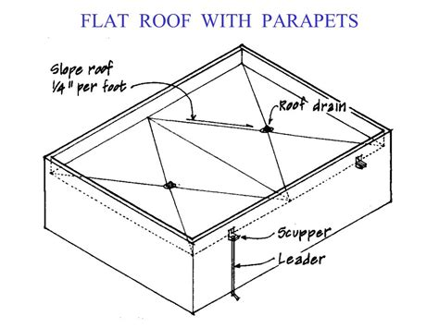

Roof Area = 50 ft x 640 ft = 32.000 ft2

16,000 ft2 per drain

640 ft

50 ft

1. Appendix D – Table D 101.1 1.5 inches per hour

1. Two Drains, 1/4" per 12" slope

Size the Drain: For 1.5 inches per hour use Note 2.

34 600 / 1.5 = 23 067 🡪 5" drain required

1. Size the Horizontal Drainage Pipe

30 200 / 1.5 = 20 133 🡪 6" pipe is required

1. Size the Vertical Drainage Pipe

Table 1101.12

34 600 / 1.5 = 23 067 🡪 5" pipe is required

The size of a storm water drainage pipe shall not be reduced in the direction of flow.

🡪 6" leader pipe is required

**What are the minimum requirements for the scupper?**

Opening – not less than 4 inches high

Width – equal to the circumference of the roof drain required for the area served

Height – not less than 2 inches above the roof surface

(prevent ponding) - structural

**Example 2.**

Size a horizontal roof drain serving 14,000 square feet of roof area on a building in Minneapolis, MN.

1. Appendix D – 2016 California Plumbing Code Table D101.1 (60 min, 100 yr)

Minneapolis MN – Always Check Code Amendments

Minnesota Plumbing Code 1101.11 Roof Drainage

1101.11.1 Primary Roof Drainage  
“Shall be sized on a basis of a rate of rainfall at a minimum 4 inches per hour.”

1. Number of drains and area sloped to each drain. 1 drain
2. Size Horizontal Drainage Pipe Required pipe size is 10"

1. Size the Vertical Drainage Pipe Minimum size of Leader pipe size is 8"

**Leader pipe must be 10**"

**Designing a Stormwater Harvesting System**

General rule of thumb when sizing a cistern to capture rainfall is that 1-inch rainfall from a 1000 square foot roof will generate approximately 600 gallons of runoff.

**Cistern Volume**

Equation V = A2 x i x c x 7.5 gal/ft3

V = volume of rain barrel (gallons)

A2 = surface area roof (square feet)

i = rainfall (1 inch = 0.08 ft)

c = coefficient of runoff (0.9 for impervious areas)

7.5 = conversion factor (gallons per cubic foot)

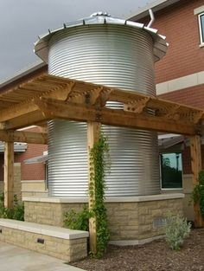

**Example 3**

Calculate the volume of runoff that can be captured from a 3500 square foot roof in Chico, CA.

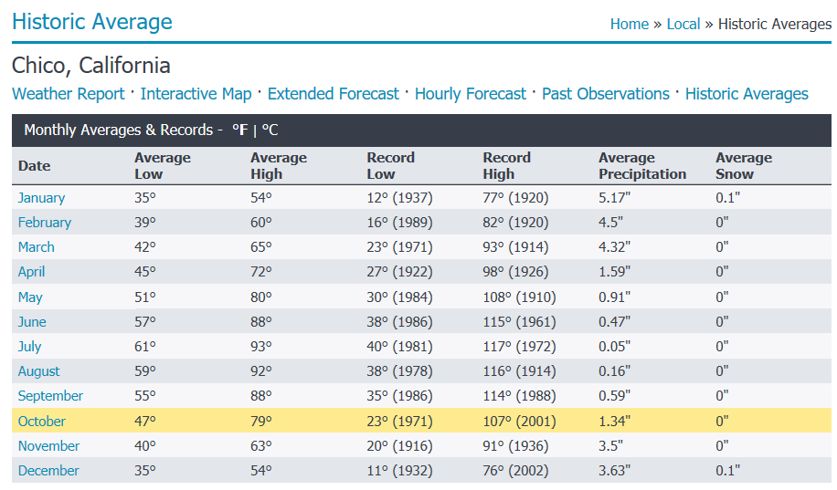

Average – 29.76 / 12 = 2.5 inches

Highest Month – 5 inches

Average

V = 3500 ft2 x 2.5 in x 1 ft/12 in x 0.9 x 7.5 gal/ft3 = 3500 ft2 x 0.21 ft x 0.9 x 7.5 gal/ ft3 = 4,961 gallons

Highest Month

V = 3500 ft2 x 5.0 in x 1 ft/12 in x 0.9 x 7.5 gal/ft3 = 3500 ft2 x 0.42 ft x 0.9 x 7.5 gal/ ft3 = 9,923 gallons

**Site Drainage and Infiltration**

To design stormwater management systems, the science of Hydrology and the calculation of runoff for each particular site are necessary considerations.

The hydrology of a storm event is the basis for all aspects of stormwater management design, including pipe size and selecting appropriate treatment devices and methods.

Methods used to determine volumes and peak flows are historical date.

Precipitation and frequency information can be found on the National Oceanic and Atmospheric Administration’s National Weather Service website (nws.noaa.gov).

**The Rational Method**

Many jurisdictions use the Rational Method for calculating peak flow rates.

It translates peak intensity of rainfall directly into peak intensity of runoff.

Q = A c i

Where

Q = Runoff, cfs

A = Drainage area, acres (1 acre = 43,560 square feet)

C = runoff coefficient, dimensionless (see table below)

i = Rainfall intensity, inches per hour

[1 acre-in/hr = 1 acre x 43,560 ft2/acre x 1 in x 1 ft/12 in x 1 hr/60 min x 1 min/60sec = 43560/43200 = 1.008 cfs]

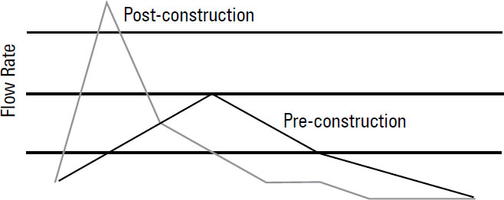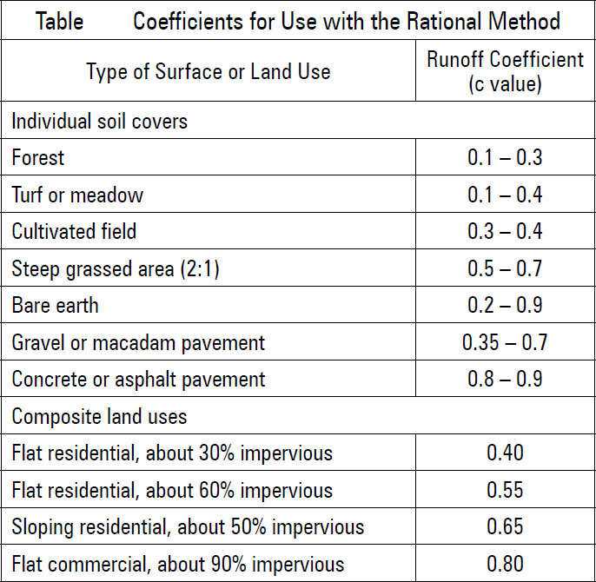

**Example 4**

Calculate the peak runoff (gpm) for a 1.5-acre site with a concrete or pavement cover and a 4-inches -per-hour rainfall.

Q = A c i

Q = 1.5-acre x 0.90 x 4 = 5.4 cfs

Convert to gallon per minute (gpm), multiply by 448.8

Q = 5.4 cfs x 448.8 = 2,424 gpm (peak flow rate)

Design must carry the peak flow rate to a treatment device or point of discharge

**Example 5**

For the residential site shown use the Rational Method to determine the peak runoff rate (gpm) and volume (gallons) for the drainage area given. The rainfall intensity is 4.2 in/hr.



The Rational Method equation is: Q = C x I x A where:

Q = Storm Water Runoff (in cubic feet per second)

C = Coefficient of Runoff

I = Rainfall Intensity (in inches per hour)

A = Area of Drainage Zone (in acres)

The equation above can be modified to give you runoff in gallons per minute.

The modified equation is: Q = (C x I x A) / 96.23 where:

Q = Storm Water Runoff (in gallons per minute, gpm)

C = Coefficient of Runoff

I = Rainfall Intensity (in inches per hour)

A = Area of Drainage Zone (in square feet)

Concrete Area

20 ft x 16 ft + 3 ft x 32 ft = 416 ft2

Compact Gravel Area

12 ft x 30 ft + ½ x (10 ft x 9 ft) + 3 ft x 10 ft = 435 ft2

Grass Area

10 ft x 58 ft + 17 ft x 42 ft – 45 ft2 = 1249 ft2

Q = [(0.90 x 416) + (0.70 x 435) + (0.35 x 1249) x 4.2] / 96.23 = [(374.4 + 304.5 + 437.15) x 4.2)]/96.23 = 48.7 gpm

Use 60-minute storm:

Volume = 48.7 gpm x 60 min = 2,922 gal