**CMGT 235 – Electrical and Mechanical Systems**

Department of Construction Management 🏵 California State University, Chico

**Discussion No. 16 – Storm Drainage Systems**

**Example Questions**

1. Determine the number of roof drains required for ideal drainage for a roof area that is 200 ft x 1500 ft located in Reno, Nevada. Round drain number up to the next whole number.
2. Use the handout **Roof Drain to Roof Area Sizing Schedule**

Calculate the Roof Area

Rainfall = ___________________________________________________________________________

Calculate the number of 5" Roof Drains

Calculate the Number of 8" Roof Drains

1. Use **2016 CPC Appendix D – Table D 101.1 and Table 1101.12**

Rainfall = ___________________________________________________________________________

Calculate the number of 5" Roof Drains

Calculate the Number of 8" Roof Drains

1. For the BMP shown below answer the following:

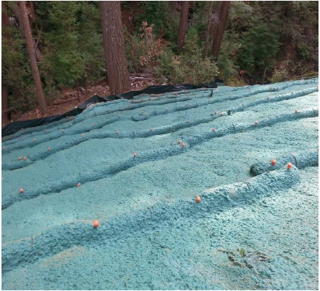

What is the BMP called? ____________________________________________________________________

What BMP objectives does it address?

What is the Standard Symbol used on site drawings? _____________________________________________

1. For the BMP shown below answer the following:

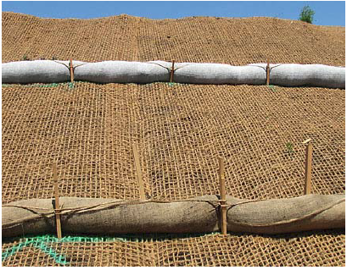

What is the BMP called? ____________________________________________________________________

What BMP objectives does it address?

What is the Standard Symbol used on site drawings? _____________________________________________

1. Using the Web site [www.usclimatedata.com](http://www.usclimatedata.com) complete the following:

|  |  |
| --- | --- |
| City | Happy Camp |
| State | California |
| Total Annual Rainfall (inches) |  |
| Average per month (inches) |  |
| Highest Month (inches) |  |

If rainfall is collected from a 5500 square foot roof in your city determine the following:

Average Volume of Runoff that can be Captured

Highest Month Volume of Runoff that can be captured