**CMGT 235 – Electrical and Mechanical Systems**

Department of Construction Management 🏵 California State University, Chico

**Discussion No. 16 – Storm Drainage Systems**

**Example Questions**

**Solution**

1. Determine the number of roof drains required for ideal drainage for a roof area that is 200 ft x 1500 ft located in Reno, Nevada. Round drain number up to the next whole number.
2. Use the handout **Roof Drain to Roof Area Sizing Schedule**

Calculate the Roof Area

Area = 200 ft x 1500 ft = 300,000 ft2

2 inches per hour

Rainfall = ___________________________________________________________________________

Calculate the number of 5" Roof Drains

No. of Drains = 300,000 ft2 / 17 300 = 17. 3 = 18 drains

Calculate the Number of 8" Roof Drains

No. of Drains = 300,000 ft2 / 58 000 = 5.17 = 6 drains

1. Use **2016 CPC Appendix D – Table D 101.1 and Table 1101.12**

1.2 inches per hour

Rainfall = ___________________________________________________________________________

Calculate the number of 5" Roof Drains

No. of Drains = 300,000 ft2 / 34 600/1.2 = 10.4 = 11 drains

Calculate the Number of 8" Roof Drains

No. of Drains = 300,000 ft2 / 116 000/1.2 = 3.1 = 4 drains

1. For the BMP shown below answer the following:

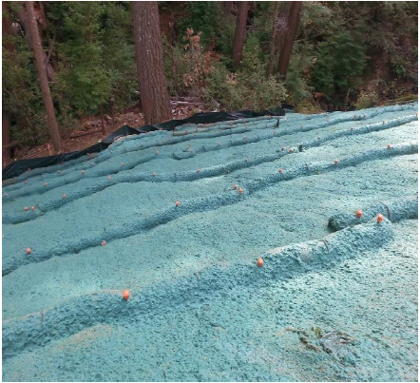

Hydraulic Mulch

What is the BMP called? ____________________________________________________________________

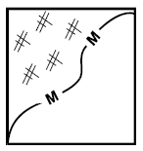What BMP objectives does it address?

Soil Stabilization

Wind Erosion Control

What is the Standard Symbol used on site drawings? _____________________________________________

1. For the BMP shown below answer the following:

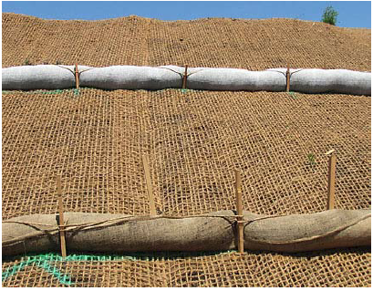

Compost Socks

What is the BMP called? ____________________________________________________________________

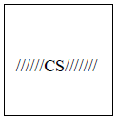What BMP objectives does it address?

Soil Stabilization

Sediment Control

What is the Standard Symbol used on site drawings? _____________________________________________

1. Using the Web site [www.usclimatedata.com](http://www.usclimatedata.com) complete the following:

|  |  |
| --- | --- |
| City | Happy Camp |
| State | California |
| Total Annual Rainfall (inches) | 51.41 inches |
| Average per month (inches) | 4.3 inches |
| Highest Month (inches) | 9.17 |

If rainfall is collected from a 5500 square foot roof determine the following:

Average Volume of Runoff that can be Captured

V = 5500 ft2 x 4.3 inches x 1 ft /12 inches x 0.9 x 7.5 gal / ft3

V = 13,303 gallons

Highest Month Volume of Runoff that can be captured

V = 5500 ft2 x 9.17 inches x 1 ft /12 inches x 0.9 x 7.5 gal / ft3

V = 28,370 gallons