**CMGT 235 – Electrical and Mechanical Systems**

Department of Construction Management 🏵 California State University, Chico

Homework #16

Points: 20

Due: 10/18/2022

ANSWER

Name: ____________________________________________________________________________________

1. Determine the number of roof drains required for ideal drainage for a roof area that has a width of 240 feet and a length of 570 feet located in Little Rock, Arkansas. Round drain number up to the next whole number.
2. Use the handout **Roof Drain to Roof Area Sizing Schedule**

Calculate the Roof Area

Area = 240 ft x 570 ft = 136,800 ft2

6 inches per hour

Rainfall = ___________________________________________________________________________

Calculate the number of 5" Roof Drains

No. of Drains = 136,800 ft2 / 5,765 = 23.7 = 24 drains

Calculate the Number of 8" Roof Drains

No. of Drains = 136,800 ft2 / 19 315 = 7.083 = 8 drains

1. Use **2016 CPC Appendix D – Table D 101.1 and Table 1101.12**

3.7 inches per hour

Rainfall = ___________________________________________________________________________

Calculate the number of 5" Roof Drains

No. of Drains = 136,800 ft2 / 34 600/3.7 = 14.6 = 15 drains

Calculate the Number of 8" Roof Drains

No. of Drains = 136,800 ft2 / 116 000/3.7 = 4.4 = 5 drains

1. For the BMP shown below answer the following:

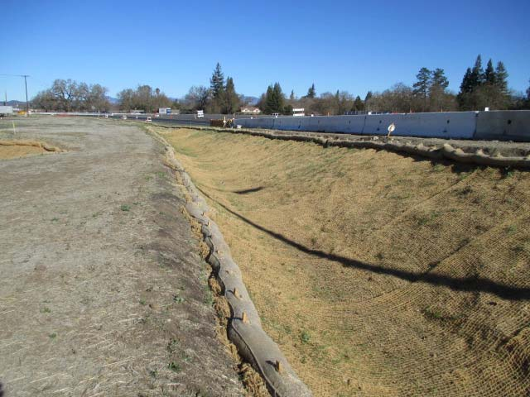

Earth Dikes/Drainage Swales and Lined Ditches

What is the BMP called? ____________________________________________________________________

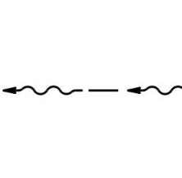What BMP objectives does it address?

Soil Stabilization

What is the Standard Symbol used on site drawings? _____________________________________________

1. For the BMP shown below answer the following:

Outlet Protection/Velocity Dissipation Devices

What is the BMP called? ____________________________________________________________________

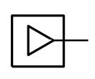What BMP objectives does it address?

Soil Stabilization

Sediment Control

What is the Standard Symbol used on site drawings? _____________________________________________

1. Using the Web site [www.usclimatedata.com](http://www.usclimatedata.com) complete the following:

|  |  |
| --- | --- |
| City | Portland |
| State | Oregon |
| Total Annual Rainfall (inches) | 36.03 |
| Average per month (inches) | 3.00 |
| Highest Month (inches) | 5.63 |

If rainfall is collected from a 12,500 square foot roof determine the following:

Average Volume of Runoff that can be Captured

V = 12,500 ft2 x 3.00 inches x 1 ft /12 inches x 0.9 x 7.5 gal / ft3

V = 21,094 gallons

Highest Month Volume of Runoff that can be captured

V = 12,500 ft2 x 5.63 inches x 1 ft /12 inches x 0.9 x 7.5 gal / ft3

V = 39,586 gallons