CMGT 235 – Electrical and Mechanical Systems
Department of Construction Management California State University, Chico
Discussion No. 16 – Storm Drainage Systems

Example: Roof Drain Sizing
Size a horizontal roof drain serving 5,000 square feet of roof area on a building located in Dallas, Texas.
Step 1. Determine the Rainfall Rate
CPC 2016 Appendix D. Table D 101.1
Houston, TX
Rainfall rate of 4.6" per hour
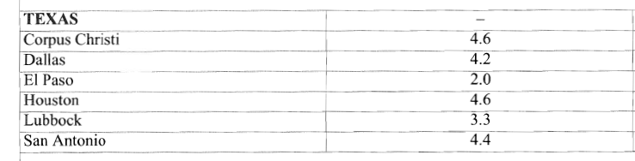
CHECK LOCAL CODE FOR ADMENDMENTS FROM THE CITY
City of Houston
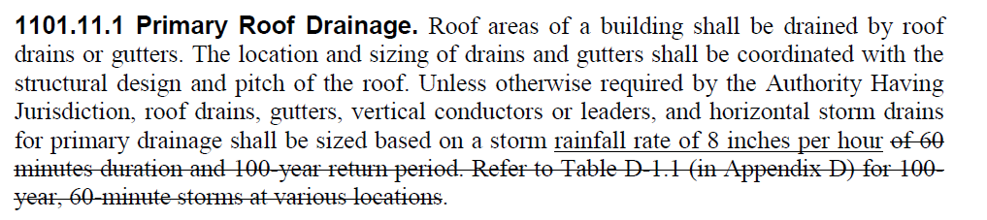
Must be based on a Rainfall Rate of 8" per hour

Step 2. Select number of roof drains and calculate the roof area sloped to each drain.
1 drain to serve 5,000 square feet.

Step 3. Table 1101.8 to determine the required size horizontal rainwater pipe.
From the chart, for 1/8" slope per 12" of pipe, for 5,000 square feet of roof area, with an 8" per hour rainfall rate, the required pipe size is 8". Use Column 1: 46 000 / 8 = 5,750 square feet
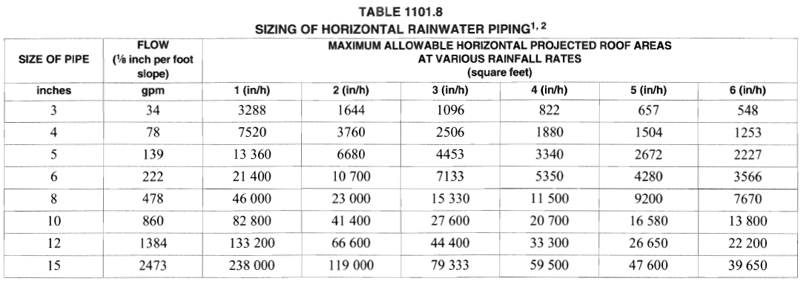
Step 4. Table 1101.12 to determine the vertical drain (leader pipe)
From the table the minimum size for the leader pipe is 6"

However, Section 101.5 of the IPC tells us not to reduce the pipe size in the direction of flow. This means that because our horizontal pipe from Step 3 was 8" our vertical pipe will be also 8".

