|  |  |  |
| --- | --- | --- |
| **CMGT 235 – Electrical and Mechanical Systems** | | |
| **Discussion No. 17** | **Unit 2 - Plumbing Systems** | **Fall 2022** |

**Fire Protection**

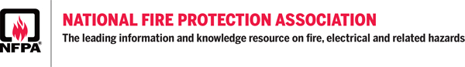

[**https://www.nfpa.org/**](https://www.nfpa.org/)

**About NFPA -** [**https://www.nfpa.org/About-NFPA**](https://www.nfpa.org/About-NFPA)

**The National Fire Protection Association (NFPA)**

Originated in 1896

Sets Guidelines for Fire Protection

OSHA also sets Standards

Fire Marshal Oversees Inspection

**Our vision:** We are the leading global advocate for the elimination of death, injury, property, and economic loss due to fire, electrical and related hazards.

**Our mission:** To help save lives and reduce loss with information, knowledge, and passion.

**NFPA Codes and Standards**

<https://www.nfpa.org/Codes-and-Standards>

**List of NFPA Codes and Standards**

<https://www.nfpa.org/Codes-and-Standards/All-Codes-and-Standards/List-of-Codes-and-Standards>

**NFPA 72 – National Fire Alarm and Signaling Code**

NFPA 72 provides the latest safety provisions to meet society's changing fire detection, signaling, and emergency communications demands. In addition to the core focus on fire alarm systems, the Code includes requirements for mass notification systems used for weather emergencies; terrorist events; biological, chemical, and nuclear emergencies; and other threats.

**Classification of Fires**

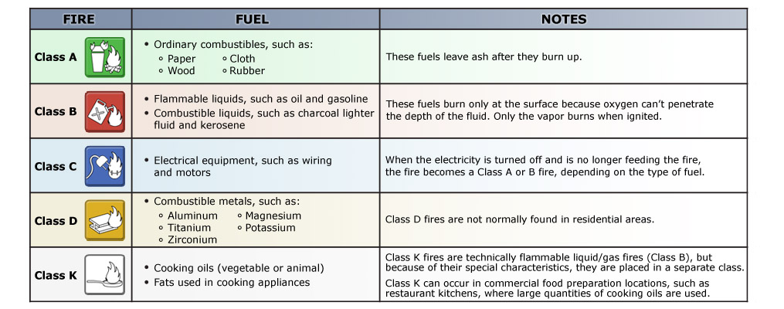

**Building Types:**

A – Assembly: Auditoriums, Theaters

B – Business: Office, Retail, Restaurants

E – Educational: Schools

F – Factories

H – Hazardous Uses

I – Institutional: Hospitals, Nursing Homes

R – Residential: Apartments, Hotels

**Life Safety Design**

* Detect Danger
* Warn the building occupants
* Provide safe egress
* Control the fire
* Eliminate the fire
* Assist firefighters

**What does it take for a fire to burn? Three elements:**

1. **Fuel**, or material to be burned, which may be a liquid, a solid, or a gas
2. **Heat** that raises the temperature of the fuel to its ignition point
3. **Oxygen**: In an atmosphere of less than 20% oxygen, most fuels can be heated until they entirely vaporize, without burning.

**Firefighting Resources**

One important reason for identifying the fire classification is to select the most effective means of suppressing the fire.

**Four types of firefighting resources are available:**

1. Portable fire extinguishers
2. Interior wet standpipes
3. Confinement
4. Creative resources
5. Portable Fire Extinguishers

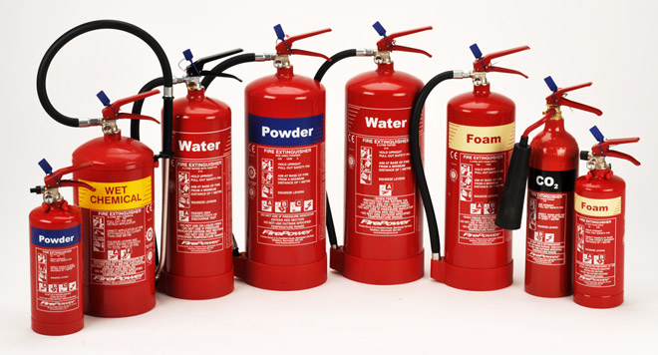

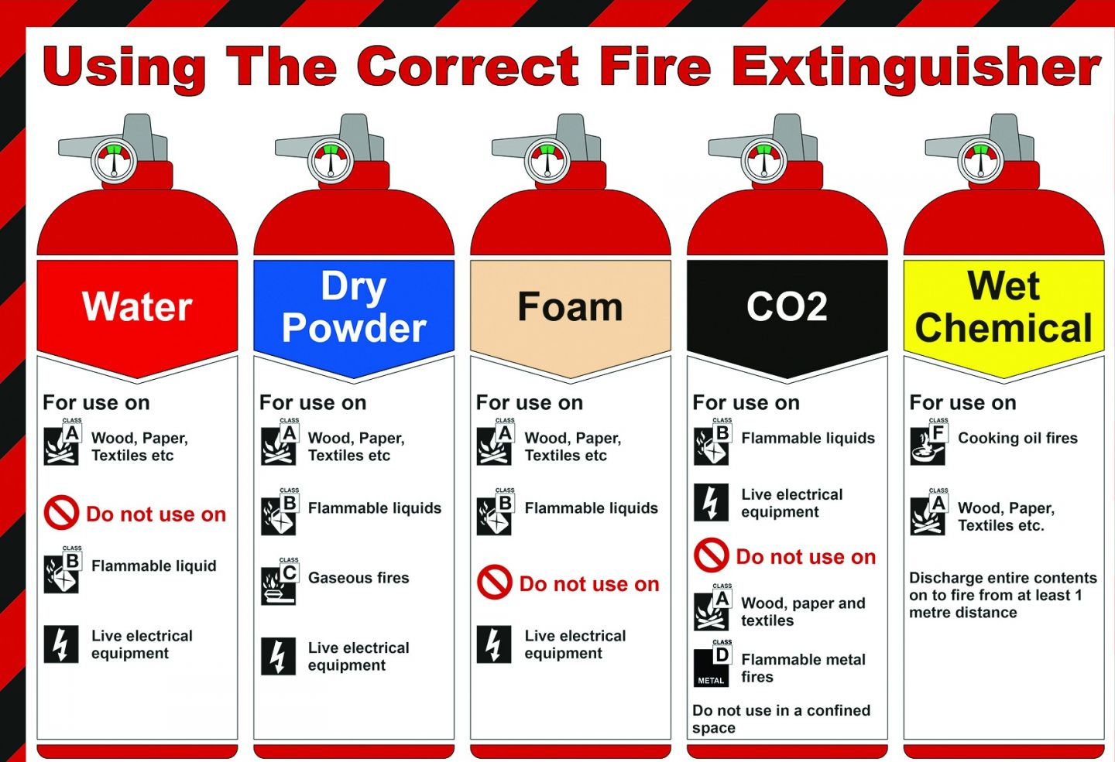

1. **Interior wet standpipes**

* Typically found in commercial and apartment buildings.
* Usually consist of 100 feet of 1-inch jacketed hose with a nozzle tip
* Deliver up to 125 gallons of water per minute
* Should be used by three-person teams (one person to handle the hose, one to bleed air from the line, and one to control water pressure)

**Interior Dry Standpipe**

* Firefighters must connect a water source to the fire department connection

1. **A kitchen with red floor

   Description automatically generated**Confinement

* Confining an interior fire by closing doors to rooms and hallways may help restrict the spread of smoke and heat, and it limits the amount of oxygen available to the fire.

1. Creative Resources

* In certain circumstances you can make use of resources on hand to fight fires. Such as:
* Swimming pool or spa water and buckets
* Sand or dirt and shovels
* A garden hose

**Main Functions of a Fire Alarm System**

* Provide a means to identify an unsafe condition through automatic methods.
* Alert building occupants to an unsafe condition and the need to evacuate.
* Another common function is the transmission of an alarm notification signal to the fire department or other emergency response organization.
* Fire alarm systems may also shut down electrical, air handling equipment or special process operations, and they may be used to initiate automatic suppression systems.

**Fire Alarm System Components**

**Fire Alarm Control Panel (FACP)** – The main fire alarm system component that monitors equipment and circuits, receives input signals from initiating devices, activates notification appliances, and transmits signals off-site. Also called the Fire Alarm Control Unit (FACU).

Controls for the system are in the FACP.

The FACP can also perform other functions, such as:

* Providing two-way firefighter communication
* Providing remote annunciator integration
* Controlling elevators, HVAC, fire doors, dampers, locks, or other fire protection features

The FACP can also provide public address messages and mass notification alerts through prerecorded evacuation messages or independent voice communications.

NOTE: Some fire alarm control units are designed for both security and fire protection. In these types of systems, fire protection is engineered into the system to assume the highest priority.

**Types of Fire Alarm Systems**

**Conventional**

* Simplest type of protected premises alarm system
* Initiating device sends a signal to the FACP
* All the alarm-signaling devices operate simultaneously until the FACP is reset
* The FACP is incapable of identifying which initiating device triggered the alarm; building and fire department personnel must walk around the entire facility and visually check to see which device was activated.
* Practical for small occupancies with a limited number of rooms and initiating devices

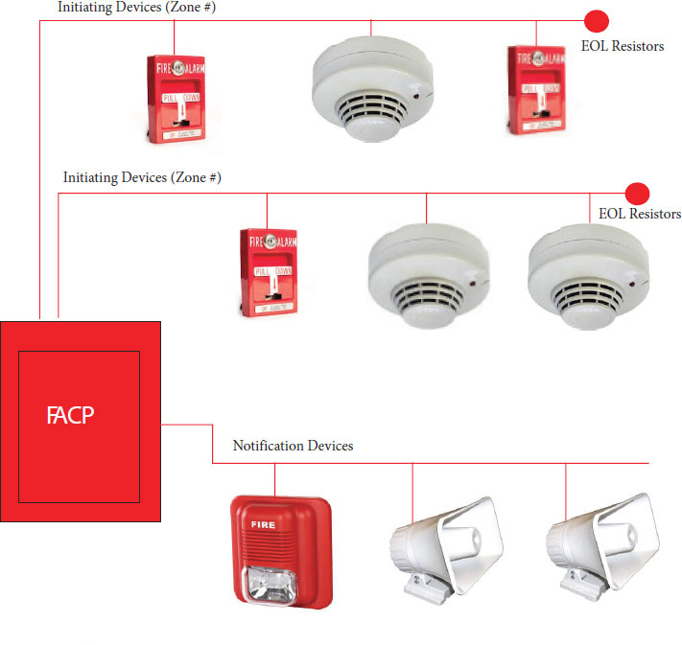

*Zoned Conventional Alarm System*

* Fire-alarm system annunciation enables emergency responders to identify the general location, or zone, of alarm device activation.
* An annunciator panel, FACP, or a printout visibly indicates the building, floor, fire zone, or other area that coincides with the location of an operating alarm-initiating device
* Designed to help emergency responders quickly identify the location of a fire.

**Addressable Alarm Systems**

* Each component has individual unique identifiers
* Displays the location of each initiating device on the **FACP** and on **fire alarm annunciator panel** **(FAAP)**
* Exact location of the specific device that has been activated is identified on the FACP and FAAP
* Large facilities utilize these systems because they can quickly pinpoint where the trouble signal originated.

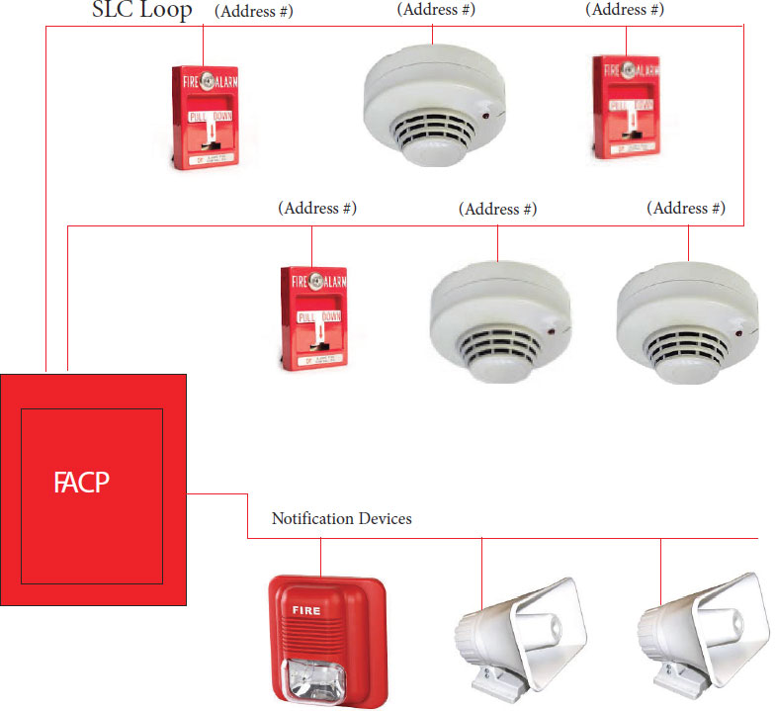

**Supervising Station Alarm Systems**

Fire alarm systems are required by model fire codes to be monitored at a constantly attended location. For buildings that are not constantly attended by qualified personnel, initiating device signals are required to be transmitted to a supervising station. A supervising station is a facility that receives signals from a protected premises fire alarm system and where the signal is processed by personnel.

**NFPA® 72 designates supervising stations as:**

* **Central** — A central supervising station is an independent business that is also listed by a nationally recognized testing laboratory. A central station is recognized as the most reliable type of supervising station.
* **Proprietary** — A proprietary supervising station is a supervising station under the same ownership as the buildings protected by the fire alarm systems. At a proprietary supervising station, personnel are constantly in attendance to supervise and investigate fire alarm system signals.
* **Remote** — A remote supervising station is not listed and operates as a business. Personnel are in attendance at all times to supervise and investigate signals.

**Alarm Initiating Devices**

|  |  |  |  |
| --- | --- | --- | --- |
| **Device** | **Function** | **Graphic** | **Preferred Symbol** |
| **Fixed Heat Detector** | Heat detectors set to predetermined temperature ratings should be installed in ceilings and in areas that are expected to accumulate heat. |  |  |
| **Rate of Rise Heat Detector** | A rate-of-rise heat detector operates on the principle that fires rapidly increase the temperature in a given area. These detectors respond at substantially lower temperatures than fixed-temperature detectors. Typically, rate-of-rise heat detectors are designed to send a signal when the rise in temperature exceeds 12° to 15°F (7°C to 8°C) degrees per minute because temperature changes of this magnitude are not expected under normal, nonfire circumstances. |  |  |
| **Smoke Detector** | Designed to actuate when visible or invisible products of combustion (other than fire gases) are present in the room or space where the unit is installed. |  |  |
| **Duct Smoke Detector** | Duct detectors are used primarily to sense smoke in the HVAC system to enable AHU (Air Handling Unit) shutdown to prevent distributing smoke throughout a facility. In some instances, duct detectors are also used to control fire/smoke dampers. |  |  |
| **Flame Detector** | A flame detector is sometimes called a light detector. There are three basic types:   * Those that detect light in the ultraviolet wave spectrum (UV detectors) * Those that detect light in the infrared wave spectrum (IR detectors) * Those that detect light in both UV and IR waves |  |  |
| **Flow Switch** | An automatic initiating device is designed to activate an audible alarm (horn/strobe) when water begins to flow through the sprinkler system. |  |  |
| **Tamper Switch** | Used to monitor the open position of an Outside Screw and Yoke (OS&Y) type gate valve or ball type valve. |  |  |
| **Manual Pull Station** | Allow occupants to manually initiate the fire alarm signaling system. Manual pull stations may be connected to systems that sound local alarms, off-premise alarm signals, or both. |  |  |

**Alarm Signaling Devices**

|  |  |  |  |
| --- | --- | --- | --- |
| **Device** | **Function** | **Graphic** | **Preferred Symbol** |
| **Horn** | Audible notification appliance used to provide loud resonant tones as a warning to alert the occupants of a fire or other emergency condition requiring action.  WP = Weather Proof |  |  |
| **Bell** |  |  |
| **Speaker** |  |  |
| **Strobe** | Visible notification appliance used to provide flashing light as a warning to alert the occupants of a fire or other emergency condition requiring action. |  |  |
| **Horn/Strobe** | Audible/visible (A/V) notification appliance with efficient electronic horn and high output xenon strobe. |  |  |

**Fire Alarm System Wiring**

Initiating Device Circuits (IDCs)

Notification Appliance Circuits (NACs)

Signaling Line Circuit (SLC)

**Addressable Systems**

Addressable systems use a Signaling Line Circuit (SLC) to communicate with detectors and modules. SLCs are a huge benefit because the fire panel can be expanded to perform more remote relay functions, dry contact monitoring, remote power control, releasing service and conventional zone monitoring.

SLCs provide 2-way communication between a device and the panel via a SLC circuit. The panel and a device "talk" to each other every 4–5 seconds, referred to as "polling."

**Circuit Types Overview**

Addressable system panels can be wired as either Class A or Class B. The circuit type determines how a break in the loop affects the system's operation.

**Class B Wiring**

Most fire alarm system installations use Class B circuits. They provide the minimum level of protection that most facilities require. Class B circuits are characterized by the following features:

1. The circuit does not include a redundant path.
2. A single open on the circuit will render the devices located behind the location of the open circuit inoperable.
3. Any condition that affects the operation of the circuit will be annunciated as a trouble signal at the fire alarm control panel.
4. A single ground fault will not render the circuit inoperable. The presence of a single ground fault will be annunciated at the fire alarm control panel.

When wiring a conventional panel Class B, an End of Line Resistor (EOLR) is required to supervise each conventional input zone as well as any NAC output. When wiring an addressable panel Class B, an EOLR is required to supervise the notification appliance circuits (NACs) and Initiating Device Circuits (IDCs). However, the SLCs on an addressable panel does not need an EOLR to supervise the circuit. A SLC uses two-way communication between each device and the panel to monitor and supervise the circuit and device. This two-way communication also allows for t-tapping on SLCs.

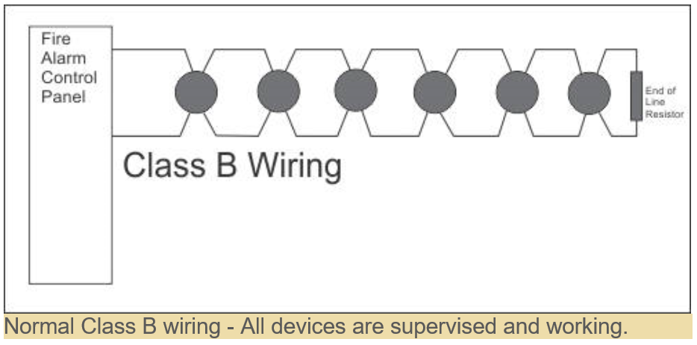 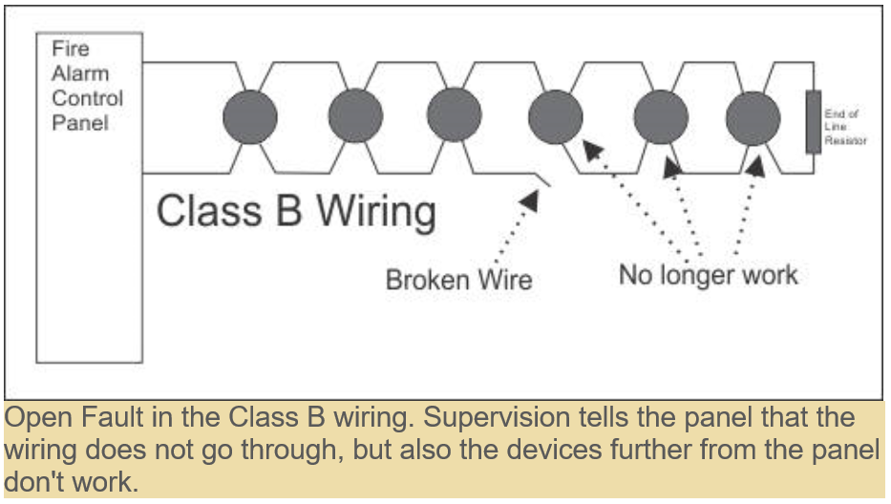

**Class A Wiring**

Class A circuits are used on certain types of installations (i.e., government, schools, hospitals, etc.), and when insurance authorities require it at a facility. Class A circuits can provide a higher level of system survivability.

Class A circuits are characterized by the following features:

1. The circuit includes a redundant path.
2. The circuit will remain operable when there is a single open. The open will annunciate the fire alarm control panel as a trouble condition.
3. Any condition that affects the operation of the circuit will be annunciated as a trouble signal at the fire alarm control panel.
4. A single ground fault will not render the circuit inoperable. The presence of a single ground fault will be annunciated at the fire alarm control panel.

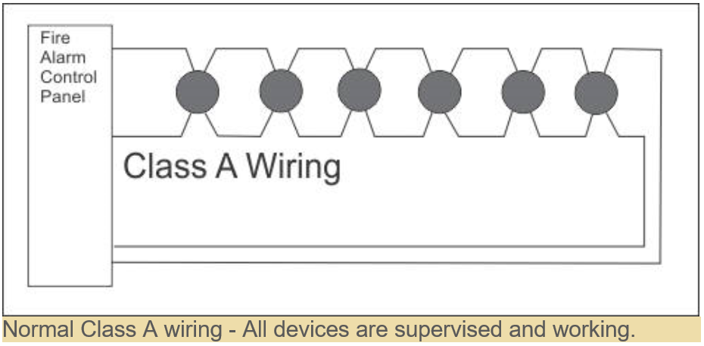 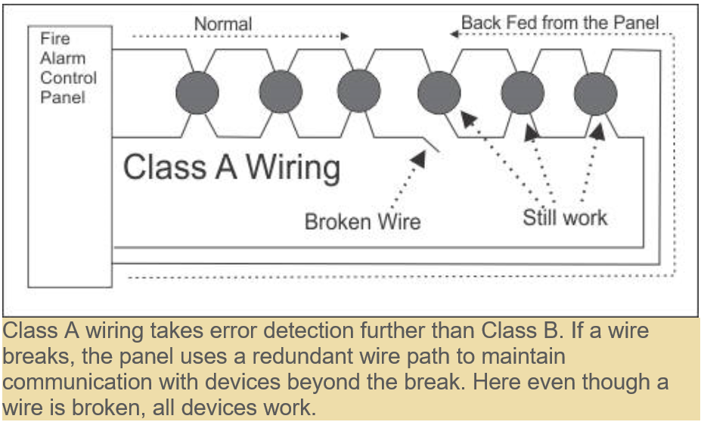

**Fire Alarm Riser Diagram**

**Fire Alarm Symbols Legend**

**Fire Suppression Systems**

A fire suppression system is any product designed to stop a fire from spreading. It gets the name suppression system as it aims to hold back the fire and the damage it may cause. Preventing the fire from spreading mitigates losses and allows time for emergency personnel to respond.

**Fire Sprinkler System**

Uses water to extinguish or control flames and minimize the spread of a fire until firefighters arrive.

**Gaseous or Chemical Agent Systems**

Different environments and different types of fires may require a suppression system that doesn’t use water to extinguish the flames. Facilities that contain flammable or combustible liquids or electronic equipment require fire suppression systems such as FM 200, Carbon Dioxide (CO2), wet chemical, or dry chemical. These systems use gaseous or chemical agents specially designed to extinguish the fire’s source.

In some cases, owners may want to protect certain items from water damage even if code only requires a fire sprinkler system.

**FM 200 Fire Suppression Systems**

FM 200 fire suppression system dispenses an agent into the fire; it absorbs the heat and lowers the fire’s temperature below the ignition point. Since the fire suppression agent leaves no residue and requires no cleanup, it’s ideal for use in computer rooms, museums, historical archives, and many other applications. FM 200 fire suppression system benefits include requiring little storage space for the fire extinguishing agent in comparison to a carbon dioxide system. Additionally, the system can be located in areas occupied by the facility’s personnel.

**Carbon Dioxide Fire Suppression Systems**

When activated a carbon dioxide fire suppression system releases a gaseous agent into the fire. It extinguishes the flames by displacing the oxygen. These systems work quickly, efficiently, and leave no residue. Many places that have printing presses, spray booths, flammable liquid storage, and dip tanks utilize this system. Major issues with carbon dioxide fire suppression systems are that the gaseous agent is extremely dangerous to humans. Unfortunately, carbon dioxide fire suppression system’s locations are sometimes where people work. In this scenario, facilities must take certain precautionary measures to comply with NFPA and OSHA requirements. These additional precautionary measures help to protect facility’s personnel.

**Wet Chemical Fire Suppression Systems**

Cooking applications use wet chemical fire suppression systems. When there’s an emergency the system dispenses a chemical; suppresses the fire, blankets the flames, and prevents the fire from reigniting. This fire suppression system requires minimal cleanup after an activation which prevents loss of work and profits.

**Dry Chemical Fire Suppression Systems**

Dry chemical fire suppression systems expel a chemical powder designed to extinguish flames caused by flammable and combustible liquids. Some areas in a facility that use the chemical powder agent include mechanical rooms, furnace rooms, flammable liquid storage areas, and other places as well. Dry chemical fire suppression systems work very quickly to extinguish fires, but their chemical agent can cause quite a mess. Although, cleaning up a mess is a small price to pay when compared to the detrimental results of a fire.

Other than a wet chemical system which is always required in kitchen areas, FM 200, carbon dioxide, and dry chemical systems are used in more than one type of application. Fire & life safety service providers will consult with The Authority Having Jurisdiction and review NFPA code requirements to determine which type of fire suppression system is needed based on the hazard in the facility.

