CMGT 235 – Electrical and Mechanical Systems
Department of Construction Management California State University, Chico

Homework #17– Stormwater Management
Points: 20
Solution
Due: 10/20/2022

Use the Rational Method to determine the peak runoff rate (gpm) and volume (gallons) for the drainage area given. The rainfall intensity is 6.3 in/hr.
C = 1.00
C = 0.35
C = 0.50

How to Calculate Storm Drainage - Doctor Drainage
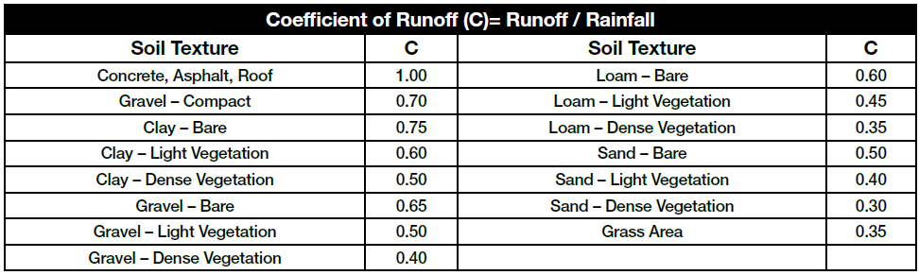

Volleyball Court - Area = 30 ft x 60 ft = 1800 ft²
Parking Lot - Area = 24 ft x 63 ft = 1512 ft²
Grass Area - Area = 60 ft x 33 ft – ½ x 45 ft x 18 ft = 1980 ft² – 405 ft² = 1575 ft²

Runoff Calculation
Q = (C x I x A) / 96.23
Q = [(0.5 x 1800 ft² + 1.00 x 1512 ft² + 0.35 x 1575 ft²) x 6.3 in/hr] / 96.23 = 159 gpm

Volume in one hour (60 min)
V = 159 gpm x 60 min = 9,540 gal

