CMGT 235 – Electrical and Mechanical Systems
Calculating Power Bill | Unit 3 - Electrical Systems

Utility Bills
- The electric utility provides working (kW) and reactive power (kVAR) to your building power distribution system (plant) in the form of apparent power (kVA).
- While reactive power (kVAR) doesn’t register on kW demand or kW hour meters, the utility’s transmission and distribution system must be large enough to provide the total power.
- Utilities have various ways of passing the expense of larger generators, transformers, cables, switches, and the like, along to the owner.
- The utility measures and bills every ampere of current, including reactive current.
- The utility charges according to the kW demand and adds a surcharge or adjustment for power factor. The adjustment may be a multiplier applied to kW demand.
- Some utilities charge for low power factor (tariff) but give a credit or bonus for power above a certain level.
- Residential energy consumers are only billed for KWH.
- Commercial or industrial energy consumers are billed based on KWH but are also subject to a charge based on the KWH/KVAH ratio (power factor). As the power factor goes lower, your extra charge goes higher.

Example 4. Some utilities charge for each kVAr of reactive power generated.
If the actual demand is 1,000 kW, the power factor is 80%, and the power factor charge is $0.30 per kVAr each month, calculate the power factor charge.
KVAR = KW x Tan [Cos⁻¹ (PF)] = 1000 kW x Tan [cos⁻¹(0.8)] = 750 KVAR
PF Charge = 750 KVAR x $0.30/KVAR-month = $225/month

Example 5. Some utilities add a demand penalty when the power factor is less than a set amount, usually 90%.
For example, a utility may specify a demand penalty of:
Demand penalty = kW (0.90 – PF) / PF when PF < 0.90

If actual demand is 1,000 kW, the power factor is 80%, and the cost of demand is $15 /kW-month, calculate the power factor charge.
(0.9 – 0.8)
0.8
Demand Penalty = 1000 kW = 125 kW

PF Charge = 125 kW x $15/kW-month = $1,875/month

Example 6. Some utilities base the demand charge on the total supplied power (kVA) rather than actual power (kW). Basing the demand charge on kVA implicitly includes a power factor charge since kVA = kW / PF.
If actual demand is 1,000 kW, the power factor is 80%, and the cost of demand is $16 /kVA-month, calculate the implicit power factor charge.
1000 kW
0.8
KVA = = 1250 KVA

PF Charge = (KVA – KW) x $16/KVA-month = (1250 KVA – 1000 KW) x $16/KVA-month = $4000/month

What is the PG&E Methodology for Power Factor Billing Adjustment?
For customers with peak demand over 400 kW, PG&E will install revenue metering capable of recording kilowatt demand, kilowatt-hours (kWh) and reactive kilovolt-amp hours (rkVAh). Interval meters can record these values every 15 minutes. For the power factor that is used in billing, the kilowatt-hours and the reactive kilovolt-amp hours are totaled for the month and a single calculation is performed to provide an average value for that billing period. The equation is

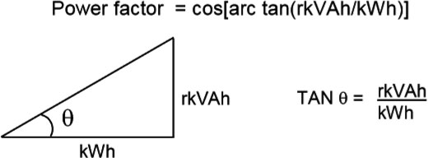

For more information see the PG&E Web site at https://www.pge.com

