CMGT 235 – Electrical and Mechanical Systems
Electrical Equations | Unit 3 - Electrical Systems | Fall 2022

Ohm’s Law – Watt’s Law  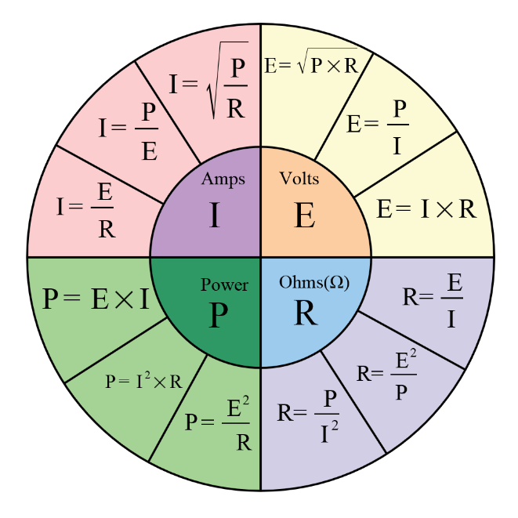  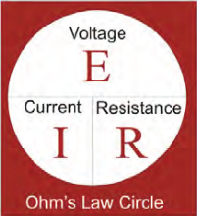 | Power Factor  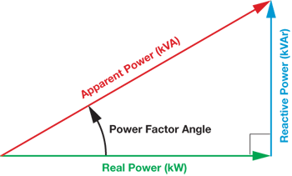  Ɵ  PF =  Real Power (KW)  Apparent Power (kVA)  Cos θ = PF  kVAR  kW  Tan θ =

Resistors in series  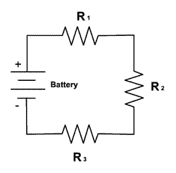 | Resistors in parallel  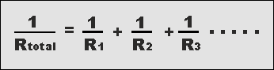  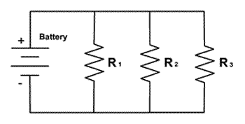

AC Circuits
Single-Phase AC
The Watt’s Law formulas for DC circuits also apply to single-phase (1ϕ) AC circuits containing only resistance.

If inductance or capacitive reactance puts the circuit out of phase, the power factor must be added to the basic power formula: P = I x E x PF

Three-Phase AC
The formula for a three-phase (3ϕ) system includes another term called the “three-phase factor”, which is a constant equal to the square root of 3, or 1.73. P_{3ϕ} = I x E x PF x 1.73
Transformer
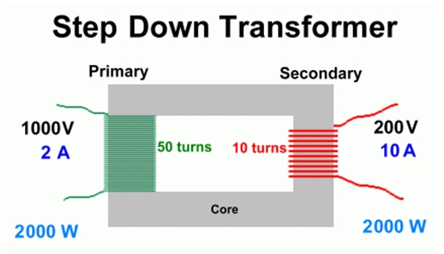 | 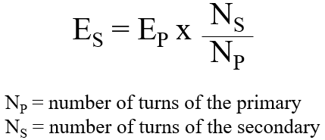

Reactance Formulas
Inductor
X_{L} = 2Π f L (Ω) Where L is in Henrys

Capacitor
X_{C} = 1 / 2Π f C (Ω) Where C is in Farads

Impedance Formula

Z = R² + (X_{L} – X_{C})² in Ohms (for series circuit)

