|  |  |  |
| --- | --- | --- |
| **CMGT 235 – Electrical and Mechanical Systems** | | |
| **Discussion No. 19** | **Unit 3 - Electrical Systems** | **Fall 2022** |

**Electrical Fundamentals**



**Electrical Quantities**

|  |  |  |  |
| --- | --- | --- | --- |
| **Quantity** | **Symbol** | **Unit of Measure** | **Unit Abbreviation** |
| Current |  |  |  |
| Voltage |  |  |  |
| Resistance |  |  |  |
| Power |  |  |  |

|  |  |  |
| --- | --- | --- |
|  **|  | Definition of an Ohm  An ohm is a unit of electrical resistance seen between two points across a resistor, conductor, device or circuit. One ohm means that a potential difference (voltage) of 1V between these two points produces a current of 1A.  Electric Power  Electric power is the rate, per unit time, at which electrical energy is transferred by an electric circuit. The SI unit of power is the watt, one joule per second. |
| **Watt’s Law**   |

**Example 1.**

If a single Red LED is connected to a 9V battery and has a voltage drop of 2V and is rated for a 20mA current, how much resistance must be added to the circuit to operate the LED at its specifications?

**Example 2.**

For the circuit shown each bulb is 75W and the source voltage is 120V.

|  |  |
| --- | --- |
| 1. What type of circuit is this? __________________________ 2. Sketch the circuit diagram. 3. Determine the total current and the voltage drop across each lamp. 4. Determine the Resistance of each of each lamp and the total Resistance. |  |

For the circuit shown each bulb is 75W and the source voltage is 120V.

|  |  |
| --- | --- |
| 1. What type of circuit is this? __________________________ 2. Sketch the circuit diagram. 3. Determine the current in each lamp and the total current. 4. Determine the Resistance of each lamp and the total Resistance. |  |

***Which circuit dissipates the most heat?***

**Electric Power**

Electricity is useful because it changes easily into other forms of energy.

|  |  |  |
| --- | --- | --- |
|  |  |  |
| The elements in a toaster changes electrical energy into _______________ energy. | An electric mixer changes electrical energy into ___________________ energy. | An electric fan transforms electrical energy into _______________ energy. |

**Can you think of another form of energy electricity is commonly changed into?**

**Convenience Receptacles**

|  |  |  |  |
| --- | --- | --- | --- |
|  |  |  |  |
| 15A, 125V  Residential | 20A, 125V  Commercial | 20A, 125V  Hospital | 20A, 125V, GFCI  NEMA 5-20R |

**How are receptacles wired?**

|  |  |
| --- | --- |
| ***Series Circuit?*** |  |
| ***Parallel Circuit?*** |  |

What is the current in the toaster?

What is the power of the blender?

**What is a UL Approved Label?**

Many products must be permanently marked or labeled with specific safety-related information such as hazards, warnings, cautions, installation instructions and electrical ratings.

**Where are UL Labels Typically Found?**

UL labels are typically used in electronic applications, including household appliances and other consumer goods. Other industries that use UL labels include medical, industrial, and outdoor applications. Labels are often referred to as a nameplate.

|  |  |
| --- | --- |
| **How much current?** | **How much power?** |
|  |  |
|  | **What is the HP of the motor?** |

**Direct Current (DC)**

Direct current (DC) is the constant flow of electricity through a conductor in one direction. A dry-cell battery connected to a light bulb is an example of a simple dc circuit.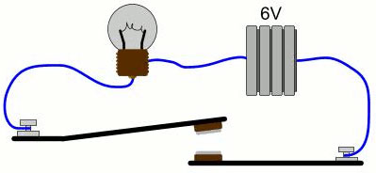

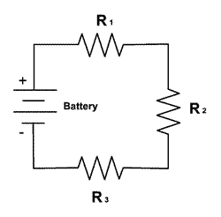**Four rules apply to DC series circuits:**

1. The total voltage is the sum of the voltages across each load.
2. The current is the same in all parts of the circuit.
3. The total resistance is the sum of the individual load resistances.

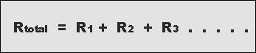

1. The total power is the sum of the powers used by the individual loads.

**The rules for DC parallel circuits are:**

1. The voltage across each load is the same.
2. 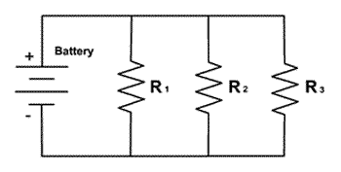The total current is the sum of the currents in each load.
3. The total resistance is always lower than the smallest load resistance. The formula for calculating total resistance (RT) is:

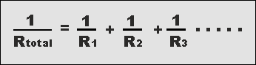

1. The total power is the sum of the powers used by the individual loads.

**Example 3.**

|  |  |
| --- | --- |
| For the series circuit shown determine IT, RT, and PT. | For the parallel circuit shown determine RT, I1, I2, IT and PT. |

**Alternating Current (AC)**

Alternating current (AC) is the flow of electric charge that periodically reverses direction. If the source varies periodically, particularly sinusoidally, the circuit is known as an alternating current circuit.

Examples include the commercial and residential power supplied by the electric power grid.

**Single-Phase AC**

|  |  |
| --- | --- |
|  | Throughout North America, homes are powered by 120-volt single-phase electricity.  At what frequency?  At that frequency, the alternating current sine wave crosses the zero point __________ times each second.  When either voltage or current crosses the zero point, the electrical power being delivered falls to zero. Does that matter to electronic equipment? |
|  | A typical residential circuit breaker box reveals four wires coming into our homes main panel: two “hot” wires, a neutral wire and ground.  For the panel shown which conductor is the neutral?  The two "hot" wires carry 240 VAC, which is used for heavy appliances like electric ranges and dryers. The voltage between both hot wire and the neutral wire is 120 VAC, which powers everything else in our homes. |

**Three-Phase AC**

|  |  |
| --- | --- |
|  |  |

* Three-phase power consists of three sine waves separated by 120 degrees that overlap.
* This form of power is created by an AC generator with three independent windings, each exactly 120 degrees apart. Each current (phase) is carried on a separate conductor.
* Due to the phase relationship, neither voltage nor current flow applied to a load ever drops to zero.
  + This means three-phase power at a given voltage can deliver more power. In fact, about 1.7 times the power of a single-phase supply (A picture containing gauge, device

    Description automatically generated).
* Three-phase allows for smaller, less expensive wiring and lower voltages, making it safer and less expensive to run.

**Why do Commercial Buildings Use Three-Phase Power?**

* Used to power large motors and other heavy loads.
* Motors perform better running on three-phase power.
* It is more efficient for larger loads, less costly to install, and the industry norm for medium to large sized facilities.
* Purchasing power at 13.8KV from the local utility is less costly. The owner will provide and maintain their own step-down transformer, which lowers the voltage to a more usable level (in the US, 480/277 volts). This transformer can be mounted on a pad outside the building or in a transformer room inside the building.

**Types of Loads**

|  |  |  |
| --- | --- | --- |
| **Purely Resistive Load** | **Purely Inductive Load** | **Purely Capacitive Load** |
|  |  |  |
| * Resistance is a measure of the opposition to current flow in an electrical circuit. * Voltage and current sine waves are in-phase when they peak and cross the zero axis at the same time. This occurs when the AC circuit is purely resistive. | * Inductive reactance is associated with the magnetic field that surrounds a wire or a coil carrying a current. * The current lags voltage by 90⁰. This is because an inductor does not allow a sudden change in current. | * Capacitive reactance is associated with the changing electric field between two conducting surfaces (plates) separated from each other by an insulating medium. * The current leads voltage by 90⁰. This is because a capacitor does not allow a sudden change in voltage. |
|  |  |  |

**Power Factor**

* Power factor is the ratio of real power (kW) to apparent power (kVA).
* This ratio can be a value from 0 to 1, and it indicates how efficiently an AC circuit is using electricity, with a value of 1 representing high efficiency.
* In AC circuits, inductive components (capacitors, motors, compressors, etc…) increases the reactive power and increases the difference between real and apparent power.
* A greater difference between real and apparent power produces a lower power factor.

**PF =**

**Real Power (KW)**

**Apparent Power (kVA)**

**kW** is Working Power (also called Actual Power or Active Power or Real Power). It is the power that actually powers the equipment and performs useful work.

**kVAR** is Reactive Power. It is the power that magnetic equipment (transformer, motor, relay etc.) needs to produce the magnetizing flux.

**kVA** is Apparent Power. It is the “vectoral summation” of KVAR and KW.

**Cos θ = PF**

Ɵ

**Example 4.**

The power bill for a commercial building is 600KWh, 216 hours of usage per month and a power factor of 0.75. Calculate the total Real Power (KW), Reactive Power (KVAR), and the Apparent Power (kVA).

Solution.

**Example 5.**

A boring mill was operating at 100 kW and the apparent power consumed was 125 kVA, what is the power factor? Sketch the power triangle.

Solution.

Sketch the power triangles for a PF = 70% and PF = 95%

**Transformers**

* Transformers are electrical devices consisting of two or more coils of wire used to transfer electrical energy by means of a changing magnetic field.
* Transformers are capable of either increasing or decreasing the voltage and current levels of their supply, without modifying its frequency, or the amount of electrical power being transferred from one winding to another via the magnetic circuit.

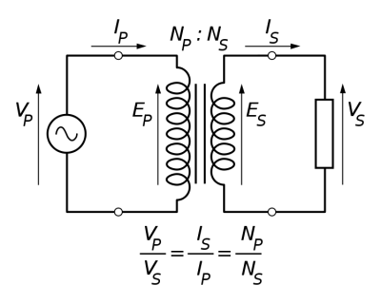

**Example 6.**

A transformer has 500 turns of the primary winding and 10 turns of the secondary winding.

1. Determine the secondary voltage if the secondary circuit is open and the primary voltage is 120 V.
2. Determine the current in the primary and secondary winding, given that the secondary winding is connected to a resistance load 15 Ω?
3. Determine the power of the primary and the power of the secondary.
4. Is this a step-up or step-down transformer?

Solution.