**Example Problems**

1. In a 24-V DC circuit, the flow of current is measured as 8 A. What is the resistance of this circuit?
2. What is the current flow in a 12-V DC simple circuit containing a total resistance of 2 ohms?
3. Determine the current for the 15-V DC circuit shown below.

**I**

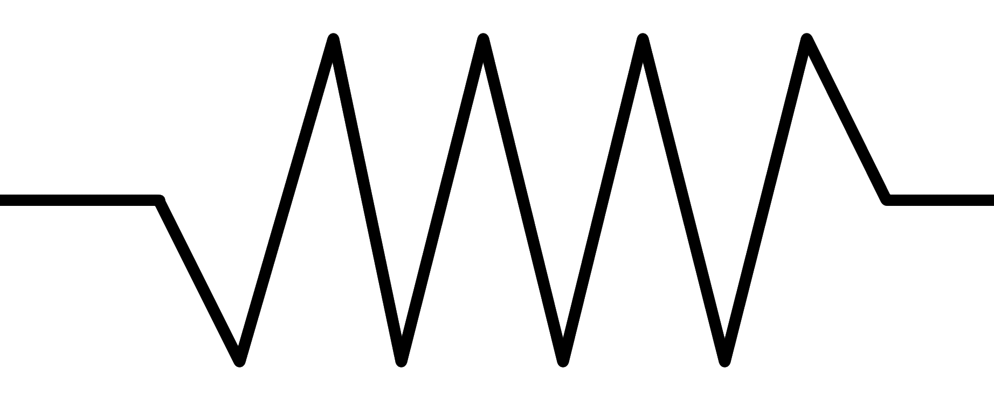

**15 V**

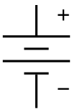

**20** Ω

1. Determine RT.

**200** Ω

**100** Ω

**300** Ω



**125** Ω

RT

1. Determine RT.

RT

R2

R1

1. Determine RT.

RT



**30** Ω

**30** Ω

**20** Ω

1. Determine the resistance of the 50-Watt lamp and the total current in the circuit shown below.



**120 V**

**50 Watt**

**120 V**

**I**

1. Determine the resistance of the 150-Watt lamp and the total current in the circuit shown below.



**230 V**

**150 Watt**

**230 V**

**I**

1. A 240-volt air conditioning compressor has an apparent resistance of 8 ohms. How much current will flow in the circuit?
2. How many watts of power are used by the compressor in question 9?
3. A doorbell requires 0.4 A at 6V. It is connected to a transformer whose primary contains 2000 turns and is connected to 120-V household outlet. How many turns should there be in the secondary? What is the current in the primary? How many Watts does the bell require from the transformer?
4. A transformer with a primary coil of 1200 turns and a secondary coil of 120 turns has 240 V connected to its primary. What is the output voltage?
5. What is the ratio of the primary turns to the secondary turns for a transformer that has an input of 20,000 V and an output of 400,000 V?
6. An ideal transformer with a 300-turn primary connected to a 480 V, 60 Hz supply line needs to output 120 V from the secondary. A 100 Ω load is connected across the secondary. How many turns the secondary must have to output the desired voltage? What is the current through the load? What is the current drawn through the primary?