CMGT 235 Electrical and Mechanical Systems

Exam #2 – Plumbing Systems - 20 points each question

Use 2016 California Plumbing Code. Show all work for full credit

Name: __________________________________________________________________________________

1. Determine the Meter and Street Service size and the Building Supply and Branches Pipe size for the Dwelling shown. MDSSPA = 80 psi. The highest water outlet in the building is 9 feet above the source of supply. Pressure loss due to the meter is 5 psi. The maximum developed length of the piping between the source of supply and the furthest fixture is 92 feet. Each side of the house has a ½" hose bibb.

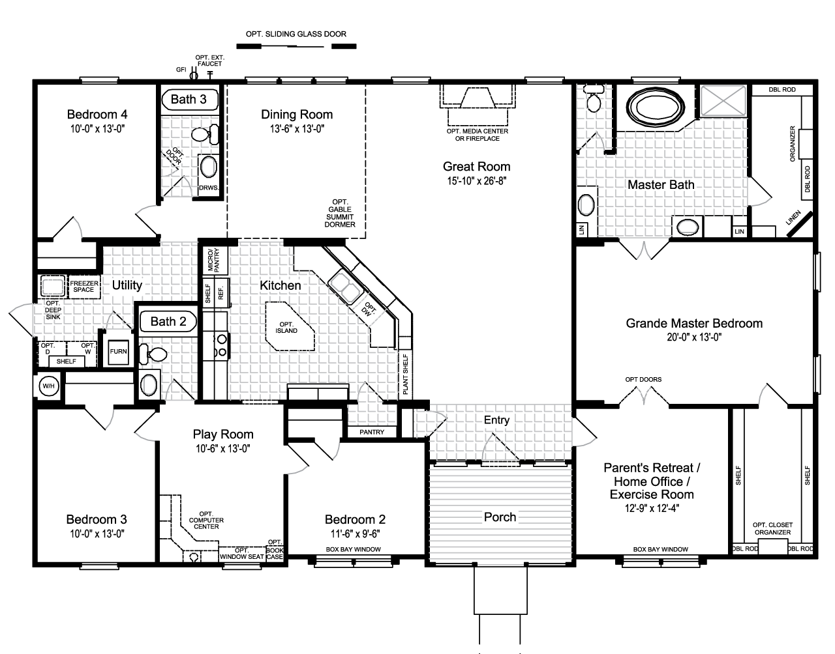

1. A busy airport has installed WaterSense toilets in all of the restrooms and 0.35 GPM aerators on the Lav faucets. If during a 24-hour period 3500 people use the toilet and wash their hands, how many gallons of water will be used? What is the percentage improvement from baseline fixtures?
2. A five-story office building has the restroom fixtures shown below on each floor. There is also one kitchen sink and a dishwasher in the staff room and a service sink in a janitor’s closet on each floor. In July, the cooling tower requires 3 gpm for makeup water and the irrigation system requires 8 gpm. What flow rate should the service be designed to handle (in gpm)?

WC-1 Wall hung, Flushometer Valve Water Closet

WC-2 Wall hung, Flushometer Valve Water Closet

UR-1 Flushometer Valve Urinal

LAV-1 Lavatory

EWC-1 Split Level Water Cooler

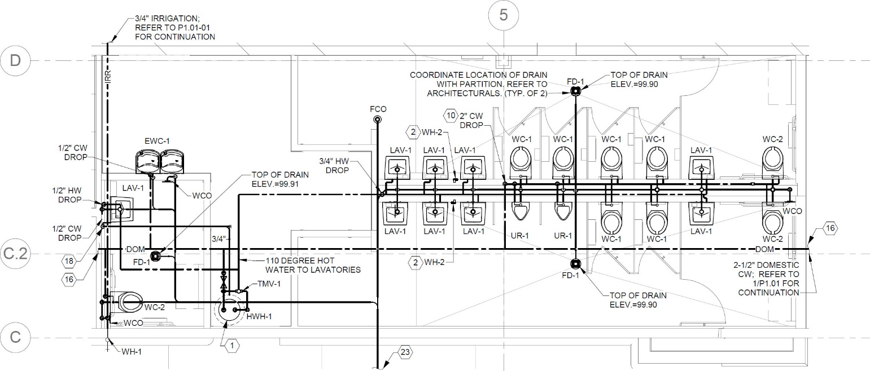

1. Determine the total DFUs for the riser shown at each location indicated.

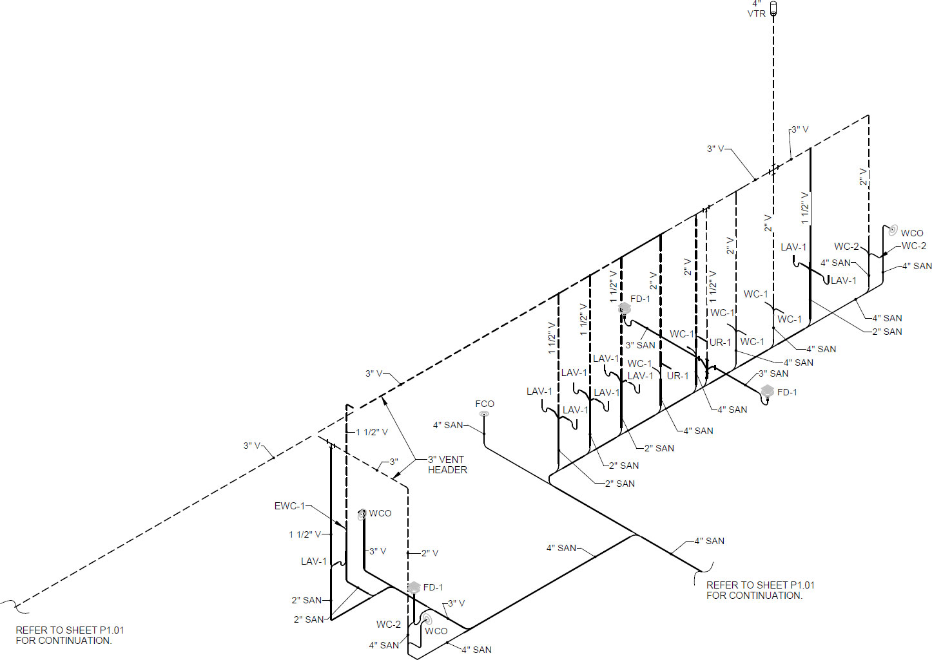

DFU - 1

DFU - 2

DFU - 3

1. For the residential site shown use the Rational Method to determine the peak runoff rate (gpm) and volume (gallons) for the drainage area given. The rainfall intensity is 4.2 in/hr.

