CMGT 235 Electrical and Mechanical Systems

Exam #2 – Plumbing Systems - 20 points each question

Use 2016 California Plumbing Code. Show all work for full credit

**Answers**

Name: __________________________________________________________________________________

1. Determine the Meter and Street Service size and the Building Supply and Branches Pipe size for the Dwelling shown. MDSSPA = 80 psi. The highest water outlet in the building is 9 feet above the source of supply. Pressure loss due to the meter is 5 psi. The maximum developed length of the piping between the source of supply and the furthest fixture is 92 feet. Each side of the house has a ½" hose bibb.

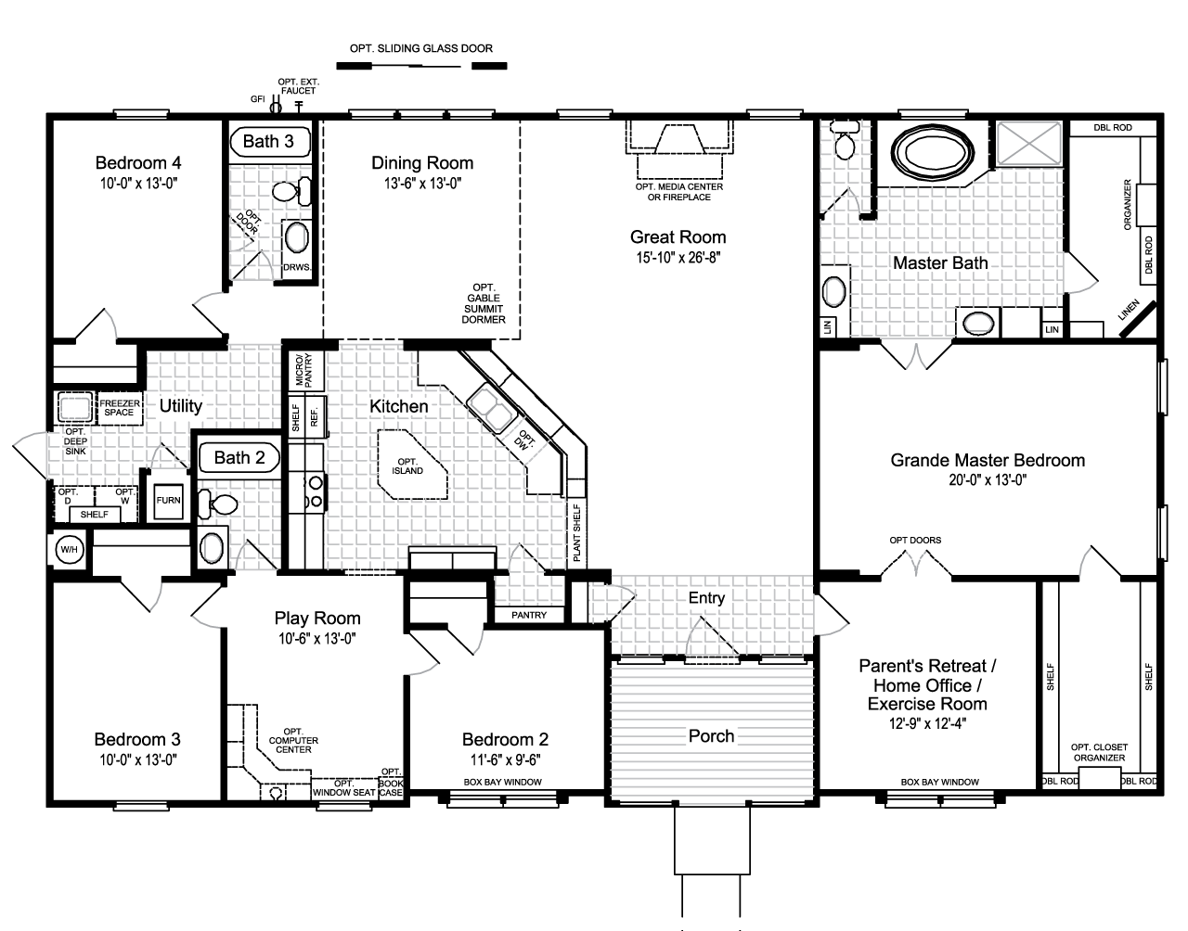

Step 1. Calculate the total WSFU

|  |  |  |  |
| --- | --- | --- | --- |
| QTY | Fixture | WSFU | Total WSFU |
| 2 | BT/SWH | 4.0 | 8.0 |
| 3 | WC | 2.5 | 7.5 |
| 4 | LAV | 1.0 | 4.0 |
| 1 | BT | 4.0 | 4.0 |
| 1 | SHW | 2.0 | 2.0 |
| 1 | LT | 1.5 | 1.5 |
| 1 | CW | 4.0 | 4.0 |
| 1 | KS | 1.5 | 1.5 |
| 1 | DW | 1.5 | 1.5 |
| 4 | HB | 2.5 | 10.0 |
| Total WSFU | | | 44.0 |

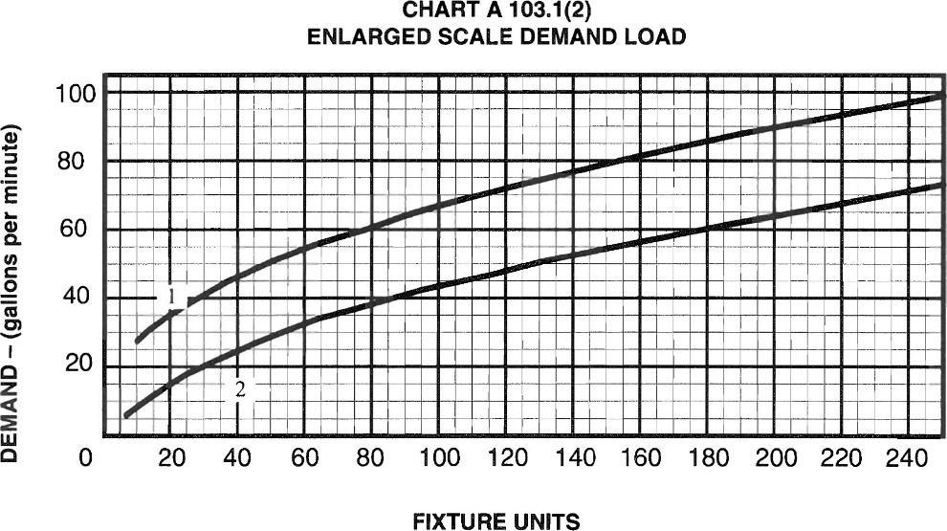

Demand Load = 26 gpm

Step 2. MDSSPA = 80 psi

Modification 1: 9 ft x 0.433 psi/ft = 3.897 psi = 4 psi

Modification 2: pressure loss due to the meter = 5 psi

Available Pressure = 80 – 4 -5 = 71 psi

Step 3. Maximum Developed Length = 1.2 x 92 feet = 110.4 ft = 110 ft

**Summary:**

WSFU = 44

Available Pressure = 71 psi

Effective Maximum Developed Length = 110 ft

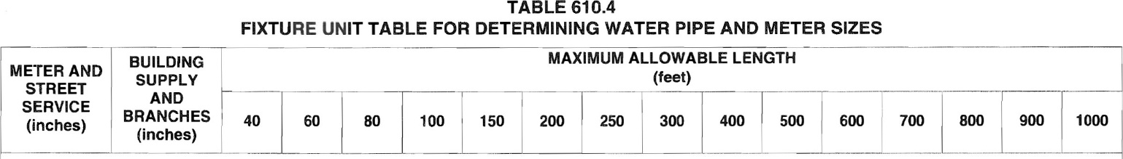

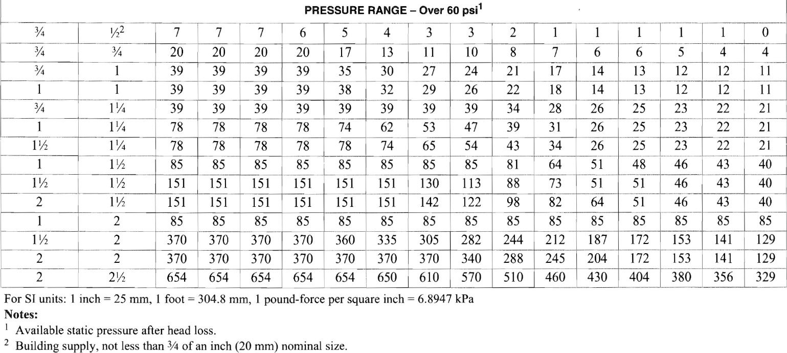

Meter and Street Service = 1 inch

Building Supply and Branches = 1 ¼ inches

1. A busy airport has installed WaterSense toilets in all of the restrooms and 0.35 GPM aerators on the Lav faucets. If during a 24-hour period 3500 people use the toilet and wash their hands, how many gallons of water will be used? What is the percentage improvement from baseline fixtures?

Flush Fixture

Design Baseline

WC 1.28 gpf x 1 x 3500 = 4480 gal 1.6 gpf X 1 X 3500 = 5600 gal

Flow Fixture

Design Baseline

LAV 0.35 gpm x 30s x 1min/60s x 3500 = 612.5 gal 0.5 x 30s x 1min/60s x 3500 = 875 gal

Total Design Baseline

5092.5 gal 6475 gal

% Improvement from Baseline = [(6475 – 5092.5) / 6475] x 100 = 21.35 = 21%

1. A five-story office building has the restroom fixtures shown below on each floor. There is also one kitchen sink and a dishwasher in the staff room and a service sink in a janitor’s closet on each floor. In July, the cooling tower requires 3 gpm for makeup water and the irrigation system requires 8 gpm. What flow rate should the service be designed to handle (in gpm)?

WC-1 Wall hung, Flushometer Valve Water Closet

WC-2 Wall hung, Flushometer Valve Water Closet

UR-1 Flushometer Valve Urinal

LAV-1 Lavatory

EWC-1 Split Level Water Cooler

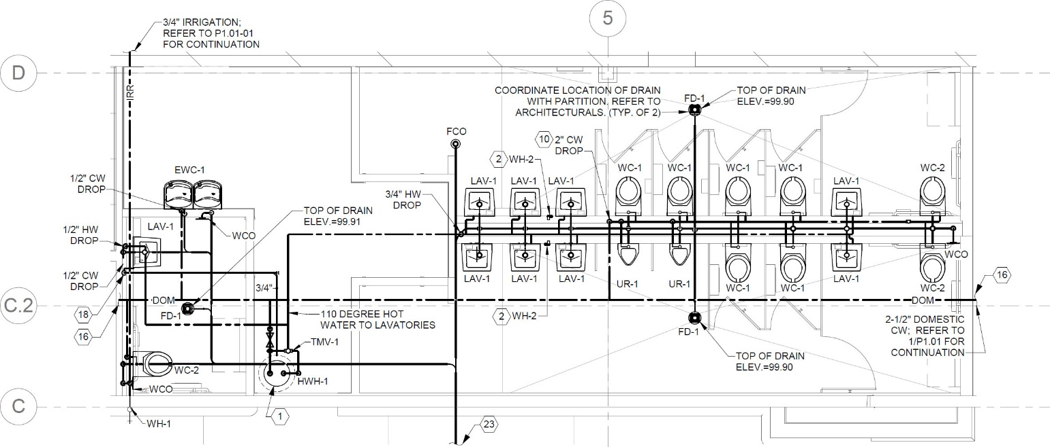

Each Floor

9 WC

2 UR

**X 5 Floors**

9

LAV

1 EWC

Table 610.10

TOTAL WSFU = 45 WC (115 + 40 X10) + 1 UR (58 + 5X5) + 45 LAV (45.0) + 5 EWC (5X0.5) + 5 KS (5X1.5) + 5 DW (5X1.5) + 5 SS (5X 3.0)

TOTAL WSFU = 515 + 83 + 45 + 2.5 + 7.5 + 7.5 + 15.0 = 675.5 WSFU’

From Chart A 103.1(1) (Next Page)

Demand = 170 gpm

Total Flow Rate = 170 gpm + 3 gpm + 8 gpm = 181 gpm

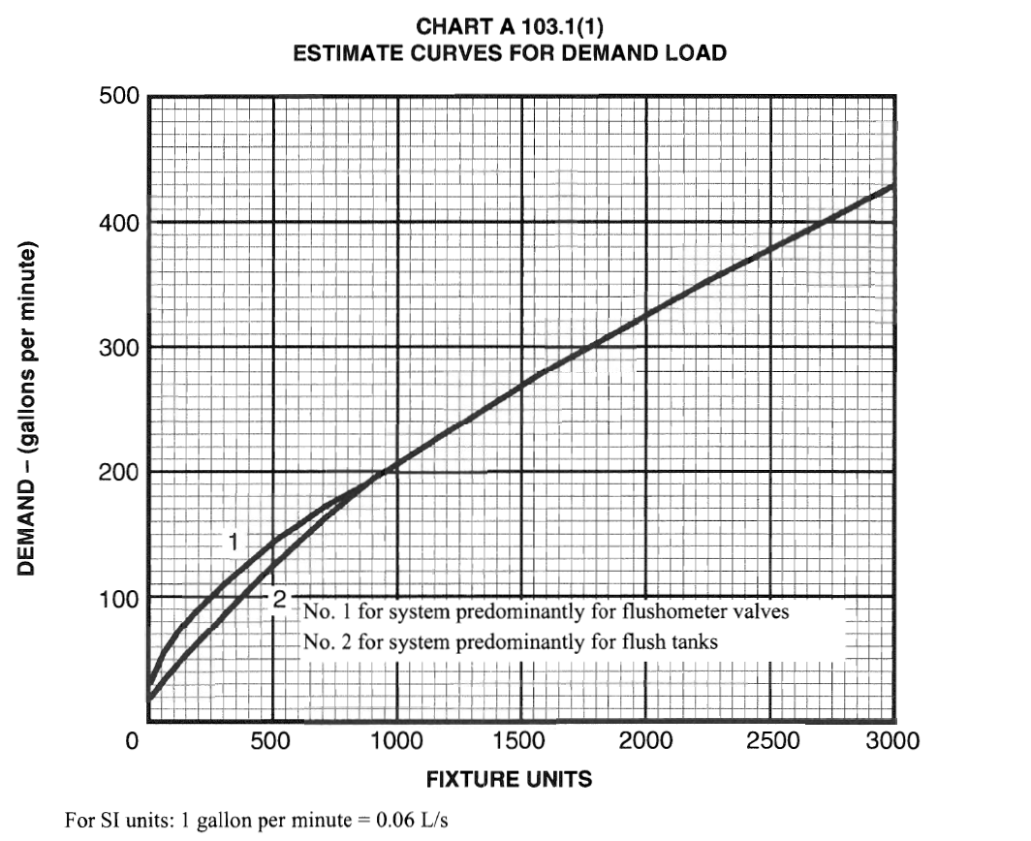

1. Determine the total DFUs for the riser shown at each location indicated.

[Table 702.1]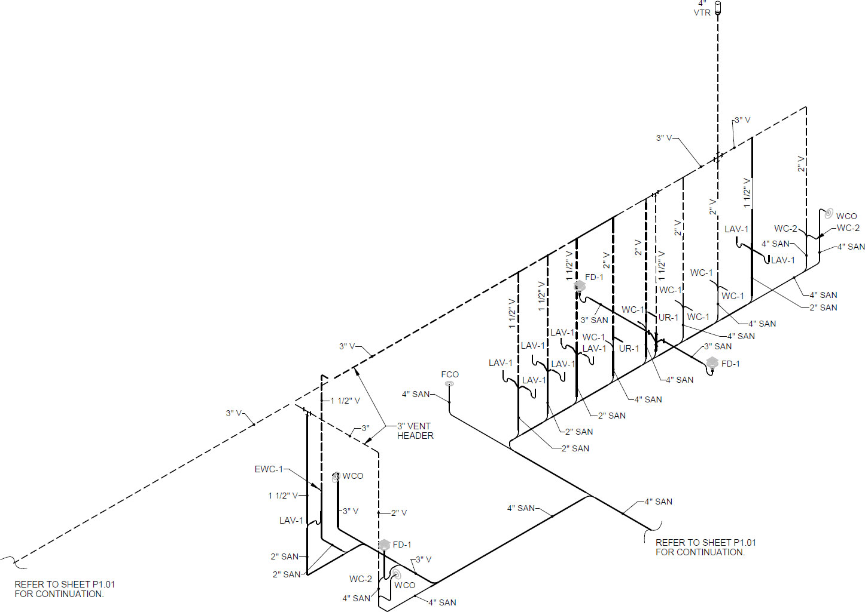

68.0

DFU - 3

56.0

DFU - 2

DFU - 1

12.0

6.0

1.0

1.0

6.0

6.0

4.0

2.0

2.0

4.0

4.0

4.0

4.0

4.0

4.0

4.0

1.0

1.0

1.0

1.0

1.0

1.0

1.0

1.0

4.0

1. For the residential site shown use the Rational Method to determine the peak runoff rate (gpm) and volume (gallons) for the drainage area given. The rainfall intensity is 4.2 in/hr.



The Rational Method equation is: Q = C x I x A where:

Q = Storm Water Runoff (in cubic feet per second)

C = Coefficient of Runoff

I = Rainfall Intensity (in inches per hour)

A = Area of Drainage Zone (in acres)

The equation above can be modified to give you runoff in gallons per minute.

The modified equation is: Q = (C x I x A) / 96.23 where:

Q = Storm Water Runoff (in gallons per minute, gpm)

C = Coefficient of Runoff

I = Rainfall Intensity (in inches per hour)

A = Area of Drainage Zone (in square feet)

Concrete Area

20 ft x 16 ft + 3 ft x 32 ft = 416 ft2

Compact Gravel Area

12 ft x 30 ft + ½ x (10 ft x 9 ft) + 3 ft x 10 ft = 435 ft2

Grass Area

10 ft x 58 ft + 17 ft x 42 ft – 45 ft2 = 1249 ft2

Q = [(0.90 x 416) + (0.70 x 435) + (0.35 x 1249) x 4.2] / 96.23 = [(374.4 + 304.5 + 437.15) x 4.2)]/96.23 = 48.7 gpm

Use 60-minute storm:

Volume = 48.7 gpm x 60 min = 2,922 gal