**CMGT 235 – Electrical and Mechanical Systems**

Department of Construction Management 🏵 California State University, Chico

Exam #2 – Plumbing Systems

Name: ____________________________________________________________________________________

1. For the project, Waste Management Hauling Facility and the drawing P1 Plumbing Plan provided, complete the following:

4 pts

* 1. Using a green, blue, and pink highlighter complete the following on the drawing provided:

Cold Water Main – highlight green

Cold Water Distribution – highlight blue

Hot Water Distribution – highlight pink

15 pts

* 1. Use Table 382.40-2 Water Supply Fixture Units for Public Use (Wisconsin Plumbing Code) to complete the WSFU Table shown below. Water closets are Flushometer and urinals are Syphon Jet. The Mop Sink and Shop Sink are typical service sinks.

|  |  |  |  |  |  |  |  |
| --- | --- | --- | --- | --- | --- | --- | --- |
| Water Supply Fixture Units | | | | | | | |
| Fixture | # of Fix. | HOT WSFU | | COLD WSFU | | TOTAL WSFU | |
| EACH | THIS JOB | EACH | THIS JOB | EACH | THIS JOB |
|  |  |  |  |  |  |  |  |
|  |  |  |  |  |  |  |  |
|  |  |  |  |  |  |  |  |
|  |  |  |  |  |  |  |  |
|  |  |  |  |  |  |  |  |
|  |  |  |  |  |  |  |  |
|  |  |  |  |  |  |  |  |
|  |  |  |  |  |  |  |  |
|  |  |  |  |  |  |  |  |
|  |  |  |  |  |  |  |  |
| TOTALS |  |  |  |  |  |  |  |

3 pts

* 1. Use the Interpolation Method and the values from Using Table 382.40-3 Conversion of Water Supply Fixture Units to Gallons Per Minute to determine the Total GPM for the total building load. Show all work.

Total Building Load = __________________ WSFU

* 1. Assign the load to the cold main immediately before the water heater

8 pts

🡪 (total load downstream + hot load upstream)

|  |  |  |  |  |  |  |  |  |  |  |  |  |  |  |  |  |  |  |  |  |  |  |  |  |  |  |  |  |  |  |  |  |  |  |  |  |  |  |  |  |  |  |  |  |  |
| --- | --- | --- | --- | --- | --- | --- | --- | --- | --- | --- | --- | --- | --- | --- | --- | --- | --- | --- | --- | --- | --- | --- | --- | --- | --- | --- | --- | --- | --- | --- | --- | --- | --- | --- | --- | --- | --- | --- | --- | --- | --- | --- | --- | --- | --- |
| **Total Load Downstream**   |  |  | | --- | --- | | **Fixture** | **Total WSFU** | |  |  | |  |  | |  |  | |  |  | |  |  | |  |  | |  |  | |  |  | |  |  | | **TOTAL** |  | | **Hot Load Upstream**   |  |  | | --- | --- | | **Fixture** | **Hot WSFU** | |  |  | |  |  | |  |  | |  |  | |  |  | |  |  | |  |  | |  |  | |  |  | | **TOTAL** |  | |

**Total Load Downstream** ___________ + **Hot Load Upstream** ___________ = ___________**Total Cold Main**

**Before water heater**

8 pts

* 1. Assign the load to the cold main coming from the water meter.

🡪Total Load Upstream (all blue pipes from green main before water heater) – Hot Load (Same Fixtures)

|  |  |  |  |  |  |  |  |  |  |  |  |  |  |  |  |  |  |  |  |  |  |  |  |  |  |  |  |  |  |  |  |  |  |  |  |  |  |  |  |  |  |  |  |  |  |  |  |  |  |  |  |  |  |  |  |  |  |  |  |  |  |  |  |  |  |  |  |  |  |
| --- | --- | --- | --- | --- | --- | --- | --- | --- | --- | --- | --- | --- | --- | --- | --- | --- | --- | --- | --- | --- | --- | --- | --- | --- | --- | --- | --- | --- | --- | --- | --- | --- | --- | --- | --- | --- | --- | --- | --- | --- | --- | --- | --- | --- | --- | --- | --- | --- | --- | --- | --- | --- | --- | --- | --- | --- | --- | --- | --- | --- | --- | --- | --- | --- | --- | --- | --- | --- | --- |
| **Total Load Upstream**   |  |  | | --- | --- | | **Fixture** | **Total WSFU** | |  |  | |  |  | |  |  | |  |  | |  |  | |  |  | |  |  | |  |  | |  |  | |  |  | |  |  | |  |  | |  |  | |  |  | |  |  | |  |  | |  |  | |  |  | |  |  | |  |  | |  |  | | **TOTAL** |  | | **Hot WSFU (Same Fixtures)**   |  |  | | --- | --- | | **Fixture** | **Hot WSFU** | |  |  | |  |  | |  |  | |  |  | |  |  | |  |  | |  |  | |  |  | |  |  | | **TOTAL** |  | |

**Total Load Upstream** ___________ - **Hot Load (Same Fixtures)** ___________ = ___________

2 pts

**Total from D.**  ______________ + **Total from E.** ______________ = ______________ **(Building Load)**

* 1. Using a yellow and orange highlighter complete the following on the drawing provided:

1 pt. E

Waste Pipe – highlight yellow

Waste Pipe Cleanouts – highlight orange

Using a blue pen circle the waste vent pipes

What size is the building’s main waste pipe? ____________

What size are the main waste vent pipes? ____________

How many vents are shown? ____________

What size are the waste pipes for the trench drains at the metal roll-up doors? ____________

* 1. What is the capacity of the water heater? ____________
  2. How many floor drains are shown on the plan? ____________
  3. What size are the waste pipes for the floor drains? ____________
  4. What type of pipe is specified on the drawing P1 for the hot and cold water piping?
  5. What type of pipe is specified in the specifications (DIV15) for the hot and cold water piping?
  6. What brands are specified for the fixtures, faucets, and drains in the specifications?
  7. What brand in specified for the fixtures in Addendum #2?
  8. What is a hub drain?
  9. What type pipe is specified for sanitary, waste, and vent piping?

1. Determine the Meter and Street Service size and the Building Supply size for the Dwelling shown. MDSSPA = 80 psi. The highest water outlet in the building is 12 feet above the source of supply. Pressure loss due to the meter is 5 psi. The water softener has a pressure loss of 9 psi. The maximum developed length of the piping between the source of supply and the furthest fixture is 140 feet. Each side of the house has a ½" hose bibb. The owner selected all the options as shown on the plan. Use 2016 California Plumbing Code.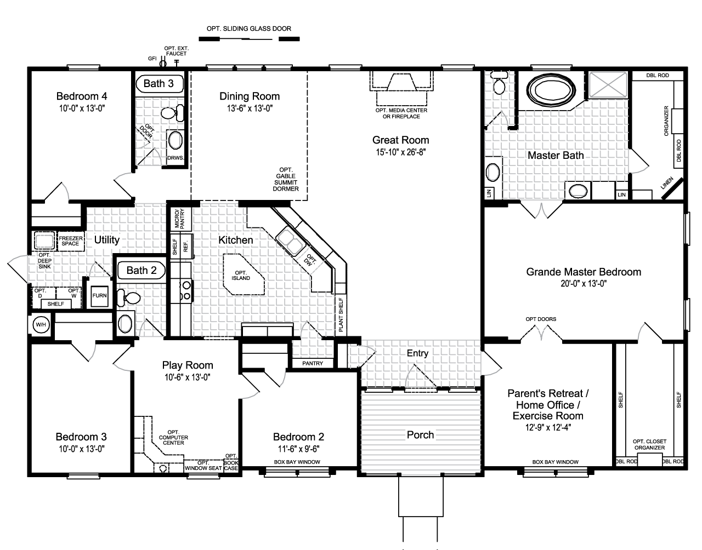

16 pts

**Step 1.** Calculate the Available Water Pressure

**Step 2.** Find the Effective Maximum Developed Length (DL) of Pipe

**Step 3**. Calculate the total WSFU

|  |  |  |  |
| --- | --- | --- | --- |
| **QTY** | **FIXTURE** | **WSFU** | **TOTAL WSFU** |
|  |  |  |  |
|  |  |  |  |
|  |  |  |  |
|  |  |  |  |
|  |  |  |  |
|  |  |  |  |
|  |  |  |  |
|  |  |  |  |
|  |  |  |  |
|  |  |  |  |
| **TOTAL WSFU** | | |  |

**Step 4.** Use the 2016 CPC Table 610.4 complete the table below for your results:

|  |  |
| --- | --- |
| **Pressure Range** |  |
| **Maximum Allowable Length** |  |
| **Distribution Piping** | **Pipe Size (inches)** |
| Meter and Street Service |  |
| Building Supply |  |

1. For the commercial building sanitary isometric shown place the DFU value next to each fixture. Place the DFU totals at the locations shown. Use the 2016 California Plumbing Code.

18 pts

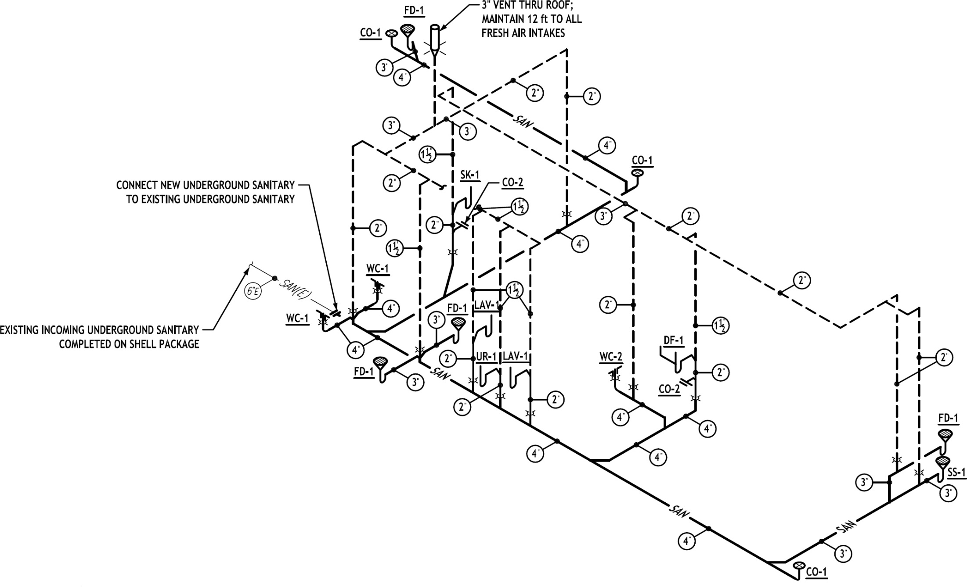

Legend

LAV-1 LAVATORY

WC-1 WATER CLOSET, FLUSHMETER

WC-2 WATER CLOSET, FLUSHMETER

UR-1 URINAL, INTERGRAL TRAP

FD-1 3” FLOOR DRAIN

DF-1 DRINKING FOUNTAIN

SK-1 SINK, WASH, 1 SET FAUCETS

SS-1 SINK, SERVICE

DFU - 6

DFU - 5

DFU - 4

DFU - 3

DFU - 2

DFU - 1

1. Determine the vertical and horizontal drain sizes for a building located in Wilmington, NC for the roof drain design shown. Use the 2016 CPC Appendix D rainfall rate with no amendments.

10 pts

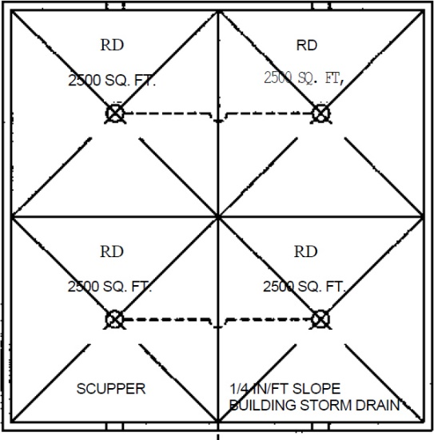

Show all calculations

1. Minimum Drain Size for the roof drainage design shown.
2. Minimum Horizontal Drain Size

Roof Area = 2500 sq. ft.

Roof Area = 5000 sq. ft.

Roof Area = 10,000 sq. ft.

1. If one leader serves the entire roof area what is the minimum size pipe required?