**CMGT 235 – Electrical and Mechanical Systems**

Department of Construction Management 🏵 California State University, Chico

Exam #2 – Plumbing Systems

All problems refer to the California Plumbing Code 2016 [Unless Noted Otherwise]

Name: ____________________________________________________________________________________

1. Determine the Meter and Street Service size and the Building Supply size for the Dwelling shown. MDSSPA = 80 psi. The highest water outlet in the building is 9 feet above the source of supply. Pressure loss due to the meter is 5 psi. The water softener has a pressure loss of 9 psi. The maximum developed length of the piping between the source of supply and the furthest fixture is 205 feet. Each side of the house has a ½" hose bibb. The owner selected all the options as shown on the plan. Use 2016 California Plumbing Code.

**Step 1.** Calculate the Available Water Pressure

**Step 2.** Find the Effective Maximum Developed Length (DL) of Pipe

**Step 3**. Calculate the total WSFU

|  |  |  |  |
| --- | --- | --- | --- |
| **QTY** | **FIXTURE** | **WSFU** | **TOTAL WSFU** |
|  |  |  |  |
|  |  |  |  |
|  |  |  |  |
|  |  |  |  |
|  |  |  |  |
|  |  |  |  |
|  |  |  |  |
|  |  |  |  |
|  |  |  |  |
|  |  |  |  |
| **TOTAL WSFU** | | |  |

**Step 4.** Use the 2016 CPC Table 610.4 complete the table below for your results:

|  |  |
| --- | --- |
| **Pressure Range** |  |
| **Maximum Allowable Length** |  |
| **Distribution Piping** | **Pipe Size (inches)** |
| Meter and Street Service |  |
| Building Supply |  |

1. A local restaurant has an occupancy of 250 people.
   1. Using the CPC 2016 complete the table for the required number of fixtures per person.

|  |  |  |  |  |  |  |
| --- | --- | --- | --- | --- | --- | --- |
| Water Closets | | Urinals | Lavatories | | Bathtubs or Showers | Drinking Fountains |
| Male | Female | Male | Male | Female |  |  |
|  |  |  |  |  |

* 1. Where in the CPC 2016 did you find the requirements?
  2. What other fixtures are required?

1. The cold-water piping for a public female restroom is shown below. The water closets have flushometer valves.
   1. What table is applicable to determining the WSFUs?
   2. Determine the total WSFU for the cold-water load.

WC

WC

WC

WC

WC

WC

WC

WC

LAV

LAV

LAV

LAV

1. For a public rest room:
   1. What is the minimum size of a toilet compartment and where in the CPC 2016 is it specified?
   2. What is the required clearance in front of a lavatory and where in the CPC 2016 is it specified?
2. Determine the total DFU for the 8 public flushometer toilets and 6 lavatories. What size vent is required for the total DFU and what is the maximum length the vent can be?

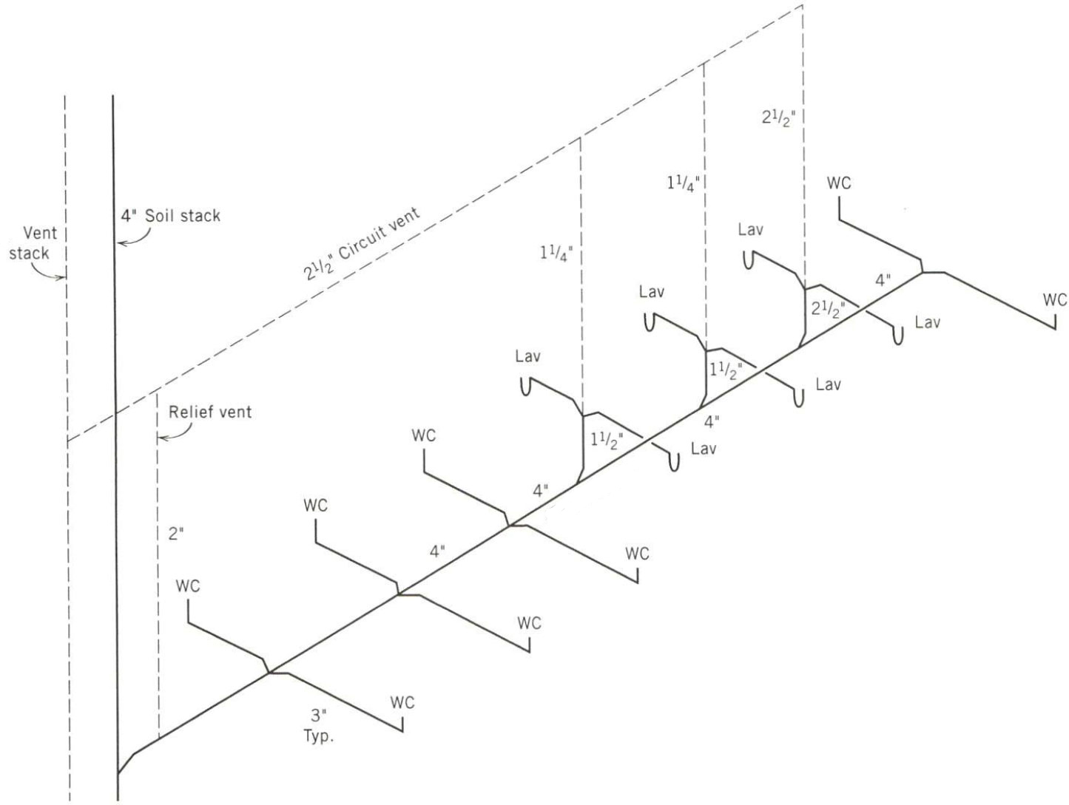

1. For the basic home shown indicate the complete the table shown below.

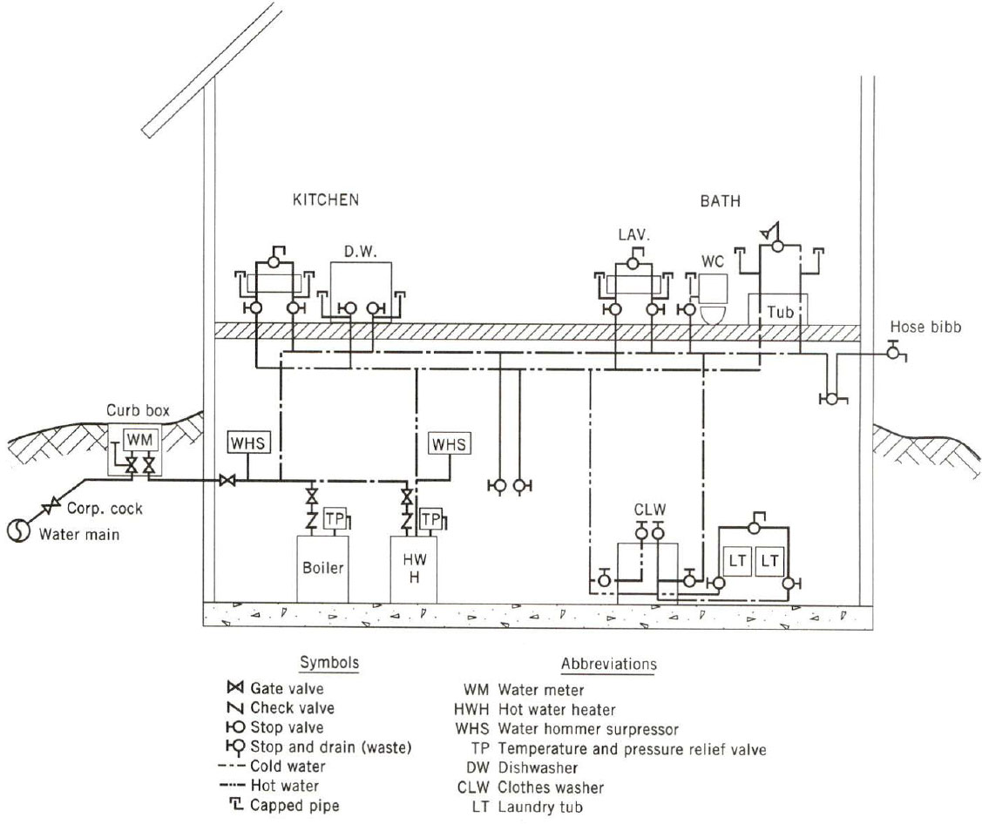

|  |  |  |  |  |  |  |  |
| --- | --- | --- | --- | --- | --- | --- | --- |
| Water Supply Fixture Units | | | | | | | |
| Fixture | # of Fix. | HOT WSFU | | COLD WSFU | | TOTAL WSFU | |
| EACH | THIS JOB | EACH | THIS JOB | EACH | THIS JOB |
|  |  |  |  |  |  |  |  |
|  |  |  |  |  |  |  |  |
|  |  |  |  |  |  |  |  |
|  |  |  |  |  |  |  |  |
|  |  |  |  |  |  |  |  |
|  |  |  |  |  |  |  |  |
|  |  |  |  |  |  |  |  |
|  |  |  |  |  |  |  |  |
|  |  |  |  |  |  |  |  |
| TOTALS |  |  |  |  |  |  |  |

TOTAL GPM _____________________

1. Determine the total DFU for the private residence shown.

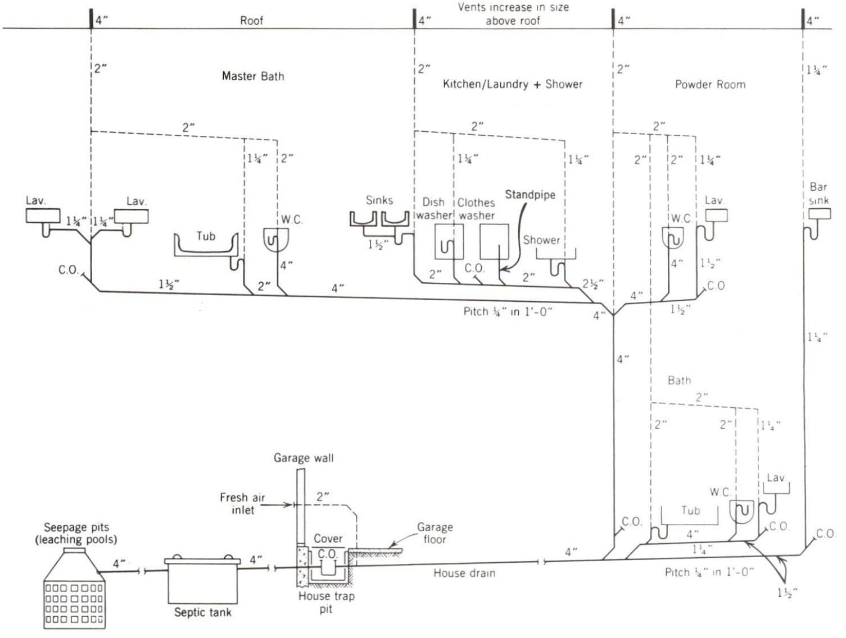

1. The problem of accommodating thermal expansion of piping is particularly important for hot water and steam piping. Amount of expansion depends on:
2. Type of piping used
3. Temperature change

Linear expansion of a pipe is given by the equation: ∆L = C x L x ∆T

Where,

C = Expansion Coefficient

L = length of pipe

∆T = temperature differential

Expansion Coefficients (C)

|  |  |
| --- | --- |
| **Material** | 10-6 in/in °F |
| Aluminum | 12.8 |
| Steel | 6.5 |
| Cast Iron | 5.9 |
| Copper | 9.3 |
| Stainless Steel | 9.9 |
| ABS Acrylonitrile butadiene styrene | 35.0 |
| HDPE High density polyethylene | 67.0 |
| PE Polyethylene | 83.0 |
| CPVC Chlorinated polyvinyl chloride | 44.0 |
| PVC Polyvinyl chloride | 28.0 |

In a school building the distance between the hot water boiler and the cafeteria dishwasher is 150 ft. What is the increase in length of the hot water piping from a “resting” condition (shutdown) of 50⁰F to an operating condition carrying 140⁰F water

(a) using copper pipe?

(b) using CPVC plastic pipe?

1. Determine the horizontal and vertical drainage pipe size for 5,000 square feet of roof area (1/8” slope per 12” of pipe) on a building located in Dallas, TX.
2. For a 4-inch horizontal storm drain, what is the maximum projected roof area if the slope of the drain is ¼-inch per 1 ft of pipe? What table is used to find the answer?
3. Determine the number of 5” roof drains required for a roof area of 230,000 sq. ft located in Denver, Colorado.
4. What is BMP an acronym for? ______________________________________________________
5. What federal act was passed in 1972 to regulate the discharge of pollutants to receiving waters such as oceans, bays, rivers, and lakes?
6. What is a system that conveys both sewage and stormwater to sewage treatment plants before the treated effluent is discharged to receiving water bodies called?