CMGT 235 – Electrical and Mechanical Systems
Department of Construction Management California State University, Chico
Exam #2 [100 points]
You may work with one person or individually. Every student SHALL complete their own answer sheet.

Name:
Name:

- Complete the following steps for the dwelling plan provided. The owner has approved all options shown.
Step 1. Calculate the Available Water Pressure
MDSSPA = 60 psi
Highest Fixture = 10 feet above the source of supply
Meter Pressure loss = 5 psi
Water Softener Pressure Loss = 9 psi

Step 2. Determine the Effective Maximum Developed Length (DL) of Pipe
Length of pipe to the Furthest Fixture = 105 feet

Step 3. Complete the WSFU table below. [2016 CPC - Table 610.3]
Mark all fixtures shown on the plan using a yellow highlighter.
There is a total of five ½" hose bibbs: three on one supply segment and two on another supply segment.
Water Supply Fixture Units
Fixture | # of Fix. | HOT WSFU |  | COLD WSFU |  | TOTAL WSFU
 |  | EACH | THIS JOB | EACH | THIS JOB | EACH | THIS JOB
SHW
BT
BT/SHW
LAV
WC FT
KS
DW
CW
LT
HB
TOTALS

Step 4. Use the 2016 CPC Table 610.4 complete the table below for your results:
2016 CPC - Table 610.4
Pressure Range
Maximum Allowable Length
Distribution Piping | Pipe Size (inches)
Meter and Street Service
Building Supply
Cold Water Supply
Hot Water Supply
- For the private residence shown write the individual DFU value above each fixture and determine the total DFU at the points indicated.

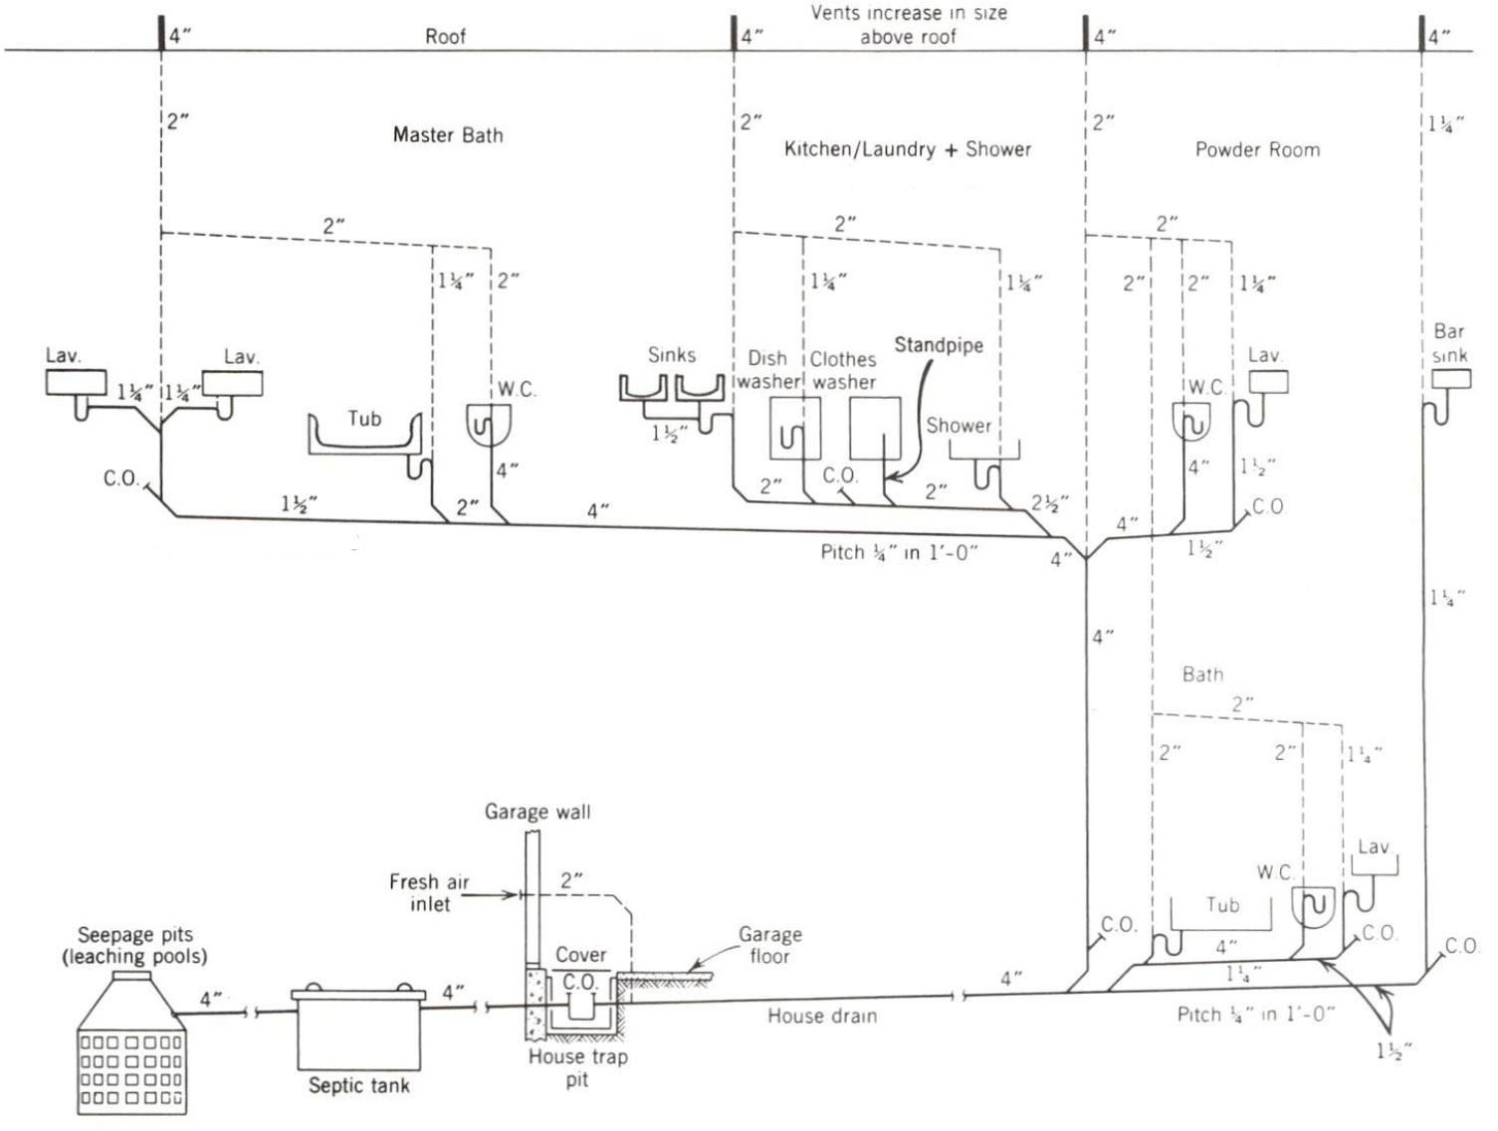

- For the 2-line drawing shown complete the 1-line drawing by replacing each fitting in the locations shown with its corresponding symbol found on drawing P-011 located on lorisweb.com [CMGT 235 DIS 20].

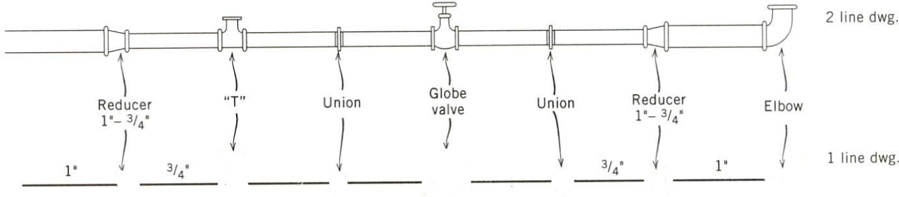

- For the residential site shown use the Rational Method to determine the peak runoff rate (gpm) and volume (gallons) for the drainage area given. The rainfall intensity is 8.0 in/hr.

- For a building in Wilmington, NC, determine the minimum size roof drain, horizontal pipe, and leader pipe for the roof shown. Use the 2016 CPC Appendix D rainfall rate with no amendments.

