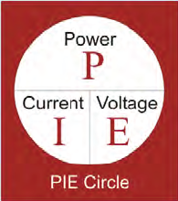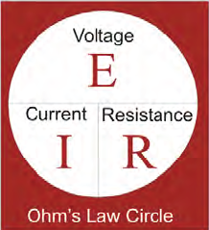**CMGT 235 – Electrical and Mechanical Systems**

Department of Construction Management 🏵 California State University, Chico

Homework #20 – Electrical Fundamentals

Points: 20

Due: 11/1/2022

Name: ______________________________________________________________________________________

[12 pts]

1. Two loads are connected in parallel to a 120 V source. If the 60 W lamp is left on for 8 hr/day and the  
   75 W lamp is left on for 18 hr/day calculate the current in each load, the total current, the resistance of each load, the total resistance in the circuit, the total energy consumed in a year for each load, and the cost of electrical energy for each load for the year (based on $0.25/kWh). Complete all work in space provided.



**60 W**

**75 W**

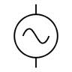

**120 V**

**IT**

**I1**

**I2**

**Current**

I1 =

I2 =

IT =

**Resistance**

R1 =

R2 =

RT =

**Power**

PT =

**Energy (Yr)**

(60 W)

E1 =

(75 W)

E2 =

**Cost (Yr)**

(60 W)

$1 =

(75 W)

$2 =

**Total Cost (Yr) = ____________________________________________________________**

[4 pts]

1. The transformer is used to step down the voltage from 13,400 volts to 480 volts. If the secondary coil contains 500 turns, how many turns are found on the primary coil?

[4 pts]

1. A 25 HP Motor, 240V, 3 phase draws 30 A and has a PF = 0.6  
   Find the Apparent Power (KVA), Reactive Power (KVAR), and the True Power (KW)