|  |  |  |
| --- | --- | --- |
| **CMGT 235 – Electrical and Mechanical Systems** | | |
| **Discussion No. 21** | **Unit 3 - Electrical Systems** | **Fall 2022** |

**Power Distribution**

**Power Generation**

* Electricity generation is the process of generating electrical energy from other forms of energy.
* Almost all electrical power on Earth is generated with a turbine of some type.
* Turbines are commonly driven by wind, water, steam or burning gas.
* The turbine drives an electric generator.
* A generator converts mechanical energy into electricity by magnetic induction.

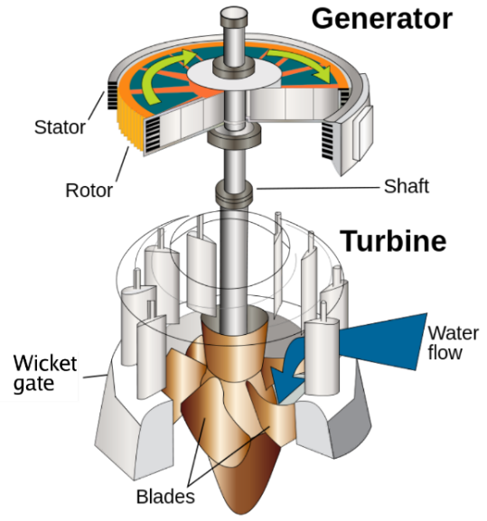

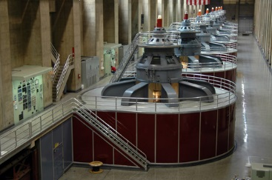

**Power Transmission Lines**

* Transmission lines are sets of wires, called conductors, that carry electric power from generating plants to the substations that deliver power to customers. At a generating plant, electric power is “stepped up” to several thousand volts by a transformer and delivered to the transmission line.

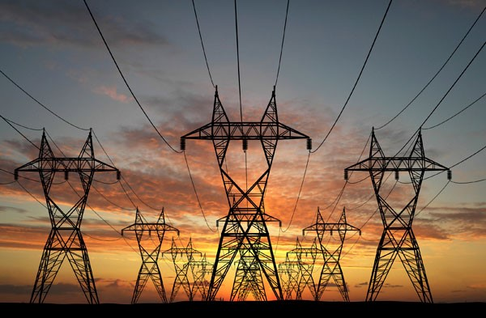

**Power Generation and Transmission**

|  |  |
| --- | --- |
| * The type of transmission structures used for any project is determined by the characteristics of the transmission line’s route, including terrain and existing infrastructure. * This is distinct from the local wiring between high-voltage substations and customers, which is typically referred to as ***electric power distribution***. * At numerous substations on the transmission system, transformers step down the power to a lower voltage and deliver it to distribution lines. Distribution lines carry power to customers. * The combined transmission and distribution network are known as the "power grid" in North America, or just "the grid". |  |

**Low Voltage Distribution Equipment**

**Service Equipment**

**NEC Article 100 Definitions**

*Service Equipment - The necessary equipment, usually consisting of circuit breakers or switches and fuses and their accessories, connected to the load end of service conductors to a building or other structure, or an otherwise designated area, and intended to constitute the main control and cutoff of the supply. Service equipment does not include the metering equipment, such as the meter and/or meter enclosures.*

|  |  |
| --- | --- |
| **Typical Electrical Distribution Equipment**  Switchboards and switchgear  Electrical panelboards – Lighting / Power / Equip.  Transformers  Lighting Control Panel  Disconnect Switches  Motor starters and motor control centers (MCCs) |  |

**Incoming Service – Power**

* All buildings have an electrical service.
* A utility transformer is installed outside the building on a pad (site drawing) or pole.
* Primary service (utility company) is shown on the One-line Diagram, Single-line Diagram, or Riser Diagram.

|  |  |  |
| --- | --- | --- |
|  |  |  |
|  |  |  |

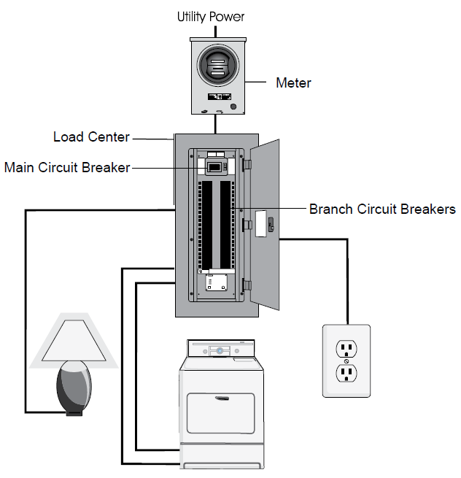

**Common Electrical Distribution Systems**

**Residential**

**Incoming Service Voltage**

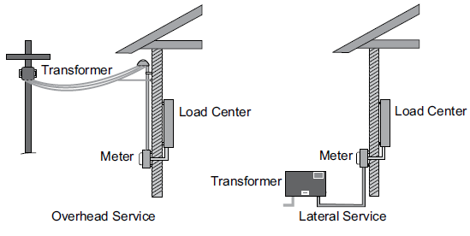

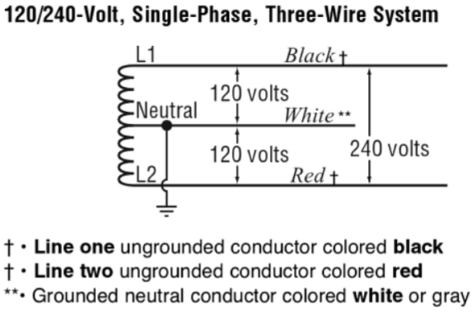

**Commercial / Industrial**

**Incoming Service Voltage**

The most common commercial building electric service in North America is 120/208-Volt wye, which is used to power 120VAC plug loads, lighting, and smaller HVAC systems. In larger facilities the voltage is 277/480-Volt and used to power single phase 277VAC lighting and larger HVAC loads.

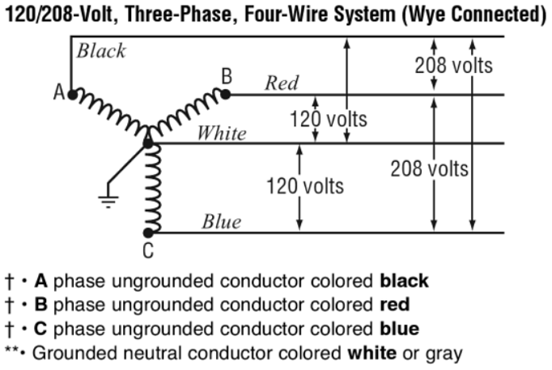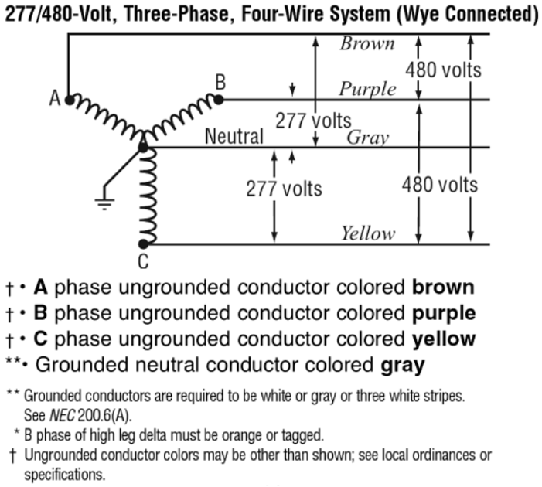

**Uncommon Electrical Service**

Also known as a high-leg or wild-leg delta system. Used in older manufacturing facilities with mostly three-phase motor loads and some 120VAC single-phase lighting and plug loads.

Similar to Three Phase Three Wire Delta but with a center-tap on one of the transformer winding to create neutral for 120VAC single-phase loads.

Motors are connected to phase A, B, and C, while single-phase loads are connected to either phase A or C and to neutral. Phase B, the high or wild leg, is not used as the voltage to neutral is 208VAC.

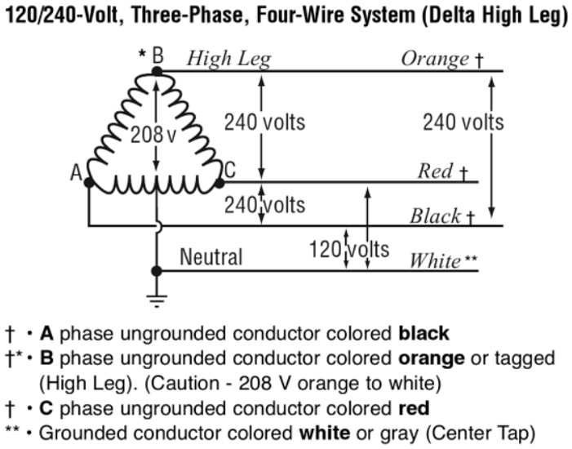

**Commercial and Industrial Power Distribution Equipment**

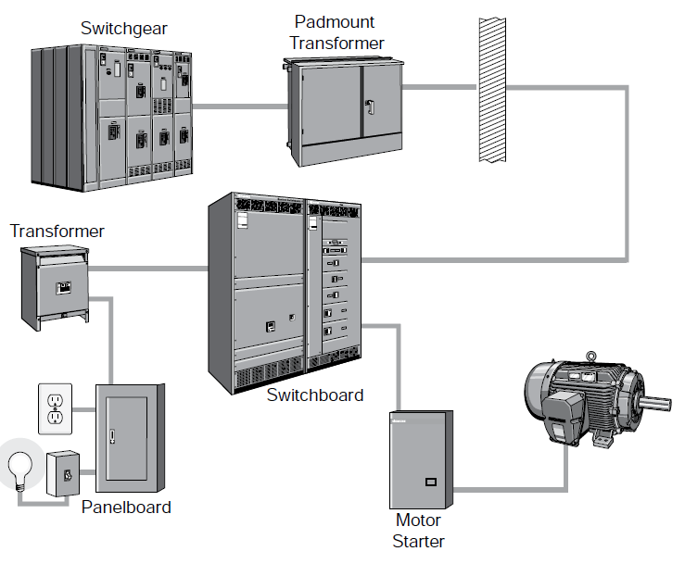

**Switchgear** may or may not be part of the distribution system.

It is typically present if the incoming power provided by the utility company is at a much higher voltage level than the commonly supplied 277/480-volt.

The owner purchases a higher voltage level (5kV, 13.8kV, 15kV) and purchases and maintains the switchgear and step-down transformer(s).

**Switchboards** are generally for voltages less than 600 volts. They are free standing and intended to be accessible from the front and rear.

**Electrical One-Line Diagram**

Drawings or schematics that describe a building’s electrical design are usually referred to as single-line diagrams because all the wires (i.e. 3-phases, neutral, and ground) are represented by a single line connecting all the major components such as; power panels, lighting panels, motor control centers, transformers, disconnects, and building equipment. The one-line may also be shown as a riser diagram.

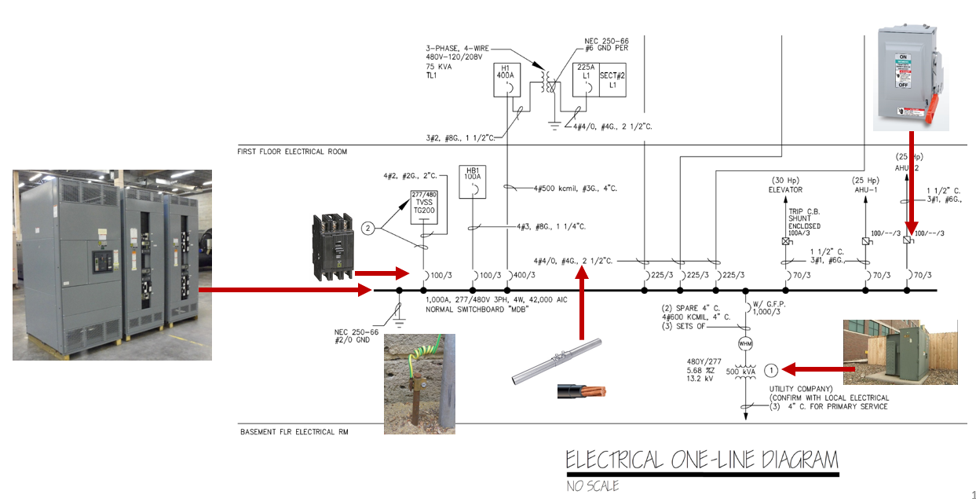

**Utility Primary Transformer**

The power provided to a building all starts at the utility primary transformer. The secondary of the transformer is connected to the switchgear, switchboard, or a panel. The power company “owns” and connects the primary service. The EC connects the secondary to the building distribution.

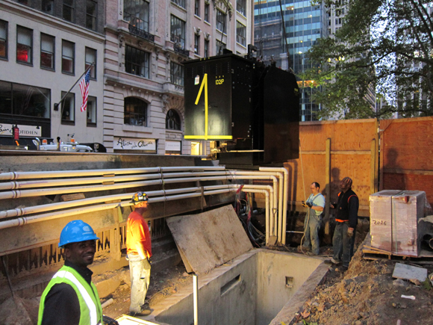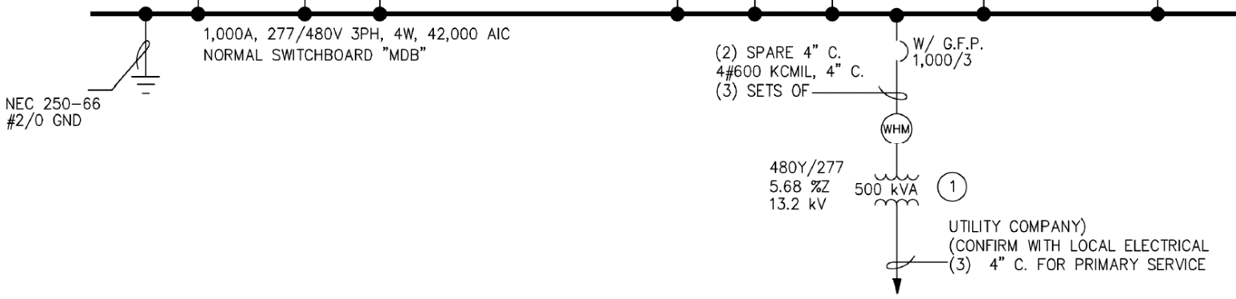

**In-Coming Service – Power**

|  |  |
| --- | --- |
|  |  |

**Power Distribution System Equipment**

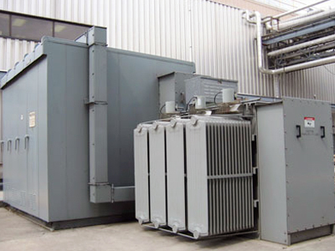 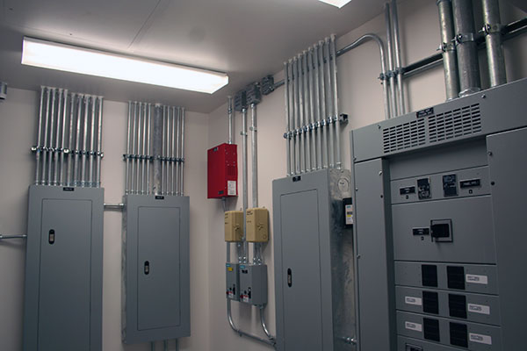

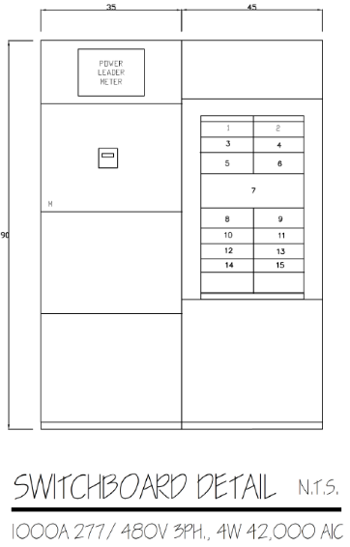**Switchboard**

Main Distribution Board (MDB)

Main Switchboard (MSB)

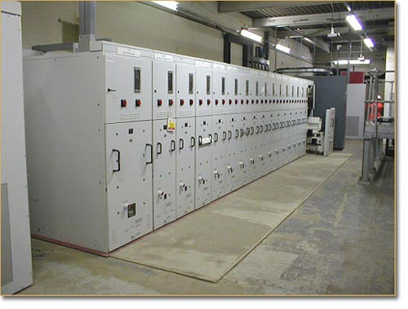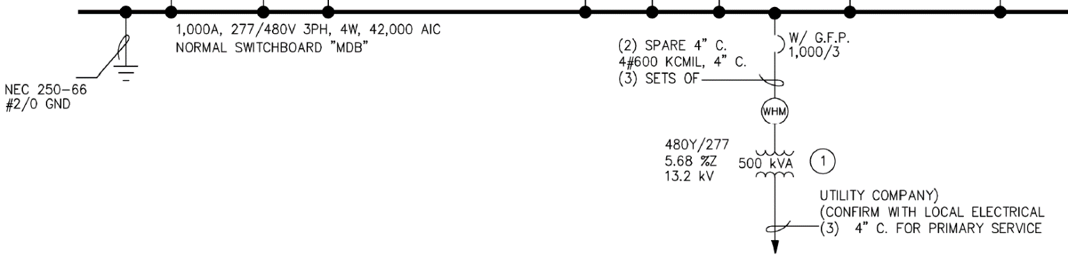

**Sections of a Switchboard**

* Incoming Section
* Meter Main Section
* Distribution Section

Circuit Breakers (CB)

Fusible Switches

* Grounding
* Bonding

**Circuit Breakers**

* A circuit breaker is a switch that automatically interrupts electrical flow in a circuit in case of an overload or short.
* The three types of circuit breakers:

|  |  |  |
| --- | --- | --- |
|  |  |  |
| Standard | GFCI | AFCI |

**3-Pole CB**

The 3-pole circuit breaker is used for three-phase circuits where there is L1, L2, L3 and N wire.

|  |  |
| --- | --- |
| **Grounding**  Article 100 of the NEC defines grounding as, "Establishing a connection, whether intentional or accidental, between an electrical circuit or equipment and the earth or to some conducting body that serves in place of the earth."  A close up of a map  Description automatically generated | **Bonding**  The NEC defines bonding as, "The permanent joining of metallic parts to form an electrically conductive path that ensures electrical continuity and the capacity to conduct safely any current likely to be imposed." |

**Panelboard**

NEC® definition, panelboards are:

* Used to control light, heat, or power circuits
* Placed in a cabinet or cutout box
* Mounted in or against a wall
* Accessible only from the front

National Electrical Code® Article 408, Switchboards and Panelboards. Panelboards are frequently divided into two categories:

* Lighting and appliance branch-circuit panelboards
* Power panelboards (also called distribution panelboards)

MCB MLO

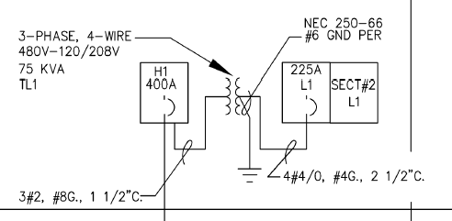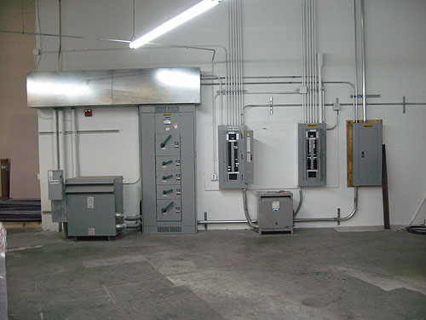

**Safety Switch - Disconnect Switch**

Fusible or Non-Fusible

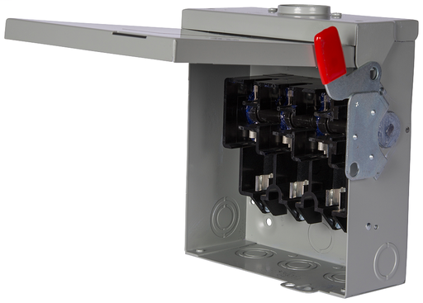250V or 600V

2 Pole or 3 Pole

30A

60A

100A

200A

400A

600A

800A

1200A

**4 & 6-Pole Heavy Duty Safety Switches**

Two-speed, two-winding motors

4-pole switches are also used in 3-phase, 4-wire circuits when a switching neutral is required.

**Electrical Drawings**

The drawings (plans) that are most important for understanding the scope of work for the project’s electrical distribution system are:

* Single-Line Diagram (One-Line Diagram, Electrical Riser Diagram)
* Panel Schedules
* Equipment Schedules and HVAC Schedules
* Lighting Control

**Example Project – Broward Northside, Climate Controlled Storage**

Drawings

E – 02 [Electrical Room, Elevator Equipment Room]

E – 03 [Single-Line Diagram, Exterior Lighting Control]

E – 04 [Panel Schedules, HVAC Equipment Schedules]

**Drawing E-1 Lower Level Electrical Plan**

**Electrical Legend (Partial)**

**Drawing E - 01**

