CMGT 235 – Electrical and Mechanical Systems
Department of Construction Management California State University, Chico
Homework #22 – Electrical Materials - https://www.platt.com/
Points: 20
Due: 11/8/2022
Answers
Name: ______________________________________________________________________________________

Item | Description |  | Item | Description
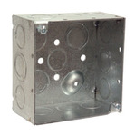 | 4” square metallic box  With knockouts (KO) |  | 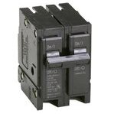 | 2-Pole  Circuit Breaker (CB)
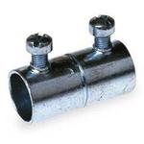 | EMT Coupling (CPLG)  Set Screw (SS) |  | 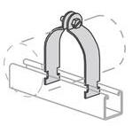 | Strut Strap
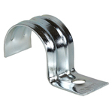 | 1-Hole Strap |  | 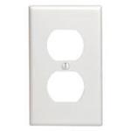 | Cover Plate
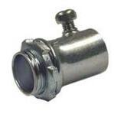 | EMT Connector (CONN)  Set Screw (SS) |  | 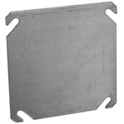 | 4” Square Cover  Metallic
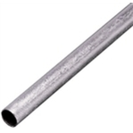 | GRS Conduit |  | 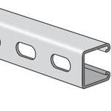 | Channel
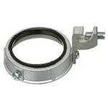 | Ground Bushing |  | 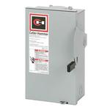 | Disconnect Switch
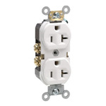 | Receptacle |  | 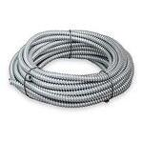 | Flexible Conduit
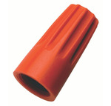 | Wire Nut |  | 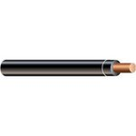 | Building Wire  Copper
Item | Description |  | Item | Description
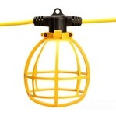 | Temporary Lighting String |  | 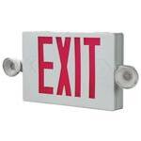 | Exit Light with Emergency Light
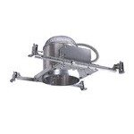 | Recessed Down Light |  | 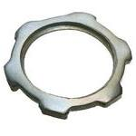 | Locknut

