|  |  |  |
| --- | --- | --- |
| **CMGT 235 – Electrical and Mechanical Systems** | | |
| **Discussion No. 22** | **Unit 3 - Electrical Systems** | **Fall 2022** |

**Electrical Material**

**National Electrical Contractors Association (NECA)**

<http://www.necanet.org/>

NECA is the voice of the $171 billion electrical construction industry that brings power, light, and communication technology to buildings and communities across the U.S.

**NECA Manual of Labor Units (MLU)**

An estimate is only as good as the information it is based on, and the NECA Manual of Labor Units (MLU) has been the estimating resource of choice for electrical contractors since 1923. The MLU provides an experience-based reference for estimating the electrical construction labor required to install typical electrical and communications systems. The labor unit data comes directly from a national average of NECA’s member contractors and is reviewed and updated bi-annually to ensure you have the best information to accurately estimate.

**NECA Categories of Work**

The NECA Manual of Labor Units divides electrical materials into 14 categories. Many electrical contractors use a different breakdown of electrical material for estimating purposes.

SECTION TITLE

01 Integrated Building Systems

02 Conduit, Raceways, Fittings, & Related Items

03 Wire, Cable, Lugs, Terminations, Busway & Bus Duct

04 Switchboards, MCC’s, Panelboards, & Power Equipment

05 Lighting Fixtures, Poles, Parking Lot Lighting

06 Wiring Devices

07 Hazardous Systems

08 Grounding & Lighting Protection Systems

09 Heating Equipment Connections

10 Temporary Power & Lighting

11 Outdoor Overhead and Underground Systems

12 Equipment Installation and Connections

13 Industrial Control and Instrumentation

14 Alternative Energy Systems

**Labor Units**

E = One or per each item

C = Per hundred items

C = Per hundred linear feet of the item

M = Per thousand linear feet of the item

LF = Linear Foot

CY = Cubic Yard

**Labor Units (Installation Conditions)**

NECA 1 Normal (N)

NECA 2 Difficult (D)

NECA 3 Very Difficult (VD)

**MLU 2015-16. Section 02 Conduit, Raceways, Fittings, & Related Items, Page 2-15**

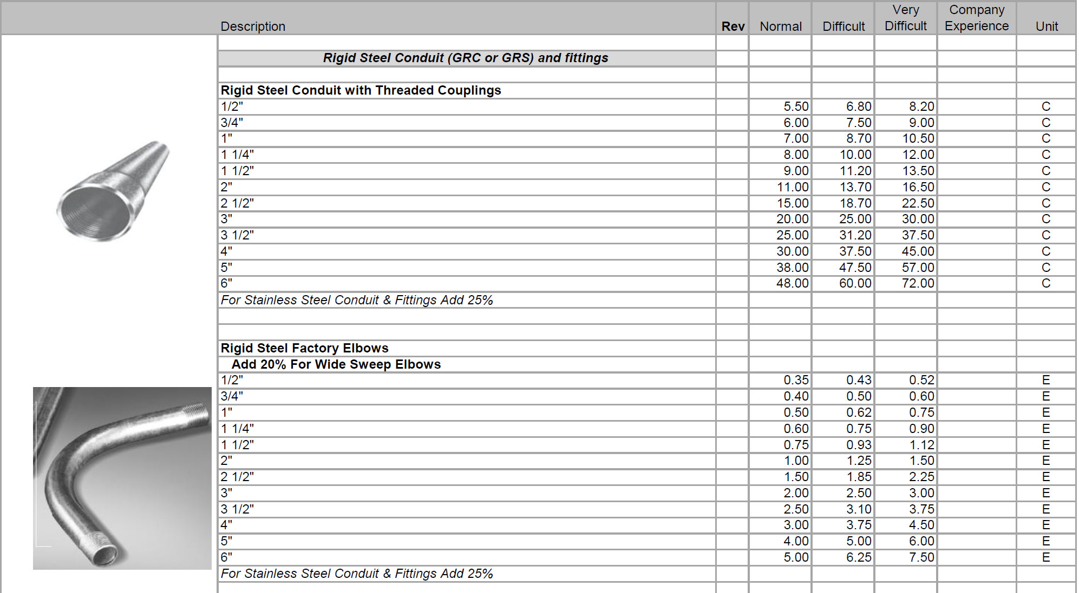

**What’s the difference between the three columns in the MLU?**

The NECA labor unit tables include three different labor units for each item. Users of the MLU are also encouraged to consider labor units between the columns, or even lower than or exceeding the columns when appropriate.

**Normal** Installation Conditions – When all of the conditions associated with the installation of an item will permit the maximum productivity of the electricians on a project, these “normal” column labor units are applicable.

**Difficult** Installation Conditions – When one or more of the conditions associated with the installation of an item will permit less than maximum productivity of the electricians on a typical project, these “difficult” column labor units are applicable.

**Very Difficult** Installation Conditions – When one or more of the conditions associated with the installation of an item will permit substantially less than maximum productivity of the electricians on a typical project, these “very difficult” column labor units are applicable.

**Example 1.**

325 feet of 3 ½" GRC is being installed in a 5" concrete slab.

Determine the total labor.

Determine the total material cost.

**Example 2.**

|  |  |  |  |  |  |  |
| --- | --- | --- | --- | --- | --- | --- |
| **Item** | **Symbol** | **MLU PG No.** | **N** | **D** | **VD** | **Unit** |
| 20A Duplex Receptacle |  | 6-5 | 30.00 | 37.50 | 45.00 | C |
| 20A Duplex Receptacle |  | 6-5 | 30.00 | 37.50 | 45.00 | C |
| Floor Outlet w/Data and 20A Double Duplex Receptacle |  | 6-5 | 30.00 | 37.50 | 45.00 | C |

**MLU 2015-16. Section 06 Wiring Devices, Page 6-5**

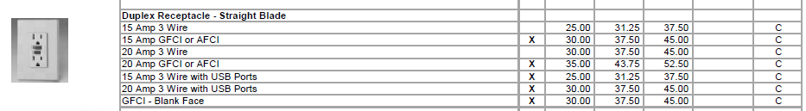

**MLU 2015-16. Section 02 Conduit, Raceways, Fittings, & Related Items, Page 2-21**

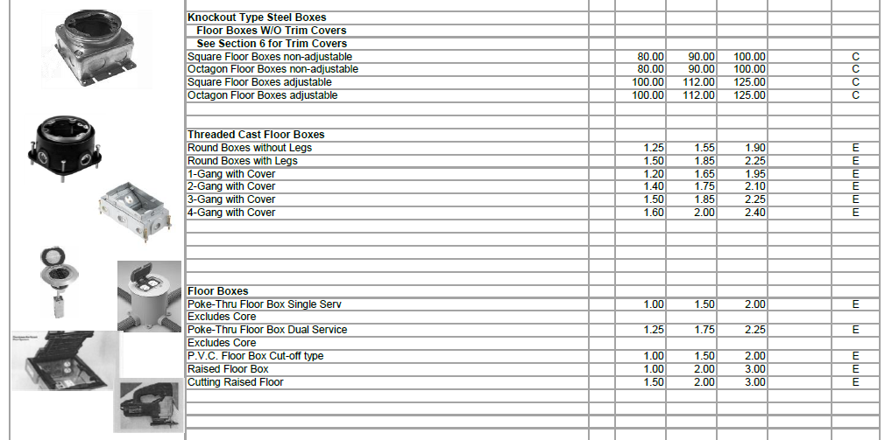

**Floor Box**

**Branch Wiring**

* Branch wiring refers to the conduit and conductors or cable that runs power to each device (receptacles, switches, floor boxes).
* Electrical drawings indicate the branch using either solid or dashed lines. Often the lines are left off the drawings and it is up to the electrical estimator to sketch the branch onto the drawing.
* Most commercial buildings have:
* Power Branch
* Lighting Branch
* Fire Alarm Branch

|  |  |
| --- | --- |
|  |  |

**Material Items**

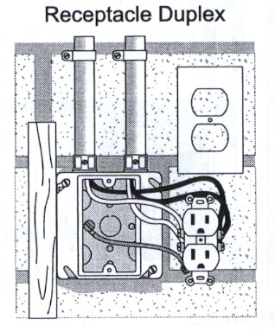4S Box

Box Holder

**Power Branch**

Box Connectors

MC Cable

20A Duplex Receptacle

**Wiring Device**

Receptacle Plate

**Groups of items that make up the installation are**

**called an assembly.**

IF MC Cable is not allowed or the specs call for conduit and

Conductors (pipe and wire) the most commonly used conduit

For indoor receptacles is EMT.

**Example 3. 20A Duplex Receptacle w/ 1/2" EMT**

|  |  |  |  |  |  |  |  |
| --- | --- | --- | --- | --- | --- | --- | --- |
| **20A 125 Volt Duplex Receptacle with ½” EMT** | | | | | | | |
| MATERIAL | QUANTITY | MATERIAL PRICE | PER | MATERIAL EXTENSION | LABOR UNIT | PER | LABOR EXTENSION |
| 4S BOX 3/4" K.O. |  |  |  |  |  |  |  |
| 4S SG P-RING |  |  |  |  |  |  |  |
| 1/2" EMT |  |  |  |  |  |  |  |
| 1/2" EMT CPLG SS |  |  |  |  |  |  |  |
| 1/2" EMT CONN SS |  |  |  |  |  |  |  |
| 1/2" LN & PB SET |  |  |  |  |  |  |  |
| 1/2" 1-H STRAP |  |  |  |  |  |  |  |
| 3/8" SELF DRILL ANCHOR |  |  |  |  |  |  |  |
| #12 THHN WIRE |  |  |  |  |  |  |  |
| 20A DPLX RECEP |  |  |  |  |  |  |  |
| 1-G PLATE |  |  |  |  |  |  |  |
| **Total** |  |  |  |  |  |  |  |

|  |  |  |
| --- | --- | --- |
| Labor Cost at $25.00 |  | $ |
| Material Cost + 15% |  | $ |
| Total Prime Cost | Σ | $ |
| Overhead at $15.00 Per hour |  | $ |
| Break Even Cost | Σ | $ |
| Profit, +15% |  | $ |
| **Unit Price** |  |  |

recep.gif

**Locknut and Plastic Bushing Set (LN & PB Set)**

|  |  |  |  |
| --- | --- | --- | --- |
| **Coupling**  **EMT CPLG SS** | **Connector**  **EMT CONN SS** | **1-Hole Strap**  **1-H Strap** | **Anchor** |
|  |  |  |  |

**Example 4. 20A Single Pole Switch w/ 1/2" EMT**

|  |  |  |  |  |  |  |  |
| --- | --- | --- | --- | --- | --- | --- | --- |
| **20A SINGLE POLE SWITCH w/ 1/2" EMT** | | | | | | | |
| MATERIAL | QUANTITY | MATERIAL PRICE | PER | MATERIAL EXTENSION | LABOR UNIT | PER | LABOR EXTENSION |
| 4S BOX 3/4" K.O. |  |  |  |  |  |  |  |
| 4S SG P-RING |  |  |  |  |  |  |  |
| 1/2" EMT |  |  |  |  |  |  |  |
| 1/2" EMT CPLG SS |  |  |  |  |  |  |  |
| 1/2" EMT CONN SS |  |  |  |  |  |  |  |
| 1/2" LN & PB SET |  |  |  |  |  |  |  |
| 1/2" 1-H STRAP |  |  |  |  |  |  |  |
| 3/8" SELF DRILL ANCHOR |  |  |  |  |  |  |  |
| #12 THHN WIRE |  |  |  |  |  |  |  |
| 20A SP SW |  |  |  |  |  |  |  |
| 1-G PLATE |  |  |  |  |  |  |  |
| **Total** |  |  |  |  |  |  |  |

|  |  |  |
| --- | --- | --- |
| Labor Cost at $25.00 |  | $ |
| Material Cost + 15% |  | $ |
| Total Prime Cost | Σ | $ |
| Overhead at $15.00 Per hour |  | $ |
| Break Even Cost | Σ | $ |
| Profit, +15% |  | $ |
| **Unit Price** |  |  |

s

sw.gif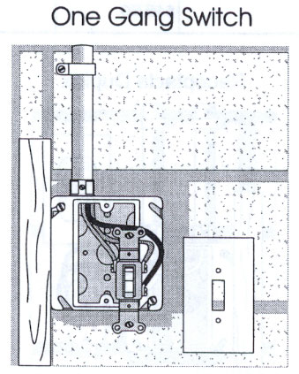

**Example 5. 2x4 FL 4L Lay-In Fixture**

|  |  |  |  |  |  |  |  |
| --- | --- | --- | --- | --- | --- | --- | --- |
| **2X4 FL 4L LAY-IN FIXTURE** | | | | | | | |
| MATERIAL | QUANTITY | MATERIAL PRICE | PER | MATERIAL EXTENSION | LABOR UNIT | PER | LABOR EXTENSION |
| 4S BOX 3/4" K.O. |  |  |  |  |  |  |  |
| 4S COVER |  |  |  |  |  |  |  |
| 1/2" EMT |  |  |  |  |  |  |  |
| 1/2" EMT CPLG SS  Lighting  Branch |  |  |  |  |  |  |  |
| 1/2" EMT CONN SS |  |  |  |  |  |  |  |
| 1/2" LN & PB SET |  |  |  |  |  |  |  |
| 1/2" 1-H STRAP |  |  |  |  |  |  |  |
| 3/8" SELF DRILL ANCHOR |  |  |  |  |  |  |  |
| #12 THHN WIRE |  |  |  |  |  |  |  |
| **Total** |  |  |  |  |  |  |  |
| 2X4 FL 4L LAY-IN FIXTURE |  |  |  |  |  |  |  |
| WHIP FL |  |  |  |  |  |  |  |
| WIRE CONN YELLOW  Fixture |  |  |  |  |  |  |  |
| CEILING CLIPS |  |  |  |  |  |  |  |
| SEISMIC WIRE |  |  |  |  |  |  |  |
| T-BAR FIXTURE CLIPS |  |  |  |  |  |  |  |
| 48” 3500K 78 CRI 32W LAMP (T8) |  |  |  |  |  |  |  |
| **Total** |  |  |  |  |  |  |  |

|  |  |  |
| --- | --- | --- |
| Labor Cost at $25.00 |  | $ |
| Material Cost + 15% |  | $ |
| Total Prime Cost | Σ | $ |
| Overhead at $15.00 Per hour |  | $ |
| Break Even Cost | Σ | $ |
| Profit, +15% |  | $ |
| **Unit Price** |  |  |

2x4.gif