|  |  |  |
| --- | --- | --- |
| **CMGT 235 – Electrical and Mechanical Systems** | | |
| **Discussion No. 23** | **Unit 3 - Electrical Systems** | **Fall 2022** |

**Voltage Drop**

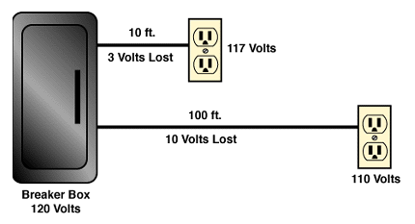

**Most building electrical calculations solve for current or voltage drop.**

**►** Current sets conductor size.

► Excess voltage drop may require an increase in conductor size.

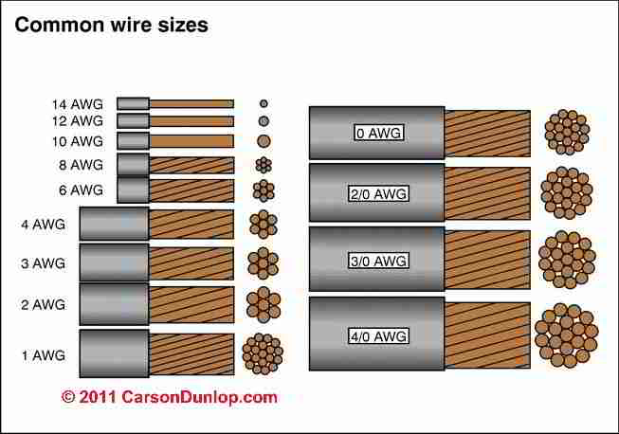

THHN Wire stands for - Thermoplastic High Heat-resistant Nylon coated.

THHN is UL listed with a rated 90 degrees Celsius in dry locations or 75 degrees Celsius in wet applications with a THWN rating.

**Excessive voltage drop in a circuit can cause:**

► Lights to flicker or burn dimly

► Heaters to heat poorly

► Motors to run hotter than normal and burn out

This condition causes the load to work harder with less voltage pushing the current.

**The National Electrical Code (NEC) recommends limiting the voltage drop from the breaker box to the farthest outlet for power, heating, or lighting to 3 percent of the circuit voltage.**

This is done by selecting the right size of wire.

Two Primary Electrical Design Concerns

1. Current Required
2. Voltage Drop

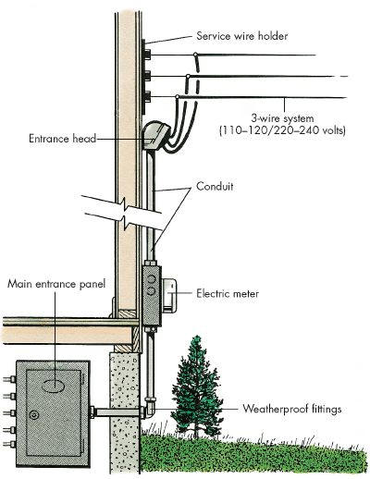

Sub

Panel

**SHOP**

L

Total connected load for all the lights and equipment in the shop is 15 kW.

1 kW = 1,000 Watts

Find the current required for the shop’s electrical service at:

|  |  |
| --- | --- |
| Service Voltage = 120 V, 1φ | Service Voltage = 240 V, 1φ |
| 15,000 W  120 V  P  E  I = = = 125 A  NEC 310.15(B)(16) (75⁰)  Minimum Size Conductor ________________  Conductor Resistance _____________ (Ω/1000 ft) | 15,000 W  240 V  P  E  I = = = 62.5 A  NEC 310.15(B)(16) (75⁰)  Minimum Size Conductor ________________  Conductor Resistance _____________ (Ω/1000 ft) |

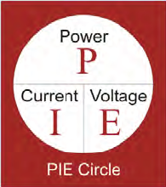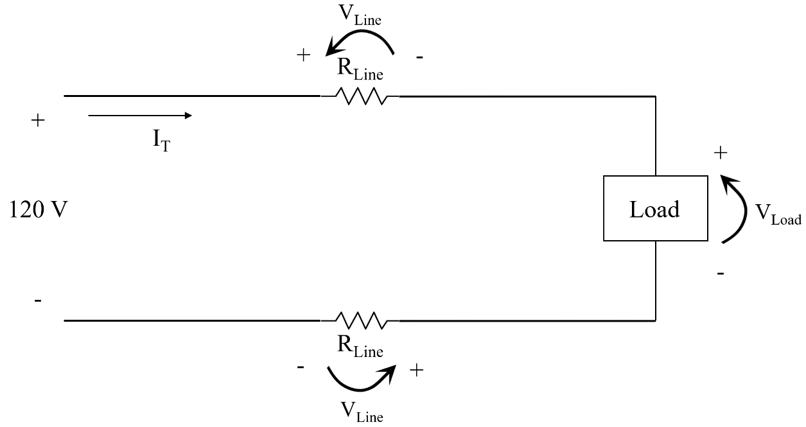**Kirchhoff’s Voltage Law**

ΣVLoop = 0

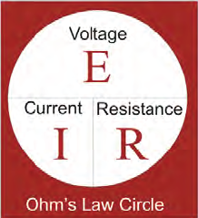

120V – VLine – VLoad – VLine = 0

VLoad = 120V – VLine – VLine

VDLine

RLine = (2 x Ohms per 1000 ft x L) [Note: this is the TOTAL resistance of the line, i.e. RLine + RLine]

VDLine = IT x RLine

VLoad = 120V – VDLine

%VD = (VLoad / 120V) x 100

**Example 1. Find the percentage voltage drop for the length (L) shown in the table.**

**Case 1: 120 V, 125 A, #1 CU – Load Power 15kW**

Supply Voltage = 120 V, Load Power = 15 kW

Supply Current = 125 A

Minimum Conductor Size = #1

RLine = (2 x 0.154 Ω x L) / 1000

Complete the table:

|  |  |  |  |  |
| --- | --- | --- | --- | --- |
| Length of Conductor (L) | RLine (Ω) | VDLine (V) | VLoad (V) | % VD |
| 90 ft | 0.02772 | 3.465 | 117 | 2.89 |
| 120 ft | 0.03696 | 4.62 | 115 | 3.85 |
| 150 ft | 0.0462 | 5.775 | 114 | 4.81 |
| 230 ft | 0.07084 | 8.855 | 111 | 7.38 |

**Case 2: 120 V, 125 A, #1/0 CU – Load Power 15kW**

Supply Voltage = 120V, Load Power = 15 kW

Supply Current = 125 A

Minimum Conductor Size = **#1/0 (increased wire size from #1)**

RLine = (2 x 0.122 Ω x L) / 1000

Complete the table:

|  |  |  |  |  |
| --- | --- | --- | --- | --- |
| Length of Conductor (L) | RLine (Ω) | VDLine (V) | VLoad (V) | % VD |
| 90 ft | 0.02196 | 2.745 | 117 | 2.29 |
| 120 ft | 0.02928 | 3.66 | 116 | 3.05 |
| 150 ft | 0.0366 | 4.575 | 115 | 3.81 |
| 230 ft | 0.05612 | 7.015 | 113 | 5.85 |

**Case 3: 240 V, 62.5 A, #6 CU – Load Power 15kW**

Supply Voltage = 240 V, Load Power = 15 kW **(Increased supply voltage)**

Supply Current = 62.5 A

Minimum Conductor Size = #6

RLine = (2 x 0.491 Ω x L) / 1000

Complete the table:

|  |  |  |  |  |
| --- | --- | --- | --- | --- |
| Length of Conductor (L) | RLine (Ω) | VDLine (V) | VLoad (V) | % VD |
| 90 ft | 0.08838 | 5.52375 | 234 | 2.30 |
| 120 ft | 0.11784 | 7.365 | 233 | 3.07 |
| 150 ft | 0.1473 | 9.20625 | 231 | 3.84 |
| 230 ft | 0.22586 | 14.11625 | 226 | 5.88 |

**Example #2**

A residential electric water heater is rated at 4.5 kW and operates at 208V (single phase wiring).

1. Determine the recommended Over Current Protection (Circuit Breaker amperage rating)
2. Determine the copper wire size AWG based on NEC.

**Example #3**

A current of 4 amps is flowing in a conductor that has a resistance of 2Ω per 1,000 feet. Find the voltage drop if the distance from the source to the load is 1,000 feet.

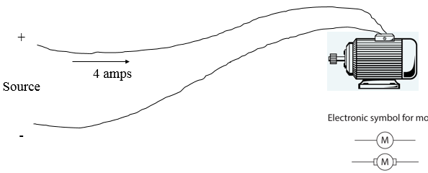

**Example #4**

An extension power cord made of CU #12 THWN is powering a lamp 300 feet from the source. The lamp resistance is 72 Ω and the source voltage is 120 V. Find the voltage drop across the light bulb.

**Example #5 - Temporary Job Site Light, Tripod, Corded (AC), Lumens 8000, Number of Lamp Heads 1**

Complete the Table below for the Temporary Job Site Light

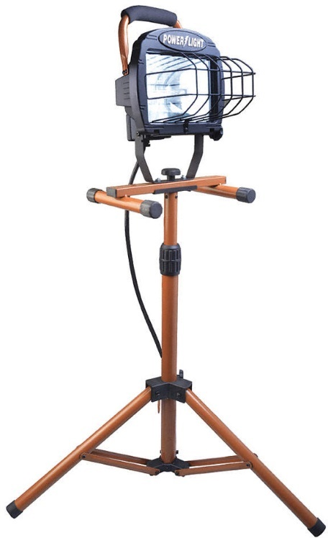

|  |  |  |
| --- | --- | --- |
| **Gauge/Conductor** | **Ohm/kFT** | **Length (L) ft** |
| 18/3 |  |  |
| 16/3 |  |  |
| 14/3 |  |  |
| 12/3 |  |  |

**Example #6**

A single-phase, 240-volt air-conditioner is being installed for a small commercial building. The nameplate reads: “Minimum Circuit Ampacity 40 Amperes.” The circuit originates at the main panel located 125 ft from the air-conditioner unit.

1. Determine the maximum voltage drop of the line recommended by the NEC?
2. What is the minimum size THWN CU conductors required and where in the NEC do you find this?
3. Determine the voltage drop due to the conductors. Does it meet the code requirement? If not, what should be done to meet the code?