|  |  |  |
| --- | --- | --- |
| **CMGT 235 – Electrical and Mechanical Systems** | | |
| **Discussion No. 23** | **Unit 3 - Electrical Systems** | **Fall 2022**  **Answers** |

**Voltage Drop**

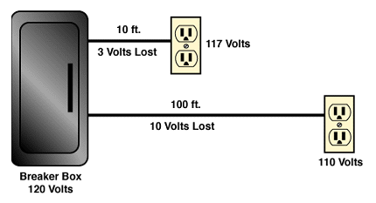

**Most building electrical calculations solve for current or voltage drop.**

**►** Current sets conductor size.

► Excess voltage drop may require an increase in conductor size.

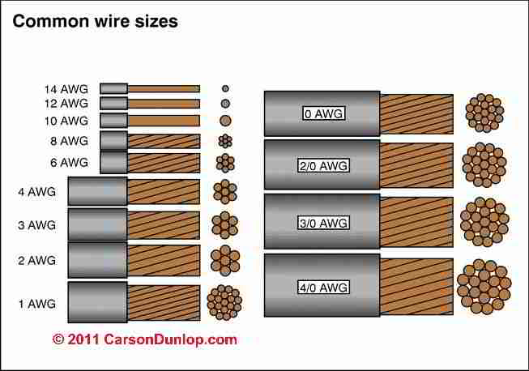

THHN Wire stands for - Thermoplastic High Heat-resistant Nylon coated.

THHN is UL listed with a rated 90 degrees Celsius in dry locations or 75 degrees Celsius in wet applications with a THWN rating.

**Excessive voltage drop in a circuit can cause:**

► Lights to flicker or burn dimly

► Heaters to heat poorly

► Motors to run hotter than normal and burn out

This condition causes the load to work harder with less voltage pushing the current.

**The National Electrical Code (NEC) recommends limiting the voltage drop from the breaker box to the farthest outlet for power, heating, or lighting to 3 percent of the circuit voltage. [Article 210.19 (A)]**

This is done by selecting the right size of wire.

Two Primary Electrical Design Concerns

1. Current Required
2. Voltage Drop

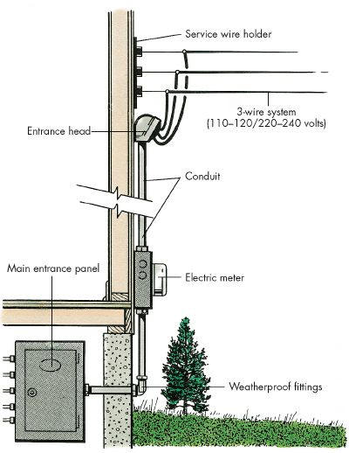

Sub

Panel

**SHOP**

**IT**

**Es**

L

Total connected load for all the lights and equipment in the shop is 15 kW.

1 kW = 1,000 Watts

Find the current required for the shop’s electrical service at:

|  |  |
| --- | --- |
| Service Voltage = 120 V, 1φ | Service Voltage = 240 V, 1φ |
| 15,000 W  120 V  P  E  I = = = 125 A  NEC 310.15(B)(16) (75⁰)  **#1 AWG**  Minimum Size Conductor ________________  **0.154**  Conductor Resistance _____________ (Ω/1000 ft) | 15,000 W  240 V  P  E  I = = = 62.5 A  NEC 310.15(B)(16) (75⁰)  **#6 AWG**  Minimum Size Conductor ________________  **0.491**  Conductor Resistance _____________ (Ω/1000 ft) |

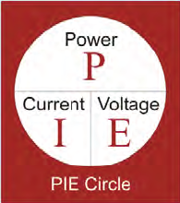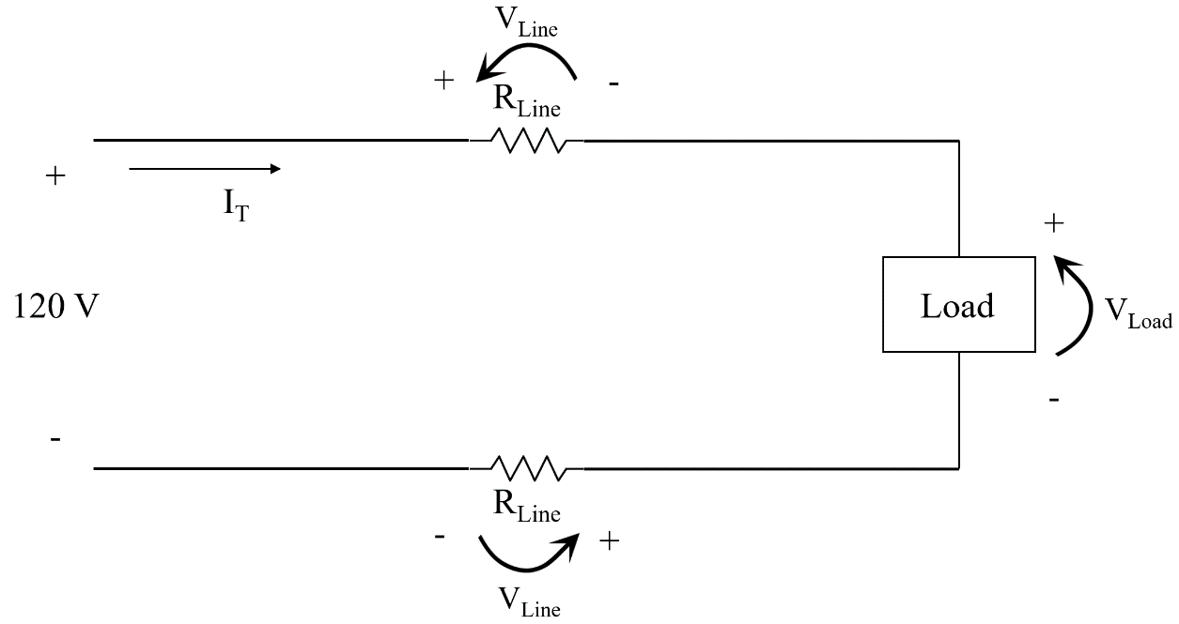**Kirchhoff’s Voltage Law**

ΣVLoop = 0

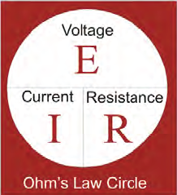

120V – VLine – VLoad – VLine = 0

VLoad = 120V – VLine – VLine

VDLine

RLine = (2 x Ohms per 1000 ft x L) [Note: this is the TOTAL resistance of the line, i.e. RLine + RLine]

VDLine = IT x RLine

VLoad = 120V – VDLine

%VD = (VLoad / 120V) x 100

**Example 1. Find the percentage voltage drop for the length (L) shown in the table.**

**Case 1: 120 V, 125 A, #1 CU – Load Power 15kW**

Supply Voltage = 120 V, Load Power = 15 kW

Supply Current = 125 A

Minimum Conductor Size = #1

RLine = (2 x 0.154 Ω x L) / 1000

Complete the table:

|  |  |  |  |  |
| --- | --- | --- | --- | --- |
| Length of Conductor (L) | RLine (Ω) | VDLine (V) | VLoad (V) | % VD |
| 90 ft | 0.02772 | 3.465 | 117 | 2.89 |
| 120 ft | 0.03696 | 4.62 | 115 | 3.85 |
| 150 ft | 0.0462 | 5.775 | 114 | 4.81 |
| 230 ft | 0.07084 | 8.855 | 111 | 7.38 |

**Case 2: 120 V, 125 A, #1/0 CU – Load Power 15kW**

Supply Voltage = 120V, Load Power = 15 kW

Supply Current = 125 A

Minimum Conductor Size = **#1/0 (increased wire size from #1)**

RLine = (2 x 0.122 Ω x L) / 1000

Complete the table:

|  |  |  |  |  |
| --- | --- | --- | --- | --- |
| Length of Conductor (L) | RLine (Ω) | VDLine (V) | VLoad (V) | % VD |
| 90 ft | 0.02196 | 2.745 | 117 | 2.29 |
| 120 ft | 0.02928 | 3.66 | 116 | 3.05 |
| 150 ft | 0.0366 | 4.575 | 115 | 3.81 |
| 230 ft | 0.05612 | 7.015 | 113 | 5.85 |

**Case 3: 240 V, 62.5 A, #6 CU – Load Power 15kW**

Supply Voltage = 240 V, Load Power = 15 kW **(Increased supply voltage)**

Supply Current = 62.5 A

Minimum Conductor Size = #6

RLine = (2 x 0.491 Ω x L) / 1000

Complete the table:

|  |  |  |  |  |
| --- | --- | --- | --- | --- |
| Length of Conductor (L) | RLine (Ω) | VDLine (V) | VLoad (V) | % VD |
| 90 ft | 0.08838 | 5.52375 | 234 | 2.30 |
| 120 ft | 0.11784 | 7.365 | 233 | 3.07 |
| 150 ft | 0.1473 | 9.20625 | 231 | 3.84 |
| 230 ft | 0.22586 | 14.11625 | 226 | 5.88 |

**Example #2**

A residential electric water heater is rated at 4.5 kW and operates at 208V (single phase wiring).

1. Determine the recommended Over Current Protection (Circuit Breaker amperage rating)

See Rheem Use & Care Manual

or

P = I x E

I = P / E = 4500 W / 208 V = 21.63 A

NEC 240.4

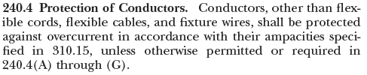

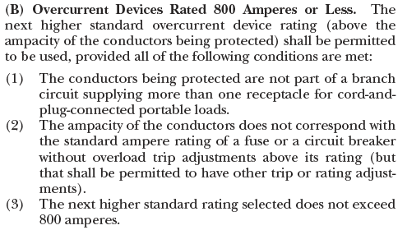

Use a 30A circuit Breaker

1. Determine the copper wire size AWG based on NEC.

See Rheem Use & Care Manual

Or

Article 310

Table 310.15(B)(16)

90°C CU THHN - #10 AWG

Or

Article 240.4

**Example #3**

A current of 4 amps is flowing in a conductor that has a resistance of 2Ω per 1,000 feet. Find the voltage drop if the distance from the source to the load is 1,000 feet.

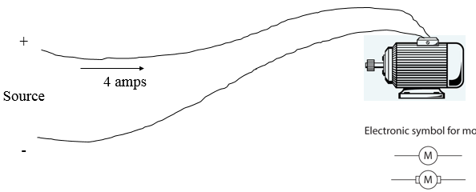



RLine

= 2 Ω



RLine

= 2 Ω

Supply Current = 4 A

RLine = 4 Ω

VDLine = 4 A x 4 Ω = 16 V

**Example #4**

An extension power cord made of CU #12 THWN is powering a lamp 300 feet from the source. The lamp resistance is 72 Ω and the source voltage is 120 V. Find the voltage drop across the light bulb.

From Chapter 9, Table 8 Conductor Properties

12 AWG CU

Solid 1.93 ohm/kFT

Stranded 1.98 ohm/kFT Extension cords use stranded wire

RLine = 2 x 1.98 ohm/kFT x 300 FT = 1.188 Ω

Total Circuit Current (including resistance of the conductors)

IT = ET / RT = 120 V / (1.188 Ω + 72 Ω) = 1.64 A

ELamp = IT x RLamp = 1.64 A x 72 Ω = 118 V

Check using VDLine equation

IT = 120 V / 72 Ω = 1.67 A

VDLine = 1.67 A x [2 x 1.98 ohm/kFT x 300 Ft] = 1.98 V = 2 V

ELamp = 120 V – 2 V = 118 V

