**CMGT 235 – Electrical and Mechanical Systems**

**Homework #24** – Voltage Drop

Due: 11/15/2022

Points: 20

Name: _______________________________________________________________________________

**Temporary Job Site Light, Floor Stand, Corded (AC), Lumens 4300, Number of Lamp Heads 2**

A job site is powering two (2) of the temporary lights described below with a 120VAC portable diesel generator. If the lamp voltage can be no less than 117V, determine the length for an 18/3 CU (uncoated) extension cord. The lamps are wired in parallel. Include the 12 ft cord for each light in your calculation (see circuit diagram). **Round answer to WHOLE number.**

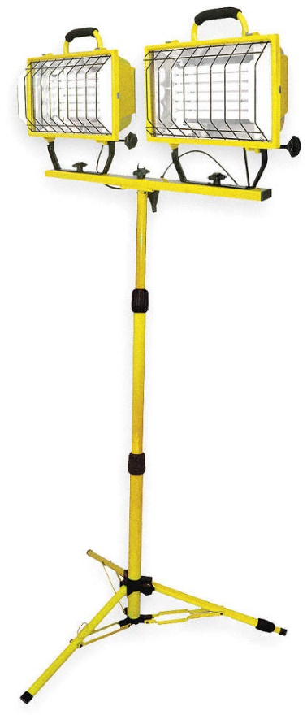

**12 ft**

**12 ft**



**120 VAC**



**L**

**SHOW ALL WORK ON THE NEXT PAGE FOR FULL CREDIT**

**Solution.**

**12 ft**

**12 ft**



**120 VAC**



**L**