|  |  |  |
| --- | --- | --- |
| **CMGT 235 – Electrical and Mechanical Systems** | | |
| **Discussion No. 25** | **Unit 3 - Electrical Systems** | **Fall 2022** |

**Commercial Building Electrical Systems - Lighting Systems**

**Lighting Terminology**

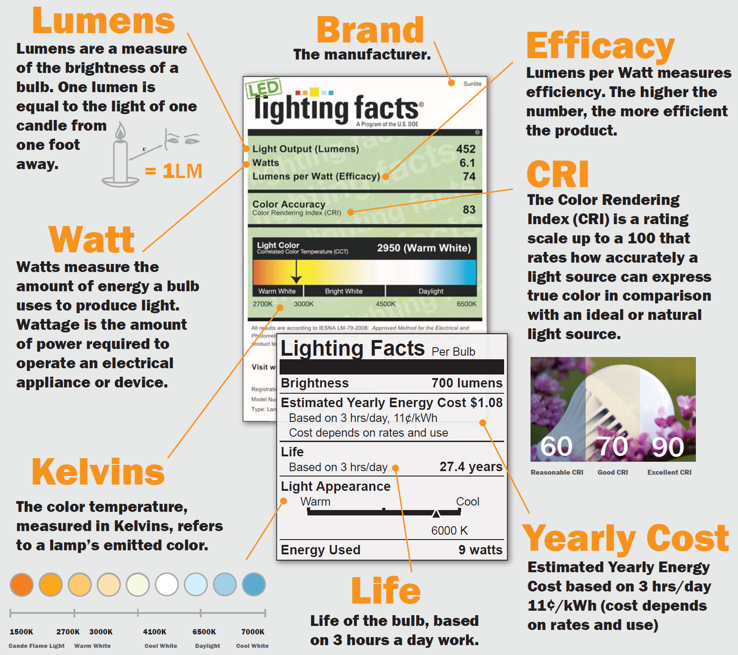

|  |  |
| --- | --- |
| **Lamp Types**  Light Emitting Diode - LED  Fluorescent - FL  Compact Fluorescent (CFL)  Incandescent (INC)  Halogens  High Intensity Discharge (HID)  High Pressure Sodium (HPS)  Metal Halide (MH)  Mercury Vapor (MV)  Low Pressure Sodium | **Watts vs. Lumens**  40W bulb: at least 450 lumens  60W bulb: at least 800 lumens  75W bulb: at least 1,100 lumens  100W bulb: at least 1,500 lumens  Fact: The more lumens of light you get per watt of electricity, the more efficient the bulb is.  A 10W LED can easily outshine a 12W competitor if it converts watts to lumens more efficiently.  Efficiency = lumens / watts |

**Light Emitting Diode – LED** <https://www.youtube.com/watch?v=oPYrldvk2is>

Energy-efficient LED bulbs are available in a variety of shapes and sizes. LEDs deliver quality light across a broad spectrum of color temperatures from warm ambient light to the bright white look of daylight, to suit any indoor or outdoor application. LED light bulbs, or light emitting diodes, are low heat, long lasting, energy efficient lighting alternatives for your home or business. The availability and selection of LED light bulbs has expanded greatly. No longer are LEDs just for exit signs. LEDs are available in almost all base and shape configurations.

**A Group: A15, A19, A21, and A25**

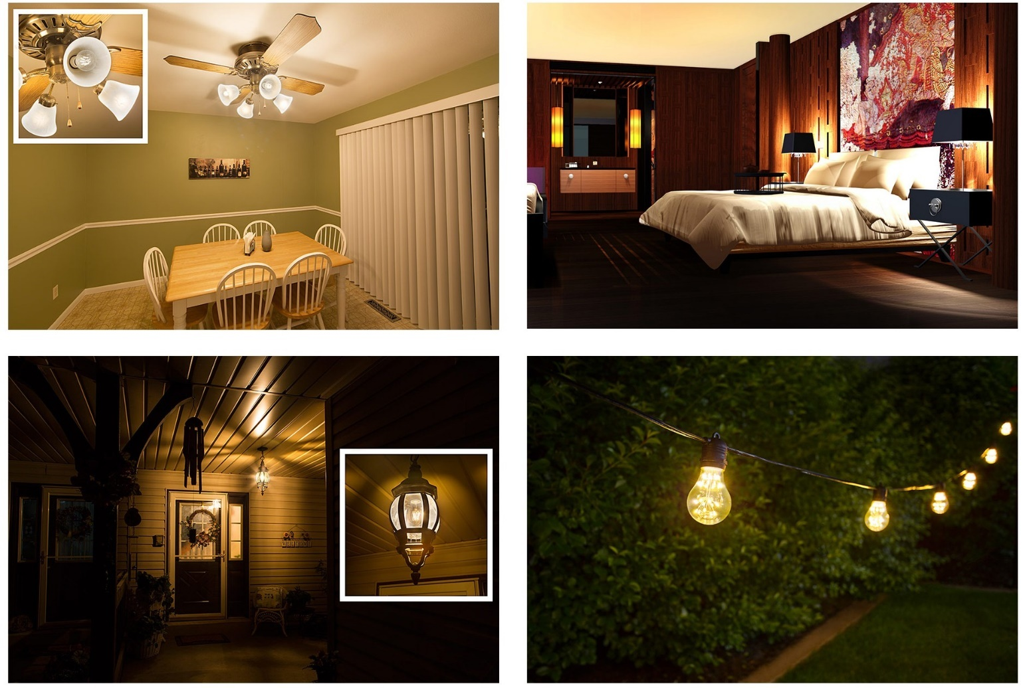

From top left to bottom right: A19 LED filament bulbs in ceiling fan fixture, A21 LED bulbs in bedroom lamps, A19 gold-tint LED filament bulb in porch light fixture, A19 LED fireworks bulbs in string lights

Standard/arbitrary (A) bulbs are the most widely used and thought of when it comes to household lighting. These bulbs work well for a variety of applications, such as ceiling lights, lamps, vanity lights, kitchen lights, closet lights, porch light fixtures, and so many more.

|  |  |
| --- | --- |
| Numbers in each code refer to the bulb’s diameter in one-eighths of an inch. | **Most common base types:**    E26/E27 medium screw base |

**G group: G11, G14, G16/G50, G60, G25/G80, G30**

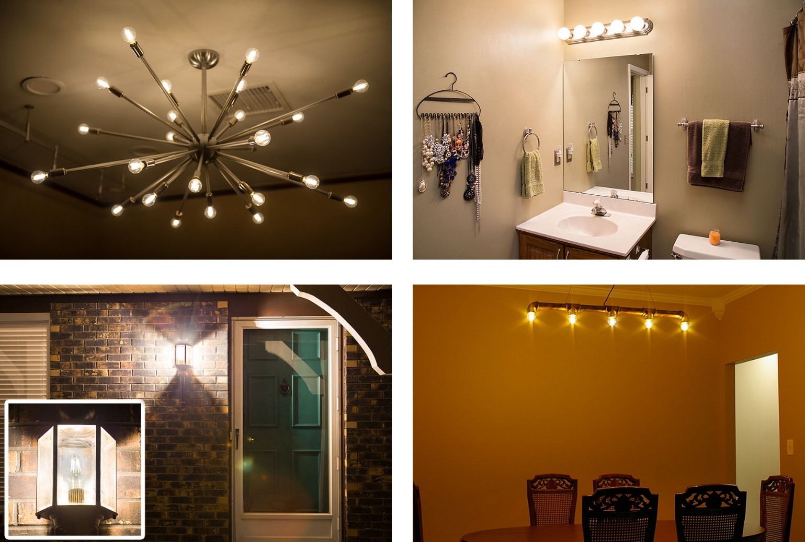

From top left to bottom right: G14 LED bulbs in ceiling light fixture, G30 LED bulbs in bathroom vanity, G30 LED filament bulb in porch light fixture, G16 gold-tint LED filament bulbs in ceiling light fixture

Globe (G) bulbs have a full, round shape and are available in various sizes. They can be used for many applications throughout the home, such as foyer lights, kitchen lights, chandeliers, and ornamental fixtures. The most common type is the large G30 bulb, which is used in bathroom and makeup vanities.

|  |  |
| --- | --- |
| Depending on the bulb, numbers in each code can refer to the bulb’s diameter in one-eighths of an inch or in millimeters. | **Most common base types:**    E26/E27 medium screw base    E12 candelabra |

**B and C groups: B10, C7, C9, C15, CA10**

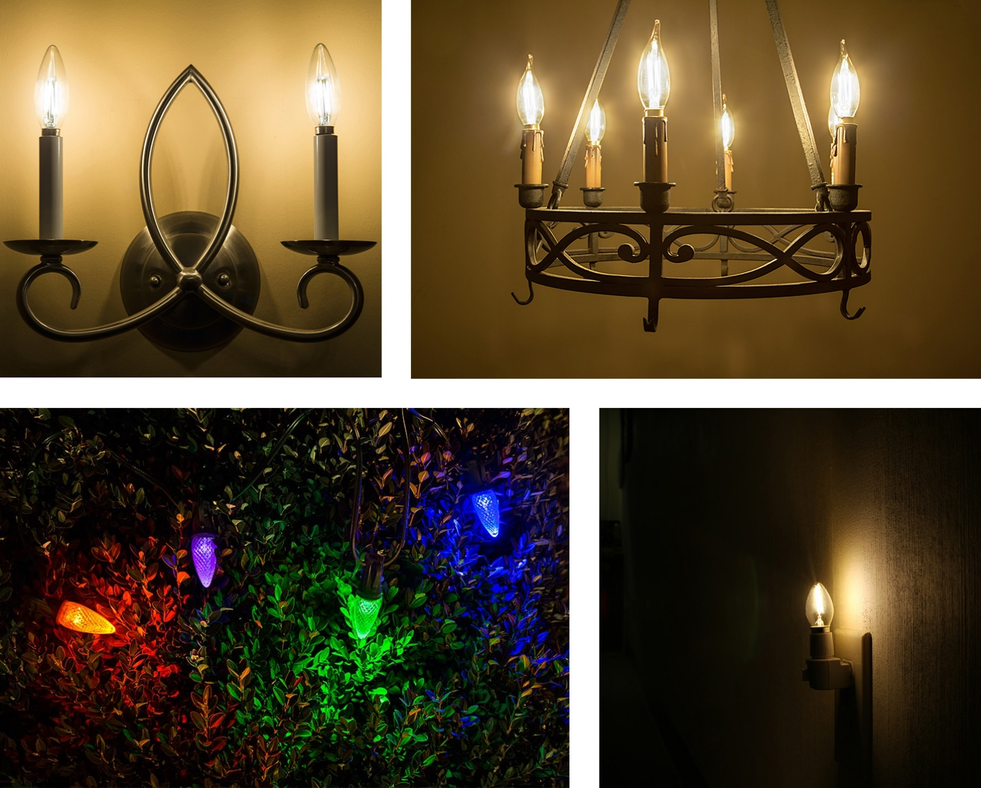

From top left to bottom right: B10 LED bulbs in wall sconce, CA10 LED bulbs in chandelier, C9 LED bulbs in Christmas light strings, C7 LED bulb in night light

All of the bulbs in these groups resemble the shape of a candle flame and are often referred to as candle bulbs. Conical (C) bulbs are shaped like a cone. Conical angular (CA) bulbs are shaped like a cone but have a bent tip. Blunt-tip (B) bulbs are very similar to C-type bulbs but have more of a torpedo or bullet shape. These bulbs can be used in chandeliers, wall sconces, pendant lights, night lights, decorative light strands, holiday light strands, and other decorative home lighting applications.

|  |  |
| --- | --- |
| Numbers in each code refer to the bulb’s diameter in one-eighths of an inch. | **Most common base types:**    E12 candelabra    E17    E26/E27 medium screw base |

**BR group: BR20/R20, BR30, BR40**

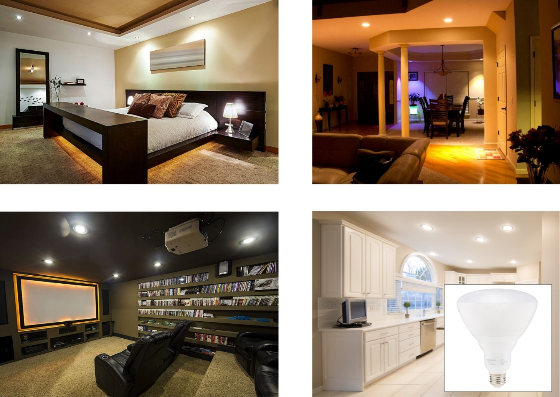

From top left to bottom right: BR20/R20 LED bulbs in bedroom can lights, BR40 LED bulbs in living room can lights, BR30 LED bulbs in home theater can lights, BR40 LED bulbs in kitchen can lights

BR stands for bulged reflector. Traditionally, the inside surface of an incandescent BR bulb is covered in reflector material that is used to gather and cast a wide beam of light away from the bulb. LED BR bulbs don’t require the reflector material. These bulbs can have a frosted, clear, or patterned dome-shaped lens that diffuses light and provides a gradual fade into nonilluminated areas. BR bulbs also produce less shadows when compared to PAR bulbs. They’re a bit longer than PAR bulbs and tend to protrude from light housings but are used in similar applications, such as track lights, recessed lights, display lights, or can lights.

BR20 bulbs are often referred to as R20 but have the same characteristics of other BR bulb types. The R stands for reflector.

|  |  |
| --- | --- |
| Numbers in each code refer to the bulb’s diameter in one-eighths of an inch. | **Most common base types:**    E26/E27 medium screw base |

**PAR group: PAR16, PAR20, PAR30, PAR36/AR111, PAR38**

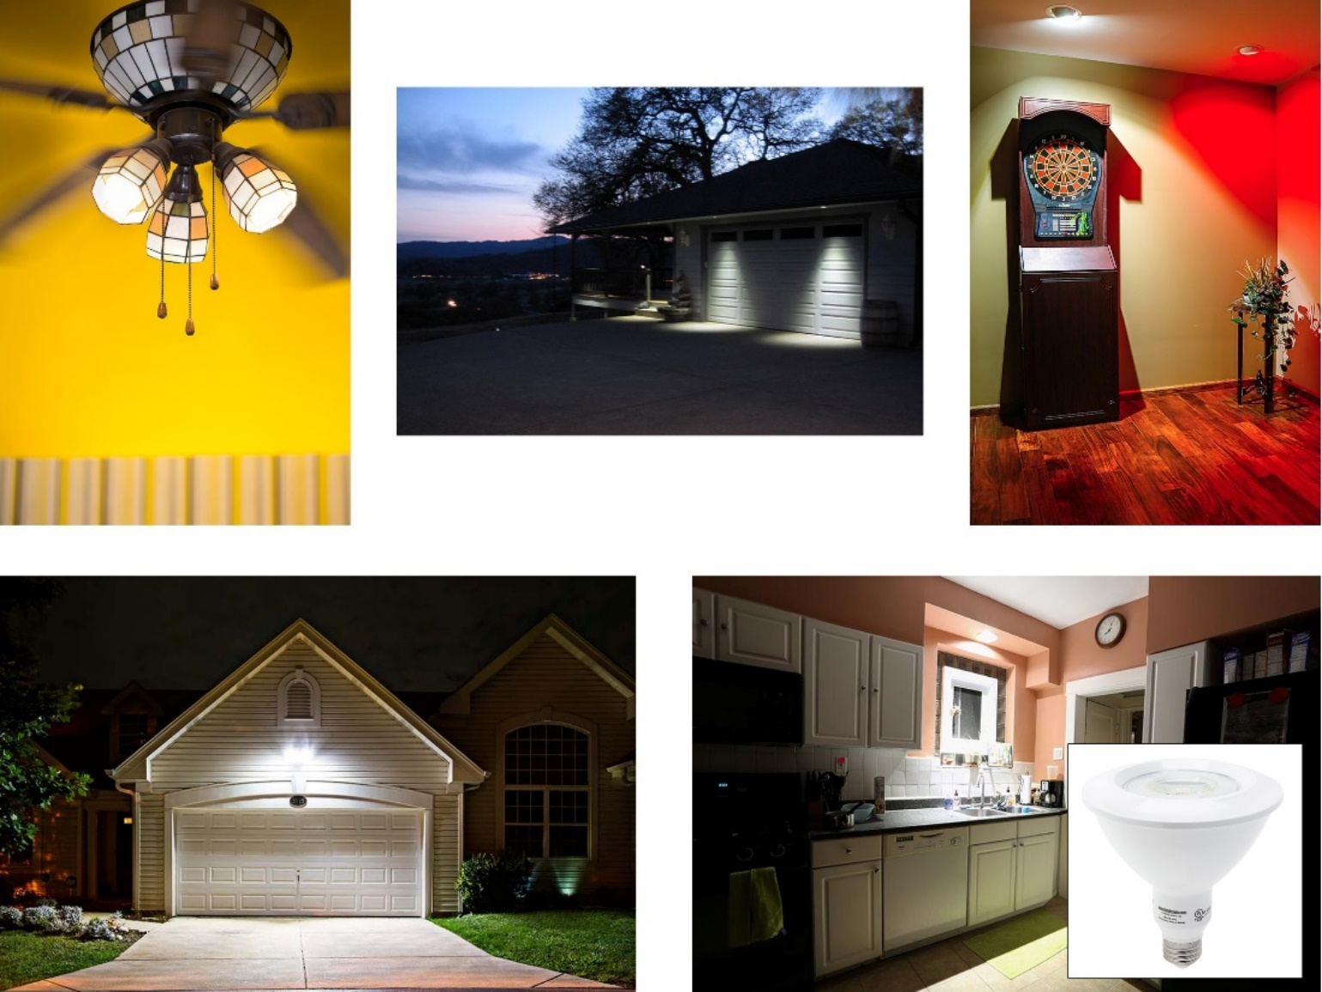

From top left to bottom right: PAR16 LED bulbs in ceiling fan fixture, PAR30 LED bulbs in recessed soffit light fixtures, PAR16 LED bulbs in eyeball light fixtures, PAR38 LED bulbs in garage security light, PAR38 LED bulb in kitchen can light

PAR stands for parabolic aluminized reflector. In traditional incandescent PAR bulbs, a U-shaped reflector is used to maximize brightness and direct light through the front of the bulb in a narrow spot beam or wide flood beam pattern. Oftentimes, LED PAR bulbs will not have a reflector but will still deliver the hard-edged lighting (less of a gradual fade than BR bulbs) that is typical of incandescent PAR bulbs. These bulbs have a shorter body than BR bulbs and usually install flush with ceilings or fixtures, which reduces glare. They’re commonly found in outdoor emergency light, spot light, or floodlight fixtures but can also be used indoors for track lights, recessed lights, display lights, or can lights.

PAR36 bulbs are sometimes referred to as aluminized reflector (AR111) bulbs. They’re shaped differently than other PAR bulbs in that they have a fairly low-profile body. The insides of these bulbs are coated in a reflector material or consist of faceted reflectors. LED bulbs don’t require the reflectors but often use them anyway. Similarly, to other PAR bulbs, they emit focused, hard-edged lighting in a spot or flood beam pattern. These bulbs run on low-voltage AC/DC wiring systems and are great for outdoor and landscape lighting applications such as architectural lights, driveway lights, path lights, gazebo lights, and paver lights that have weatherproof housings.

|  |  |
| --- | --- |
| Numbers in each code refer to the bulb’s diameter in one-eighths of an inch. The numbers after “AR” refer to the bulb’s diameter in millimeters. | **Most common base types:**    E26/E27 medium screw base    G53 screw pin |

**MR group: MR11 and MR16**

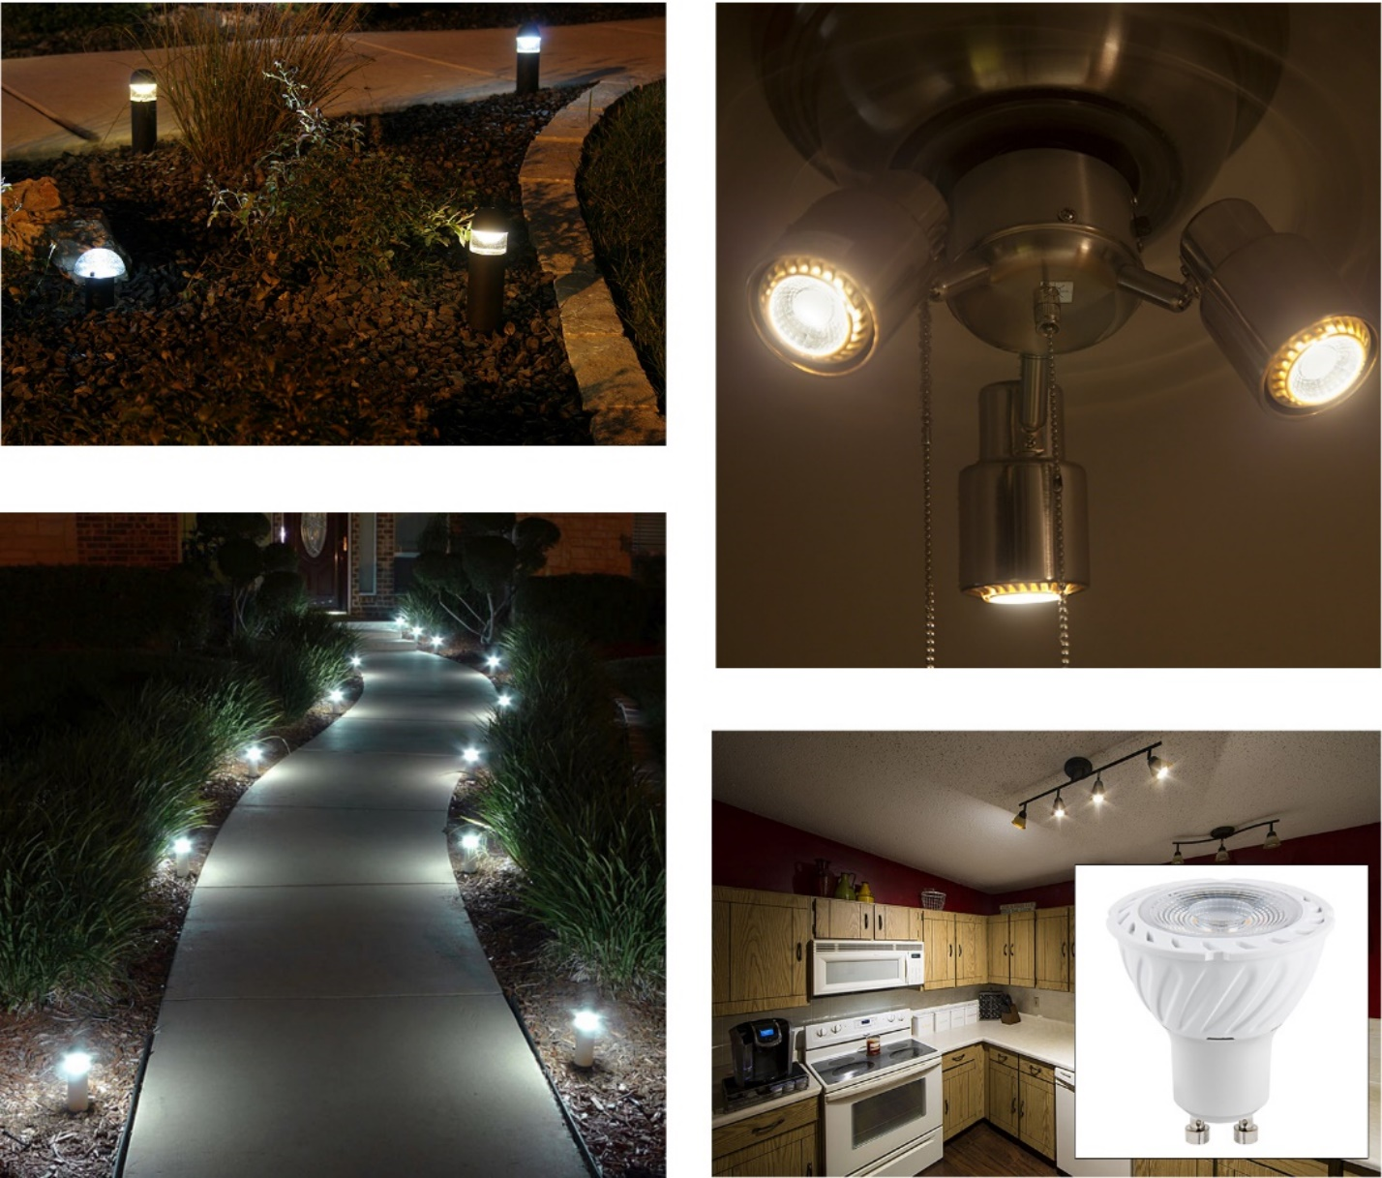

From top left to bottom right: MR11 LED bulbs in bollard lights, MR16 LED bulbs in ceiling fan fixture, MR11 LED bulbs in path lights, MR16 LED bulbs in kitchen track light fixture

Multifaceted reflector (MR) bulbs are small in size with a reflective, faceted interior. The facets create a concentrated beam of light that can be displayed in a narrow spot or wide flood beam pattern. Because of the directional light they provide, MR LED bulbs don’t require the facets but often still have them. These bulbs are available in a variety of colors and can be used for many applications, including track lighting, recessed lighting, desk lights, and display case lighting. Many MR bulbs operate on low-voltage wiring systems, which makes them great for outdoor and landscape applications such as driveway lights, path lights, gazebo lights, paver lights, and malibu lights that have weatherproof housings.

Numbers in each code refer to the bulb’s diameter in one-eighths of an inch.

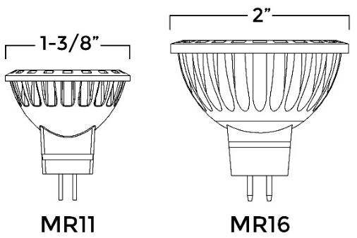

**Most common base types**

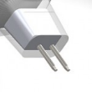 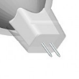 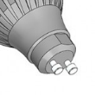

**GX5.3 bi-pin GZ4 bi-pin GU10 bi-pin**

**T group: T7, T8, T10, T14**

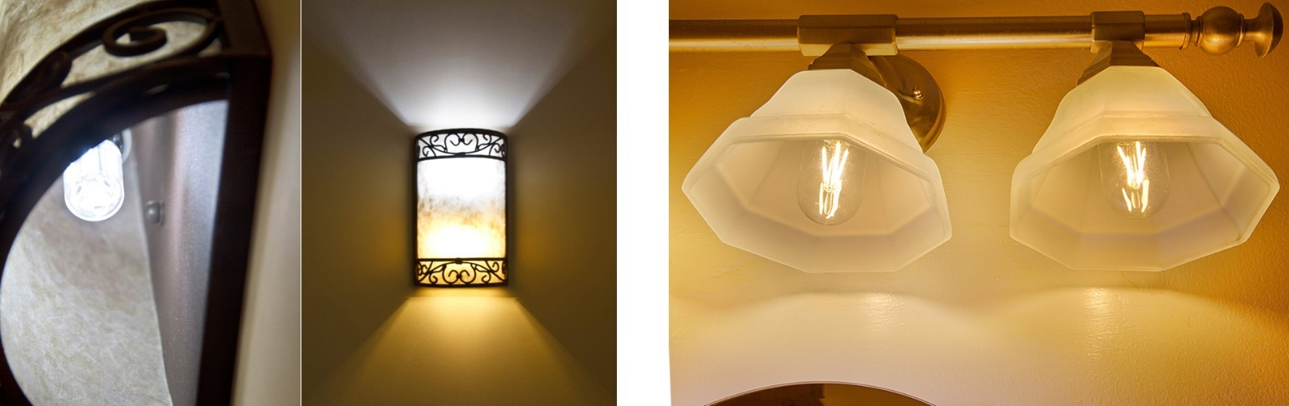

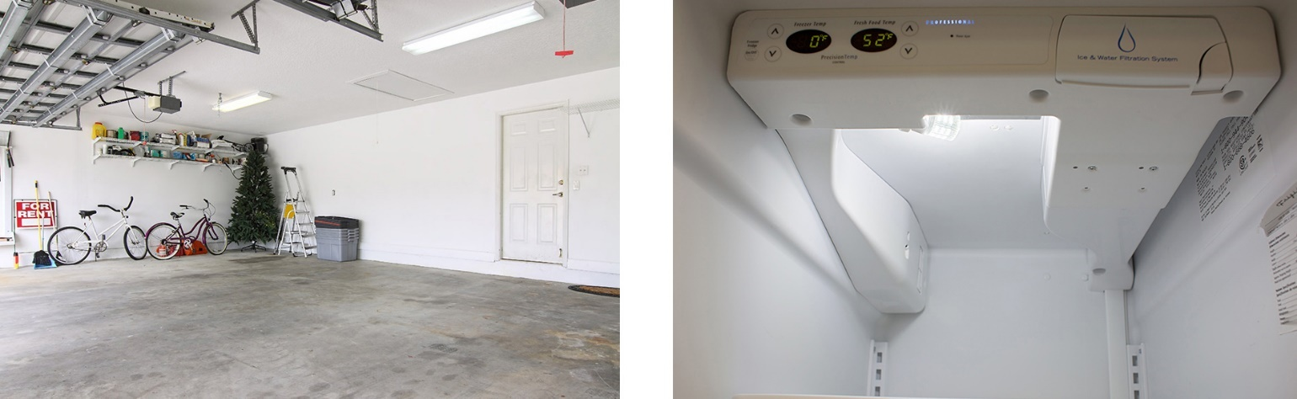

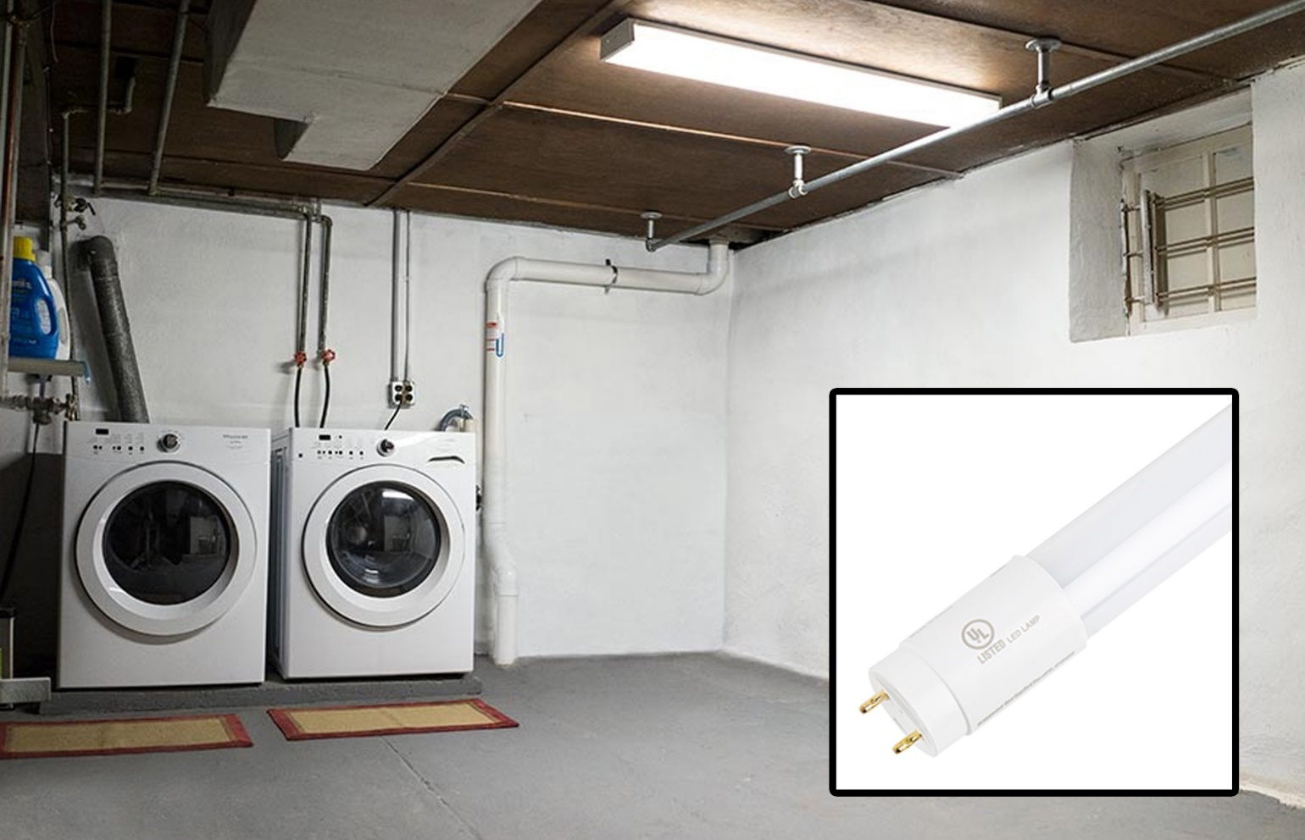

From top left to bottom right: T7 LED bulb in wall sconce, T14 LED bulbs in bathroom vanity light fixture, T8 LED bulbs in garage tube light fixture, T10 LED bulb in freezer, T8 LED bulb in basement tube light fixture

Tubular (T) bulbs come in a variety of lengths and widths. Depending on their size, these bulbs can be used in applications ranging from chandeliers, wall sconces, and pendant lights to basement and garage troffer light fixtures.

Numbers in each code refer to the bulb’s diameter in one-eighths of an inch.

|  |  |
| --- | --- |
|  |  |

**Most common base types:**

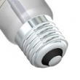 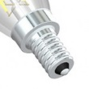 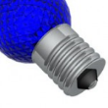

E26/E27 medium E12 candelabra E17

screw base

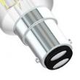 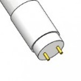

BA15D bayonet G13 bi-pin

**Types of Light Fixtures**

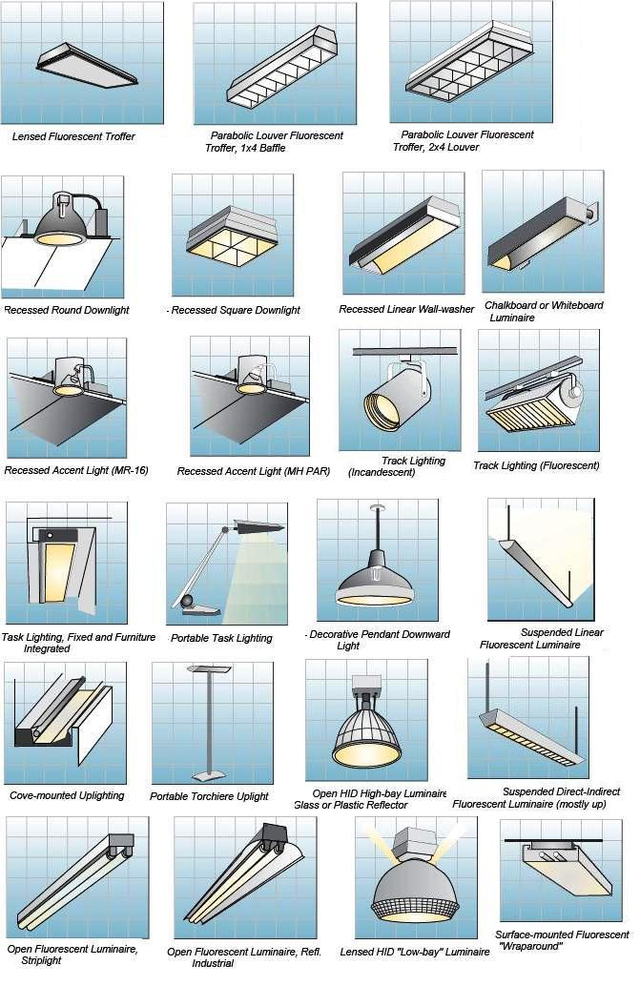

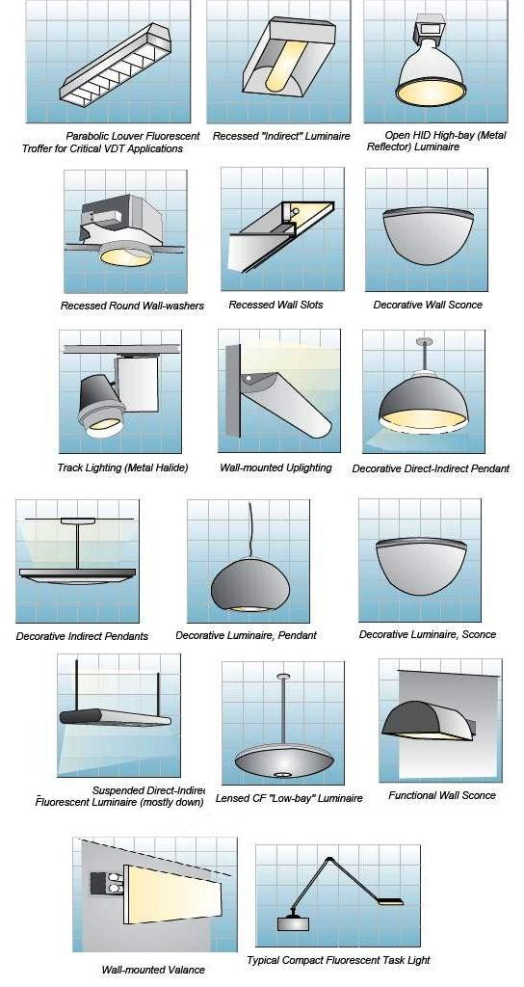

**Installation**

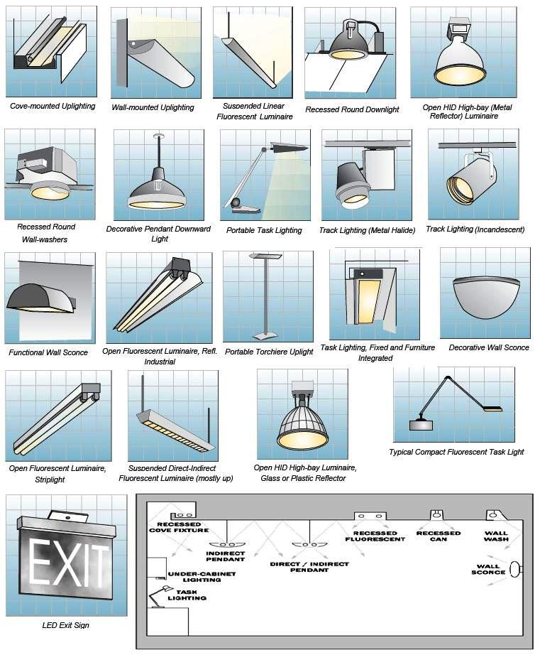

Petsmart

Electrical Plans

