CMGT 235 – Electrical and Mechanical Systems
Discussion No. 26 | Unit 3 - Electrical Systems | Fall 2022
Sizing Electrical Raceway

Proper Sizing of Conduit and Raceways
When selecting the conduit size, it’s important to consider the following variables:
- Number of conductors
- Size of the conductors
- Type of conduit

NFPA 731 Section 4.6.3.12(2) requires raceways to be sized properly in accordance with the NEC.

2017 Edition National Electric Code (NFPA 70)
Article 300
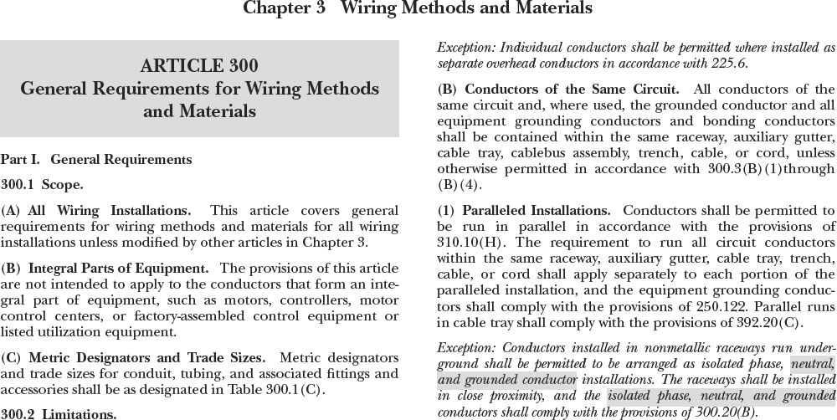

Article 300.17
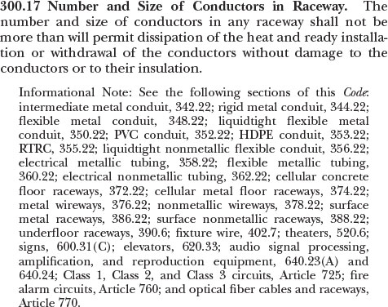
In the NEC, there are two main locations used when determining the maximum number of conductors in a conduit or tubing:

NEC Annex C is used for determining the maximum number of conductors permitted in conduit or tubing, when all conductors in the conduit are of the same size and insulation type.

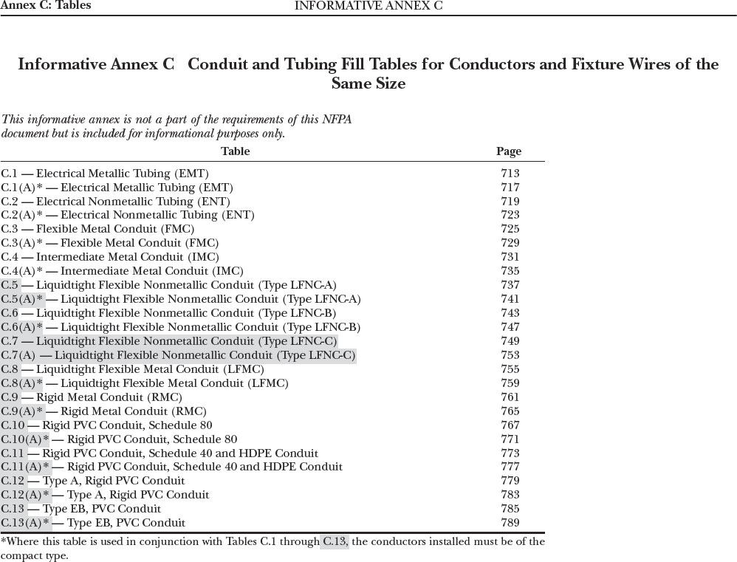
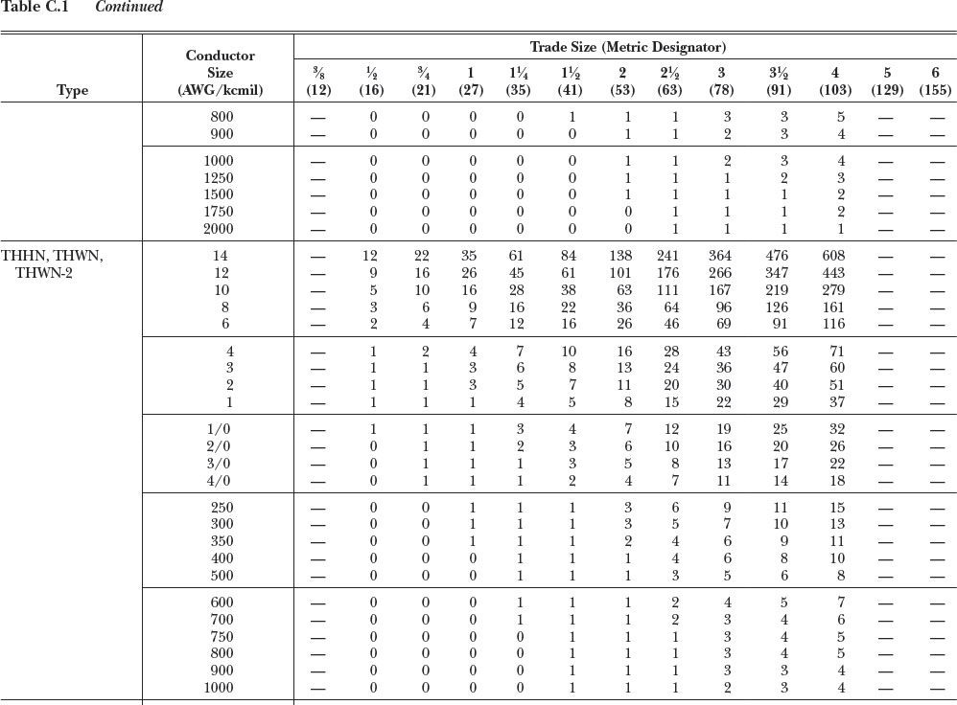

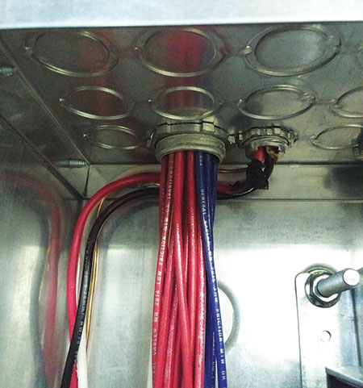 | 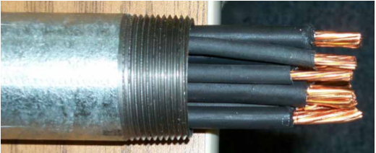
 | 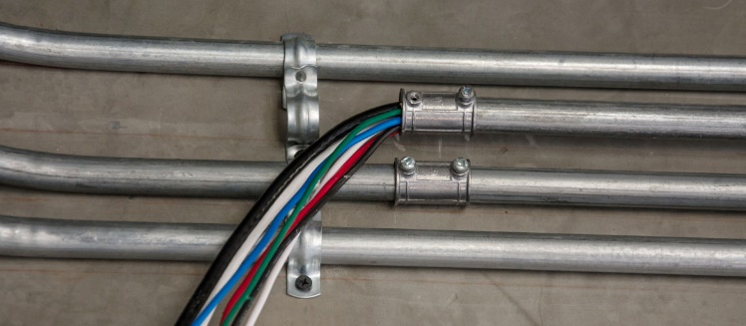

NEC Chapter 9 is used for combinations of conductors of different sizes or insulation types installed in the same conduit or tubing.

Chapter 9

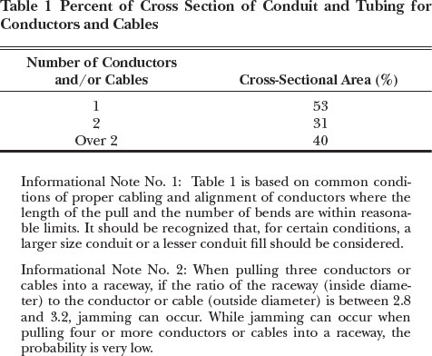 | 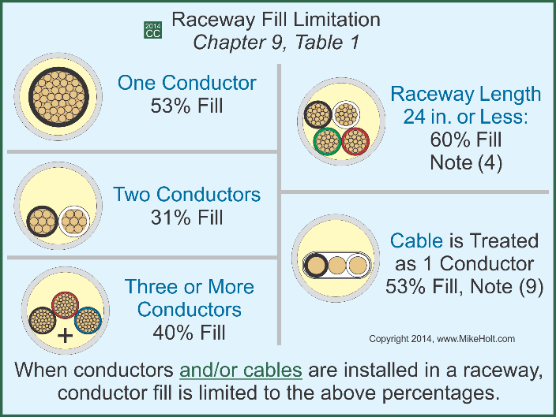
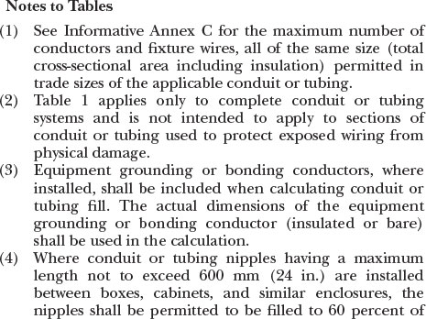 | 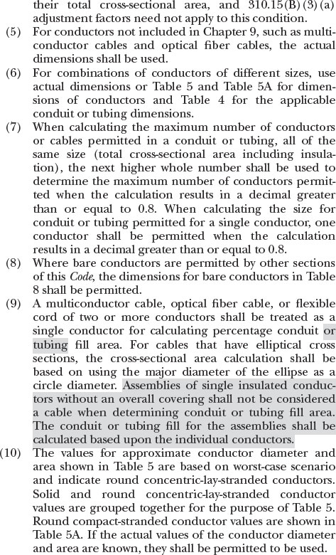

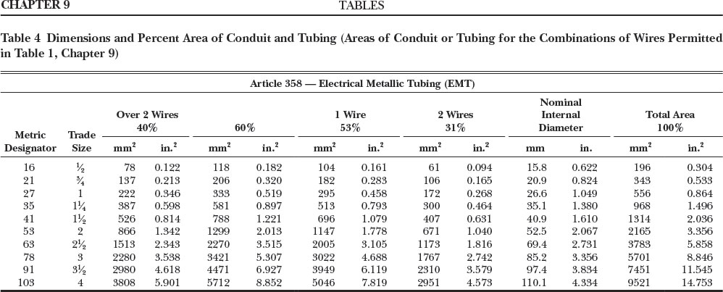

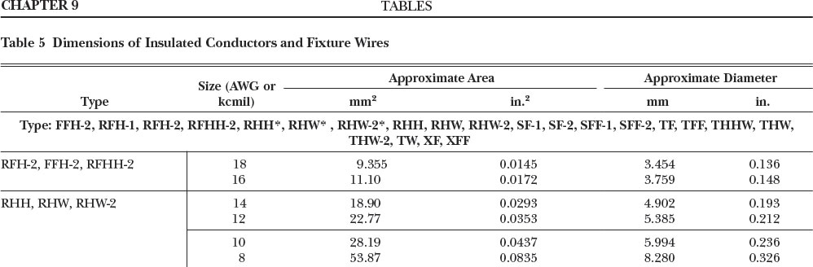

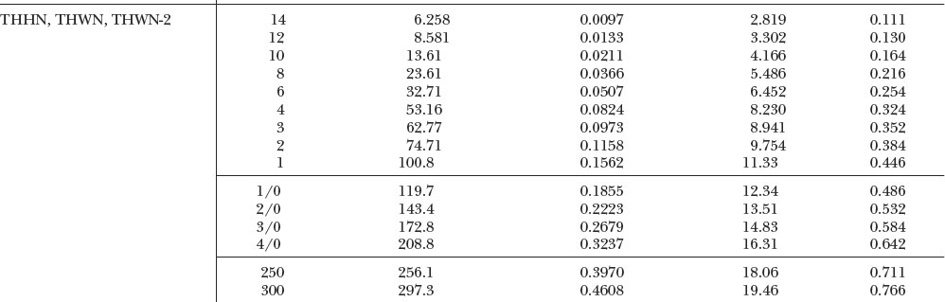

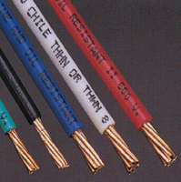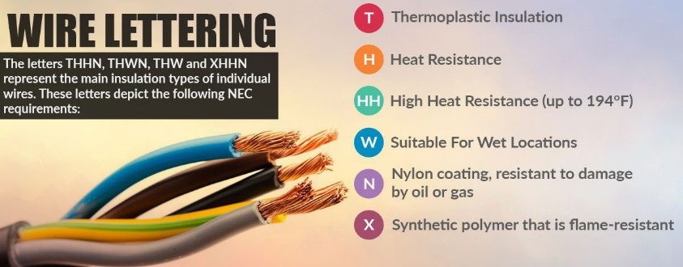
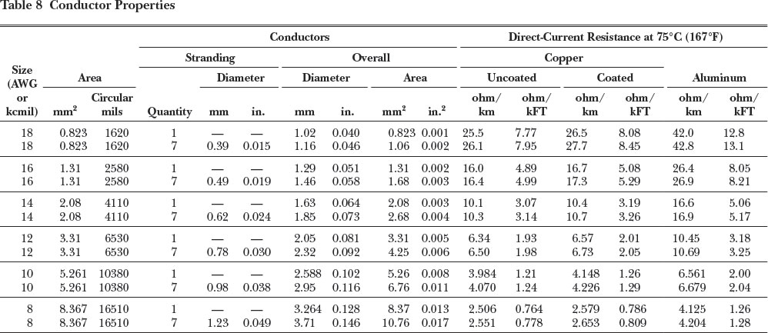

Example 1
What is the minimum size Schedule 40 PVC raceway required for three 500 kcmil THHN conductors, one 250 kcmil THHN conductor, and one 3 THHN conductor?

Example 2
What size RMC nipple is required for three 3/0 THHN conductors, one 1 THHN conductor and one 6 THHN conductor?

Example 3
How many 8 THHN conductors can be installed in a trade size 3/4 EMT?

Example 4
How many 18 TFFN conductors can be installed in trade size ¾ LFMC?

Example 5
What’s the smallest trade size PVC Schedule 40 raceway that can be used for the installation of four 1/0 THHN conductors?

Example 6
A 200A feeder installed in Schedule 80 PVC has three 3/0 THHN conductors, one 2 THHN conductor, and one 6 THHN conductor. What size raceway is required?
QTY | GAUGE | TYPE | Cross-Section Area
3 | 3/0 | THHN
1 | 2 | THHN
1 | 6 | THHN |  |  | PVC Sched. 80
 |  |  | Total Cross-Section Area

Example 7
What size EMT raceway is required for 4 wires, with insulation type THHN, and gauge of 8 AWG and 2 wires, with insulation type THW, and gauge of 4 AWG.?
QTY | GAUGE | TYPE | Cross-Section Area
 |  |  |  |  | EMT
 |  |  | Total Cross-Section Area

