CMGT 235 – Electrical and Mechanical Systems
Discussion No. 26 | Unit 3 - Electrical Systems | Fall 2022
Sizing Electrical Raceway

Proper Sizing of Conduit and Raceways
When selecting the conduit size, it’s important to consider the following variables:
- Number of conductors
- Size of the conductors
- Type of conduit

NFPA 731 Section 4.6.3.12(2) requires raceways to be sized properly in accordance with the NEC.

2017 Edition National Electric Code (NFPA 70)
Article 300
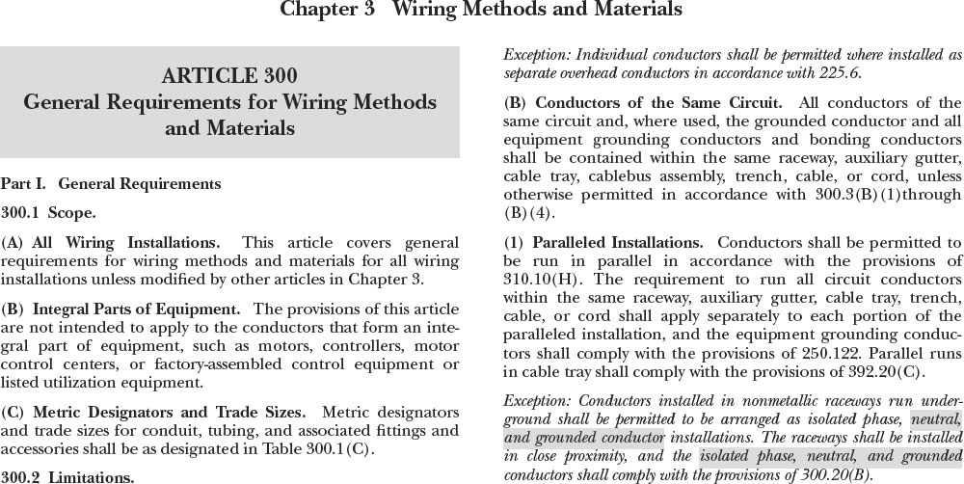

Article 300.17
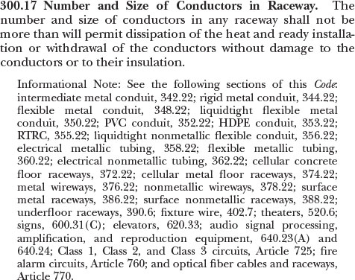
In the NEC, there are two main locations used when determining the maximum number of conductors in a conduit or tubing:

NEC Annex C is used for determining the maximum number of conductors permitted in conduit or tubing, when all conductors in the conduit are of the same size and insulation type.

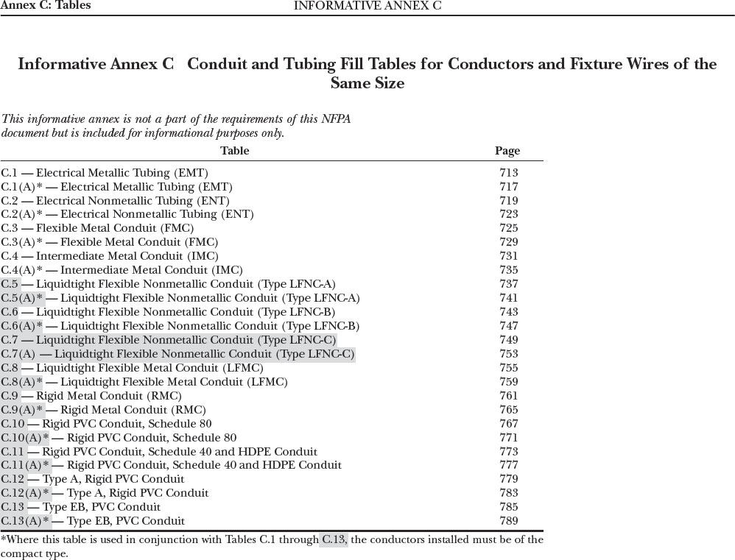
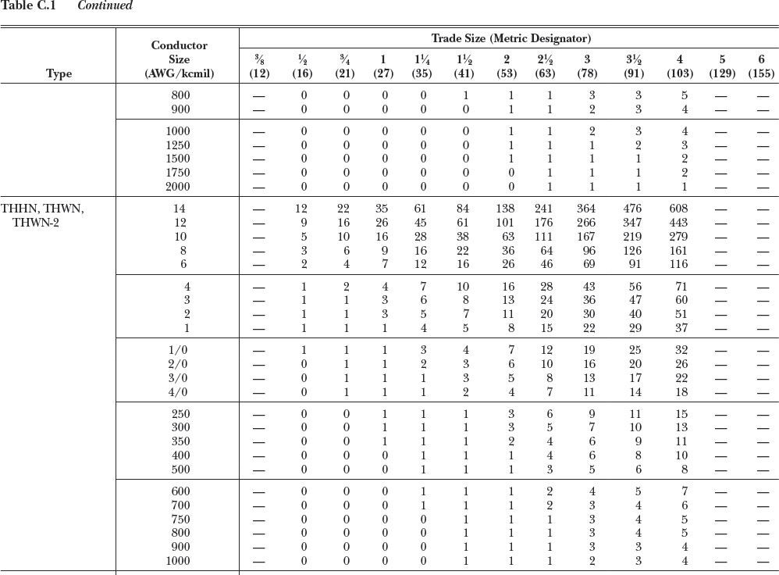

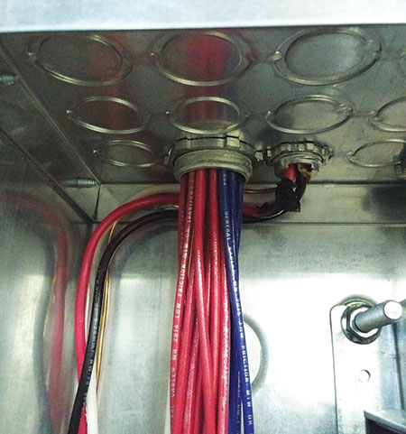 | 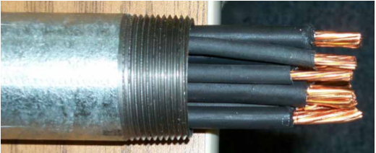
 | 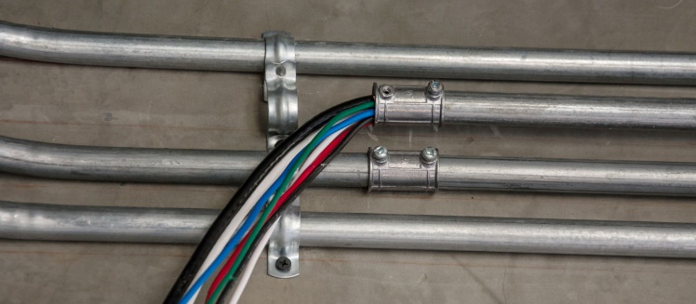

NEC Chapter 9 is used for combinations of conductors of different sizes or insulation types installed in the same conduit or tubing.

Chapter 9

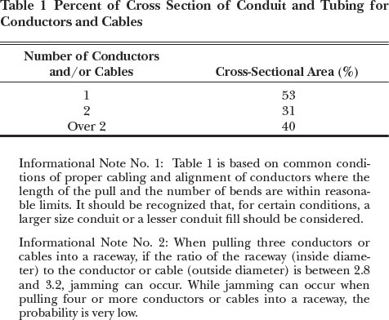 | 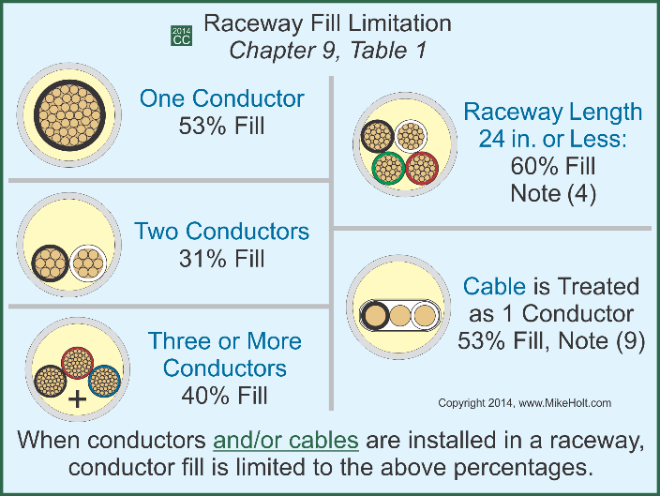
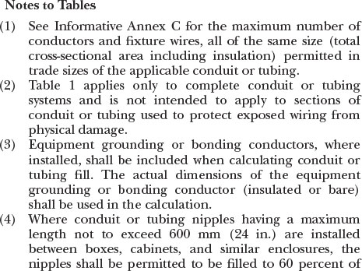 | 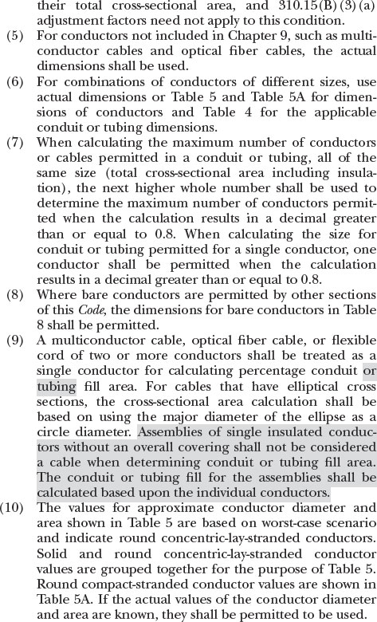

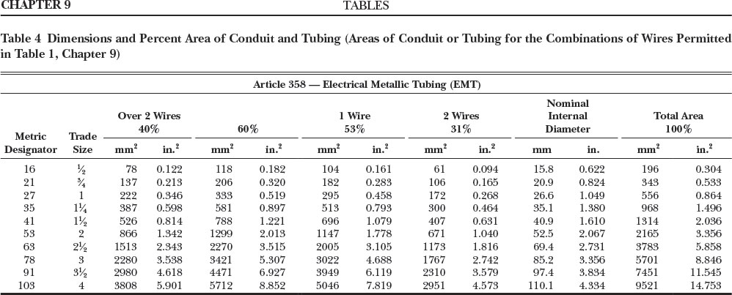

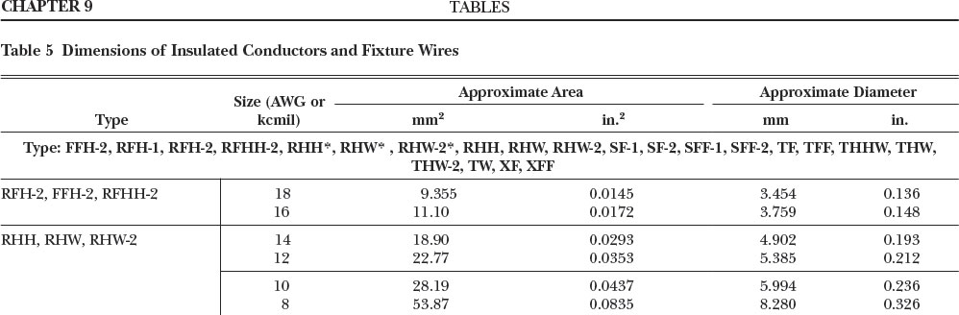

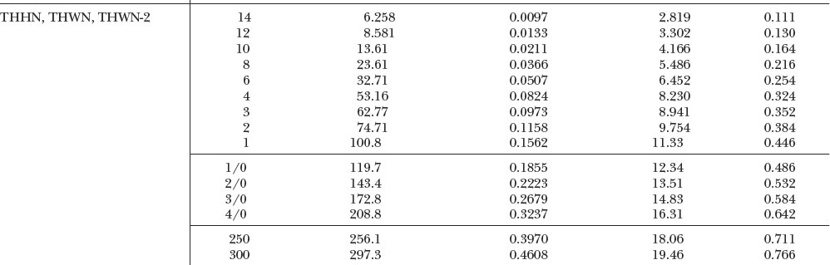

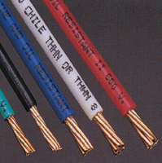
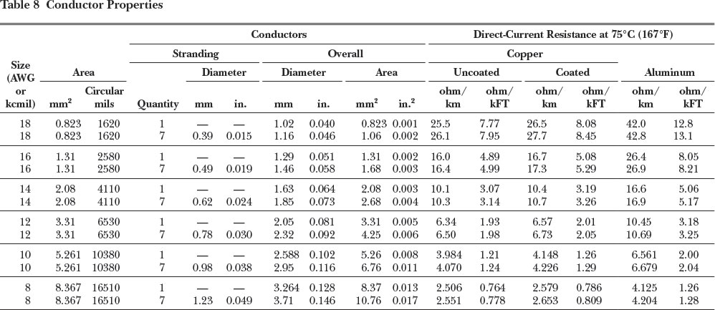

Example 1
What is the minimum size Schedule 40 PVC raceway required for three 500 kcmil THHN conductors, one 250 kcmil THHN conductor, and one 3 THHN conductor?

[Chapter 9, Table 5]
Step 1. 500 THHN [0.7073 in.² x 3 wires = 2.1219 in.²]
250 THHN [0.3970 in.² x 1 wire = 0.3970 in.²]
3 THHN [0.0973 in.² x 1 wire = 0.0973 in.²]

Step 2. Total cross-sectional area of all conductors = 2.6162 in.²

Step 3. [Chapter 9, Table 4]
Size conduit at 40% fill (PVC schedule 40)
Trade Size 3 = allowable cross-sectional area of 2.907 in.²

Example 2
What size RMC nipple is required for three 3/0 THHN conductors, one 1 THHN conductor and one 6 THHN conductor?

Step 1. 3/0 THHN [0.2679 in.² x 3 wires = 0.8037 in.²]
1 THHN [0.1562 in.² x 1 wire = 0.1562 in.²]
6 THHN [0.0507 in.² x 1 wire = 0.0507 in.²]

Step 2. Total cross-sectional area of all conductors = 1.0106 in.²

Step 3. [Chapter 9, Table 1, Note 4] - Size conduit at 60% fill
Trade Size 1 ¼ nipple = 0.916 in.² (too small)
Trade Size 1 ½ nipple = 1.243 in.² (just right)
Trade Size 2 nipple = 2.045 in.² (larger than required)

Example 3
How many 8 THHN conductors can be installed in a trade size 3/4 EMT?
Annex C. Table C.1, pg. 70-714
Total of (6) 8 AWG THHN conductors in a ¾” EMT conduit

Example 4
How many 18 TFFN conductors can be installed in trade size ¾ LFMC?
Annex C. Table C.8, pg. 70-757
Total of (39) 18 AWG TFFN conductors in a ¾” LFMC conduit

Example 5
What’s the smallest trade size PVC Schedule 40 raceway that can be used for the installation of four 1/0 THHN conductors?
Annex C. Table C.11(A), pg. 70-777
1 ½” PVC Schedule 40 conduit

Example 6
A 200A feeder installed in Schedule 80 PVC has three 3/0 THHN conductors, one 2 THHN conductor, and one 6 THHN conductor. What size raceway is required? Chapter 9 Tables
QTY | GAUGE | TYPE | Cross-Section Area
3 | 3/0 | THHN | 3 x 0.2679 in² = 0.8037 in²
1 | 2 | THHN | 1 x 0.1158 in² = 0.1158 in²
1 | 6 | THHN | 1 x 0.0507 in² = 0.0507 in² |  | PVC Sched. 80
 |  |  | Total Cross-Section Area | 0.9702 in² | 2”

Example 7
What size EMT raceway is required for 4 wires, with insulation type THHN, and gauge of 8 AWG and 2 wires, with insulation type THW, and gauge of 4 AWG.?
QTY | GAUGE | TYPE | Cross-Section Area
4 | 8 | THHN | 4 x 0.0366 in² = 0.1464 in²
2 | 4 | THW | 2 x 0.0973 in² = 0.1946 in² |  | EMT
 |  |  | Total Cross-Section Area | 0.341 in² | 1”

