**CMGT 235 – Electrical and Mechanical Systems**

**Homework #28** – Electrical Systems

Due: 12/2/2021

Points: 20 [Extra Credit]

Answers

Name: _______________________________________________________________________________

1. 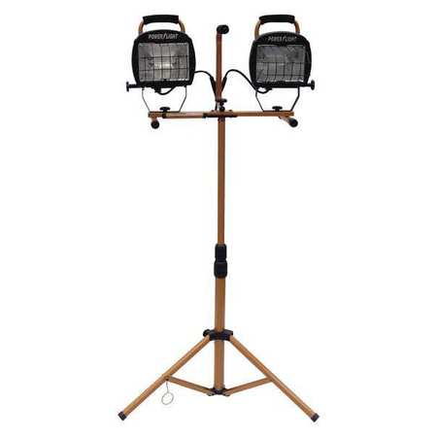A job site is powering two of the temporary lights described below with a 120VAC portable diesel generator. If the lowest the lamp voltage can be is 115V, determine the maximum length for a 18/3 CU uncoated and 16/3 CU uncoated extension cord. The lamps are wired in parallel and the light cord can be neglected.

Specifications: Temporary Job Site Light, Light Distribution Flood, Lamp Type Halogen, Number of Lamp Heads 2, Voltage 120VAC, Lamp Watts 1000, Lumens 16,000, Color Copper, Base Style Floor Stand, Job Site Lighting Max. Height 63 In., Not Safety Rated, Lamp Included Yes, Rated Life 2000 hr., Cord Length 5 ft., NEC Cord Designation SJTW, Gauge/Conductor 18/3, NEMA Plug Configuration 5-15P, Guard Type Metal, Replacement Lamp 500W 4-5/8 In.

Hint: Draw the circuit.

Two Lights = 2000 W

I = 2000 W / 120 V = 16.7 A

(18/3) L = (120 V – 115 V)/16.7 A x 2 x 7.95 Ω/ 1000 ft = 5 x 1000 / 16.7 A x 2 x 7.95 Ω = 19 ft

(16/3) L = (120 V – 115 V)/16.7 A x 2 x 4.99 Ω/ 1000 ft = 5 x 1000 / 16.7 A x 2 x 4.99 Ω = 30 ft